

National Genetics Reference Laboratory (Wessex) & Asuragen

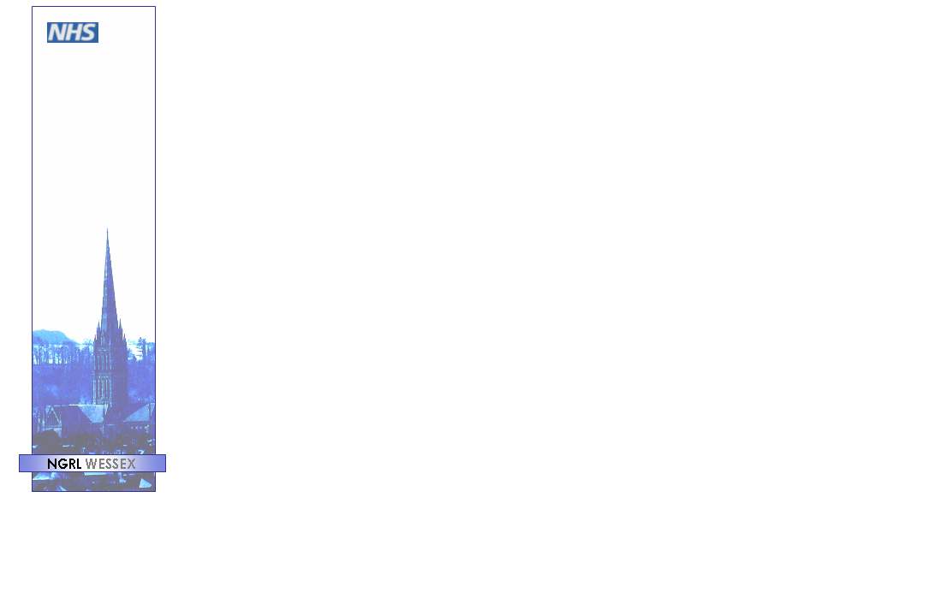

Reference Reagents

Armored RNA as reference material for standardisation of BCR-ABL RQ-PCR methods: report of field trial evaluation

June 2008

Title | Armored RNA as reference materials for standardisation of BCR-ABL RQ-PCR methods: report of field trial evaluation
NGRL Ref | NGRLW_aRNA_BCR_ABL_1.0
Publication Date | June 2008
Document Purpose | Dissemination of information about production and field trial evaluation of reference materials for BCR-ABL RQ PCR methods
Target Audience | Laboratories performing BCR-ABL RQ-PCR and participants of NGRL (Wessex) / Asuragen field trial.
NGRL Funded by | 

Contributors to report writing

Name | Role | Institution
Dr Helen White | Senior Scientist | NGRL (Wessex)
Prof Nick Cross | Director | NGRL (Wessex)

Peer Review and Approval

This document has been reviewed by the field trial participants.

Conflicting Interest Statement

The authors declare that they have no conflicting financial interests

How to obtain copies of NGRL (Wessex) reports

An electronic version of this report can be downloaded free of charge from the NGRL website (http://www.ngrl.org.uk/Wessex/downloads)

or by contacting

Dr Helen White
National Genetics Reference Laboratory (Wessex)
Salisbury District Hospital
Odstock Road
Salisbury
SP2 8BJ
UK

E mail: hew@soton.ac.uk
Tel: 01722 429016
Fax: 01722 338095

Table of Contents

Summary…...…………………………………………………………………………….…1

1. Introduction 3

2. Materials and Methods 4
2.1 Cloning of target sequences 4
2.2 aRNA production 4
2.3 aRNA field trial (October – December 2007) 5
2.3.1 Aims of field trial 5

3. Results of aRNA Field trial 7
3.1 Field trial participants 7
3.2 Methodologies used 7
3.2.1 Transcripts analysed 7
3.2.2 RQ-PCR machines used 7
3.2.3 RQ-PCR methods 7
3.2.3.1 RNA Extraction methods 7
3.2.3.2 RT-PCR method cited 7
3.2.3.3 RT-PCR method and primers used 7
3.2.3.4 Standard type and source 7
3.3 Field trial data analysis 7
3.3.1 Control gene copy numbers from extracted and heat lysed (unextracted) aRNA samples. 7
3.3.1.1 ABL copy number loss following RNA extraction of b3a2 samples 8
3.3.1.2 ABL copy number loss following RNA extraction of b2a2 samples 10
3.3.1.3 BCR copy number loss following RNA extraction of b3a2 samples 12
3.3.1.4 BCR copy number loss following RNA extraction of b2a2 samples 13
3.3.1.5 GUSB copy number loss following RNA extraction of b3a2 aRNA samples 14
3.3.1.6 GUSB copy number loss following RNA extraction of b2a2 aRNA samples 16
3.3.1.7 Control gene copy number loss following RNA extraction 17
3.3.2 Mean, standard deviation and coefficient of variation for % BCR-ABL / Control gene 17
3.3.2.1 Overall CV for aRNA samples analysis 25
3.3.3 Linear regression for b3a2 aRNA samples 26
3.3.4 Linear regression for b2a2 aRNA samples 32
3.3.5 r² values for linear regressions 32

4. Conclusions 38

5. Acknowledgments 39

6. References 39

Appendix A Field trial participants 40
Appendix B b3a2 linear regression plots for individual labs*
Appendix C b2a2 linear regression plots for individual labs*

* Appendices B and C are available as separate documents and can be downloaded from the NGRL (Wessex) website: http://www.ngrl.org.uk/Wessex/downloads

SUMMARY

- An international scale (IS) for quantitative measurement of BCR-ABL mRNA has been established that is anchored to two key points defined in the IRIS trial: a common baseline (100% BCR-ABL^{IS}) and major molecular response (0.1% BCR-ABL^{IS}). Definition of the IS currently relies on relating results directly or indirectly to the Adelaide international reference laboratory. A more robust definition of the IS requires the development of internationally accredited reference reagents.

- The aim of this collaborative study was to produce and assess the use of Armored RNA® (aRNA) as a candidate reference material for the standardisation of BCR-ABL RQ-PCR protocols.

- Nine aRNA reference standards were prepared containing estimated numbers of molecules as follows: 3x10⁴ (Level 1), 3x10³ (Level 2), 3x10² (Level 3) and 3x10¹ (Level 4) copies/ul of b3a2 (or b2a2) aRNA with each control gene (ABL, BCR, GUSB) at 3x10⁴ copies/ul.

- The performance of the aRNA samples was assessed by an international field trial (October - December 2007) that involved 29 laboratories (22 EU, 3 USA, 4 Asia/Australasia) analysing 3 different control genes on 14 different RQ-PCR platforms. The aRNA samples were tested following RNA extraction or direct heat lysis.

- The median number of copies/ul obtained for ABL, BCR and GUSB for the b3a2 aRNA samples following RNA extraction were 8.13x10³, 3.46x10² and 4.09x10² respectively and following direct heat lysis were 1.25x10⁵, 1.25x10⁴ and 7.72x10³ respectively. The expected copy number for the control genes was 3x10⁴ copies/ul

- The median number of copies/ul obtained for ABL, BCR and GUSB for the b2a2 aRNA samples following RNA extraction were 6.32x10³, 4.86x10² and 3.80x10² respectively and following direct heat lysis were 1.16x10⁵, 1.57x10⁴ and 7.9x10³ respectively. The expected copy number for the control genes was 3x10⁴ copies/ul

- Overall, the aRNA samples tested after RNA extraction showed a 12 fold extraction loss when compared to the samples analysed after direct heat lysis. Labs using Trizol demonstrated a median 28 fold loss and those using QIAGEN columns showed a median 2 fold loss.

- The mean % BCR-ABL / control gene values for the extracted and heat lysed aRNA samples were not statistically different (2 sample t-test at 99% confidence; i.e. p<0.01). However, for the extracted samples, 6/28 labs failed to detect level 3 (n=2) and level 4 (n=6) b3a2 transcripts respectively and 6/22 labs failed to detect level 3 (n=1) and level 4 (n=6) b2a2 transcripts respectively. For the heat lysed aRNA samples level 4 b3a2 and b2a2 could not be detected by one lab.

- The coefficient of variance for the %BCR-ABL / control gene values for the extracted and heat lysed samples were statistically different (90% confidence; i.e. p<0.1) for 7 analyses (b3a2: ABL Level 4, BCR Levels 1 & 4, GUSB Level 1; b2a2: BCR Level 2, GUSB Levels 2 & 3).

- Linear regression plots were produced for log transformed lab data plotted against the log transformation of the reference standard values for the b3a2 and b2a2 a RNA samples. The r² values for the linear regression of the b3a2 samples were >98% in 53% and 18% of labs for the heat lysed and extracted samples respectively. The r² values for the linear regression of the b2a2 samples were >98% in 63% and 34% of labs for the heat lysed and extracted samples respectively.

- We conclude that the pilot aRNA reference standards worked well when directly heat lysed prior to cDNA synthesis but further protocol optimisation is required to ensure adequate recovery of low aRNA mass input during RNA extraction. The aRNA samples will undergo a further round of field trial evaluation with the aim of establishing them as secondary reference reagents for BCR-ABL measurement.

Introduction
Reverse-transcription real-time quantitative PCR (RQ-PCR) is routinely used to quantify levels of BCR-ABL mRNA transcripts in peripheral blood and bone marrow samples from chronic myeloid leukaemia (CML) patients. The technique can determine accurately the response to treatment and is particularly valuable for patients who have achieved complete chromosomal remission. Despite efforts to establish standardised protocols for BCR-ABL fusion transcript quantitation¹ there is still substantial variation in the way in which RQ-PCR for BCR-ABL is carried out and how results are reported in different laboratories worldwide². In particular, the use of different control genes for normalisation of results means that there are several different units of measurement worldwide, e.g. BCR-ABL/ABL; BCR-ABL/BCR; BCR-ABL/GUSB, BCR-ABL/G6PD, BCR-ABL/β2M etc.

The CML meeting at the National Institutes of Health in Bethesda in October 2005 made several recommendations for the harmonisation of RQ-PCR for BCR-ABL including the use of one of three control genes (ABL, BCR or GUSB) ^{3,4}. Most importantly, a new international scale (IS) for BCR-ABL RQ-PCR measurements was proposed which is anchored to two key levels used in the IRIS study ⁵, namely a standardised baseline defined as 100% BCR-ABL^{IS}, and major molecular response (3 log reduction relative to the standardised baseline) defined as 0.1% BCR-ABL^{IS}. Laboratories interested in using the IS should derive a laboratory-specific conversion factor to relate values obtained in their laboratory to IS values. The converted value from a given laboratory should then be equivalent to an analogous converted value obtained in any other collaborating laboratory. The strength of this approach is that (i) laboratories can continue to use their existing assay conditions (provided their assay is linear on analysis of the reference samples), and (ii) that they can continue to express results according to local preferences in addition to expressing results on the international scale. The concept of the international scale is analogous to established procedures for other quantitative assays, for example the International Normalised Ratio (INR) for prothrombin time.

The original standards used for the IRIS trial are no longer available, however traceability to the IRIS scale is provided by the extensive quality control data generated by the Adelaide laboratory over a period of several years. Establishment of the IS therefore requires the alignment of local test results either directly or indirectly with those obtained in Adelaide. Currently, this can be achieved by exchange of a series of patient samples with either the Adelaide or Mannheim international reference laboratories. Although this system works well, it is very laborious and consequently only open to a limited number of laboratories at any given time. The availability of internationally accredited reference reagents should in principle help to make the IS more accessible, as well providing a more robust framework for the scale itself.

Ideally, the formulation for reference reagents should be as close as possible to the usual analyte, should cover the entire analytical process, i.e. from RNA extraction to result and should be applicable to methods in use throughout the world. However it is essential that the formulation is stable over a period of several years and that it is physically possible to produce batches of sufficient size to satisfy demand over a similar period of time.

The aim of this collaborative study was to produce and perform a preliminary assessment of the use of Armored RNA® (aRNA) mixtures as prototype reference materials. aRNA is a proprietary technology invented and developed by Asuragen Inc. (www.asuragen.com) and Cenetron Diagnostics (Austin, Texas) for protecting RNA from degradation by ribonucleases. aRNA is based on bacteriophage coat protein encapsulation of specific RNA targets to form pseudo-viral particles ⁶. The bacteriophage coat protein protects RNA transcripts from nuclease degradation and can stabilize RNA sequences. aRNA is designed for use as standards and controls in assays, in particular for use as positive controls or quantitative internal spiked controls for amplification and detection using RT-PCR and are produced in a non-infectious configuration that enables safe handling and shipping. This report details the preparation of nine pilot aRNA reference materials and their evaluation in an international field trial that involved 29 laboratories (22 EU, 3 USA, 4 Asia/Australasia) analysing 3 different control genes on 14 different RQ-PCR platforms.

Materials and Methods

Cloning of target sequences
ABL, BCR, GUSB and b3a2 target sequences were amplified from K562 cDNA using the primers listed in table 1. The b2a2 target sequence was amplified from the cDNA of a patient expressing the b2a2 fusion transcript (informed consent obtained). The five amplicons were cloned into pCR2.1 using the TA Cloning kit (Invitrogen). The plasmid constructs were transferred to Asuragen for synthesis of the aRNA constructs.

Target | Forward Primer | Reverse Primer | Ref seq start | Ref seq finish | Amplicon (bp)
ABL | cgttggaactccaaggaaaa | gaaggcgctcatcttcattc | 142 | 1774 | 1633
BCR | GTCCACTCAGCCACTGGATT | CAAGGACCAGCTGTCAGTCA | 3345 | 4307 | 963
GUSB | tttccgtaccagccactacc | gtaaacgggctgttttccaa | 1166 | 1978 | 813
b3a2 | TCTCTGCACCAAGCTCAAGA | ctgcaccaggttagggtgtt | - | - | 1399
b2a2 | TCTCTGCACCAAGCTCAAGA | ctgcaccaggttagggtgtt | - | - | 1324

- Primer sequences used to amplify ABL, BCR, GUSB, b3a2 and b2a2. Reference sequences for ABL, BCR and GUSB are NM005157.3, NM_004327.3 and NM_000181.1 respectively

aRNA production
The aRNA constructs were produced by Asuragen Inc and were supplied at the concentrations given in table 2.

Construct | Product name | Concentration (copies / µl) | Quantification Method | Volume | Trace DNA detected
GUSB | USH-1 | 2.28 x 10¹¹ | PA | 25 µl | No
ABL | USH-2 | 8.93 x 10⁹ | OD₂₆₀ | 112 µl | No
BCR | USH-3 | 4.63 x 10¹⁰ | PA | 25 µl | Yes
b2a2 | USH-4 | 6.67 x 10¹⁰ | PA | 25 µl | No
b3a2 | USH-5 | 4.58 x 10¹⁰ | PA | 25 µl | No

- Concentration and volume of aRNA constructs supplied by Asuragen. PA = NIST traceable phosphate assay, One unit of OD₂₆₀ is roughly equivalent to 1.9 x 10¹⁴ copies.

Using the stock concentrations provided by Asuragen, nine aRNA reference standards were prepared containing 3x10⁴ (Level 1), 3x10³ (Level 2), 3x10² (Level 3) and 3x10¹ (Level 4) copies/ul of b3a2 (or b2a2) aRNA with each control gene (ABL, BCR, GUSB) at 3x10⁴ copies/ul. aRNA constructs were diluted in 1X TSM (10mM Tris (pH 7.0), 100mM NaCl, 1mM MgCl₂) supplemented with 0.1% gelatin using a CAS-1200™ Precision Liquid Handling Instrument (Corbett Life Sciences). Note that the amount of aRNA produced for ABL was insufficient to measure by the NIST traceable phosphate assay and therefore an estimation of copy number by OD₂₆₀ measurement was used

aRNA field trial (October – December 2007)

Aims of field trial
The aims of the field trial were to:

- test if aRNAs could be shipped worldwide successfully at ambient temperature

- test four different levels of b3a2 aRNA and / or b2a2 aRNA diluted in a background of GUSB, BCR and ABL aRNA.

- measure absolute copy numbers of BCR-ABL (b3a2 and / or b2a2), absolute copy numbers of control genes (GUSB, BCR and ABL) and the BCR-ABL / control gene ratios.

- compare the performance of:

  - aRNA mixes put through an RNA extraction procedure
  - aRNA mixes which were heat lysed and added directly to a cDNA reaction without undergoing an RNA extraction procedure.

Samples were shipped to labs by express courier at ambient temperature. The samples were supplied in three bags labelled batch 1, batch 2 and batch 3. Each bag contained either 9 tubes (labs testing b3a2 and b2a2) or 5 tubes (labs testing b3a2 only) containing 60µl aRNA mix labelled as follows:

a) Labs testing b3a2 and b2a2: b) Labs testing b3a2 only:

Level 1 b3a2 aRNA Level 1 b3a2 aRNA
Level 2 b3a2 aRNA Level 2 b3a2 aRNA
Level 3 b3a2 aRNA Level 3 b3a2 aRNA
Level 4 b3a2 aRNA Level 4 b3a2 aRNA
Level 1 b2a2 aRNA Control genes only aRNA
Level 2 b2a2 aRNA
Level 3 b2a2 aRNA
Level 4 b2a2 aRNA
Control genes only aRNA

Field trial participants were asked to analyse the aRNA samples from each batch on a different day using the following protocol and schedule given in figure x:

- Add 20µl of aRNA sample to 1ml Trizol or 600µl RLT Buffer (QIAGEN), mix well (eg vortex) and extract aRNA following your usual RNA extraction protocol. Please record the volume of elution buffer or RNase free water used for resuspension.

- Set up two cDNA reactions (using your established method). Please use the same cDNA reagents for both reactions and perform both of the cDNA reactions at the same time:

cDNA reaction 1: add extracted aRNA sample (from step 1) to the cDNA reaction to give a final cDNA reaction volume of 40µl. Please use as much of the extracted sample that you can and if possible all of it in a single reaction (this will depend on your elution/resuspension volume). Please record the volume of aRNA added and the final volume of the cDNA reaction. There is no need to measure spectrophotometrically how much RNA was recovered.

cDNA reaction 2: heat 20µl of unextracted aRNA sample (i.e. sample supplied) at 80ºC for 3 minutes. Add this directly to the cDNA reaction to give a final cDNA reaction volume of 40µl.

3. Using 2ul of cDNA per reaction perform quantitative PCR for BCR-ABL (b3a2 and b2a2 as appropriate) and the control gene(s) on each set of cDNA samples. Please process samples from each batch in separate quantitative runs. Analyse the samples for BCR-ABL and the control gene(s) in the usual manner (established lab method).
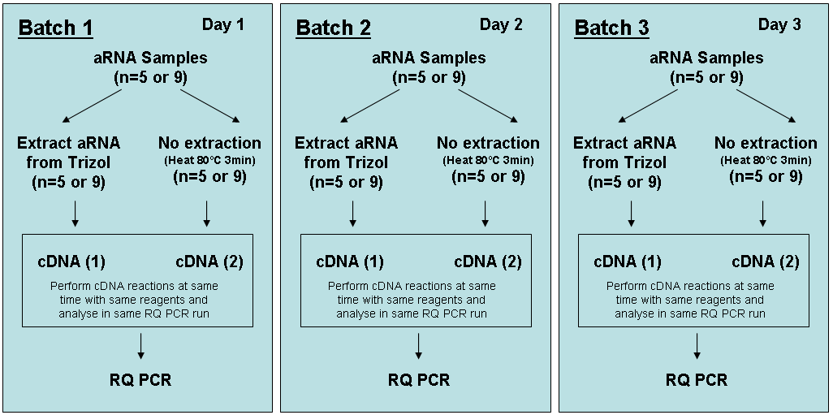

- Schematic flow diagram showing suggested order of analysis for the minimal number of reverse transcription reactions and RQ-PCR runs.

The following information was requested: date of ‘RNA extraction’ or heat lysis, resuspension volume, volume used for cDNA synthesis, final volume of cDNA reaction, date of cDNA synthesis, date of qPCR, BCR-ABL transcript value (Ct value and copy number), control gene transcript value(s) (Ct value and copy number), BCR-ABL / control gene(s) (%) before conversion to IS, BCR-ABL / control gene(s) (%) converted to IS .

Participants were advised that since the aRNA control genes have been supplied at different relative levels compared to normal leucocytes the results on conversion to the international scale were expected to differ depending on the control gene analysed.

Results of aRNA Field trial

Field trial participants
29 laboratories participated in the field trial and all labs returned data; 22 participants from Europe, 3 from the USA, 3 from Asia and 1 from Australasia (Appendix A). Results were obtained from all laboratories and 28 labs returned completed methodology forms.

Methodologies used

Transcripts analysed
Three control genes were analysed: ABL (25 labs), BCR (7 labs), GUSB (18 labs). 18 labs analysed the samples using more than one control gene. One lab failed to amplify ABL as the region cloned into the ABL aRNA construct was not compatible with the location of their primer sequences. 22 labs analysed both the b3a2 and b2a2 aRNA samples and 6 labs analysed the b3a2 samples only.

RQ-PCR machines used
14 different type of RQ-PCR machines were used: ABI 7000 (n=4), ABI 7500 (n=2), ABI 7300 (n=1), ABI 7700 (n=5), ABI 5700 (n=1), ABI 7900HT (n=4), ABI 7900 (n=1), Corbett RotorGene 3000 (n=1), Corbett RotorGene 6000 (n=1), Roche LightCycler 1.0 (n=1), Roche LightCycler 1.5 (n=1), Roche LightCycler 2.0 (n=2), Roche LightCycler 480 (n=3), Stratagene MX3000P (n=1).

RQ-PCR methods

RNA Extraction methods
7 RNA extraction protocols were used; Trizol (Invitrogen) (n=15), Trizol LS (Invitrogen) (n=1), RNeasy kits (QIAGEN) (n=8), Trizol followed by an RNeasy kit (n=1), TriReagent (Sigma) (n=1), RNAzol (n=1), Roche MagNa pure LC HP protocol (n=1).

RT-PCR method cited
22 of the participants cited Gabert et al. (2003)¹ as one of the references used as their RQ-PCR protocol and 2 labs cited Emig et al (1999)⁷. Other references cited are listed in the reference section ⁸⁻¹⁰. One lab used a ‘home brew’ method and another laboratory’s method was proprietary.

RT-PCR method and primers used
27 labs reported the use of random hexamers for reverse transcription. The most common final concentration was 25µM. One lab used a proprietary method and another lab did not provide information.

Standard type and source
25 labs used plasmid DNA as standards and these were either made in house or obtained from another lab (n=11) or purchased from Ipsogen (n=15) and Nanogen (n=1). Other standards used were cDNA standards derived from the K562 cell line (n=1), RNA purchased from In vivo Scribe (n=1) and Armored RNA Quant reagents (Asuragen) (n=1).

Field trial data analysis

Control gene copy numbers from extracted and heat lysed (unextracted) aRNA samples.
Box plots showing the copy numbers (log transformed) obtained from the aRNA samples following direct heat lysis (unextracted, pink boxes) and following an RNA extraction procedure (extracted, blue boxes) are shown below. The bottom of the box corresponds to the first quartile (Q1), and the top to the third quartile (Q3) value. The whiskers extend from the lowest and highest observations inside the region defined by the following limits: Lower Limit: Q1 - 1.5 (Q3 - Q1), Upper Limit: Q3 + 1.5 (Q3 - Q1). Outliers are indicated by asterisks and the median value is indicated by the line running through the box. The dotted horizontal line corresponds to the expected copy number (log₁₀ 3x10⁴ = 4.4771). Copy number values have been corrected for variation in the volume of aRNA extracted and used in the cDNA reaction and the amount of cDNA added to the RQ-PCR so that the data between labs are comparable.

ABL copy number loss following RNA extraction of b3a2 samples
Box plots showing the number of ABL copies obtained by labs using different RNA extraction protocols are shown in figure 2 (Trizol extraction) and figure 3 (QIAGEN and other RNA extraction protocols). Tables 3 and 4 shows the median number of ABL copies (Trizol and other methods of RNA extraction respectively) obtained from each lab following extraction and heat lysis. The median fold loss in copy number resulting from RNA extraction using the Trizol and QIAGEN protocols were 18.4 and 2.1 respectively.

Lab ID | RNA extraction method | Median Extracted Copy number | Median Unextracted Copy number | Fold Extraction loss
2 | Trizol | 3.65E+04 | 2.69E+05 | 7.4
3 | Trizol | 2.79E+04 | 1.19E+05 | 4.2
5 | Trizol | 1.33E+03 | 2.35E+04 | 17.6
8 | Trizol | 7.43E+03 | 1.59E+05 | 21.4
9 | Trizol | 2.86E+03 | 7.56E+05 | 264.3
11 | Trizol | 1.32E+04 | 1.32E+05 | 10.0
12 | Trizol | 9.66E+02 | 2.73E+04 | 28.2
13 | Trizol | 5.36E+03 | 2.60E+05 | 48.5
16 | Trizol | 2.31E+03 | 1.75E+05 | 75.8
18 | Trizol | 4.52E+03 | 8.33E+04 | 18.4
21 | Trizol | 2.12E+00 | 9.97E+01 | 47.0
22 | Trizol | 6.27E+04 | 3.23E+05 | 5.1
25 | Trizol | 5.28E+03 | 7.07E+05 | 133.9
28 | Trizol | 7.54E+03 | 6.68E+04 | 8.9
29 | Trizol | 3.65E+04 | 2.69E+05 | 7.4
Median Fold extraction loss | Trizol | - | - | 18.4

- Median ABL copy numbers and the fold loss in copy number obtained from the b3a2 aRNA samples analysed by labs using a Trizol RNA extraction protocol.

Lab ID | RNA extraction method | Median Extracted Copy number | Median Unextracted Copy number | Fold Extraction loss
4 | QIAGEN | 2.44E+03 | 1.96E+04 | 8.0
6 | QIAGEN | 4.29E+04 | 8.85E+04 | 2.1
7 | QIAGEN | 3.86E+05 | 7.38E+05 | 1.9
10 | QIAGEN | 6.31E+03 | 9.70E+04 | 15.4
15* | QIAGEN | 1.74E-01 | 3.67E-01 | 2.1
17 | QIAGEN | 1.40E+05 | 2.93E+05 | 2.1
19 | QIAGEN | 1.65E+05 | 2.97E+05 | 1.8
24 | QIAGEN | 1.33E+05 | 2.28E+05 | 1.7
14 | Roche | 2.22E+03 | 1.52E+04 | 6.8
20 | RNAzol | 1.75E+05 | 2.15E+05 | 1.2
26 | TriReagent | 1.72E+03 | 9.86E+04 | 57.4
Median Fold extraction loss | QIAGEN | - | - | 2.1

- Median ABL copy numbers and the fold loss in copy number obtained from the b3a2 aRNA samples analysed by labs using QIAGEN, Roche, RNAzol and TriReagent RNA extraction protocols. * relative values compared to K562 expression where the level of K562 ABL expression is defined as 1.
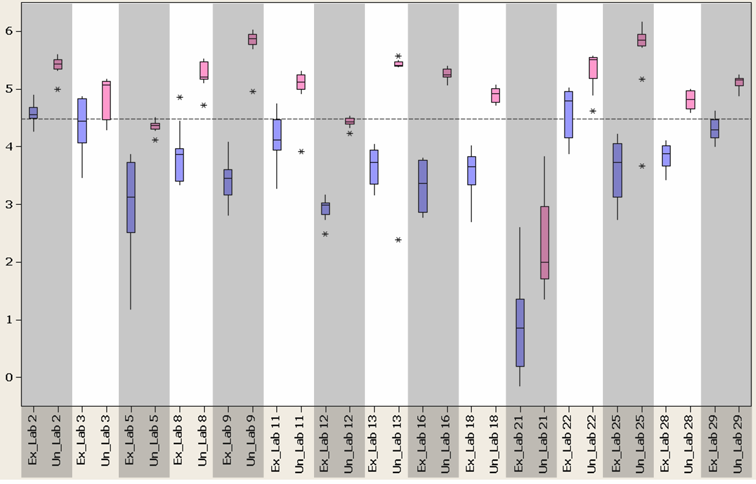
- Box plot of ABL copy numbers (log transformed) obtained from the b3a2 aRNA samples analysed by labs using a Trizol RNA extraction protocol. Ex = extracted (blue bars), Un = unextracted, heat lysis only (pink bars).
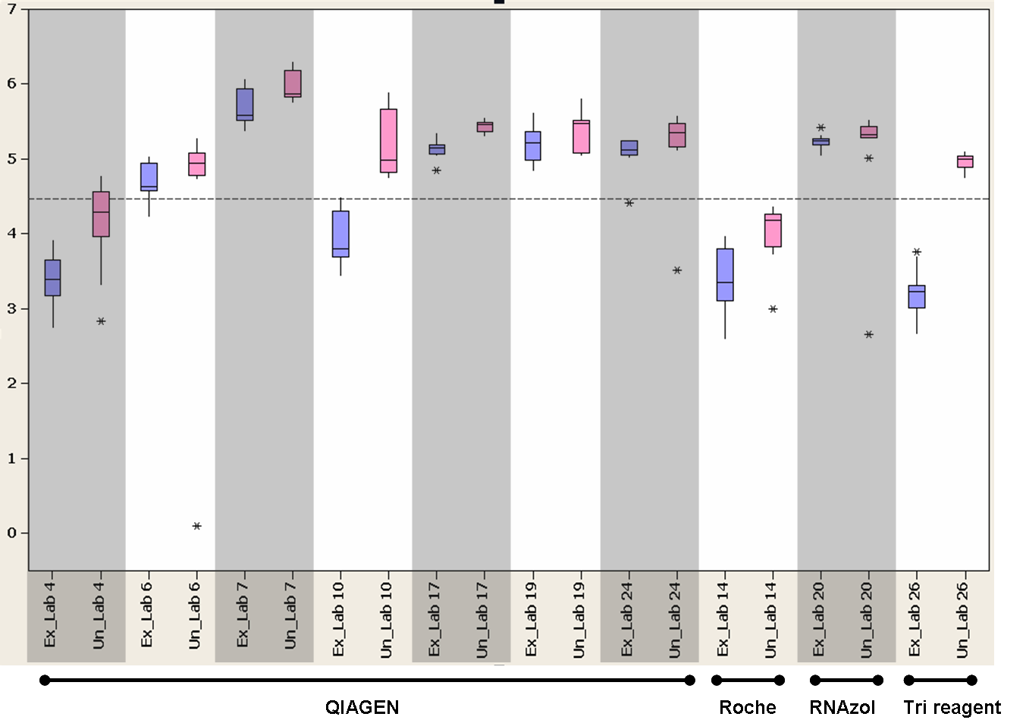

- Box plot of ABL copy numbers (log transformed) obtained from the b3a2 aRNA samples analysed by labs using QIAGEN, Roche, RNAzol and TriReagent RNA extraction protocols. Ex = extracted (blue bars), Un = unextracted, heat lysis only (pink bars).

ABL copy number loss following RNA extraction of b2a2 samples
A box plot showing the number of ABL copies obtained from the b2a2 aRNA samples by labs using a Trizol RNA extraction protocol is shown in figure 4. Table 5 shows the median number of ABL copies obtained from each lab following extraction and heat lysis. The median fold loss in copy number resulting from RNA extraction using the Trizol protocol was 12.3
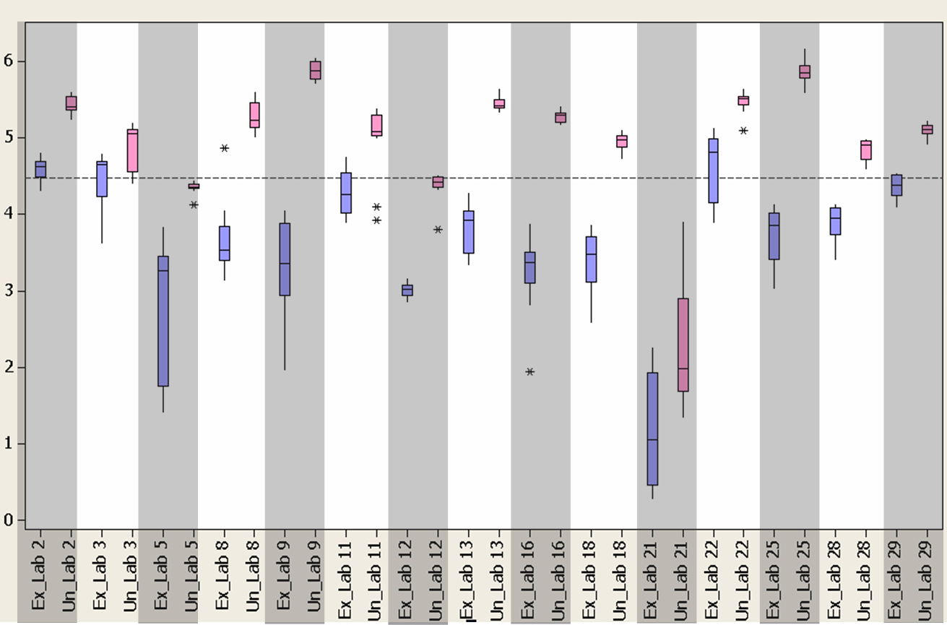

- Box plot of ABL copy numbers (log transformed) obtained from the b2a2 aRNA samples analysed by labs using a Trizol RNA extraction protocol. Ex = extracted (blue bars), Un = unextracted, heat lysis only (pink bars).

Lab ID | RNA extraction method | Median Extracted Copy number | Median Unextracted Copy number | Fold Extraction loss
2 | Trizol | 4.15E+04 | 2.56E+05 | 6.2
3 | Trizol | 4.45E+04 | 1.13E+05 | 2.5
5 | Trizol | 1.85E+03 | 2.28E+04 | 12.3
8 | Trizol | 3.38E+03 | 1.71E+05 | 50.7
9 | Trizol | 2.30E+03 | 7.56E+05 | 328.7
11 | Trizol | 1.82E+04 | 1.19E+05 | 6.6
12 | Trizol | 1.06E+03 | 2.63E+04 | 24.8
13 | Trizol | 8.40E+03 | 2.59E+05 | 30.8
16 | Trizol | 2.38E+03 | 1.95E+05 | 82.0
18 | Trizol | 2.99E+03 | 9.39E+04 | 31.4
21 | Trizol | 1.22E+01 | 9.51E+01 | 7.8
22 | Trizol | 6.48E+04 | 3.21E+05 | 5.0
25 | Trizol | 7.17E+03 | 7.00E+05 | 97.6
28 | Trizol | 8.85E+03 | 8.13E+04 | 9.2
29 | Trizol | 2.43E+04 | 1.29E+05 | 5.3
Median Fold extraction loss | Trizol | - | - | 12.3

- Median ABL copy numbers and the fold loss in copy number obtained from the b2a2 aRNA samples analysed by labs using a Trizol RNA extraction protocol.

A box plot showing the number of ABL copies obtained from the b2a2 aRNA samples by labs using other RNA extraction protocols is shown in figure 5. Table 6 shows the median number of ABL copies obtained from each lab following extraction and heat lysis. The median fold loss in copy number resulting from RNA extraction using the QIAGEN protocol was 2.1

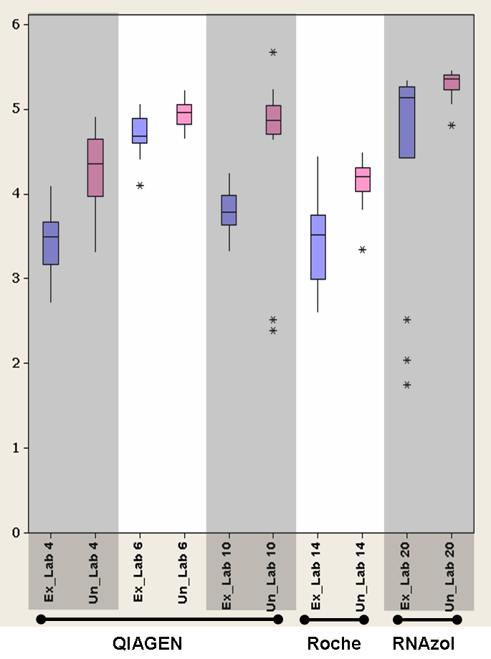

- Box plot of ABL copy numbers (log transformed) obtained from the b2a2 aRNA samples analysed by labs using QIAGEN, Roche and RNAzol RNA extraction protocols. Ex = extracted (blue bars), Un = unextracted, heat lysis only (pink bars).

Lab ID | RNA extraction method | Median Extracted Copy number | Median Unextracted Copy number | Fold Extraction loss
4 | QIAGEN | 3.10E+03 | 2.25E+04 | 7.2
6 | QIAGEN | 4.76E+04 | 9.08E+04 | 1.9
10 | QIAGEN | 6.13E+03 | 7.30E+04 | 11.9
14 | Roche | 3.27E+03 | 1.62E+04 | 4.9
20 | RNAzol | 1.36E+05 | 2.25E+05 | 1.6
Median fold extraction loss | QIAGEN | - | - | 2.1

- Median ABL copy numbers and the fold loss in copy number obtained from the b3a2 aRNA samples analysed by labs using QIAGEN, Roche and RNAzol RNA extraction protocols.

BCR copy number loss following RNA extraction of b3a2 samples
A box plot showing the number of BCR copies obtained from the b3a2 aRNA samples by labs using a Trizol RNA extraction protocol is shown in figure 6. Table 7 shows the median number of BCR copies obtained from each lab following extraction and heat lysis. The median fold loss in copy number resulting from RNA extraction using the Trizol protocol was 36.4
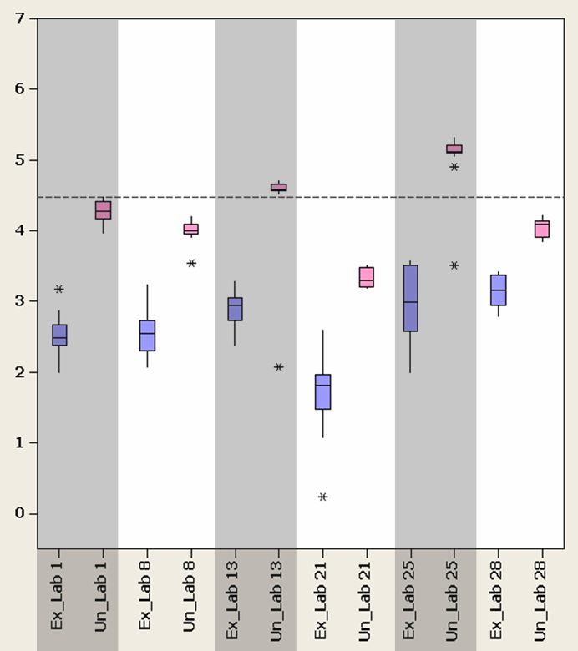

- Box plot of BCR copy numbers (log transformed) obtained from the b3a2 aRNA samples analysed by labs using a Trizol RNA extraction protocol. Ex = extracted (blue bars), Un = unextracted, heat lysis only (pink bars).

Lab ID | RNA extraction method | Median Extracted Copy number | Median Unextracted Copy number | Fold Extraction loss
1 | Trizol | 3.10E+02 | 1.92E+04 | 61.8
8 | Trizol | 3.46E+02 | 1.01E+04 | 29.2
13 | Trizol | 8.75E+02 | 3.76E+04 | 43.0
21 | Trizol | 6.56E+01 | 1.96E+03 | 29.9
25 | Trizol | 7.42E+02 | 1.33E+05 | 179.1
28 | Trizol | 1.45E+03 | 1.25E+04 | 8.6
15* | QIAGEN | 1.77E-01 | 3.03E-01 | 1.7
Median fold extraction loss | Trizol | - | - | 36.4

- Median BCR copy numbers and the fold loss in copy number obtained from the b3a2 aRNA samples analysed by labs using a Trizol RNA extraction protocol. * relative values compared to K562 expression where the level of K562 BCR expression is defined as 1.

BCR copy number loss following RNA extraction of b2a2 samples
A box plot showing the number of BCR copies obtained from the b2a2 aRNA samples by labs using a Trizol RNA extraction protocol is shown in figure 7. Table 8 shows the median number of BCR copies obtained from each lab following extraction and heat lysis. The median fold loss in copy number resulting from RNA extraction using the Trizol protocol was 37.3.

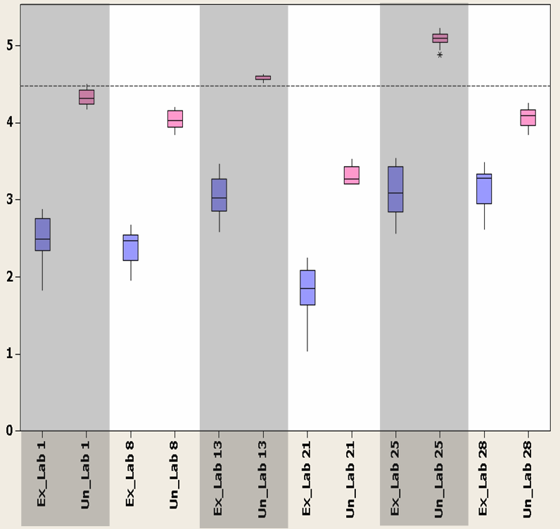

- Box plot of BCR copy numbers (log transformed) obtained from the b2a2 aRNA samples analysed by labs using a Trizol RNA extraction protocol. Ex = extracted (blue bars), Un = unextracted, heat lysis only (pink bars).

Lab ID | RNA extraction method | Median Extracted Copy number | Median Unextracted Copy number | Fold Extraction loss (Unextracted / Extracted)
1 | Trizol | 3.05E+02 | 2.06E+04 | 67.4
8 | Trizol | 2.94E+02 | 1.07E+04 | 36.6
13 | Trizol | 1.05E+03 | 3.99E+04 | 38.1
21 | Trizol | 7.13E+01 | 1.85E+03 | 25.9
25 | Trizol | 1.21E+03 | 1.25E+05 | 103.5
28 | Trizol | 1.90E+03 | 1.25E+04 | 6.6
Median fold extraction loss | Trizol | - | - | 37.3

- Median BCR copy numbers and the fold loss in copy number obtained from the b2a2 aRNA samples analysed by labs using a Trizol RNA extraction protocol.

GUSB copy number loss following RNA extraction of b3a2 aRNA samples
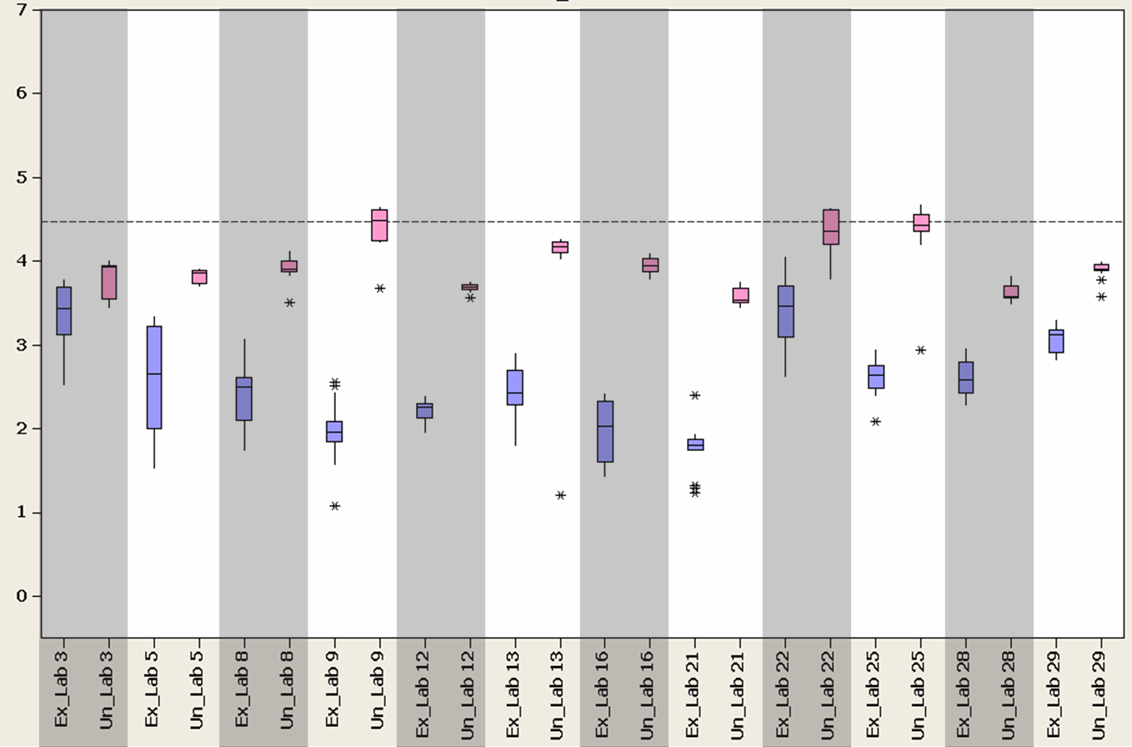
A box plot showing the number of GUSB copies obtained from the b3a2 aRNA samples by labs using a Trizol RNA extraction protocol is shown in figure 8. Table 9 shows the median number of GUSB copies obtained from each lab following extraction and heat lysis. The median fold loss in copy number resulting from RNA extraction using the Trizol protocol was 26.8.

- Box plot of GUSB copy numbers (log transformed) obtained from the b3a2 aRNA samples analysed by labs using a Trizol RNA extraction protocol. Ex = extracted (blue bars), Un = unextracted, heat lysis only (pink bars).

Lab ID | RNA extraction method | Median Extracted Copy number | Median Unextracted Copy number | Fold Extraction loss
3 | Trizol | 2.70E+03 | 8.44E+03 | 3.1
5 | Trizol | 4.45E+02 | 7.24E+03 | 16.3
8 | Trizol | 3.14E+02 | 8.09E+03 | 25.8
9 | Trizol | 9.00E+01 | 3.07E+04 | 341.1
12 | Trizol | 1.78E+02 | 4.94E+03 | 27.8
13 | Trizol | 2.68E+02 | 1.49E+04 | 55.5
16 | Trizol | 1.05E+02 | 8.86E+03 | 84.2
21 | Trizol | 6.40E+01 | 3.43E+03 | 53.6
22 | Trizol | 2.92E+03 | 2.28E+04 | 7.8
25 | Trizol | 4.08E+02 | 2.69E+04 | 66.0
28 | Trizol | 3.80E+02 | 3.73E+03 | 9.8
29 | Trizol | 1.32E+03 | 8.09E+03 | 6.1
Median fold extraction loss | Trizol | - | - | 26.8

- Median GUSB copy numbers and the fold loss in copy number obtained from the b3a2 aRNA samples analysed by labs using a Trizol RNA extraction protocol.

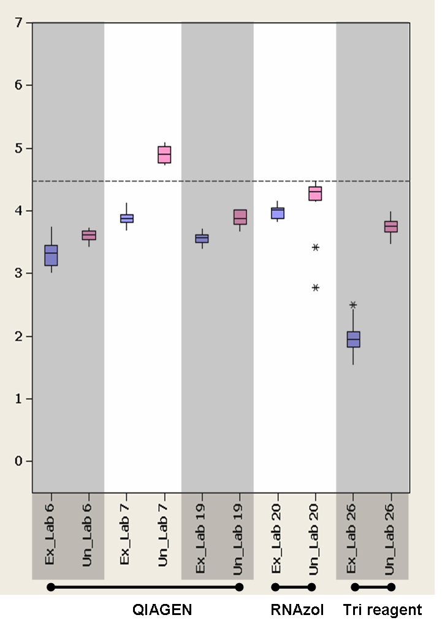
A box plot showing the number of GUSB copies obtained from the b3a2 aRNA samples by labs using other RNA extraction protocols is shown in figure 9. Table 10 shows the median number of GUSB copies obtained from each lab following extraction and heat lysis. The median fold loss in copy number resulting from RNA extraction using the QIAGEN protocol was 3.1

- Box plot of GUSB copy numbers (log transformed) obtained from the b3a2 aRNA samples analysed by labs using QIAGEN, RNAzol and TriReagent RNA extraction protocols. Ex = extracted (blue bars), Un = unextracted, heat lysis only (pink bars).

Lab ID | RNA extraction method | Median Extracted Copy number | Median Unextracted Copy number | Fold Extraction loss
6 | QIAGEN | 2.15E+03 | 4.07E+03 | 1.9
7 | QIAGEN | 7.63E+03 | 8.08E+04 | 10.6
15* | QIAGEN | 2.85E-02 | 1.21E-01 | 4.2
19 | QIAGEN | 3.70E+03 | 7.44E+03 | 2.0
20 | RNAzol | 1.02E+04 | 2.02E+04 | 2.0
26 | TriReagent | 9.00E+01 | 5.69E+03 | 63.2
Median fold extraction loss | QIAGEN | - | - | 3.1

- Median GUSB copy numbers and the fold loss in copy number obtained from the b3a2 aRNA samples analysed by labs using QIAGEN, RNAzol and TriReagent RNA extraction protocols. * relative values compared to K562 expression where the level of K562 GUSB expression is defined as 1.

GUSB copy number loss following RNA extraction of b2a2 aRNA samples
A box plot showing the number of GUSB copies obtained from the ba2 aRNA samples by labs using a Trizol RNA extraction protocol is shown in figure 10. Table 11 shows the median number of GUSB copies obtained from each lab following extraction and heat lysis. The median fold loss in copy number resulting from RNA extraction using the Trizol protocol was 28.4.

- Box plot of GUSB copy numbers (log transformed) obtained from the b2a2 aRNA samples analysed by labs using a Trizol RNA extraction protocol. Ex = extracted (blue bars), Un = unextracted, heat lysis only (pink bars).

Lab ID | RNA extraction method | Median Extracted Copy number | Median Unextracted Copy number | Fold Extraction loss (Unextracted / Extracted)
3 | Trizol | 3.46E+03 | 7.96E+03 | 2.3
5 | Trizol | 5.20E+02 | 7.24E+03 | 13.9
9 | Trizol | 6.45E+01 | 3.12E+04 | 483.7
12 | Trizol | 1.78E+02 | 5.05E+03 | 28.4
13 | Trizol | 4.05E+02 | 1.34E+04 | 33.2
16 | Trizol | 1.11E+02 | 9.20E+03 | 83.2
21 | Trizol | 6.02E+01 | 3.49E+03 | 58.0
22 | Trizol | 2.60E+03 | 2.36E+04 | 9.1
25 | Trizol | 3.46E+02 | 3.13E+04 | 90.7
28 | Trizol | 5.17E+02 | 4.03E+03 | 7.8
29 | Trizol | 1.52E+03 | 8.47E+03 | 5.6
Median fold extraction loss | Trizol | - | - | 28.4

- Median GUSB copy numbers and the fold loss in copy number obtained from the b2a2 aRNA samples analysed by labs using a Trizol RNA extraction protocol.

A box plot showing the number of GUSB copies obtained from the b2a2 aRNA samples by labs using other RNA extraction protocols is shown in figure 11. Table 12 shows the median number of GUSB copies obtained from each lab following extraction and heat lysis.
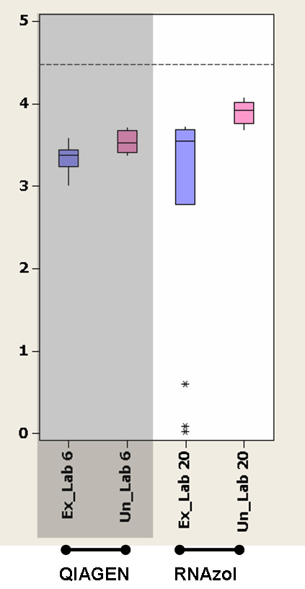

- Box plot of GUSB copy numbers (log transformed) obtained from the b2a2 aRNA samples analysed by labs using QIAGEN and RNAzol RNA extraction protocols. Ex = extracted (blue bars), Un = unextracted, heat lysis only (pink bars).

Lab ID | RNA extraction method | Median Extracted Copy number | Median Unextracted Copy number | Fold Extraction loss
6 | QIAGEN | 2.36E+03 | 3.34E+03 | 1.4
20 | RNAzol | 3.53E+03 | 8.40E+03 | 2.4

- Median GUSB copy numbers and the fold loss in copy number obtained from the b2a2 aRNA samples analysed by labs using QIAGEN and RNAzol RNA extraction protocols.

Control gene copy number loss following RNA extraction
The overall median fold loss of control gene copy number for the five different RNA extraction protocols are shown in table 13.

RNA Extraction method | Number of extractions | Median fold loss of control gene copy number following extraction
Trizol | 65 | 27.8
QIAGEN | 17 | 2.1
Roche | 4 | 5.85
RNAzol | 2 | 1.8
TriReagent | 2 | 60.3
Overall | 90 | 12.1

- Median fold loss of control gene copy number for the five different RNA extraction protocols.

Mean, standard deviation and coefficient of variation for % BCR-ABL / Control gene
The mean, standard deviation (SD) and coefficient of variation (CV) for the % BCR-ABL / control gene values for each reference material in each lab are shown in tables 14, 15 and 18 (ABL; b3a2 extracted, b3a2 unextracted and b2a2 respectively), tables 16 and 19 (BCR; b3a2 and b2a2 respectively) and tables 17 and 20 (GUSB; b3a2 and b2a2 respectively). The expected % BCR-ABL / control gene based on the aRNA copy number prior to dilution and blending of the 9 pilot reference samples is 100%, 10%, 1%, and 0.1% for Level 1, 2, 3, and 4, respectively.

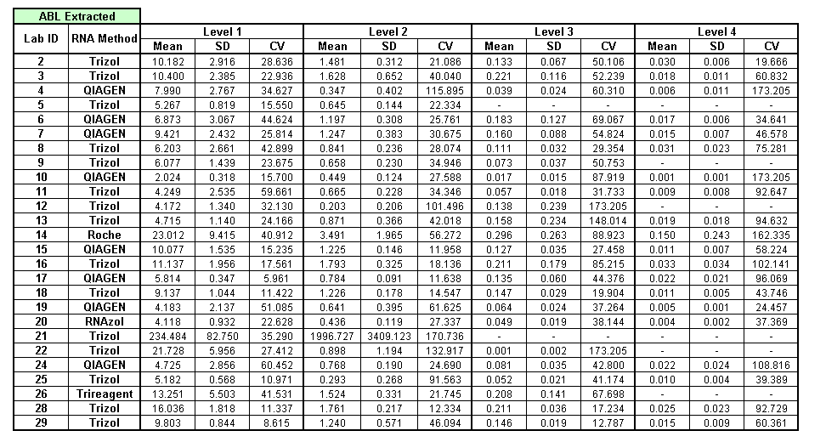

- Mean, SD and CV values for %b3a2 / ABL for each laboratory for the b3a2 aRNA reference materials following RNA extraction

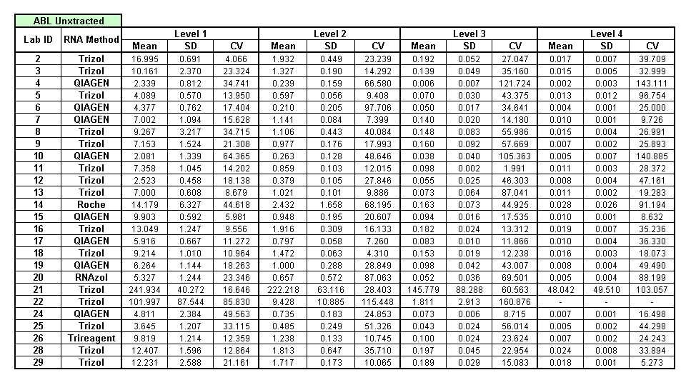

- Mean, SD and CV values for %b3a2 / ABL for each laboratory for the b3a2 aRNA reference materials following heat lysis (unextracted)

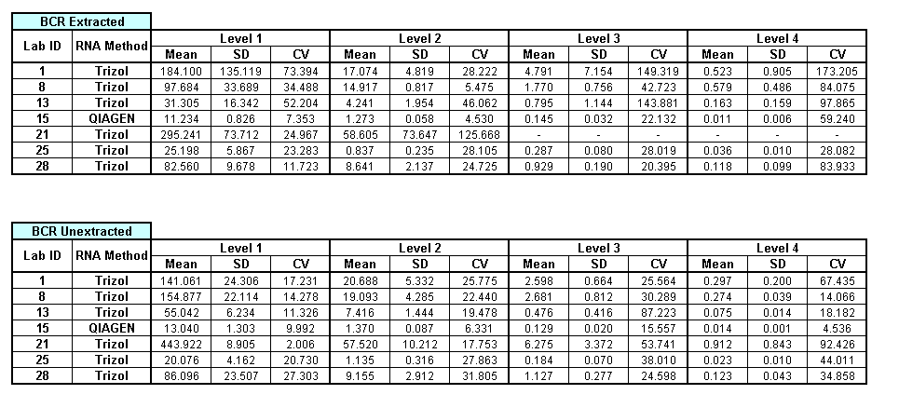
a)

b)

- Mean, SD and CV values for %b3a2 / BCR for each laboratory for the b3a2 aRNA reference materials following a) RNA extraction and b) heat lysis (unextracted)
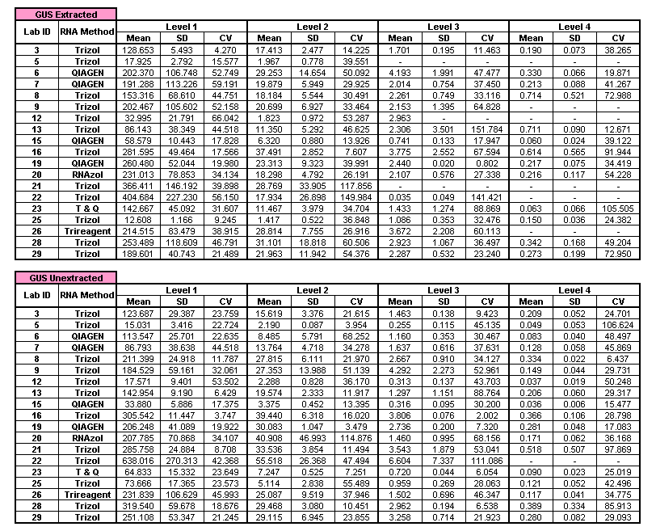
a)

b)

- Mean, SD and CV values for %b3a2 / BCR for each laboratory for the b3a2 aRNA reference materials following a) RNA extraction and b) heat lysis (unextracted)
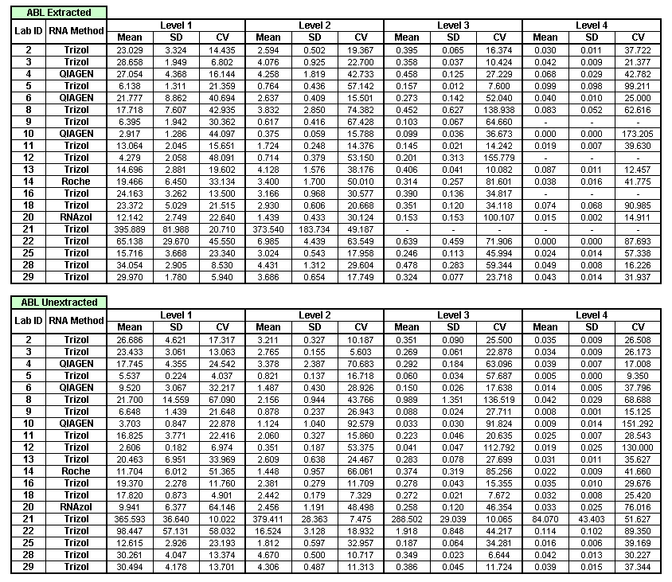
a)

b)

- Mean, SD and CV values for %b2a2 / ABL for each laboratory for the b2a2 aRNA reference materials following a) RNA extraction and b) heat lysis (unextracted)

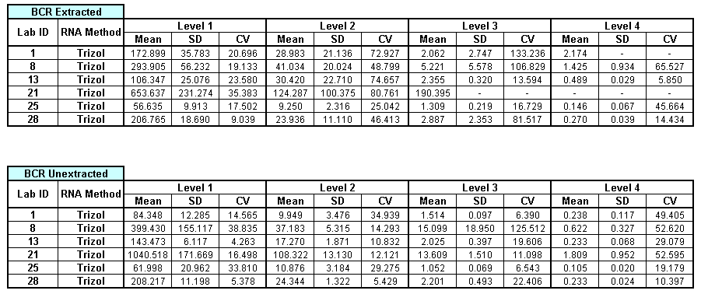
a)

b)

- Mean, SD and CV values for %b2a2 / BCR for each laboratory for the b2a2 aRNA reference materials following a) RNA extraction and b) heat lysis (unextracted)
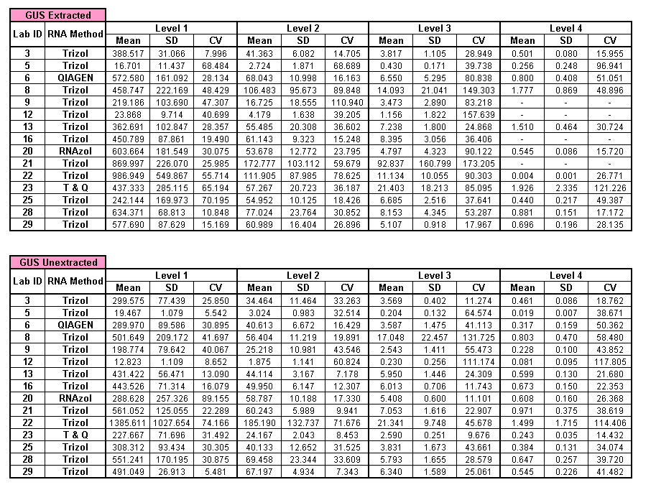

a)

b)

- Mean, SD and CV values for %b2a2 / GUSB for each laboratory for the b2a2 aRNA reference materials following a) RNA extraction and b) heat lysis (unextracted)
Protocol | Control gene | Level 1 | p | Level 2 | p | Level 3 | p | Level 4 | p
Extracted | ABL | 24.99 | 0.405 | 29.37 | 0.198 | 50.43 | 0.161 | 68.06 | 0.019*
Unextracted | ABL | 17.77 | 0.405 | 24.05 | 0.198 | 39.08 | 0.161 | 33.89 | 0.019*
Extracted | BCR | 24.97 | 0.099* | 28.10 | 0.358 | 35.37 | 0.329 | 84.00 | 0.070*
Unextracted | BCR | 14.28 | 0.099* | 22.44 | 0.358 | 30.29 | 0.329 | 34.86 | 0.070*
Extracted | GUSB | 38.92 | 0.058* | 36.85 | 0.163 | 36.97 | 0.259 | 41.27 | 0.405
Unextracted | GUSB | 22.72 | 0.058* | 21.97 | 0.163 | 34.13 | 0.259 | 32.25 | 0.405

Overall CV for aRNA samples analysis

The overall median CVs for the b3a2 and b2a2 aRNA samples tested after RNA extraction and direct heat lysis (unextracted) are shown in table 21 and table 22 respectively. The p values are given for a 2-sample t-test analysis for the difference in CVs for the extracted and unextracted samples (calculated using full data set).

- Overall median CVs for the b3a2 aRNA samples tested after RNA extraction and direct heat lysis (unextracted). * statistically different at a confidence of 90% (i.e p<0.1)

Protocol | Control gene | Level 1 | p | Level 2 | p | Level 3 | p | Level 4 | p
Extracted | ABL | 21.437 | 0.840 | 30.351 | 0.375 | 36.673 | 0.507 | 40.702 | 0.708
Unextracted | ABL | 22.032 | 0.840 | 21.700 | 0.375 | 27.705 | 0.507 | 36.486 | 0.708
Extracted | BCR | 19.914 | 0.778 | 60.863 | 0.005* | 81.517 | 0.244 | 30.049 | 0.873
Unextracted | BCR | 15.532 | 0.778 | 13.207 | 0.005* | 15.352 | 0.244 | 39.242 | 0.873
Extracted | GUSB | 30.075 | 0.438 | 36.187 | 0.075* | 80.838 | 0.043* | 30.724 | 0.986
Unextracted | GUSB | 30.305 | 0.438 | 19.891 | 0.075* | 28.579 | 0.043* | 38.671 | 0.986

- Overall median CVs for the b2a2 aRNA samples tested after RNA extraction and direct heat lysis (unextracted). * statistically different at a confidence of 90% (i.e p<0.1)

Linear regression for b3a2 aRNA samples
The linear regression of the log transformed data obtained from all labs are summarised in figures 12 and 13 (ABL), figure 14 (BCR) and figure 15 (GUSB). Data have been plotted against reference material values which have been calculated as 100% (level 1), 10% (level 2), 1% (level 3) and 0.1% (level 4) BCR-ABL / Control Gene based on the input copy number of each aRNA construct. The regression equations for the log transformed data for each cell line and each control gene are given in table 23 (ABL), table 24 (BCR) and table 25 (GUSB). The individual regression plots and associated data for each lab are shown in appendix B.

Lab ID | b3a2 / ABL Heat Lysed | R² (Adj) | b3a2 / ABL Extracted | R² (Adj)
2 | Log(y)= -0.7574 + 1.006 log(x) | 99.0% | Log(y)= -0.7548 + 0.8662 log(x) | 97.2%
3 | Log(y)= -0.8752 + 0.9519 log(x) | 99.1% | Log(y)= -0.7854 + 0.9279 log(x) | 97.0%
4 | Log(y)= -1.975 + 1.119 log(x) | 84.4% | Log(y)= -1.333 + 0.9791 log(x) | 82.3%
5 | Log(y)= -1.157 + 0.8912 log(x) | 95.9% | Insufficient data points | -
6 | Log(y)= -1.390 + 0.9970 log(x) | 98.8% | Log(y)= -0.8710 + 0.8677 log(x) | 95.6%
7 | Log(y)= -0.9660 + 0.9471 log(x) | 99.0% | Log(y)= -0.8919 + 0.9426 log(x) | 96.9%
8 | Log(y)= -0.8978 + 0.9234 log(x) | 97.4% | Log(y)= -0.8787 + 0.8035 log(x) | 95.8%
9 | Log(y)= -1.046 + 0.9937 log(x) | 97.2% | Log(y)= -1.175 + 0.9747 log(x) | 96.5%
10 | Log(y)= -1.687 + 1.009 log(x) | 85.6% | Log(y)= -1.780 + 1.099 log(x) | 83.4%
11 | Log(y)= -1.013 + 0.9400 log(x) | 99.6% | Log(y)= -1.238 + 0.9381 log(x) | 94.8%
12 | Log(y)= -1.285 + 0.8430 log(x) | 97.7% | Insufficient data points | -
13 | Log(y)= -0.9860 + 0.9369 log(x) | 99.6% | Log(y)= -0.9978 + 0.8143 log(x) | 77.8%
14 | Log(y)= -0.6409 + 0.8763 log(x) | 94.4% | Log(y)= -0.4082 + 0.8465 log(x) | 82.1%
15 | Log(y)= -1.022 + 1.003 log(x) | 99.7% | Log(y)= -0.9504 + 0.9955 log(x) | 98.7%
16 | Log(y)= -0.7540 + 0.9603 log(x) | 99.3% | Log(y)= -0.6277 + 0.8267 log(x) | 94.7%
17 | Log(y)= -1.082 + 0.9402 log(x) | 99.3% | Log(y)= -0.9274 + 0.8428 log(x) | 95.9%
18 | Log(y)= -0.8331 + 0.9255 log(x) | 99.5% | Log(y)= -0.9299 + 0.9734 log(x) | 98.9%
19 | Log(y)= -1.084 + 0.9760 log(x) | 97.4% | Log(y)= -1.291 + 0.9750 log(x) | 97.3%
20 | Log(y)= -1.240 + 1.005 log(x) | 95.1% | Log(y)= -1.363 + 0.9897 log(x) | 98.7%
21 | Log(y)= 1.699 + 0.4629 log(x) | 27.3% | Insufficient data points | -
22 | Log(y)= -0.7154 + 1.348 log(x) | 59.4% | Insufficient data points | -
24 | Log(y)= -1.159 + 0.9335 log(x) | 98.6% | Log(y)= -1.031 + 0.8344 log(x) | 93.0%
25 | Log(y)= -1.383 + 0.9743 log(x) | 96.8% | Log(y)= -1.259 + 0.9096 log(x) | 93.3%
26 | Log(y)= -1.041 + 1.049 log(x) | 99.4% | Log(y)= -0.7399 + 0.9180 log(x) | 94.9%
28 | Log(y)= -0.7157+ 0.916log(x) | 98.7% | Log(y)= -0.7369 + 0.9800 log(x) | 96.4%
29 | Log(y)= -0.7569 + 0.9402 log(x) | 99.6% | Log(y)= -0.8889 + 0.9496 log(x) | 98.0%

- Linear regression equations of log transformed %b3a2 / ABL data for the heat lysed and extracted aRNA samples for each lab.
Lab ID | b3a2 / BCR Heat Lysed | R² (Adj) | b3a2 / BCR Extracted | R² (Adj)
1 | Log(y)= 0.3594 + 0.9124 log(x) | 97.8% | Log(y)= 0.6739 + 0.7023 log(x) | 81.3%
8 | Log(y)= 0.3718 + 0.9113 log(x) | 99.3% | Log(y)= 0.3500 + 0.7976 log(x) | 95.0%
13 | Log(y)= -0.1506 + 0.9626 log(x) | 99.6% | Log(y)= -0.2056 + 0.7788 log(x) | 73.5%
15 | Log(y)= -0.8739 + 0.9954 log(x) | 99.9% | Log(y)= -0.9343 + 1.015 log(x) | 98.7%
21 | Log(y)= 0.5444 + 1.116 log(x) | 77.2% | Insufficient data points | -
25 | Log(y)= -0.7585 + 0.9707 log(x) | 97.3% | Log(y)= -0.6082 + 0.9214 log(x) | 94.9%
28 | Log(y)= 0.0217 + 0.9470 log(x) | 98.7% | Log(y)= -0.0564 + 0.9880 log(x) | 96.9%

- Linear regression equations of log transformed %b3a2 / BCR data for the heat lysed and extracted aRNA samples for each lab.

Lab ID | b3a2 / GUSB Heat Lysed | R² (Adj) | b3a2 / GUSB Extracted | R² (Adj)
3 | Log(y)= 0.2194 + 0.9340 log(x) | 99.3% | Log(y)= 0.2302 + 0.9560log(x) | 99.4%
5 | Log(y)= -0.6018 + 0.8960 log(x) | 94.6% | Insufficient data points | -
6 | Log(y)= -0.0424 + 1.033 log(x) | 97.9% | Log(y)= 0.4927+ 0.9090 log(x) | 96.6%
7 | Log(y)= 0.1010 + 0.9430 log(x) | 97.0% | Log(y)= 0.2829 + 0.9770 log(x) | 97.3%
8 | Log(y)= 0.4520 + 0.9430 log(x) | 99.3% | Log(y)= 0.4618 + 0.8150 log(x) | 95.0%
9 | Log(y)= 0.3444 + 1.010 log(x) | 95.8% | Log(y)= 0.2820+ 0.9970 log(x) | 94.3%
12 | Log(y)= -0.5597+ 0.8910 log(x) | 97.0% | Insufficient data points | -
13 | Log(y)= 0.2783 + 0.9570 log(x) | 99.5% | Log(y)= 0.2270+ 0.7750 log(x) | 70.1%
15 | Log(y)= -0.4753 + 0.9960 log(x) | 99.5% | Log(y)= -0.2001 + 0.9940 log(x) | 99.3%
16 | Log(y)= 0.5617 + 0.9810 log(x) | 99.6% | Log(y)= 0.6767 + 0.8670 log(x) | 96.5%
19 | Log(y)= 0.4354 + 0.9630 log(x) | 99.5% | Log(y)= 0.3535 + 1.0240 log(x) | 99.1%
20 | Log(y)= 0.2421 + 1.0840 log(x) | 92.3% | Log(y)= 0.2940 + 1.010 log(x) | 98.2%
21 | Log(y)= 0.3088 + 1.131 log(x) | 78.4 % | Insufficient data points | -
22 | Log(y)= 0.1990 + 1.333 log(x) | 66.0% | Insufficient data points | -
23 | Log(y)= -0.1123 + 0.958 log(x) | 99.6% | Log(y)= -0.0988 + 1.142 log(x) | 94.6%
25 | Log(y)= -0.6578 + 0.909 log(x) | 96.9% | Log(y)= -0.1594 + 0.598 log(x) | 90.8%
26 | Log(y)= 0.17473 + 1.109 log(x) | 98.4% | Insufficient data points | -
28 | Log(y)= 0.4665 + 1.013 log(x) | 97.1% | Log(y)= 0.4512 + 0.9610 log(x) | 96.3%
29 | Log(y)= 0.4562 + 0.982 log(x) | 99.2% | Log(y)= 0.3342 + 0.970 log(x) | 97.3%

- Linear regression equations of log transformed %b3a2 / GUSB data for the heat lysed and extracted aRNA samples for each lab.

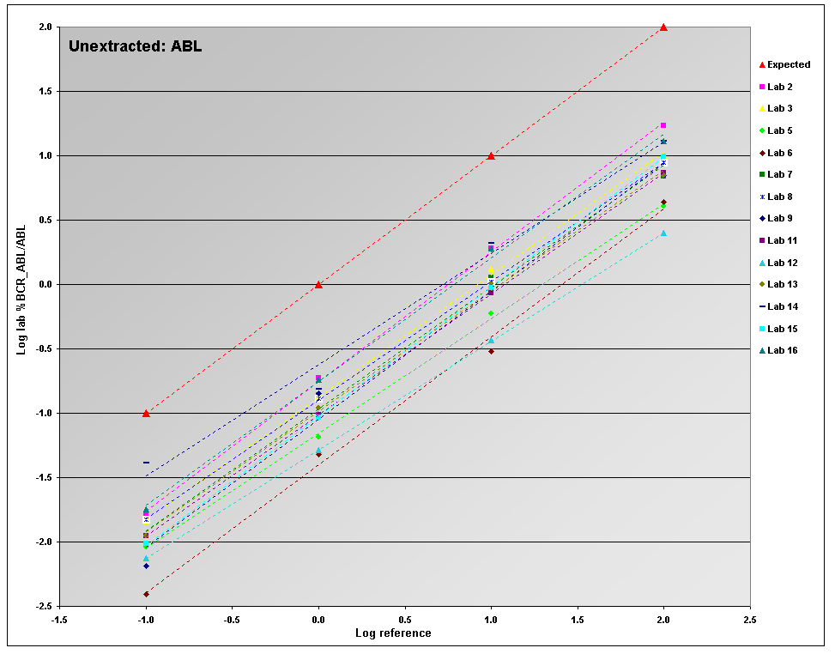
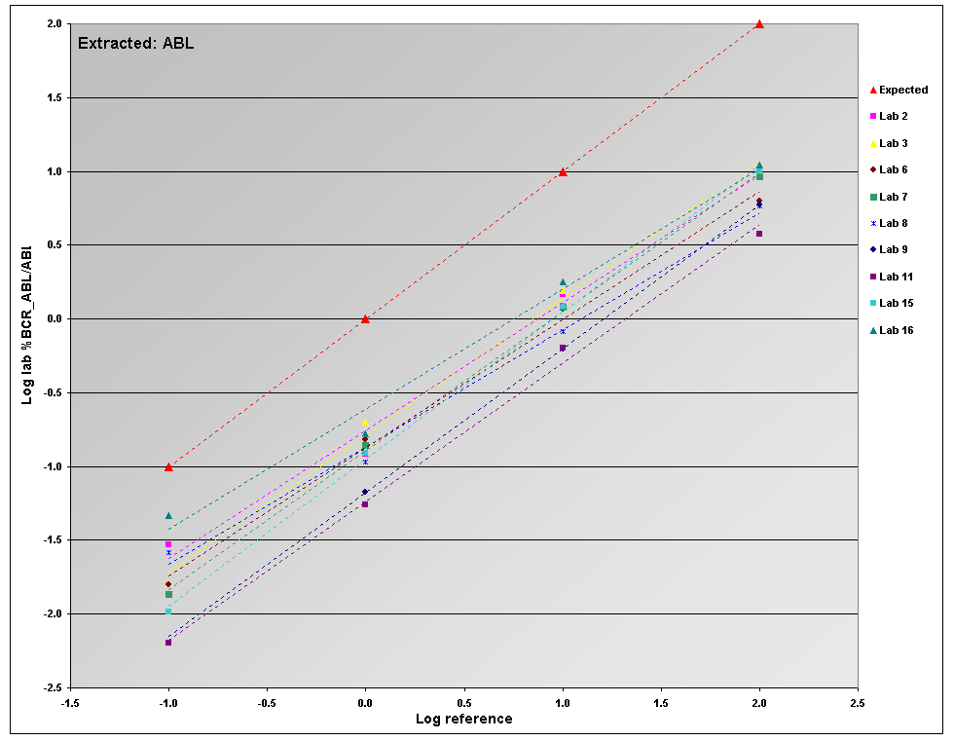
a)

b)

- Summary of the linear regressions of the log transformed %b3a2 / ABL data obtained from labs 2 - 16 using the aRNA material a) taken through an RNA extraction procedure b) heat lysed before adding to cDNA reaction (Unextracted)

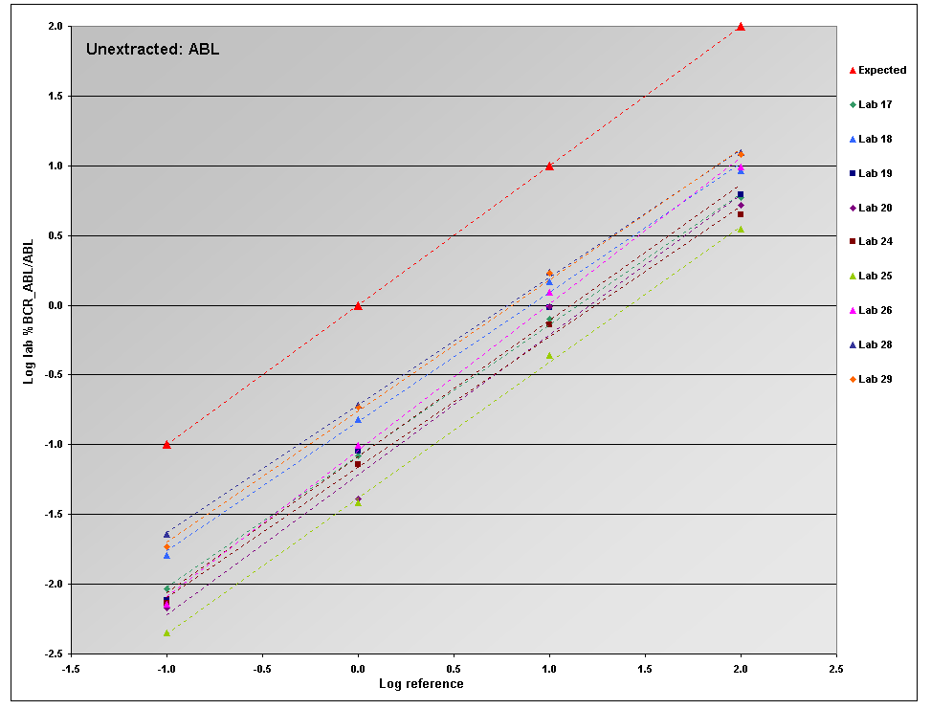
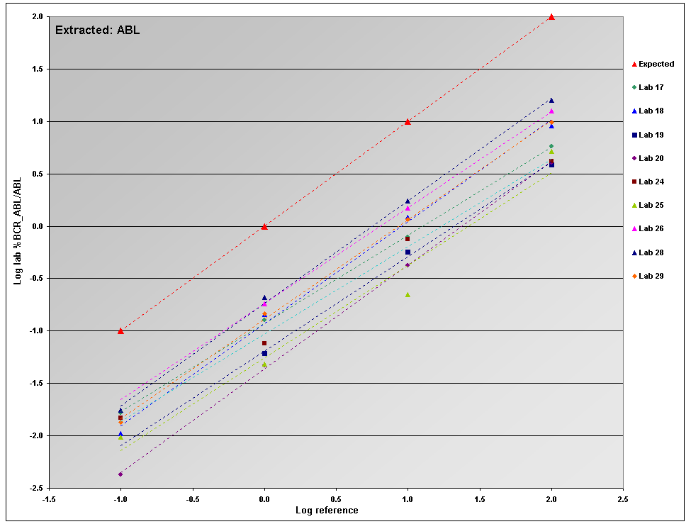
a)

b)

- Summary of the linear regressions of the log transformed %b3a2 / ABL data obtained from labs 17 - 29 using the aRNA material a) taken through an RNA extraction procedure b) heat lysed before adding to cDNA reaction (Unextracted)

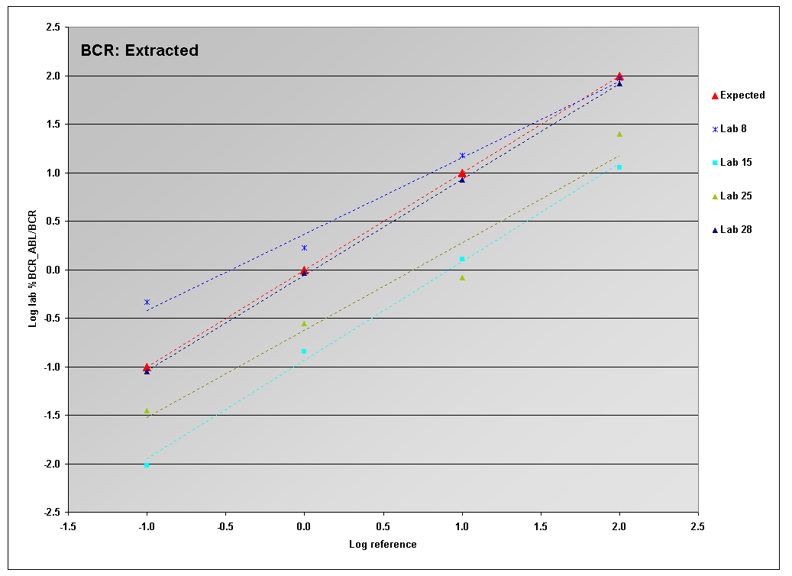

a)

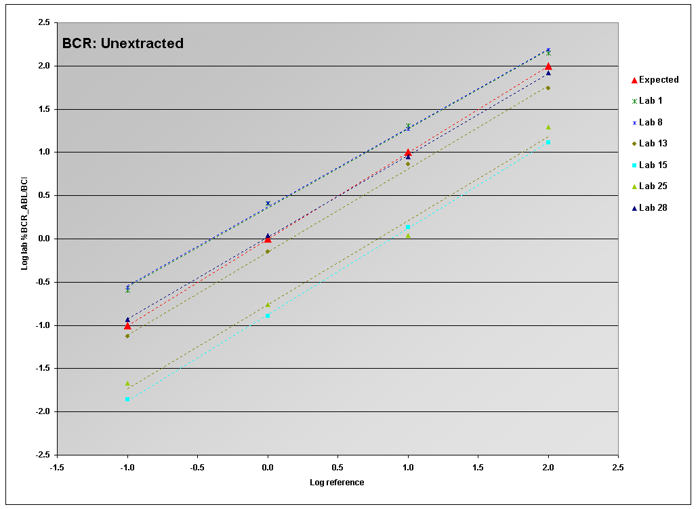
b)

- Summary of the linear regressions of the log transformed %b3a2 / BCR data obtained from labs 1 - 29 using the aRNA material a) taken through an RNA extraction procedure b) heat lysed before adding to cDNA reaction (Unextracted)

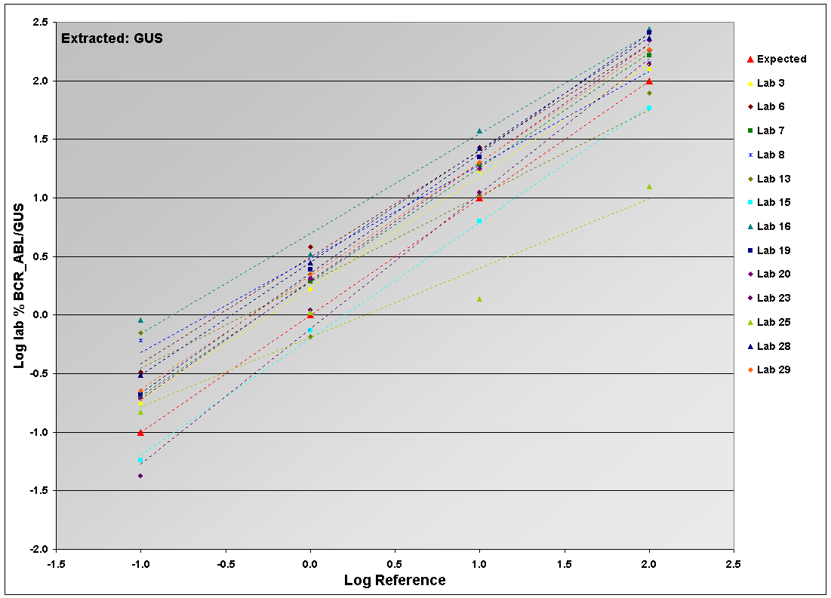
a)

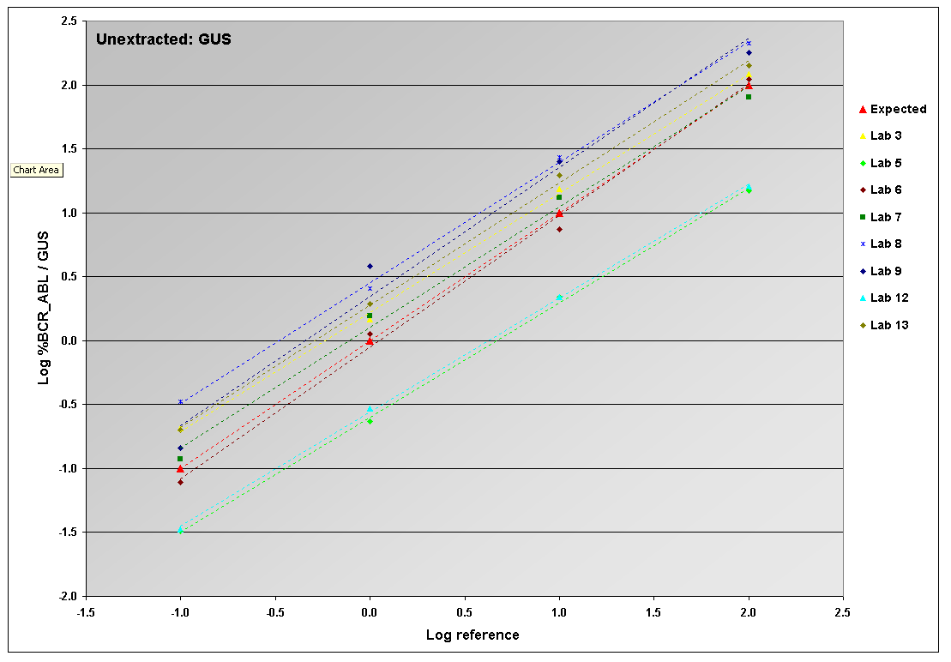
b)

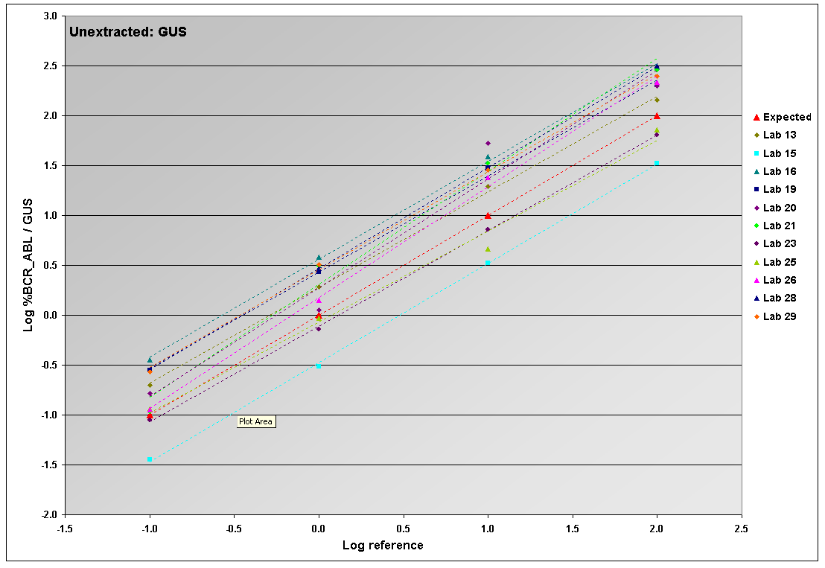
c)

- Summary of the linear regressions of the log transformed %b3a2 / GUSB data obtained from labs 1 - 29 using the aRNA material a) taken through an RNA extraction procedure, b) heat lysed (unextracted) before adding to cDNA reaction (labs 3-13) and c) heat lysed (unextracted) before adding to cDNA reaction (labs 13-29).

Linear regression for b2a2 aRNA samples
The linear regression of the log transformed data obtained from all labs are summarised in figure 16 (ABL), figure 17 (BCR) and figure 18 (GUSB). Data have been plotted against reference material values which have been calculated as 100% (level 1), 10% (level 2), 1% (level 3) and 0.1% (level 4) BCR-ABL / Control Gene based on the input copy number of each aRNA construct. The regression equations for the log transformed data for each cell line and each control gene are given in table 26 (ABL), table 27 (BCR) and table 28 (GUSB). The individual regression plots and associated data for each lab are shown in appendix C.

r² values for linear regressions
The number of labs where the r² value for the linear regression was >98% are shown in table 29.

Lab ID | b2a2 / ABL Heat Lysed | R² (Adj) | b2a2 / ABL Extracted | R² (Adj)
2 | Log(y)= -0.4805 + 0.9620 log(x) | 99.4% | Log(y)= -0.5239 + 0.9540 log(x) | 98.9%
3 | Log(y)= -0.5385 + 0.9550 log(x) | 99.5% | Log(y)= -0.4212 + 0.9570 log(x) | 99.5%
4 | Log(y)= -0.5231 + 0.8990 log(x) | 96.8% | Log(y)= -0.3241 + 0.8840 log(x) | 97.7%
5 | Log(y)= -1.2442 + 1.0270 log(x) | 97.4% | Log(y)= -0.6491 + 0.6610 log(x) | 88.9%
6 | Log(y)= -0.8695 + 0.9500 log(x) | 98.6% | Log(y)= -0.5343 + 0.9190 log(x) | 97.3%
8 | Log(y)= -0.4866 + 0.8790 log(x) | 88.6% | Log(y)= -0.4462 + 0.8250 log(x) | 83.9%
9 | Log(y)= -1.0962 + 0.9780 log(x) | 99.2% | Log(y)= -1.1216 + 0.9290 log(x) | 87.9%
10 | Log(y)= -1.3513 + 1.0400 log(x) | 88.6% | Log(y)= -1.4017 + 0.9800 log(x) | 87.6%
11 | Log(y)= -0.6603 + 0.9470 log(x) | 99.3% | Log(y)= -0.7957 + 0.9670 log(x) | 99.0%
12 | Log(y)= -1.4356 + 0.9130 log(x) | 78.6% | Insufficient data points | -
13 | Log(y)= -0.5672 + 0.9410 log(x) | 98.5% | Log(y)= -0.3096 + 0.7660 log(x) | 97.7%
14 | Log(y)= -0.7177 + 0.8790 log(x) | 93.4% | Log(y)= -0.5310 + 0.9260 log(x) | 95.9%
16 | Log(y)= -0.5531 + 0.9200 log(x) | 99.6% | Log(y)= -0.4215 + 0.9030 log(x) | 98.2%
18 | Log(y)= -0.5669 + 0.9200 log(x) | 99.7% | Log(y)= -0.3196 + 0.8060 log(x) | 96.9%
20 | Log(y)= -0.6482 + 0.8350 log(x) | 91.9% | Log(y)= -0.8078 + 0.9570 log(x) | 98.7%
21 | Log(y)= 2.2570 + 0.2200 log(x) | 56.5% | Insufficient data points | -
22 | Log(y)= 0.0524 + 1.0250 log(x) | 91.5% | Log(y)= -1.0796 + 1.6270 log(x) | 86.8%
25 | Log(y)= -0.7942 + 0.9718 log(x) | 98.1% | Log(y)= -0.6514 + 0.9719 log(x) | 97.0%
28 | Log(y)= -0.4131 + 0.9738 log(x) | 99.3% | Log(y)= -0.3560 + 0.9539 log(x) | 98.7%
29 | Log(y)= -0.4221 + 0.9783 log(x) | 99.1% | Log(y)= -0.4424 + 0.9652 log(x) | 99.2%

- Linear regression equations of log transformed %b2a2 / ABL data for the heat lysed and extracted aRNA samples for each lab.

Lab ID | b2a2 / BCR Heat Lysed | R² (Adj) | b2a2 / BCR Extracted | R² (Adj)
1 | Log(y)= 0.1797 + 0.8540 log(x) | 98.5% | Log(y)= 0.4126 + 0.8660 log(x) | 70.7%
8 | Log(y)= 0.7542 + 0.9110 log(x) | 92.5% | Log(y)= 0.7315 + 0.8130 log(x) | 90.6%
13 | Log(y)= 0.2946 + 0.9340 log(x) | 99.5% | Log(y)= 0.4696 + 0.8030 log(x) | 96.6%
21 | Log(y)= 1.1344 + 0.9290 log(x) | 98.9% | Insufficient data points | -
25 | Log(y)= -0.005 + 0.9277 log(x) | 98.7% | Log(y)= 0.0501 + 0.8717 log(x) | 98.2%
28 | Log(y)= 0.3562 + 0.9906 log(x) | 99.8% | Log(y)= 0.3837 + 0.9640 log(x) | 97.6%

- Linear regression equations of log transformed %b2a2 / BCR data for the heat lysed and extracted aRNA samples for each lab.

Lab ID | b2a2 / GUSB Heat Lysed | R² (Adj) | b2a2 / GUSB Extracted | R² (Adj)
3 | Log(y)= 0.5788 + 0.9390 log(x) | 99.1% | Log(y)= 0.6304 + 0.9720 log(x) | 99.4%
5 | Log(y)= -0.7068 + 1.0320 log(x) | 98.5% | Log(y)= -0.2202 + 0.6310 log(x) | 81.1%
6 | Log(y)= 0.5116 + 1.002 log(x) | 98.3% | Log(y)= 0.7931 + 0.9810 log(x) | 96.1%
8 | Log(y)= 0.8445 + 0.9250 log(x) | 92.4% | Log(y)= 0.9347+ 0.8420 log(x) | 81.9%
9 | Log(y)= 0.3456 + 0.9840 log(x) | 97.8% | Log(y)= 0.3227 + 0.9380 log(x) | 81.2%
12 | Log(y)= -0.7218 + 0.9100 log(x) | 79.9% | Insufficient data points | -
13 | Log(y)= 0.7299 + 0.9460 log(x) | 99.5% | Log(y)= 0.9213 + 0.8010 log(x) | 98.1%
16 | Log(y)= 0.7651 + 0.9380 log(x) | 99.7% | Log(y)= 0.9081+ 0.8710 log(x) | 98.3%
20 | Log(y)= 0.7122 + 0.8650 log(x) | 93.7% | Log(y)= 0.7603 + 1.000 log(x) | 99.2%
21 | Log(y)= 0.8675 + 0.9270 log(x) | 99.1% | Insufficient data points | -
22 | Log(y)= 1.1161 + 1.0210 log(x) | 91.6% | Log(y)= 0.0389 + 1.6170 log(x) | 83.8%
23 | Log(y)= 0.3877 + 0.9850 log(x) | 99.6% | Log(y)= 0.8364 + 0.8870 log(x) | 73.3%
25 | Log(y)= 0.5596 + 0.9756 log(x) | 98.5% | Log(y)= 0.6634 + 0.9030 log(x) | 94.6%
28 | Log(y)= 0.7755 + 0.9900 log(x) | 98.4% | Log(y)= 0.8934 + 0.9579 log(x) | 98.9%
29 | Log(y)= 0.7571 + 0.9968 log(x) | 99.1% | Log(y)= 0.7740 + 0.9838 log(x) | 99.2%

- Linear regression equations of log transformed %b2a2 / GUSB data for the heat lysed and extracted aRNA samples for each lab.

 | b3a2 aRNA |  | b2a2 aRNA
 | Unextracted | Extracted | Unextracted | Extracted
ABL | 14/25 (56%) | 4/25 (16%) | 11/20 (55%) | 7/20 (35%)
BCR | 4/7 (57%) | 1/7 (14%) | 5/6 (83%) | 1/6 (17%)
GUS | 9/19 (47%) | 4/19 (21%) | 10/15 (67%) | 6/15 (40%)

- The number of labs where the r² value for the linear regression was >98%

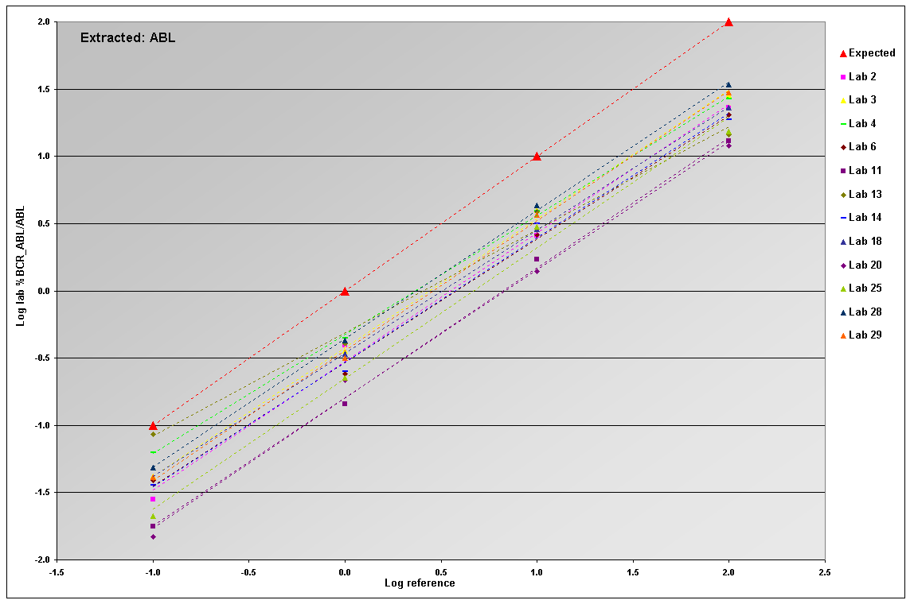
a)

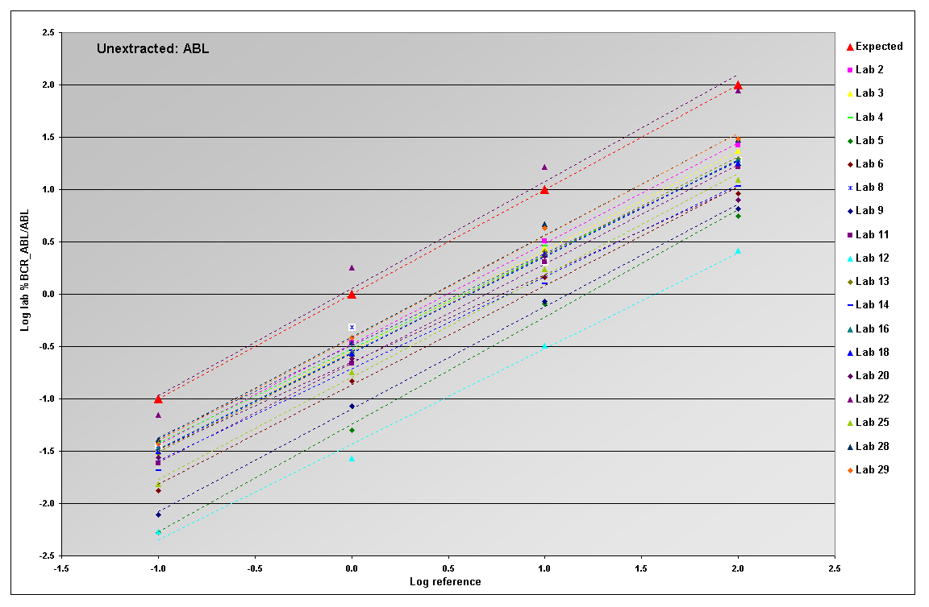
b)

- Summary of the linear regressions of the log transformed %b2a2 / ABL data obtained from labs 2 - 29 using the aRNA material a) taken through an RNA extraction procedure b) heat lysed before adding to cDNA reaction (Unextracted)

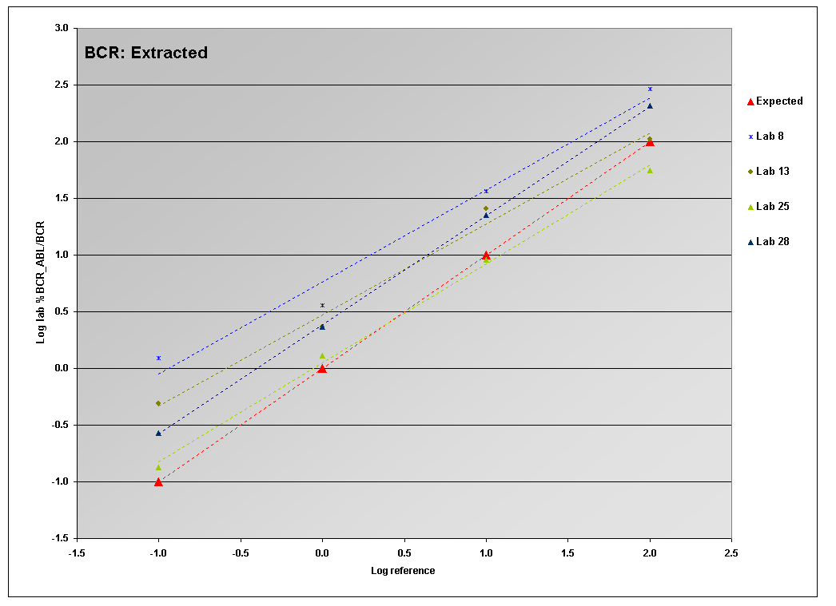
a)

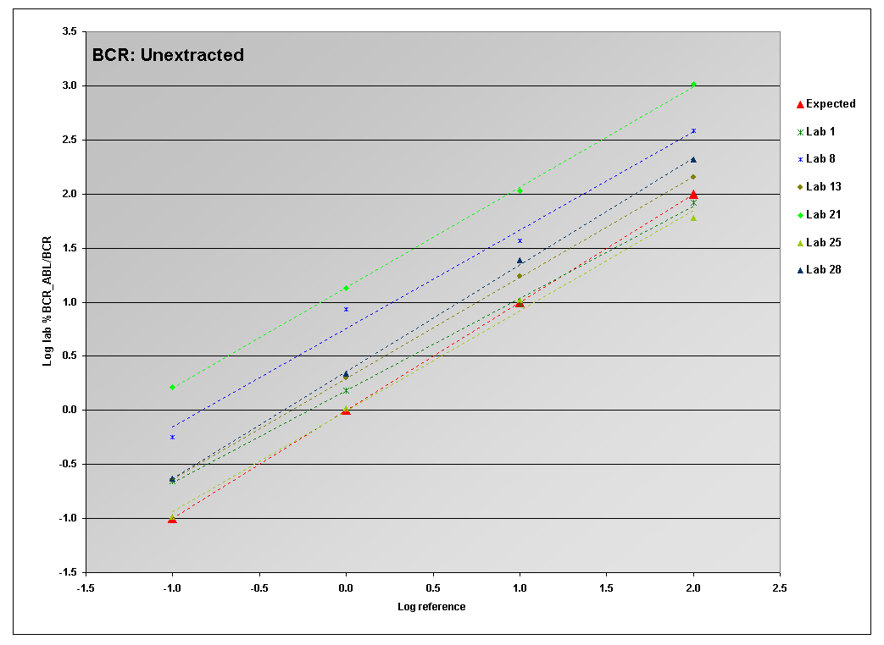
b)

- Summary of the linear regressions of the log transformed %b2a2 / BCR data obtained from labs 1- 28 using the aRNA material a) taken through an RNA extraction procedure b) heat lysed before adding to cDNA reaction (Unextracted)
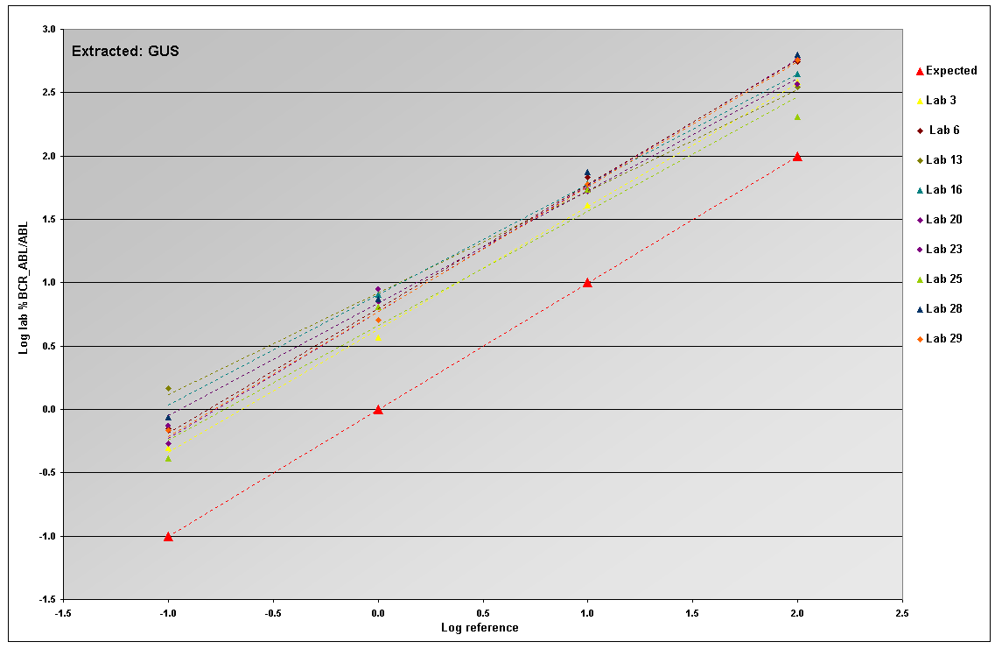
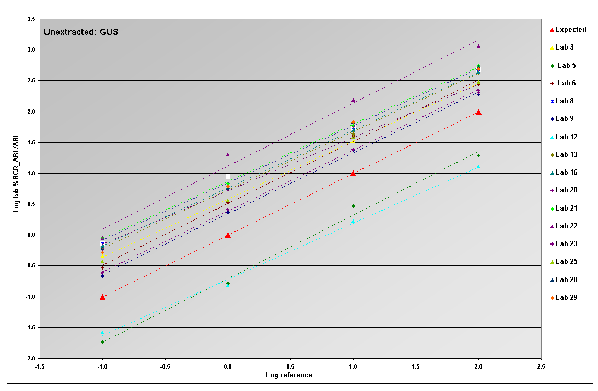
- Summary of the linear regressions of the log transformed %b2a2 / GUSB data obtained from labs 1- 28 using the aRNA material a) taken through an RNA extraction procedure b) heat lysed before adding to cDNA reaction (Unextracted)

Conclusions
The aim of this collaborative study was to produce and assess the use of aRNA as a candidate reference material for the standardisation of BCR-ABL RQ-PCR protocols. Nine prototype aRNA reference materials were produced all of which were estimated to contain 3x10⁴ copies/µl of the control genes ABL, BCR and GUSB. Four levels of b3a2 and b2a2 aRNA were added to the background of control gene aRNA to produce samples with predicted %BCR-ABL / Control gene values of 100% (level 1), 10% (level 2), 1% (level 3) and 0.1% (level 4). A control gene only sample was also included for analysis.

The performance of the aRNA prototype reference material was assessed by an international field trial (October - December 2007). aRNA samples were shipped at ambient temperature by express courier to 29 laboratories (22 EU, 3 USA, 4 Asia/Australasia). The aRNA samples were tested following RNA extraction (7 different protocols) or after direct heat lysis using 3 different control genes on 14 different RQ-PCR platforms. Seventeen labs and 8 labs made modifications to the field trial protocol for the extracted and direct heat lysed samples respectively. For the purposes of this report the copy number values have been corrected for variation in the volume of aRNA extracted and used in the cDNA reaction and the amount of cDNA added to the RQ-PCR so that the data between labs are comparable.

The expected copy number for each control gene in each aRNA sample was 3x10⁴ copies/µl (based on the copy number supplied by Asuragen). The median number of copies/ul obtained for ABL, BCR and GUSB for the b3a2 aRNA samples following RNA extraction were 8.13x10³, 3.46x10² and 4.09x10² respectively and following direct heat lysis were 1.25x10⁵, 1.25x10⁴ and 7.72x10³ respectively.

The median number of copies/ul obtained for ABL, BCR and GUSB for the b2a2 aRNA samples following RNA extraction were 6.32x10³, 4.86x10² and 3.80x10² respectively and following direct heat lysis were 1.16x10⁵, 1.57x10⁴ and 7.9x10³ respectively. The overall 12-fold loss in control gene copy number observed when samples were analysed after RNA extraction appeared to be related to the RNA extraction protocol used. Labs using a Trizol protocol showed a median 28-fold loss and those using QIAGEN protocols showed a median 2-fold loss. For the direct heat lysed samples the median copy numbers of BCR and GUSB were approximately 2 and 4 fold less than the expected copy number. The median copy number of ABL for the direct heat lysed samples was approximately 4-fold higher than the expected copy number. The ABL copy number values were based on an estimated OD₂₆₀ conversion factor and not the NIST-traceable phosphate assay which probably accounts for the unexpectedly high values for this gene.

The mean % BCR-ABL / control gene values for the extracted and heat lysed aRNA samples were not statistically different (2 sample t-test at 99% confidence; i.e. p<0.01). However, for the extracted samples, 6/28 labs failed to detect level 3 (n=2) and level 4 (n=6) b3a2 transcripts respectively and 6/22 labs failed to detect level 3 (n=1) and level 4 (n=6) b2a2 transcripts respectively. For the heat lysed aRNA samples level 4 b3a2 and b2a2 could not be detected by one lab. This was most likely due to the loss of recovery of the aRNA following RNA extraction using the Trizol protocol.

The coefficient of variance for the %BCR-ABL / control gene values for the extracted and heat lysed samples were statistically different (90% confidence; i.e. p<0.1) for 7 analyses (b3a2: ABL Level 4, BCR Levels 1 & 4, GUSB Level 1; b2a2: BCR Level 2, GUSB Levels 2 & 3). The CVs for the extracted samples were generally higher than those for the heat lysed samples.

Linear regression plots were produced for log transformed lab data plotted against the log transformation of the reference standard values for the b3a2 and b2a2 a RNA samples. The r² values for the linear regression of the b3a2 samples were >98% in 53% and 18% of labs for the heat lysed and extracted samples respectively. The r² values for the linear regression of the b2a2 samples were >98% in 63% and 34% of labs for the heat lysed and extracted samples respectively. The r² values for the freeze dried cell line field trial (report available at http://www.ngrl.org.uk/ Wessex/downloads.htm) were >98% for all laboratories.

Overall, the aRNA samples worked well when directly heat lysed prior to cDNA synthesis but further modifications are required to ensure adequate yields following RNA extraction e.g. addition of carrier RNA during extraction or formulation of the aRNA in a carrier-containing biological matrix. The 9 reference samples used in this study contained a total of 0.9 to 1.2x10⁵ copies/μL of aRNA. At this very low RNA input, RNA extraction protocols have to be optimized to obtain efficient and reproducible recovery of RNA. The aRNA samples will undergo a further round of field trial evaluation with the aim of establishing them as secondary reference reagents. For this field trial, higher copy numbers of the control genes will be used and if possible the control gene ratios will be altered to reflect the control gene transcript levels found in normal leucocytes.

Acknowledgments
We would like to thank

- all field trial participants for their assistance with this project
- Gemma Watkins (NGRL (Wessex)), John Hedges and Cindy Walker Peach (Asuragen) for construction of the aRNA constructs

References
1. Gabert J, Beillard E, van der Velden VH, Bi W, Grimwade D, Pallisgaard N, Barbany G, Cazzaniga G, Cayuela JM, Cavé H, Pane F, Aerts JL, De Micheli D, Thirion X, Pradel V, González M, Viehmann S, Malec M, Saglio G, van Dongen JJ. (2003) Standardization and quality control studies of 'real-time' quantitative reverse transcriptase polymerase chain reaction of fusion gene transcripts for residual disease detection in leukemia - a Europe Against Cancer program. Leukemia 17(12):2318-57.

2. Müller MC, Saglio G, Lin F, Pfeifer H, Press RD, Tubbs RR, Paschka P, Gottardi E, O'Brien SG, Ottmann OG, Stockinger H, Wieczorek L, Merx K, König H, Schwindel U, Hehlmann R, Hochhaus A. An international study to standardize the detection and quantitation of BCR-ABL transcripts from stabilized peripheral blood preparations by quantitative RT-PCR.
Haematologica. 2007 Jul;92(7):970-3.

3. Hughes T, Deininger M, Hochhaus A, Branford S, Radich J, Kaeda J, Baccarani M, Cortes J, Cross NC, Druker BJ, Gabert J, Grimwade D, Hehlmann R, Kamel-Reid S, Lipton JH, Longtine J, Martinelli G, Saglio G, Soverini S, Stock W, Goldman JM (2006) Monitoring CML patients responding to treatment with tyrosine kinase inhibitors: review and recommendations for harmonizing current methodology for detecting BCR-ABL transcripts and kinase domain mutations and for expressing results. Blood 108(1):28-37.

4. Branford S, Cross NC, Hochhaus A, Radich J, Saglio G, Kaeda J, Goldman J, Hughes T (2006) Rationale for the recommendations for harmonizing current methodology for detecting BCR-ABL transcripts in patients with chronic myeloid leukaemia. Leukemia 20(11):1925-30.

5. Hughes TP, Kaeda J, Branford S, Rudzki Z, Hochhaus A, Hensley ML, Gathmann I, Bolton AE, van Hoomissen IC, Goldman JM, Radich JP; International Randomised Study of Interferon versus STI571 (IRIS) Study Group (2003) Frequency of major molecular responses to imatinib or interferon alfa plus cytarabine in newly diagnosed chronic myeloid leukemia. N Engl J Med. 349(15):1423-32.

6. CR Walker Peach and BL Pasloske (2004). DNA Bacteriophage as Controls for Clinical Viral Testing. Clin Chem. 50(11)1970-71.

7. Emig M, Saussele S, Wittor H, Weisser A, Reiter A, Willer A, Berger U, Hehlmann R, Cross NC, Hochhaus A (1999) Accurate and rapid analysis of residual disease in patients with CML using specific fluorescent hybridization probes for real time quantitative RT-PCR. Leukemia 13(11):1825-32.

8. Branford S, Hughes TP, Rudzki Z. (1999) Monitoring chronic myeloid leukaemia therapy by real-time quantitative PCR in blood is a reliable alternative to bone marrow cytogenetics.Br J Haematol 107(3):587-99.

9. Wang YL, Lee JW, Cesarman E, Jin DK, Csernus B (2006) Molecular monitoring of chronic myelogenous leukemia: Identification of the most suitable internal control gene for real-time quantification of BCR-ABL transcripts. J. Mol. Diagn. 8: 231-9.

10. Lee JW, Chen Q, Knowles DM, Cesarman E Wang YL (2006) ß-glucoronidase is an optimal normalization control gene for molecular monitoring of chronic myelogenous leukemia. J. Mol. Diagn. 8: 385-9.
Appendix A: Field Trial Participants

Asia

Dr Koichi Miyamura, Department of Hematology, Japansese Red Cross Nagoya First Hospital, 3-34, Michishita-cho, Nakamura-ku, Nagoya 453-8511, JAPAN

Dr Harriet Goh, Prof. Dong-Wook Kim and Sa-hee Park, #6011 Lab. of Molecular Genetics, The Catholic Research Institute of Medical Science, The Catholic University of Korea, #505 Banpo-dong, Seocho-gu, Seoul 137-701, KOREA

Gee- Fung How, Haematology Laboratory, Singapore General Hospital, Outram Road, SINGAPORE, S169608

Australia

Prof Tim Hughes, Dr Sue Branford and Linda Fletcher, Division of Molecular Pathology, Institute of Medical and Veterinary Science, Frome Road, Adelaide, South Australia, 5000, AUSTRALIA

Europe

Austria

Prof Thomas Lion, Dagmar Denk and Michaela Neßlböck,, Labdia Labordiagnostik GmbH, CHILDREN'S CANCER RESEARCH INSTITUTE, St. Anna Kinderkrebsforschung, Zimmermannplatz 8, 1090 Vienna, AUSTRIA

Czech Republic

Dr. Dana Dvorakova and Tomas Jurcek, University Hospital Brno, Center of Molecular Biology and Gene Therapy, Department of Internal Medicine-Hematooncology, Cernopolní 9, 625 00 Brno, Czech Republic

Dr. Jana Moravcová and Jana Rulcová, Institute of Hematology and Blood Transfusion, Department of Molecular Genetics, U Nemocnice 1, Praha 2, 128 20, Czech republic

France

Prof Jean Gabert and Nathalie Beaufils, IFR Jean Roche, Faculté de médecine, NORDBd. Dramard 13916 MARSEILLE cedex 20 FRANCE

Drs Fabienne Hermitte and Nicolas Maroc, IPSOGEN, 163 avenue de Luminy, Case
923, 13288 Marseille Cedex 9, France

Dr Jean-Michel Cayuela and Xavier Fund, Laboratoire Central d'Hématologie, Hôpital Saint-Louis, 1 av Claude Vellefaux, 75010 Paris, FRANCE

Prof François-Xavier Mahon and Eric Lippert, Laboratoire Hématopoïèse, Université Victor Ségalen Bordeaux 2, 146 rue Léo Saignat, INSERM E217, 33076 Bordeaux, FRANCE

Finland

Dr Veli Kairisto, Turku University Hospital Laboratories, TYKSLAB, Dept. 931, Kiinamyllynk. 4-6, FIN-20520 Turku, Finland

Germany

Prof A Hochhaus and Dr Martin Mueller, Wissenschaftliches Labor, III. Medizinische Klinik, Wiesbadener Str. 7-11, D-68305 Mannheim, GERMANY

Dr. med. Heike Pfeifer and Dr. med. Oliver Ottmann, Universitätsklinikum Frankfurt, Medizinische Klinik II, Abteilung für Hämatologie, MRD-Labor, Haus 33, UG, R 03, Theodor-Stern Kai 7, 60590 Frankfurt/Main, GERMANY

Greece

Dr Katerina Zoi, Haematology Research Laboratory, Biomedical Research Foundation, Academy of Athens, 4, Soranou tou Efessiou St, 115 27 Athens, GREECE

Italy

Dr Giuseppe Saglio, Ospedale San Luigi, 10043 Orbassano, Torino, ITALY

Fabrizio Pane and Dr. Quarantelli, CEINGE – University of Naples, Via Comunale Margherita 482, 80131 Naples, ITALY

Dr Ilaria Iacobucci and Giovanni Martinelli, Istituto di Ematologia e Oncologia Medica, Seràgnoli, via Massarenti 9, 40138 Bologna, ITALY

Spain

Dr Dolors Colomer, Unitat D’Hematopatologia Hospital Clinic, Villarroel 170, 08036 Barcelona, SPAIN

Dr M Teresa Gomez Casares, Laboratorio de Hematologia. Biologia molecular,Hospital Universitario de Gran Canaria Dr. Negrin, Barranco de La Ballena S/N,35020, Las Palmas de Gran Canaria (SPAIN)

Sweden

Gisela Barbany and Andrea Carpelan, Clinical Genetics, Karolinska University Hospital, Solna, 171 76 Stockholm, SWEDEN

United Kingdom

Dr Letizia Foroni, Dr Jamshid Sorouri Khorashad and Dr Gareth Gerrard, MRD group, Adult Leukaemia Unit, Department of Haematology, Imperial College, Hammersmith Hospital Campus, Du Cane Road, W12 ONN, London, UK

Anne Sproul, Department of Haematology, Western General Hospital, Edinburgh, EH4 2XU, UK

Dr. Lihui Wang, Department of Haematology, Royal Liverpool University Hospital, Liverpool, L7 8XP, UK

Dr Abida Awan, Molecular Diagnostics Centre, Top Floor multipurpose Building, Manchester Royal Infirmary, Oxford Road, Manchester, M13 9WL, UK

Dr Helen White, National Genetics Reference Laboratory (Wessex), Salisbury District Hospital, Odstock Road, Salisbury, Wilts, SP2 8BJ, UK

United States of America

Dr Janina Longtine, Department of Pathology, Brigham and Women's Hospital, 75 Francis Street
Boston, MA 02115, USA

Dr Y. Lynn Wang, Molecular Hematopathology Laboratory, Dept. of Pathology and Laboratory Medicine, Box 69, Weill Medical College of Cornell University, 525 East 68th Street, New York, NY 10021-4873, USA

Dr John Hedges and E Labourier, Asuragen, Inc., 2150 Woodward, Suite 100, Austin TX 78744, USA

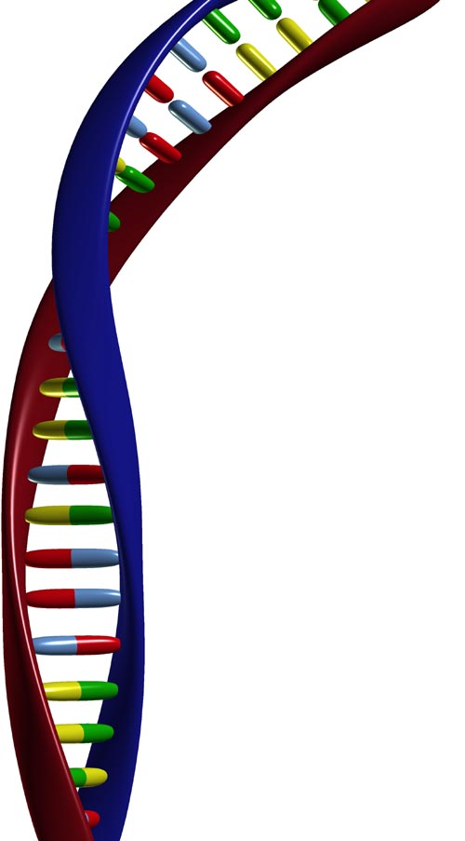
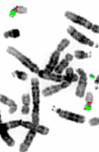

National Genetics Reference Laboratory (Wessex)
Salisbury District Hospital
Salisbury SP2 8BJ, UK

www.ngrl.org.uk

