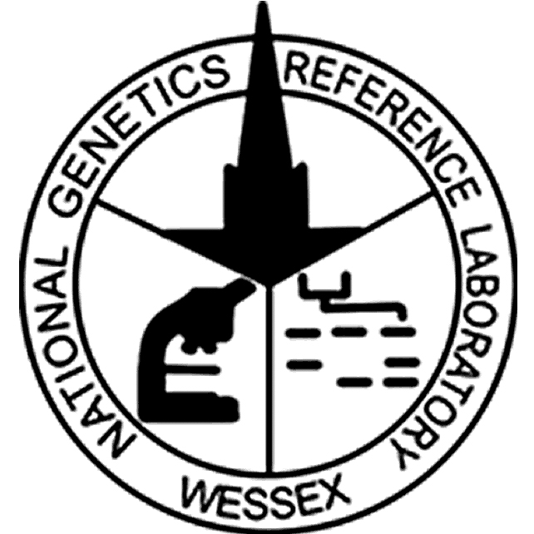

National Genetics Reference Laboratory
(Wessex)



Technology Assessment Report
Automated Extraction Methodologies

November 2004

Title | Automated Extraction Methodologies
NGRL Ref | NGRLW_DNAex_2.0
Publication Date | November 2004  Minor reviosions and addendum added June 2005
Document Purpose | Dissemination of information about DNA Extraction methodologies
Target Audience | Laboratories performing DNA Extraction
NGRL Funded by | 

Contributors

Name | Organisation
Chris Mattocks | NGRL (Wessex)
Nick Owen | NGRL (Wessex)
Dan Ward | NGRL (Wessex)

Peer Review and Approval

This document has been subject to peer review.

Conflicting Interest Statement

The authors declare that they have no conflicting financial interests

How to obtain copies of NGRL (Wessex) reports

An electronic version of this report can be downloaded free of charge from the NGRL website (http://www.ngrl.co.uk/Wessex/downloads)

or by contacting

National Genetics Reference Laboratory (Wessex)
Salisbury District Hospital
Odstock Road
Salisbury
SP2 8BJ
UK

E mail: ncpc@soton.ac.uk
Tel: 01722 429016
Fax: 01722 338095

Table of Contents

1. Introduction and background 1
2. About this report 2
2.1 General guidance 2
2.2 Report structure 2
3. Technology Assessment 3
3.1 Samples 3
3.2 System descriptions 3
3.3 Notes on specifications 4
3.4 Notes on performance measures 5
3.4.1 DNA Yield 5
3.4.2 DNA Purity 5
3.4.3 Presence of DNA and Integrity 5
3.4.4 PCR 6
3.4.5 Cross contamination 6
4. System evaluations 7
4.1 ABI Prism™ 6100 Nucleic Acid Prepstation 7
4.1.1 Description 7
4.1.2 Specification 7
4.1.3 Evaluation 8
4.1.4 Performance measures 8
4.1.5 Discussion 9
4.2 Autogen NA-3000EU 10
4.2.1 Description 10
4.2.2 Specification 10
4.2.3 Evaluation 11
4.2.4 Performance measures 11
4.2.5 Discussion 12
4.3 Chemagen Module I 13
4.3.1 Description 13
4.3.2 Specification 13
4.3.3 200μl Evaluation 14
4.3.4 5ml Evaluation 16
4.3.5 Discussion 17
4.4 DRI Charge Switch Technology (CST) 18
4.4.1 Description 18
4.4.2 Specification 18
4.4.3 Evaluation 19
4.4.4 Performance measures 19
4.4.5 Discussion 20
4.5 Macherey Nagel Nucleospin 21
4.5.1 Description 21
4.5.2 Specification 21
4.5.3 Evaluation 22
4.5.4 Performance measures 22
4.5.5 Discussion 23
4.6 Promega MagneSil 24
4.6.1 Description 24
4.6.2 Specification 24
4.6.3 Evaluation 25
4.6.4 Performance measures 25
4.6.5 Discussion 26
4.7 Qiagen EZ1 27
4.7.1 Description 27
4.7.2 Specification 27
4.7.3 200μl extraction Evaluation 28
4.7.4 350μl extraction Evaluation 29
4.7.5 Discussion 30
4.8 Roche MagNA Pure Compact 31
4.8.1 Description 31
4.8.2 Specification 31
4.8.3 300μl extraction Evaluation 32
4.8.4 1ml extraction Evaluation 33
4.8.5 Discussion 34
5. Performance summaries 35
6. Conclusions 37
6.1 System types 37
6.2 Strategies 37
6.2.1 Maximum yield approach 37
6.2.2 Minimum yield approach 38
7. Other options and further work 40
8. Acknowledgements 40
9. References 40
10. Useful Links 41

Introduction and background
DNA extraction is a key stage in the processing of samples within most molecular genetics laboratories. Automating this process is potentially beneficial for a number of reasons including increased throughput, more consistent and reproducible processing and improved sample tracking.

The publication of the White Paper on genetics in June 2003 (Our inheritance, our future - realising the potential of genetics in the NHS) made substantial funding available for the modernisation of the diagnostic genetic laboratories within England. This investment has generated much interest in the utility of automated DNA extraction in a diagnostic setting. In view of this interest, NGRL (Wessex) carried out a survey of diagnostic laboratories to establish the requirements of a suitable extraction system. The survey canvassed opinion on factors ranging from type and size of samples received, anticipated throughputs and requirements for sample tracking to implemetation costs and space requirements. Two major conclusions can be drawn from the responses to this survey: There was very little experience relating to automated DNA extraction amongst the participating labs, and the requirements for an automated system varied extensively between labs. It was not clear whether this disparity was a result of critical local requirements or if a more uniform approach could be adopted if the respondents were more informed about the capabilities and limitations of different automation strategies. The full results of the survey are available at http://www.ngrl.co.uk/Wessex/extraction.htm.

To address the need for more informed opinion on this subject we have expanded our initial evaluation of the Autogen NA-3000EU automated DNA extraction system to take a broader view of the systems available. Given the large number of manufacturers in this market, the choice of which specific systems to evaluate was a significant problem. To resolve this issue we have followed two basic principles.

Firstly we have tried to cover as wide a range of different strategies as possible. This has meant covering both dedicated instruments with their associated chemistries (referred to as integrated systems) as well as kit based chemistries that may be suitable for automation using standard liquid handling robotics. Within this we have also tried to cover different types of chemistry including salt extractions, solid phase extractions (SPE – filter plate based) and extractions based on paramagnetic beads.

Secondly, because the intention was to inform the genetics community whilst avoiding duplication of effort, we have tried to accommodate requests for evaluation of specific instruments where this has been both appropriate and possible.

About this report

General guidance
Given the wide range of requirements amongst the interested parties it has not been possible to provide specific advice with regard to particular instruments or chemistries or their suitability for any particular lab. Instead the intention is to provide a good understanding of what is on the market to allow the user to match a system, or type of system to their requirements.

From a general perspective we have provided a summary of points relating to the performance of the different types of systems evaluated (e.g. integrated system vs in house automation of a kit based chemistry on a standard liquid handling robot). This should facilitate broad choices about the appropriate strategy.

More specifically we have tested the systems with respect to a number of factors including DNA yield, DNA purity, DNA integrity and suitability of DNA for down stream processing such as PCR. In conjunction with this we have provided specifications for each system including throughput, sample volume capacity, dimensions and costs. Finally we have summarised our experience of each system, giving comments on the ease of use, any problems that arose and the overall practicability of the system for use in a diagnostic laboratory. These data taken together should enable a user to quickly identify a short list of instrumentation that will be suitable for their purposes. However, it is recommended that detailed in house evaluation is carried out before purchase to ensure local requirements are met.

Report structure
This report has been structured to allow easy access to different levels of detail. A summary of all the results from the various evaluations can be found in section 5 together with outline specifications. This can be used to easily compare the various systems. Please note that due to the developmental nature of some of the evaluations some data in this summary may be too simplistic to give a balanced view of the system in question (this has been highlighted where it occurs). Therefore final conclusions should not be drawn from this summary without reference to the detailed reports for each system.

The detailed reports for each system are given in section 4. These provide summary data for each system followed by a discussion on their utility and practicability. The final section focuses on a more general discussion of the different types of systems evaluated, and gives some suggestions for strategies that may be suitable for automation of DNA extraction.

Technology Assessment
In total eight different systems have been evaluated over the period from March 2003 to October 2004. In two cases two different sample volumes were tested on the same instrument and in one case three sample volumes were tested giving a total of 12 different evaluations.

The evaluations varied in duration according to the time the instrument was available and how much time was required to set the instrument up. Although this variation is reflected in the number of samples that were extracted in each evaluation, the key factor influencing the throughput achieved was the format used in the extraction. Thus the number of extractions performed in each evaluation was closely related to the batch size used in the protocol.

In some instances, notably the in house automation of kit-chemistries, a great deal of time was needed to optimise the protocol. Although this limited the time available for the actual evaluation, a good ‘feel’ for the procedure was gained and this has been used in the discussions.

Samples
All samples were anonymised EDTA bloods in 4.5ml Vacutainers. Most samples were ~4.0ml but ranged from 2.0-4.5ml.

For most of the evaluations water blanks were randomly dispersed within the batch run to monitor for cross contamination. The re-suspensions from these extractions was analysed in parallel with the test samples.

In total 1860 samples and 408 water blanks were extracted giving 2268 extractions in all.

System descriptions
For the integrated systems a description of the instrument has been given. All the chemistry only protocols were set up on a Tecan Freedom EVO 150 robot by representatives from the suppliers of the chemistry and Tecan. The standard deck lay out comprised of two racks to hold sample tubes, a wash station for the liquid handling probes, positions for reagent racks and a waste disposal container. A combination of disposable tips and fixed probes was used. A specially designed cowling was installed over the tip disposal chute to prevent blood splatter when disposable tips were ejected.

A brief description of each chemistry has been given but for reasons of simplicity details of the robot protocol have been omitted although additions to the standard deck setup have been highlighted. We have tried to point out where the protocols would need to be altered for routine use in a diagnostic laboratory in the relevant discussion sections.

Notes on specifications

System type | The systems have been classified as either an ‘integrated system’, which describes an instrument specifically designed for DNA extraction using specified reagents or ‘chemistry only’, which describes a kit based chemistry that has been automated using a generic liquid handling robotic platform. All chemistry only evaluations were set up using a TECAN Freedom EVO 150 with extensive assistance from TECAN engineers. However, these trials should not be taken as an evaluation of the robot nor is this the only platform capable of automating these protocols.
Chemistry | The type of chemistry used for the extraction protocol tested has been specified. In some cases (for example the Autogen NA-3000EU) the instrument may be programmed to carry out a variety of protocols that have not been tested
Dimensions | In each case the space required for the instrument has been given and whether it is a floor standing or bench top instrument. If further space is required for controlling computers this has been indicated.
Instrument cost and Consumables cost | All costs given are a rough guide to 2004 list prices only. Clearly these are likely to be subject to discounts depending on usage so individual quotes should be obtained for any instrument or chemistry of interest.
Batch size | The maximum number of samples processed in a single run. An indication of the tube format is also given
Sample volume | The range of sample volumes that a system can cope with have been given. Where the chemistry is scalable (i.e. any volume within the range can be extracted) this has been indicated. Otherwise the protocols are fixed volume.
Bench time | The amount of hands-on time required to setup a run and complete any down stream processing. This has been assessed with respect to all processing required from blood in a sample tube to re-suspended DNA in a 1.5ml cryo-tube ready for storage. Processing time has not been included here.
Processing time | The amount of machine time required for the complete extraction of a single batch of samples. This is the time required for the ‘walk away’ part of the procedure and does not include any user intervention.
Manual tube transfers | In many cases some manual handling of samples is required, either to aliquot the blood sample into a container suitable for the extraction protocol (referred to as a system tube) and / or transfer of re-suspended DNA from a system tube into a cryo-tube for storage. The number of such transfers has been indicated as these can have implications for sample tracking.
Sample and reagent tracking | In many cases sample tracking is positional only with no bar-coding specifically built into the system. If bar-coded tracking of either samples or reagents is required an external system will need to be installed.
Maintenance | This parameter describes the day-to-day maintenance and cleaning suggested or required.

Notes on performance measures

DNA Yield
The optical density (OD) of the re-suspensions from all extractions was measured at 260nm, 280nm and 320nm. In all instances except the Roche evaluations measurements were taken on a TECAN GENios Plus spectrophotometer using optically clear, UV transparent 96 well plates. Measurements for the Roche evaluation were taken on an Perkin Elmer Lamda 3. At least one reference blank using milliQ water was included in each measurement batch.

Dilution of the DNA samples ranged from 1:10 to 1:50 and was adjusted to ensure the OD260 readings taken lay between 0.01 and 1.00. DNA samples were allowed to homogenise for at least a day (in most cases at least a week) before measurements were taken. A second set of readings was taken for a random set of samples (one per extraction batch) to ensure complete homogeneity of the samples. A deviation in the calculated DNA concentration of more than 20% was taken to indicate incomplete homogenisation and further readings were taken for the complete extraction batch until satisfactory results were achieved.

The DNA concentration in each DNA sample was calculated using the following formula:

[DNA](μg/ml) = (OD260-OD320) x 50 ÷ L x D

Where:
L = light path (cm)
D = dilution factor

For each extraction we have given the absolute yield to give an idea of the utility of the instrument. In addition the relative yield for each extraction has been given (μg/ml of blood extracted) to allow comparison between different protocols with different starting and re-suspension volumes. This is referred to in this document as the extraction rate. An extraction rate of 25-30μg/ml blood was considered a standard bench mark for the automated extractions although rates over 100μg/ml blood were observed and 50-60μg/ml blood was not uncommon. For comparison the average rate achieved using the in house salt extraction over 48 samples was 66μg/ml blood.

With respect to yield an extraction was deemed to have failed if the extraction rate was less than 5μg/ml blood.

DNA Purity
All samples that were deemed to have failed with respect to yield (i.e. yield < 5μg/ml blood) were excluded from this measure. The purity of the DNA in the remaining re-suspended samples was measured using OD260 / OD280 ratio using the following formula:

DNA purity value = (OD260-OD320)/(OD280-OD320)

Since an optimum value for this ratio for pure DNA is 1.8 we have given the percentage of samples with a purity ratio between 1.6 and 2.0 (i.e. 1.8 ± 0.2) as a comparative measure. A high standard deviation here is indicative of an inconsistent extraction protocol.

Presence of DNA and Integrity
Based on an assumed extraction rate the equivalent amount of DNA from each extraction (one hundredth of the extraction rate in μg) was run out on a 0.8% agarose gel. For example if the extraction rate is assumed to be 25μg/ml blood for all extractions the volume of re-suspension containing 0.25μg DNA was run. A λ Hind III digest was also run on each gel for size reference. Each lane was scored according to the presence or absence of a band, size of the band and whether or not the band was smeared (a single un-smeared band is referred to as ‘clean’).
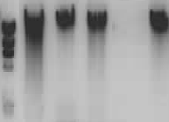
23kb
9kb
6kb
4kb

2kb
λ Hind III digest
P G G F G

P= Partially degraded sample
G= Good quality / non-degraded F= Failed sample

- DNA run out on 0.8% agarose gel

PCR
The suitability of the DNA for PCR was tested use a five fragment control gene PCR (van Dongen et al. 2003). The PCR mix contains primers for five different sized fragments (100, 200, 300, 400 and 600bp) located on different chromosomes and optimised to give equally intense bands for each fragment when run out on a 2% agarose or 6% acrylamide gel. The larger bands tend to disappear as DNA quality diminishes or becomes less suitable for PCR. Bands of widely differing intensity are also indicative of poor quality DNA for PCR amplification.
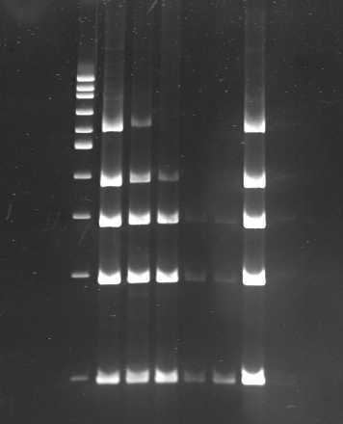
L G P P P P G

L= 100bp ladder
G= good amplification
P= Poor amplification

- Control PCR run on of 6% acrylamide gel -Various DNA concentrations.

The control gene PCR was performed on all DNA samples and the resultant products run on a 2% agarose gel. Lanes were scored according to the number of bands present. The relative intensity of the bands in each lane was also considered and incorporated in to an overall score for the lane (0-5). The percentage of samples scoring 5 and the percentage scoring 0 have both been given as summary results.

Cross contamination
Water controls were extracted for all protocols except the ABI6100 and the Roche MagNA Pure 300μl. These were randomly positioned in each extraction batch. Cross contamination was assessed by the presence or absence of control gene PCR products in the water controls. Where water controls were not included, a sexing PCR was also performed on the samples. This PCR generates three bands with male DNA (358, 787 and 976bp) and only one with female DNA (976bp). If Male DNA is present in female DNA the 976bp band should appear much more intense than the smaller bands, a result that would normally not be expected.

System evaluations

ABI Prism™ 6100 Nucleic Acid Prepstation

Description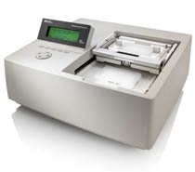
The ABI 6100 is a small bench top instrument comprising of a programmable vacuum manifold with key pad control and an LCD display screen. The system uses 96 well filtration plates as the extraction format and facilitates the extraction of DNA and RNA from a range of sample types including whole blood, buffy coat and cell cultures.

A protocol specific extraction plate is clamped in a movable frame, which can be positioned over a waste position or a collection position. To initiate a run the required protocol is selected from an electronic menu. During the run the instrument prompts the correct positioning of the extraction plate carrier and the appropriate addition of samples and reagents. Extracted DNA is eluted directly into a choice of either standard or deep well 96 well plates.

Specification

System type | Integrated (semi-automated)
Chemistry | Solid phase extraction
Dimensions (WxDxH) | 530 x 480 x 270mm (benchtop)
Weight | 20kg
Instrument cost | ~£10K
Consumables cost | Subject to quotation
Batch size | 96
Sample volume | 150μl
Bench time | See processing time
Processing time | ~2 hrs - Requires user intervention about every 15 minutes (8 interventions)
Manual tube transfers | 1 (sample tube > system tube)  Elution directly into 96 deep well plate
Sample tracking | Positional
Reagent tracking | None – manual addition of reagents
Maintenance | Minimal cleaning ~10 minutes per run

Evaluation
Duration | One day rapid evaluation – single batch
Samples | 48
Water blanks | 0

Performance measures
Yield | 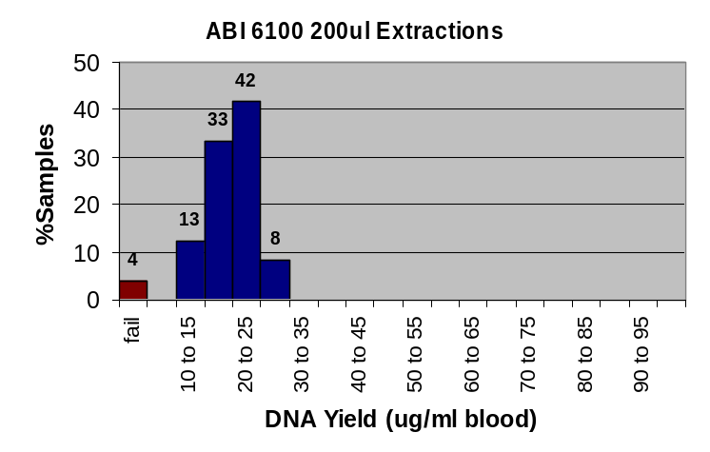
Yield | Mean absolute yield (ug) | 3.8
Yield | Mean relative yield (ug/ml blood) | 19.2
Yield | Standard deviation (relative yield) | 5.1
Yield | % Extractions failed (<5ug/ml blood) | 4

DNA Purity | 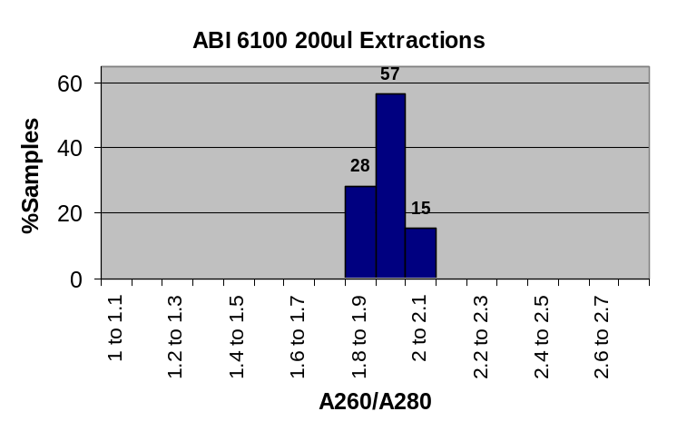
DNA Purity | Average OD260/OD280 ratio | 1.94
DNA Purity | Standard deviation | 0.06
DNA Purity | % DNA samples with OD260/OD280 1.6-2.0 | 85

PCR | % DNA samples with all five bands on PCR | 96
PCR | % DNA samples with all 1-4 bands on PCR | 2
PCR | % DNA samples with no bands on control PCR (failed) | 2
PCR | Cross contamination | 0

DNA integrity | % DNA samples with clean band >20kb on 0.8% agarose | 94

Discussion
As a result of limited access to the ABI 6100, a rapid evaluation was carried out in single day. Since the instrument was located off-site, sample throughput was limited by what it was possible to transport.

The instrument was simple to use but the protocol could only be described as ‘semi-automatic’. For the blood DNA extraction evaluated, eight separate user interventions were required during the extraction run. These were separated by intervals of hands free operation lasting between 10 and 25 minutes. Thus the operator was essentially tied up for the duration of the extraction procedure.

The 48 samples extracted in this evaluation only filled half a plate. This has been a problem with other vacuum manifold based systems since the empty wells can effectively dissipate the pressure. No intervention was made to the empty wells during this evaluation (e.g. sealing unused wells). Although this did not significantly affect the protocol, the duration of the vacuum stages may have been marginally extended. The wells not used in the run could potentially be used for further samples although an effective procedure for determining which wells had been used would need to be adopted.

During the extraction two of the wells became clogged with cell debris and would no longer drain properly. This made further addition of reagents difficult and extraction of these two wells had to be abandoned. As would be expected these two extractions corresponded to the two samples that failed to yield >5μg/ml blood extracted. The problem of clogging wells was encountered on a reasonably regular basis by the normal users of the instrument that we tested.

Although the yield from successful extractions was not particularly high (19.2 μg/ml blood extracted), it was very consistent. The DNA purity was in general good although the OD260/OD280 ratio tended to be a little high. All DNAs were of high molecular weight and all samples except the two failures gave good PCR results.

This instrument is certainly capable of extracting DNA from blood to a diagnostic standard. It is simple to use and can easily be programmed for new protocols. However the procedure is not fully automated and is quite labour intensive. The problem of clogged wells may be an issue although, since only a small aliquot of the total sample is used, any such extractions could be repeated. The size of extraction is probably two low for most diagnostic applications especially given that the extraction yield was not particularly high.

Autogen NA-3000EU

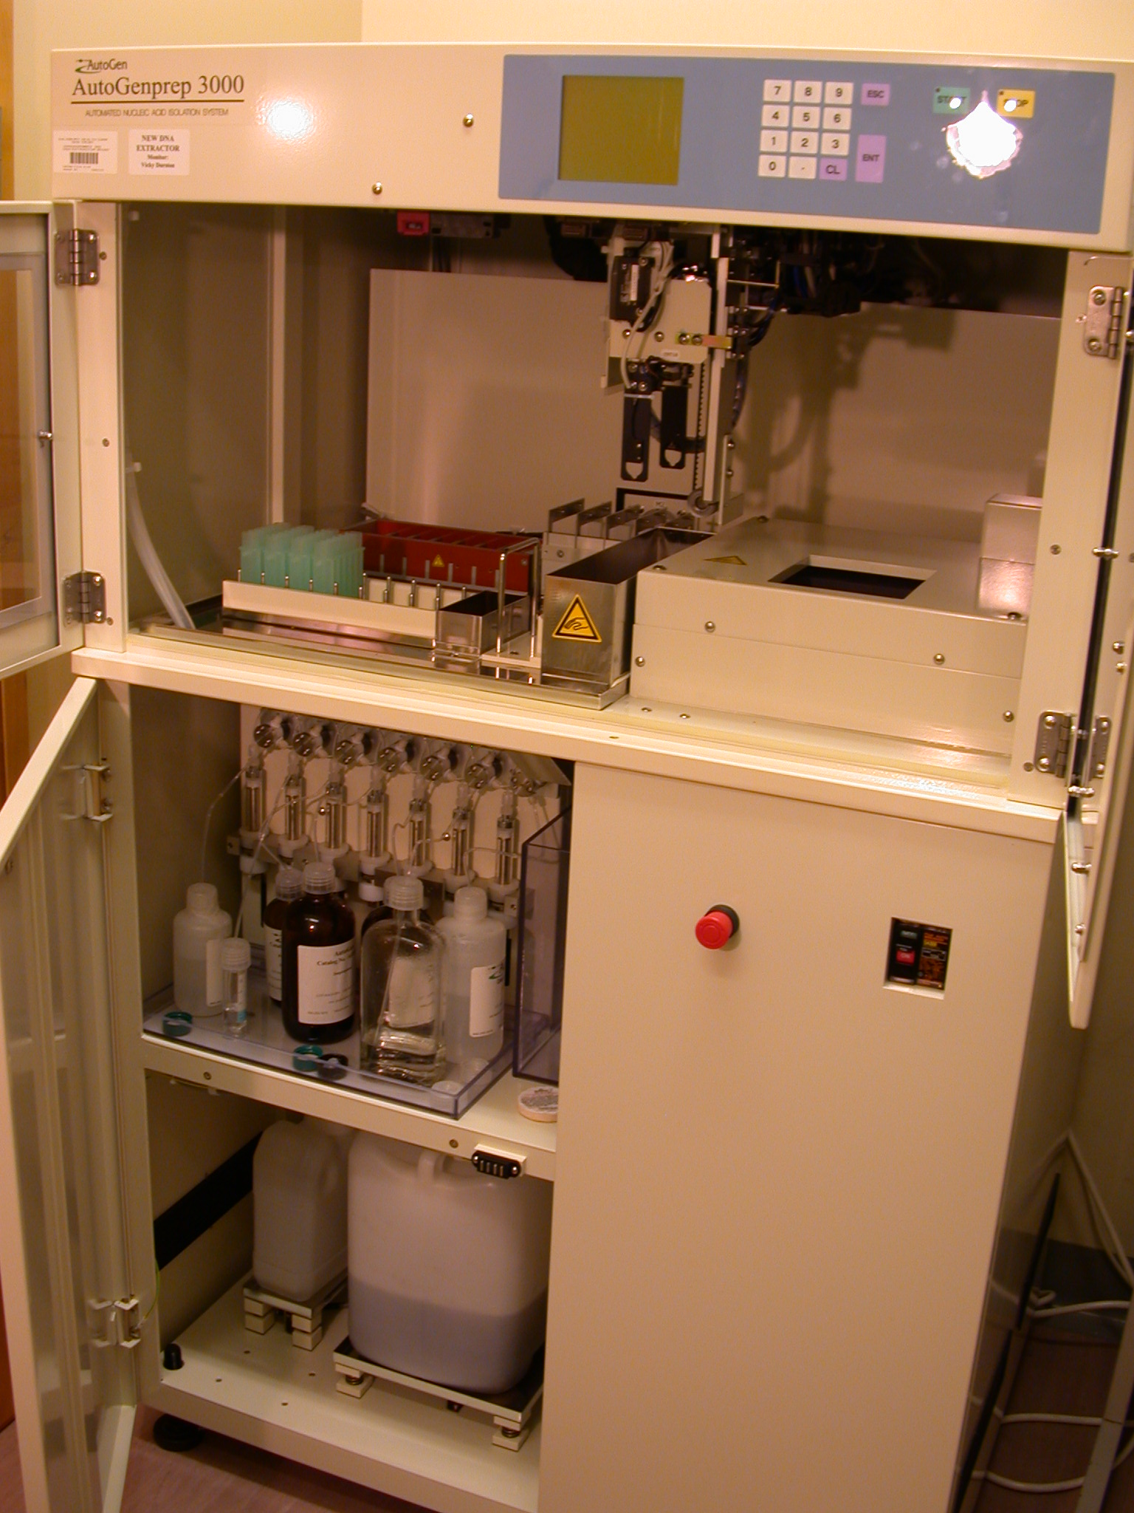
Description

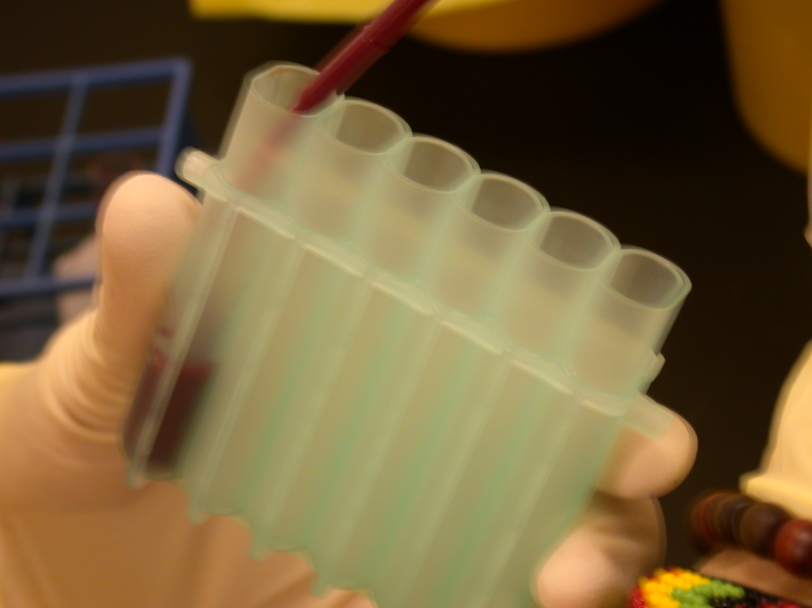

System tube

Autogen NA-3000EU

The Autogen is a floor standing instrument, which is mounted on castors for easy relocation with screw down feet to provide stability once in position. The upper, working compartment contains input and output racks, a four bucket centrifuge, a shaker, an incubator and an x-y-z robotic head for manipulation of sample tubes and dispensation of reagents. Access to the working space is via a door fitted with a safety cut out switch to prevent access whilst the instrument is running. Eight individual pumps, located in the lower compartment, allow controlled delivery of up to eight different reagents via the robotic head. The lower compartment also houses two waste bottles that are filled via two separate waste chutes from the upper compartment: a 10L waste bottle which is fitted with a weight sensor and a 2L waste bottle.

The instrument is controlled using a simple key pad located on the front panel. It is pre-programmed with a number of different protocols each comprising both fixed steps which can not be adjusted by the operator and variable steps which can. For example the quantity of each reagent, incubation time and centrifugation parameters can be adjusted. Up to nine variations of each protocol can be stored by the user. There is no integrated bar-code system and sample tracking must be performed manually by means of tube / sample location.

The instrument is capable of handling a number of different protocols including DNA and RNA extractions from various sample types. The system can handle samples from 0.5 ml to 7 ml, but for the protocol tested, samples between 2 and 5ml were used. Extractions are performed in specially designed, disposable tube units, each comprising six fused sample chambers arranged in a row. In order to balance the centrifuge samples can only be extracted in batches of 12 (2 tube units), 24 (4 tube units) or 48 (8 tube units). Other batch sizes can be accommodated by the use of appropriately sized water blanks.

Specification
System type | Integrated
Chemistry | Salt extraction
Dimensions (WxDxH) | 920 x 750 x 1500mm (floor standing)
Weight | 220kg
Instrument cost | ~£100k
Consumables cost | ~£2/sample
Batch size | 48
Sample volume | 2-5ml
Bench time | Cleaning lines, refreshing reagents, transferring samples to system tubes ~40minutes/run
Processing time | ~8 hrs
Manual tube transfers | 2 (sample tube > system tube>storage tube)
Sample tracking | Positional
Reagent tracking | None – manual addition of reagents
Maintenance | Empty waste, cleaning ~10 minutes per run

Evaluation
Duration | 3/2003-7/2003
Samples | 288
Water blanks | 50

Performance measures
Yield | 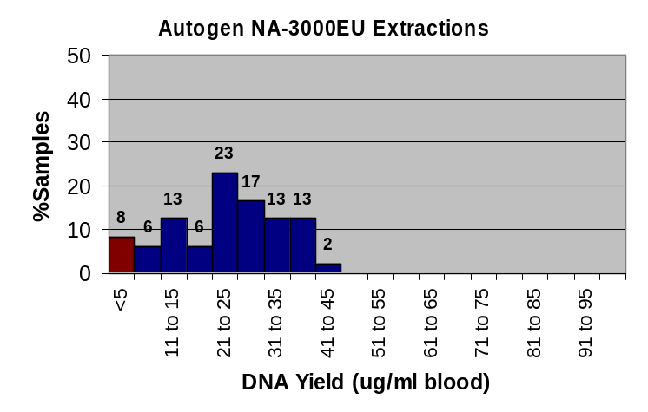
Yield | Mean absolute yield (ug) | 66.4
Yield | Mean relative yield (ug/ml blood) | 23.9
Yield | Standard deviation (relative yield) | 15.6
Yield | % Extractions failed (<5ug/ml blood) | 8

DNA Purity | 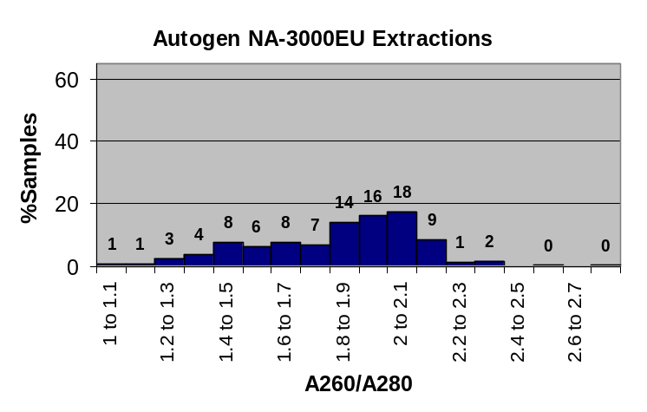
DNA Purity | Average OD260/OD280 ratio | 1.87
DNA Purity | Standard deviation | 0.64
DNA Purity | % DNA samples with OD260/OD280 1.6-2.0 | 45

PCR | % DNA samples with all five bands on PCR | 69
PCR | % DNA samples with all 1-4 bands on PCR | 5
PCR | % DNA samples with no bands on control PCR (failed) | 26
PCR | Cross contamination | 0

DNA integrity | % DNA samples with clean band >20kb on 0.8% agarose | 85

Discussion
Prior to extraction samples were frozen overnight to aid cell lysis. Samples were placed in a freezer in a rack placed in a tray to protect against the possibility of shattered tubes. We tried freezing samples at both -20°C and -80°C and had no instances of shattered tubes. No significant differences were detected in the resultant DNA as a result of the freezing regime. One hour before a run samples were removed from the freezer and set aside to thaw. We found that incubating in a water bath at 35°C reduced the lead in time to ~15 mins and had no significant affect on the resultant DNA. A frozen aliquot of proteinase K (pk) also removed from the freezer ~20mins before a run was started and allowed to thaw.

Before starting a run all system tubing was flushed to remove any air locks and old reagents. This was particularly important for the pk line since fresh pk is required for each run. The line capacity was ~10ml and this needed to be re-filled with reagent before starting a run. The potential wastage was therefore quite high.

Once the samples were defrosted they were transferred to system tubes. This was most easily achieved using disposable Pasteur pipettes. Because the system tubes are comprised of six fused compartments it was unavoidable to have all these compartments open during this transfer process. Great care was needed to avoid dripping blood into the wrong compartment.

A standard volume for re-suspension of the DNA is used for all samples in a single batch. This means it is sensible to use approximately the same amount of blood from each sample within a batch to maintain an approximately even yield. However, if using different samples volumes care was needed to ensure adjacent sets of six samples (in two tube racks) were balanced for centrifugation. In practice the simplest way to achieve this was by topping up each tube to a standard volume using water. The same principle was applied to non-standard batch sizes.
`
A second set of identical tubes was also placed on the instrument adjacent to the sample tubes for elution of the DNA. After processing, the re-suspended DNA was manually transferred from the system tubes to appropriate cryo-tubes for storage. Due to the shape of the tubes, the green colouration and the fact that six containers were fused together, this process was found to be awkward and time consuming. Greater dilution of the DNA was found to alleviate this problem slightly but the suitability of this more dilute DNA for down stream processes needs to be considered.

At start up the instrument calculates the required volumes of the various reagents depending on the protocol being used. Given this information the operator must manually check that sufficient reagents are present and that the correct reagent is on the correct line. After system start up checks, the protocol can be initiated.

The first two batches run on the Autogen had a very high failure rate (>20%). After advice from other users and the distributor we tried to correct this by adjusting various parameters in the protocol. Notably the duration of centrifugation steps was increased and the number of washes was decreased. However this did not decrease the failure rate. We then proceeded to perform an optimisation by sequentially adjusting different parameters. Thus a large proportion of this evaluation was spent trying to decrease the failure rate. Only the data obtained from the final protocol, in which we managed to reduce the failure rate to 8% is given.

The instrument was well built and simple to operate although the necessity for line flushing was very time consuming. In general the extractions that did work yielded good high molecular weight DNA that gave good results on PCR. However the 8% failure rate would certainly be of concern in a diagnostic lab. Laboratories that are using this instrument routinely typically extract DNA from only half the sample, ensuring a back up in case of extraction failure. In addition, as a result of the design of the system tubes, we found the manual transfer stages troublesome and would be concerned about the possibility for cross contamination at these stages (particularly the initial transfer from sample tube to system tube). This system has attempted to replicate the manual process of a simple salt extraction but in automated form. With the availability of paramagnetic bead extractions and solid phase extractions this may not be the most appropriate approach for automation of DNA extraction.

Chemagen Module I

Description

Chemagen Module I
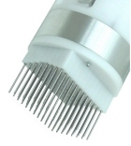
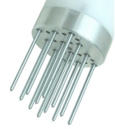
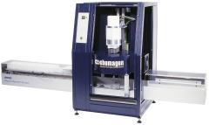

The instrument consists of a horizontal track that is able to move backwards and forwards in the x-axis only. In the centre, enclosed in a cabinet, is a z-axis robotic head on which a separation head is mounted. The separation head is an array of rotating rods (either 12 or 96) each with a paramagnetic tip. The whole robotic head moves up and down the z-axis passing through a large electro magnet. Both the cabnet and the track are enclosed with safety doors that stop the instrument should they be opened during operation.

The instrument uses paramagnetic bead chemistry. At the start of a run the horizontal track is located at the far left end. Samples, beads and a series of washes are loaded on the track together with empty tubes to receive the re-suspended DNA samples. During the run the track moves backwards and forwards to locate the appropriate position under the robotic head. With the electro magnet off the separation head can be used to vortex solutions with the rotating rods. Turning the magnet on activates the paramagnetic tips of the rods and allows the beads to be picked up and transferred from tube to tube. To prevent cross-contamination the rods are sheathed in plastic tips for the duration of the run.

The instrument is controlled from a PC using simple software. A variety of protocols are available for both low volume extractions, in a 96 well plate format, and high volume extractions using the 3 x 4 rod array extraction head.

Specification
System type | Integrated
Chemistry | Paramagnetic beads
Dimensions (WxDxH) | 1940 x 640 x 950mm + computer (bench top)
Weight | 220kg
Instrument cost | ~£60K instrument only –  ~£100K with fully automated liquid handling
Consumables cost | 1ml ~£2.50, 5ml ~£5, (10ml and 200μl extraction scales also available)
Batch size | 200μl 96, large volumes 12
Sample volume | 200μl, 1-10ml (potentially scalable)
Bench time | Cleaning lines, refreshing reagents, transferring samples to system tubes ~40minutes/run
Processing time | ~40 minutes + 45 minutes with manual reagent dispensation and protease incubation
Manual tube transfers | 2 (sample tube > system tube>storage tube)
Sample tracking | Positional
Reagent tracking | Bar coding with integrated robot
Maintenance | Minimal cleaning

200μl Evaluation
Duration | 4/2004
Samples | 94
Water blanks | 2

Performance measures
Yield | 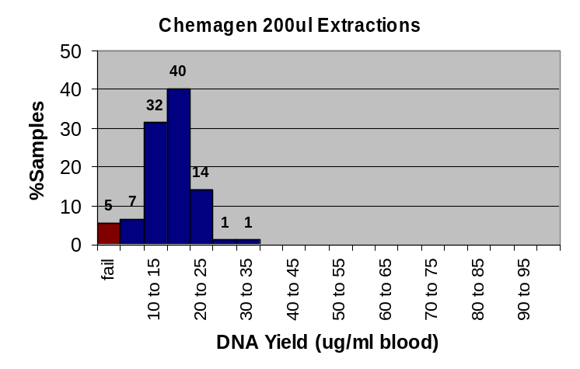
Yield | Mean absolute yield (ug) | 3.1
Yield | Mean relative yield (ug/ml blood) | 16.2
Yield | Standard deviation (relative yield) | 4.7
Yield | % Extractions failed (<5ug/ml blood) | 5

DNA Purity | 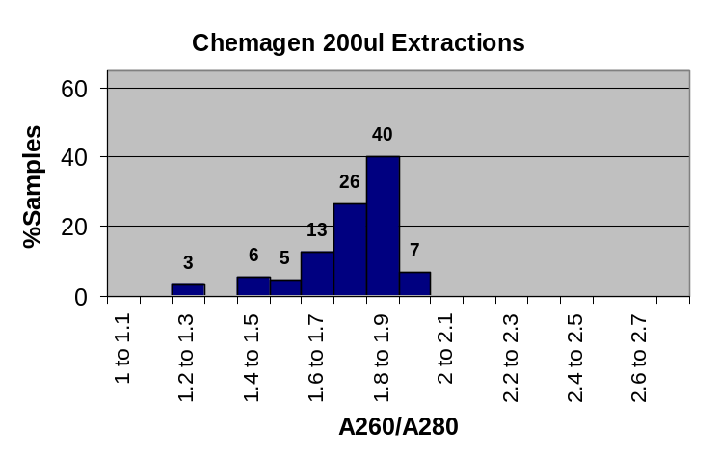
DNA Purity | Average OD260/OD280 ratio | 1.75
DNA Purity | Standard deviation | 0.16
DNA Purity | % DNA samples with OD260/OD280 1.6-2.0 | 86

PCR | % DNA samples with all five bands on PCR | 95
PCR | % DNA samples with all 1-4 bands on PCR | 0
PCR | % DNA samples with no bands on control PCR (failed) | 5
PCR | Cross contamination | 0

DNA integrity | % DNA samples with clean band >20kb on 0.8% agarose | 93
1ml Evaluation
Duration | 2/2004-3/2004
Samples | 207
Water blanks | 69

Performance measures
Yield | 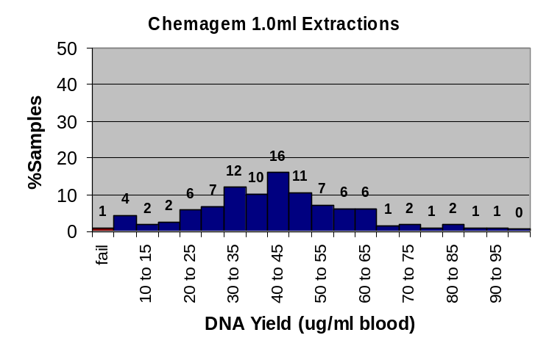
Yield | Mean absolute yield (ug) | 43.2
Yield | Mean relative yield (ug/ml blood) | 43.2
Yield | Standard deviation (relative yield) | 19.9
Yield | % Extractions failed (<5ug/ml blood) | 1

DNA Purity | 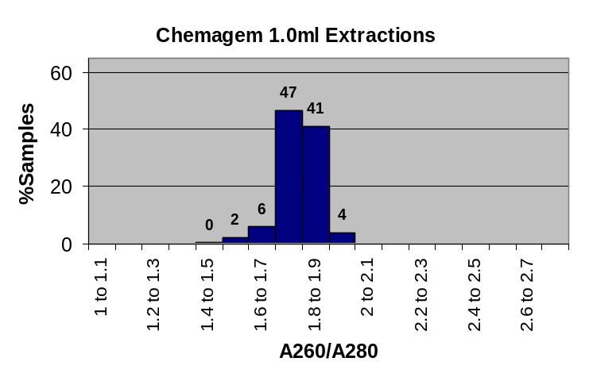
DNA Purity | Average OD260/OD280 ratio | 1.79
DNA Purity | Standard deviation | 0.07
DNA Purity | % DNA samples with OD260/OD280 1.6-2.0 | 98

PCR | % DNA samples with all five bands on PCR | 99
PCR | % DNA samples with all 1-4 bands on PCR | 1
PCR | % DNA samples with no bands on control PCR (failed) | 0
PCR | Cross contamination | 0

DNA integrity | % DNA samples with clean band >20kb on 0.8% agarose | 100

5ml Evaluation
Duration | 3/2004-4/2004
Samples | 207
Water blanks | 69

Performance measures
Yield | 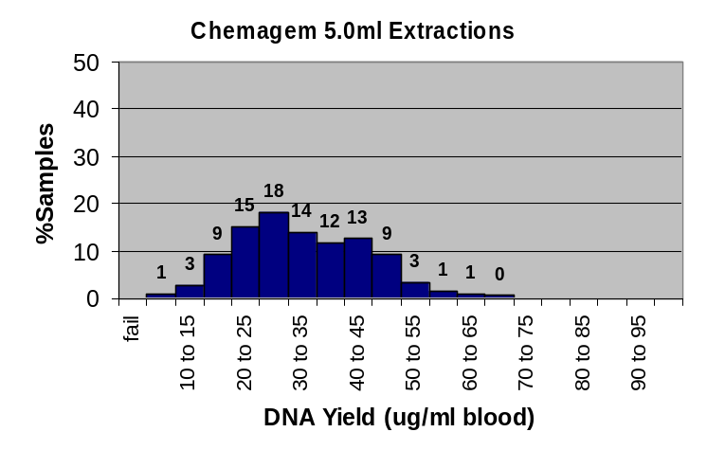
Yield | Mean absolute yield (ug) | 162.8
Yield | Mean relative yield (ug/ml blood) | 32.6
Yield | Standard deviation (relative yield) | 11.5
Yield | % Extractions failed (<5ug/ml blood) | 0

DNA Purity | 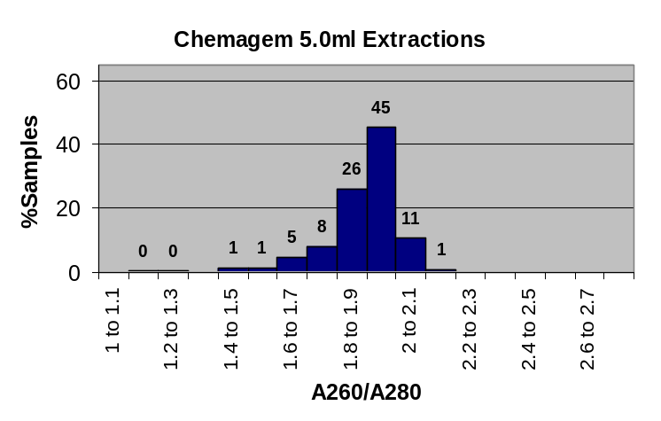
DNA Purity | Average OD260/OD280 ratio | 1.89
DNA Purity | Standard deviation | 0.13
DNA Purity | % DNA samples with OD260/OD280 1.6-2.0 | 85

PCR | % DNA samples with all five bands on PCR | 91
PCR | % DNA samples with all 1-4 bands on PCR | 5
PCR | % DNA samples with no bands on control PCR (failed) | 4
PCR | Cross contamination | 0

DNA integrity | % DNA samples with clean band >20kb on 0.8% agarose | 100

Discussion
The system was installed and operational within one day and minimal training was required. In this evaluation we used the Module I in isolation, which required the protease incubation and reagent dispensation to be carried out manually. For the large sample volume extractions (1ml and 5ml) blood samples were transferred into 50ml universal tubes and lysis buffer containing protease was added to each sample and incubated at room temperature for 20 minutes. The incubation time was critical since the protease was a harsh treatment. Over incubation could lead to poor quality samples, low yield or even fails. During the protease incubation four wash buffers and a hydration solution were dispensed into 50ml universal tubes. This involved a total of 60 dispensations, achieved using pump dispensers. In total seven universal tubes are used for each extraction (84 per batch of 12 samples), which is a significant consumables cost.

After the incubation the beads were added to the sample along with a binding buffer, which also stopped the protease reaction. All the tubes were then placed on the Module I before initiating the run.

For the 200μl extractions the above procedure is replicated but using a 96 well plate. Due to the number of samples in a batch the protease and stop solution needed to be added to the plate in the same order to ensure incubation time was the same for each sample. The slightly poorer results obtained for the 200μl extractions may have been caused by inconsistent protease incubation between samples.

It is possible to completely automate all the processes upstream of the actual extraction by linking the Module I to a Cartesian robot. This would perform all reagent dispensations as well as the protease incubation, which should be improve the consistency of results for all extraction sizes as a result. Such integration could potentially allow the chemistry to be truly scalable between 1-10ml by automatically adjusting sample and reagent volumes and concentrations. Automated bar-coded tracking of both reagents and samples would also be a relatively simple addition with this setup.

On completion of the run re-suspended DNA samples were manually transferred form the system tube to a cryo-tube for storage. Since each system tube was large, clear and a single container this transfer was simple and presented no problems with respect to cross contamination.

Of all the systems trialled to date the Chemagen was the only integrated system specifically designed to cope with extractions from large sample volumes (1-10ml). The 1ml and 5ml extractions gave some of the best results for both yield and DNA quality as viewed on 0.8% agarose gel and both had > 85% of samples with OD260/ODF280 ratio between 1.6 and 2.0. In both cases a wide range of yields was observed with the maximum exceeding 100μg/ml blood extracted for the 1ml protocol and 60μg/ml blood extracted for the 5ml protocol. This may be due to OD260 readings being artificially high due to the presence of protein contamination.

The PCR results for the 5ml extractions were slightly less impressive with 4% of samples giving no band in the control gene PCR and only 91% of samples with all five bands. All the samples from this extraction were also amplified using a sexing PCR with expected products up to 976bp. In this test only one sample (<0.5%) failed to amplify.

The 200μl extractions gave a much lower yield (16.2 μg/ml blood) and five of the control PCRs completely failed. The sexing PCR was also carried out on these samples and gave identical results to the control gene PCR. The five samples that failed corresponded with the five samples with an extraction rate <5μg/ml blood. These less satisfactory results may be due result of inconsistencies of incubation time due to manual reagent addition.

Overall the instrument performed very well and we would recommend it for large volume sample extractions. The cost of complete automation (linking to a Cartesian robot) is somewhat prohibitive especially if only small numbers of samples need to be processed. Although manual preparation for each run took about 40 minutes, the process was simple and easy to manage and would be a viable alternative to full automation.

More cost effective solutions are available for low volume samples but the fact that this instrument can cope with both small and large sample volumes is particularly advantageous. The speed with which this instrument could be implemented is also noteworthy.

DRI Charge Switch Technology (CST)

Description
A paramagnetic bead based nucleic acid extraction technology based on differential binding of nucleic acids to the beads dependant on pH. The system therefore avoids the use of enzyme inhibitors such as ethanol, chaotropic salts or organic solvents. Theoretically this is a very efficient and non-aggressive method for extraction of DNA and should yield high quality, high molecular weight DNA. The standard robot deck setup required the addition of magnet station and an integrated plate shaker capable of being operated by the robot software.

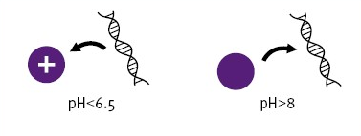
At pH < 6.5. Charge is 'on' At pH > 8.0 , Charge is 'off'

Specification
System type | Chemistry only
Chemistry | Paramagnetic beads
Dimensions (WxDxH) | 1450 x 780 x 870mm + computer (bench top) Tecan Freedom EVO 150
Weight | 125kg Tecan Freedom EVO 150
Instrument cost | ~£60k
Consumables cost | Subject to quotation
Batch size | 96
Sample volume | 10-20μl (used), 50-100μl, 1ml
Bench time | Locating plate / reagents on robot deck ~15 minutes
Processing time | ~2hr
Manual tube transfers | 0
Sample tracking | Positional (bar-code possible)
Reagent tracking | None – manual addition of reagents
Maintenance | Empty waste, cleaning ~10 minutes per run

Evaluation
Duration | 3/2004
Samples | 348
Water blanks | 84

Performance measures
Yield | 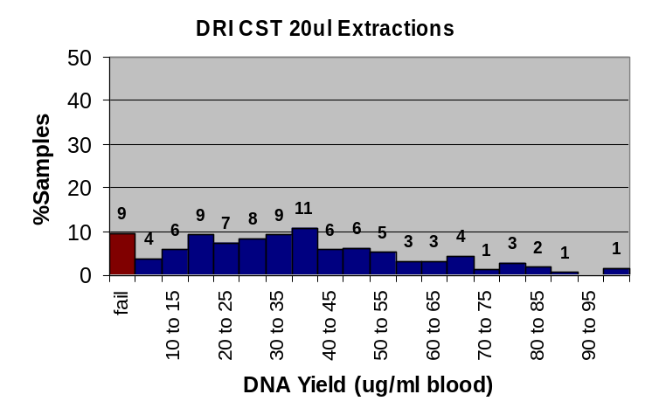
Yield | Mean absolute yield (ug) | 0.7
Yield | Mean relative yield (ug/ml blood) | 35.2
Yield | Standard deviation (relative yield) | 22.3
Yield | % Extractions failed (<5ug/ml blood) | 9

DNA Purity | 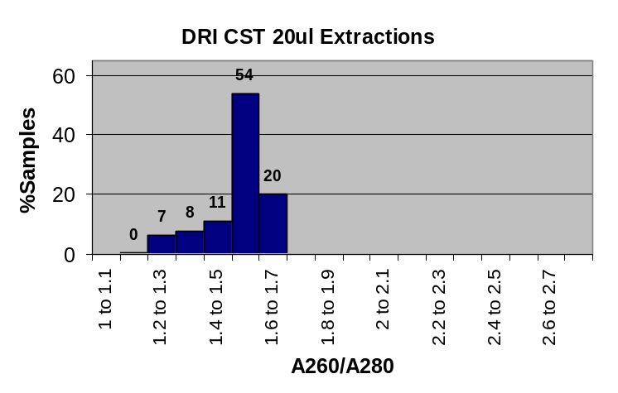
DNA Purity | Average OD260/OD280 ratio | 1.53
DNA Purity | Standard deviation | 0.11
DNA Purity | % DNA samples with OD260/OD280 1.6-2.0 | 20

PCR | % DNA samples with all five bands on PCR | 56
PCR | % DNA samples with all 1-4 bands on PCR | 8
PCR | % DNA samples with no bands on control PCR (failed) | 36
PCR | Cross contamination | 0

DNA integrity | % DNA samples with clean band >20kb on 0.8% agarose | 95

Discussion
This evaluation was carried out using the 20μl sample volume kit because work to automate this kit on the Tecan Freedom EVO was already underway. Although in most cases this sample volume would not be suitable for a diagnostic laboratory, the work was useful in highlighting problems associated with automating kit based chemistries on a generic Cartesian robot. This CST is also supplied in a 1ml sample volume kit for human blood that may be of use.

Despite two weeks work by the DRI and Tecan specialists setting up the protocol, there were still noticeable technical problems with the procedure. In particular aspiration of wash buffers was not fully optimised resulting in widespread and in some cases substantial, contamination of the re-suspended DNA. Other problems included homogenisation of the blood sample prior to aspirating the 20μl required for the extraction, problems with the shaker and incubation time errors.

A very wide range of yields was observed with this protocol some as high as 100μg/ml blood extracted. Protein, RNA or organic solvent (e.g. ethanol) contamination can also have an affect on OD260 readings thus distorting yield calculations. OD260/OD280 (average 1.53) ratios suggest the presence of protein contamination. This is probably due to the incomplete removal of wash buffers observed during the protocol and the problems associated with incubation. Alcohol contamination is also likely given the problems with aspirating the wash buffers. The generally low OD260/OD280 ratios suggest that the yield measurements were not reliable. The presence of contamination is clearly demonstrated in the poor PCR success rate; only 56% of the control gene PCRs gave all five bands. As would be expected the samples that had the higher OD260/OD280 ratios generally corresponded with those that succeeded in the PCR.

The issues encountered were not chemistry specific but are clearly reflected in the performance results. Consequently we do not feel the results from this evaluation are a fair reflection of the performance of the chemistry. Since this chemistry has been proven in manual format it seems likely that, given more time, automation could be successfully achieved. Our experience with this chemistry clearly demonstrates the need for sufficient time for development if kit based chemistries are to be automated on generic robotics.

Macherey Nagel Nucleospin

Description

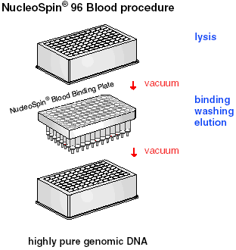
A solid phase extraction utilising a silica membrane binding, washing and elution system. The Nucleospin 96 is an array of 96 cartridges, in standard 8 x 12 format able to cope with samples up to 200μl. The standard robot deck setup required the additional integration of a vacuum manifold.

A range of other formats are available covering single extractions, sample volumes up to 10ml and various tissue types. However not all of these would be easily automated using standard liquid handling robotics.

Specification
System type | Chemistry only
Chemistry | Solid phase extraction
Dimensions (WxDxH) | 1450 x 780 x 870mm + computer (bench top) Tecan Freedom EVO 150
Weight | 125kg Tecan Freedom EVO 150
Instrument cost | ~£60k
Consumables cost | Subject to quotation
Batch size | 96 (48 was used in this evaluation)
Sample volume | 200μl
Bench time | Locating plate / reagents on robot deck ~15 minutes
Processing time | ~1hr
Manual tube transfers | 0
Sample tracking | Positional (bar-code possible)
Reagent tracking | None – manual addition of reagents
Maintenance | Empty waste, cleaning ~10 minutes per run

Evaluation
Duration | 3/2004
Samples | 240
Water blanks | 48

Performance measures
Yield | 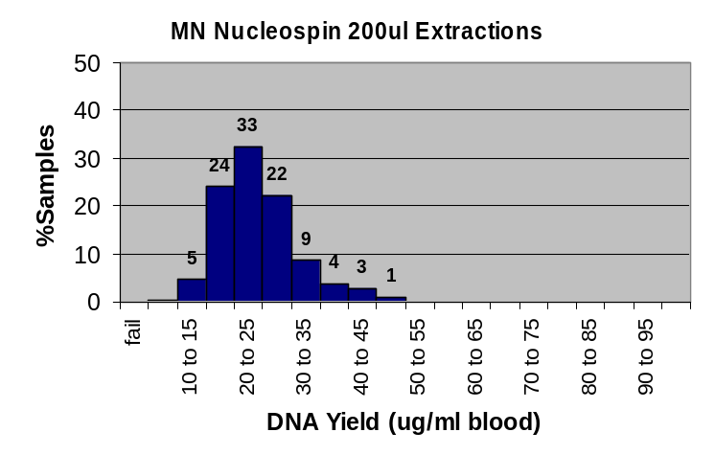
Yield | Mean absolute yield (ug) | 4.8
Yield | Mean relative yield (ug/ml blood) | 24.1
Yield | Standard deviation (relative yield) | 6.9
Yield | % Extractions failed (<5ug/ml blood) | 0

DNA Purity | 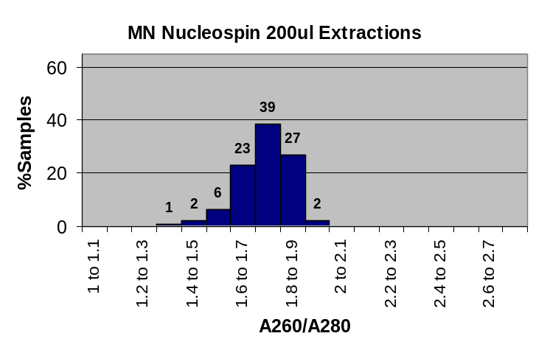
DNA Purity | Average OD260/OD280 ratio | 1.71
DNA Purity | Standard deviation | 0.13
DNA Purity | % DNA samples with OD260/OD280 1.6-2.0 | 91

PCR | % DNA samples with all five bands on PCR | 99
PCR | % DNA samples with all 1-4 bands on PCR | 0.5
PCR | % DNA samples with no bands on control PCR (failed) | 0.5
PCR | Cross contamination | 0

DNA integrity | % DNA samples with clean band >20kb on 0.8% agarose | 99

Discussion
Of the kit base chemistries set up on the Tecan Freedom EVO, the Macherey Nagel system required the least implementation time. Even so the final setup used for the evaluation was not free from problems and these would need to be addressed before any implementation for routine use.

The seal on the vacuum manifold was not consistent enough to provide sufficient pull through. This was particularly problematic with the bloods due to their high viscosity. This problem was partially due to using and incomplete batch (48 rather than 96), which left a path of lower resistance via the empty wells. Although the problem was reduced by taping over unused wells, the primary cause was improper seating of the system plate on the vacuum manifold. The system could not directly detect poor vacuum but was set up to check for residue waste in each well before proceeding to the next wash buffer addition. If residue was detected the vacuum stage was repeated. However, this process is very time consuming and manual pressure applied to the plate was often required to expedite the protocol. Obviously this would not be suitable for routine use. Therefore the DNAs evaluated here are a reflection of the quality and quantity that could be obtained if a proper vacuum seal could be ensured without manual intervention. This problem could be addressed by sourcing a more efficient manifold or modification of the existing one. Alternatively the gripper arm could be to programmed to apply pressure to the plate.

It was noted that the vacuum pump was very loud when this protocol was used. Suitable location of this system would therefore need some consideration.

Notwithstanding the problems associated with the vacuum, this protocol gave some of the best results for all the systems in this study. DNA yield was satisfactory and no extractions gave <5μg/ml blood. The yield standard deviation was also low indicating consistent extractions. DNA purity and integrity were both good and only one sample failed in the control gene PCR. The standard deviations of both yield and DNA purity were both low indicating a consistent and reliable extraction. With time to sort out the procedural problems this system should be a reliable method for extracting DNA from small volumes of blood.

Promega MagneSil

Description
A paramagnetic bead based system carried out in 50ml centrifuge tube. The standard robot deck setup required the addition of a specifically designed magnet platform, racks to hold the centrifuge tubes and an integrated plate shaker capable of being operated by the robot software.

Specification

System type | Chemistry only
Chemistry | Paramagnetic beads
Dimensions (WxDxH) | 1450 x 780 x 870mm + computer (bench top) Tecan Freedom EVO 150
Weight | 125kg Tecan Freedom EVO 150
Instrument cost | ~£60k
Consumables cost | Subject to quotation
Batch size | Max 8 (variable according to protocol)
Sample volume | 1-5ml (scalable)
Bench time | Locating plate / reagents on robot deck ~15 minutes
Processing time | ~2hrs
Manual tube transfers | 0
Sample tracking | Positional (bar-code possible)
Reagent tracking | None – manual addition of reagents
Maintenance | Empty waste, cleaning ~10 minutes per run

Evaluation
Duration | 3/2004-4/2004
Samples | 144
Water blanks | 48

Performance measures
Yield | 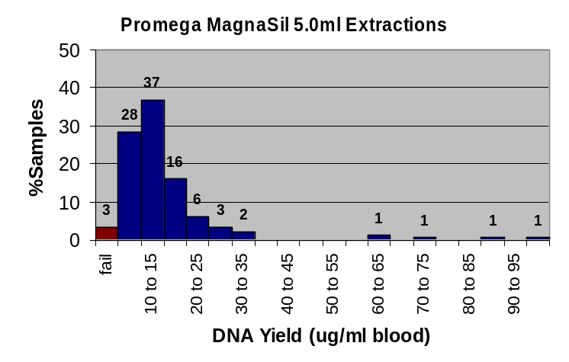
Yield | Mean absolute yield (ug) | 69.1
Yield | Mean relative yield (ug/ml blood) | 15.4
Yield | Standard deviation (relative yield) | 13.3
Yield | % Extractions failed (<5ug/ml blood) | 3

DNA Purity | 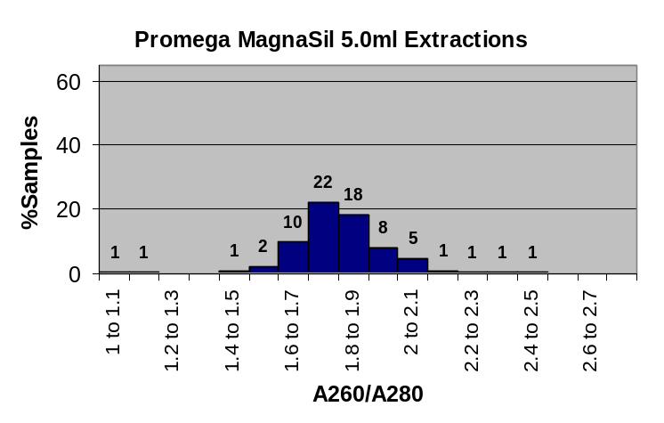
DNA Purity | Average OD260/OD280 ratio | 1.83
DNA Purity | Standard deviation | 0.46
DNA Purity | % DNA samples with OD260/OD280 1.6-2.0 | 59

PCR | % DNA samples with all five bands on PCR | 94
PCR | % DNA samples with all 1-4 bands on PCR | 5
PCR | % DNA samples with no bands on control PCR (failed) | 1
PCR | Cross contamination | 0

DNA integrity | % DNA samples with clean band >20kb on 0.8% agarose | 99.3

Discussion
This protocol was performed entirely using the fixed probes. Since the system was setup to extract DNA from 5ml samples, a volume substantially grater than the capacity of the probes, blood and other reagents were regularly aspirated into the system tubing. After each dispensation the lines and probes were flushed through with excess bleach to minimise the possibility of any cross contamination. Although we did not see any cross-contamination in the tests run during this evaluation, heavy internal and external staining of tips and system tubing was observed. It seems likely that this would build up over time becoming an unacceptable cross-contamination risk. We would recommend that any system setup to run this chemistry in a diagnostic lab should be redesigned to avoid this practice. Most importantly disposable filter tips should be used. To handle the large volumes of liquid required for this extraction the procedure would either need to be broken down into several ‘sub-extractions’ or a large volume disposable tip adapter will need to be designed.

During waste removal from the system tubes the tips were programmed to enter the tubes at the side. This often resulted in the end of the tips being jammed against the side, thereby reducing the aspiration efficiency. Thus excess waste remained in the tube going into the next process. This excess waste gradually built up during the various washing steps until the elution stage was reached. At the end of the protocol many tubes were noted to have significantly more liquid than the volume of hydration buffer added. This could be addressed in a number of ways; by repositioning the tip drop to centre of tube, leaving the tip in liquid for a couple of seconds after suction is complete to ensure all waste is aspirated or performing the aspiration in a number of steps.

The tube rack was poorly designed leading to difficulty maintaining sufficient grip with the gripper arm (ROMA) to move it around the deck. This is a very serious problem since dropping the tube rack would not only abort the run with loss of all the samples but may involve the potentially hazardous and substantial spillage of blood. An alternative gripping system is required involving a more positive engagement between the gripper arm and the rack. It would also be useful if the rack was be made from transparent material to enable the contents of the tubes located at the back to be viewed.

The protocol for this procedure was very complex and relied on numerous variables that were defined at the beginning of the protocol (e.g. batch size, sample volume, re-suspension volume). If, for any reason, a run was aborted, the value of these variables was lost meaning the run could not be restarted.

The protocol frequently stalled at the point when the shaker subroutine was initiated. This led to a few instances where various incubations were left far longer than they should have been. This problem was due to insufficient computer processing power and would be solved simply by using a more powerful computer.

Three runs had to be aborted during the course of the trial due to “invalid operand” errors. On all occasions these errors occurred when the tips were trying to dispense liquid (magnetic beads, lysis buffer or alcohol wash) from the back four tips and appeared to have no particular trigger. This appeared to be due to a damaged tip.

As with the DRI CST protocol the problems encountered were not chemistry specific but related to insufficient development of the automation protocol. Given the number and types of problems the extractions gave remarkably good results. Although the extraction yield was quite poor, all DNA samples except one were of good quality when run out on 0.8% agarose, and only two samples failed to give any bands in the control gene PCR. DNA purity was generally good but the range of results indicates inconsistency in the extractions.

Overall these results suggest that if the practical problems could be resolved this system would provide a flexible procedure capable of handling samples from 1-5ml with defined batch sizes. However, some of the issues raised are quite serious and would require not only complete re-programming of the robot, but a redesign of some hardware.

Qiagen EZ1

Description

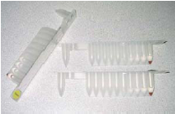
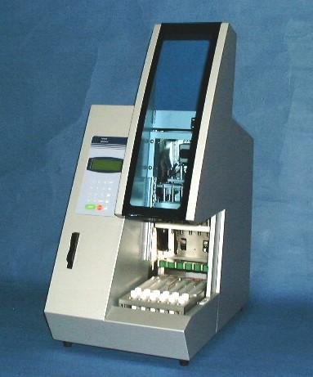

This is a compact bench top instrument that uses a paramagnetic bead based chemistry, which is conveniently packaged in a foil sealed reagent cartridge. All reagents and plastic ware are supplied with the extraction kits. The working deck has 6 slots to take the kit cartridges with an aligned tube rack to locate tubes for samples and re-suspended DNA. Above the deck is a robotic head with 6 positions, each having a spike for piercing the foil seals on the reagent cartridges, a pipette and a magnetic probe. All six pipettes are operated from the same syringe pump. This means that the same amount of reagent is always delivered to all samples. Therefore only one re-suspension volume can be used for each run.

The instrument is controlled via a simple key pad and LCD screen. Different protocols are loaded onto the instrument via cards, which are plugged into a slot on the front.

The working space is enclosed in a cabinet with a sliding lid. A run is halted if the cabinet door is opened during operation.

Specification
System type | Integrated
Chemistry | Paramagnetic beads
Dimensions (WxDxH) | 400x500x700mm approx (bench top)
Weight | unspecified
Instrument cost | ~£19k
Consumables cost | 200μl ~£2, 350μl ~£4 / sample
Batch size | 6
Sample volume | 200μl, 350μl (fixed volumes)
Bench time | Transferring samples to system tubes ~15 minutes/run
Processing time | ~25 minutes
Manual tube transfers | 1 (sample tube > system tube)
Sample tracking | Positional
Reagent tracking | None – reagent cartridges
Maintenance | Empty waste, minimal cleaning ~5 minutes per run

200μl extraction Evaluation
Duration | 6/2004
Samples | 96
Water blanks | 18

Performance measures
Yield | 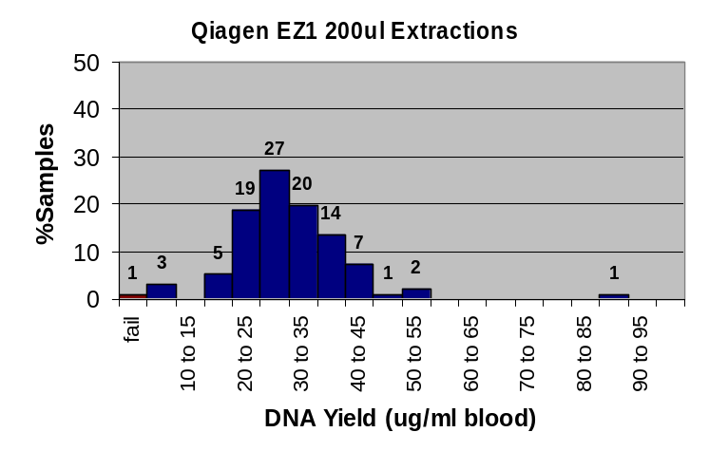
Yield | Mean absolute yield (ug) | 6.0
Yield | Mean relative yield (ug/ml blood) | 30.1
Yield | Standard deviation (relative yield) | 10.5
Yield | % Extractions failed (<5ug/ml blood) | 1

DNA Purity | 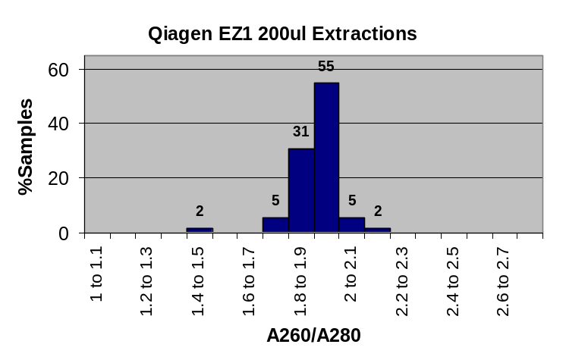
DNA Purity | Average OD260/OD280 ratio | 1.89
DNA Purity | Standard deviation | 0.09
DNA Purity | % DNA samples with OD260/OD280 1.6-2.0 | 91

PCR | % DNA samples with all five bands on PCR | 89
PCR | % DNA samples with all 1-4 bands on PCR | 6
PCR | % DNA samples with no bands on control PCR (failed) | 5
PCR | Cross contamination | 0

DNA integrity | % DNA samples with clean band >20kb on 0.8% agarose | 97

350μl extraction Evaluation
Duration | 6/2004
Samples | 94
Water blanks | 18

Performance measures
Yield | 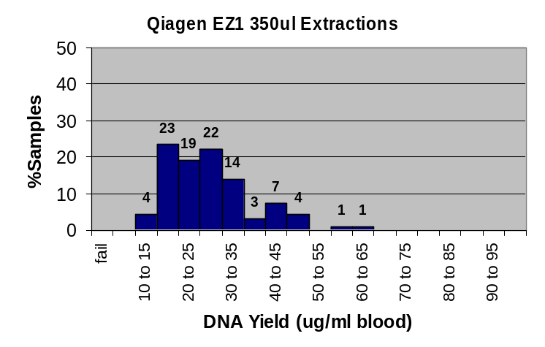
Yield | Mean absolute yield (ug) | 9.5
Yield | Mean relative yield (ug/ml blood) | 27.2
Yield | Standard deviation (relative yield) | 9.9
Yield | % Extractions failed (<5ug/ml blood) | 0

DNA Purity | 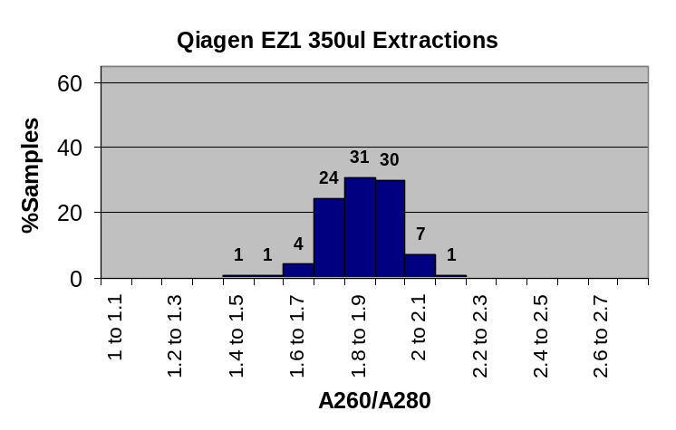
DNA Purity | Average OD260/OD280 ratio | 1.86
DNA Purity | Standard deviation | 0.11
DNA Purity | % DNA samples with OD260/OD280 1.6-2.0 | 89

PCR | % DNA samples with all five bands on PCR | 98
PCR | % DNA samples with all 1-4 bands on PCR | 2
PCR | % DNA samples with no bands on control PCR (failed) | 0
PCR | Cross contamination | 0

DNA integrity | % DNA samples with clean band >20kb on 0.8% agarose | 100

Discussion

We found the system very easy to use with minimum installation and training time required (one afternoon). The reagent cartridge system works very well and allows the batch sizes to be varied (up to six) without wastage of reagents. The speed of the extraction protocol was also very impressive. Allowing for all preparation we were able to have completed DNAs in storage tubes in less than one hour. This does not allow any time for homogenisation of the samples, which would certainly be needed before the DNA is used in any downstream process.

Although no bar-coding facility is currently available this option is promised as an upgrade in the near future.

Both extractions (200μl and 350μl) gave very good results for all the performance measures. The 200μl extractions performed slightly better in terms of yield but five of the PCRs completely failed. Three of these corresponded with the three samples failing to give a band when run out on 0.8% agarose indicating that no DNA was present. Since DNA was clearly present in the remaining two PCR failures these must be related to either contamination causing the PCR to fail or some other failure in a down stream process.

The cartridge system for protocols worked well, although it should be noted that each card costs ~£400. Care would be needed to ensure protocol cards were not damaged or lost. Protocols are available to cope with most types of extraction likely to be encountered in a diagnostic lab (not tested here). This instrument would be suitable for extraction of DNA from blood samples that do not require a very high total yield. If a higher throughput is required Qiagen sell another instrument, the M48 (not tested) capable of extracting a batch of 48 samples in about 50 minutes using the the same chemistry as the. The M48 has pre-programmed protocols (i.e. not the card system) and uses bulk materials, which means the reagents need to be dispensed into troughs before the protocol is started.

Most respondents to the extraction survey had a need for DNA extraction from a variety of samples including amniotic fluid samples, CVS buccal swabs, cell culture and other tissue samples. In most cases these types of extractions were a small proportion of the lab throughput. Although these different protocols have not been tested in this evaluation the capacity and flexibility in terms of starting materials of the EZ1 is a prime candidate for dealing with these samples. However, it should be noted that each run will only deal with one type of extraction. Thus if many different protocols need to be used they would have to be run consecutively.

Roche MagNA Pure Compact

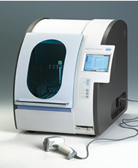
Description

Roche MagNA pure compact

This is a compact bench top instrument that uses a paramagnetic bead based chemistry, which is conveniently packaged in a foil sealed reagent cartridge. All reagents and plastic ware are supplied with the extraction kits. The working deck has eight slots to take the kit cartridges with an aligned tube rack to locate tubes for samples and re-suspended DNA. Above the deck is a robotic head with eight positions, each having a spike for piercing the foil seals on the reagent cartridges, a pipette and a magnetic probe. All eight pipettes are operated from the same syringe pump. This means that the same amount of reagent is always delivered to all samples. Therefore only one re-suspension volume can be used for each run.

The instrument is controlled via a simple key pad and LCD screen. Different protocols are stored on the built in computer and accessed via a menu system. This configuration allows for simple upgrading or addition of new protocols. Reagent cartridges are bar coded and linked to the appropriate protocol. The built in bar-code reader can also be used for sample tracking.

The instrument also has a built in UV lamp to enable the working space to be irradiated for decontamination purposes. The duration of irradiation can be selected by the user. The working space is enclosed in a cabinet with a sliding lid. A run is halted if the cabinet door is opened during operation.

Specification
System type | Integrated
Chemistry | Paramagnetic beads
Dimensions (WxDxH) | 700x 700 x 700mm approx (bench top)
Weight | unspecified
Instrument cost | ~£24k
Consumables cost | 300μl ~£4, 1ml ~£8 / sample
Batch size | 8
Sample volume | 300μl, 1ml (fixed volumes)
Bench time | Transferring samples to system tubes ~15 minutes/run
Processing time | ~25 minutes
Manual tube transfers | 1 (sample tube > system tube)
Sample tracking | Bar-code
Reagent tracking | Bar-code – reagent cartridges
Maintenance | Empty waste, minimal cleaning ~5 minutes per run (integrated UV irradiation protocol)

300μl extraction Evaluation
Duration | 9/2004
Samples | 48
Water blanks | 0

Performance measures
Yield | 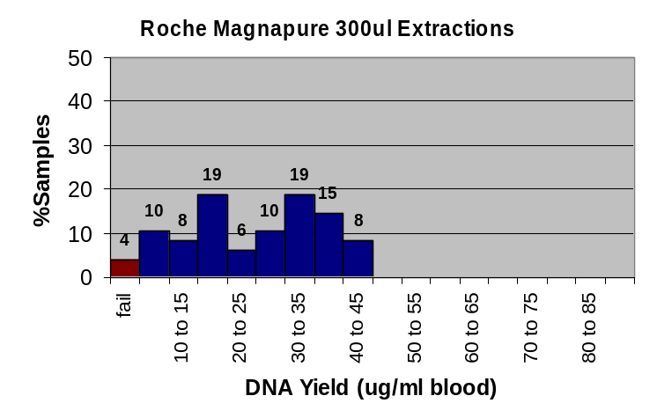
Yield | Mean absolute yield (ug) | 7.3
Yield | Mean relative yield (ug/ml blood) | 24.2
Yield | Standard deviation (relative yield) | 11.5
Yield | % Extractions failed (<5ug/ml blood) | 4

DNA Purity | 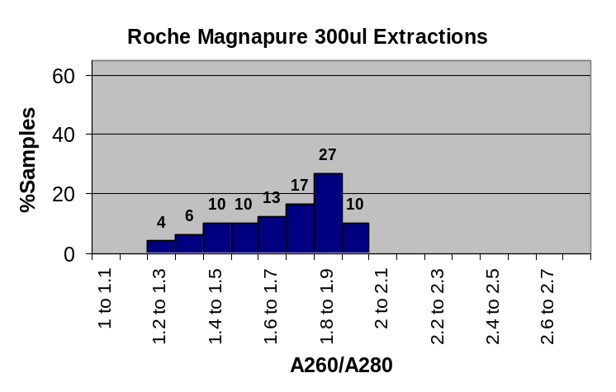
DNA Purity | Average OD260/OD280 ratio | 1.67
DNA Purity | Standard deviation | 0.22
DNA Purity | % DNA samples with OD260/OD280 1.6-2.0 | 67

PCR | % DNA samples with all five bands on PCR | 94
PCR | % DNA samples with all 1-4 bands on PCR | 0
PCR | % DNA samples with no bands on control PCR (failed) | 6
PCR | Cross contamination | 0

DNA integrity | % DNA samples with clean band >20kb on 0.8% agarose | 92

1ml extraction Evaluation
Duration | 9/2004
Samples | 46
Water blanks | 2

Performance measures
Yield | 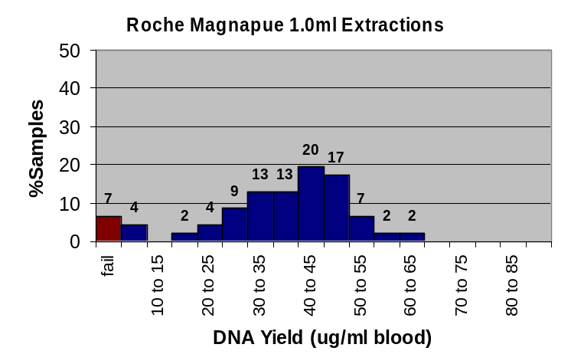
Yield | Mean absolute yield (ug) | 35.9
Yield | Mean relative yield (ug/ml blood) | 35.9
Yield | Standard deviation (relative yield) | 14.5
Yield | % Extractions failed (<5ug/ml blood) | 7

DNA Purity | 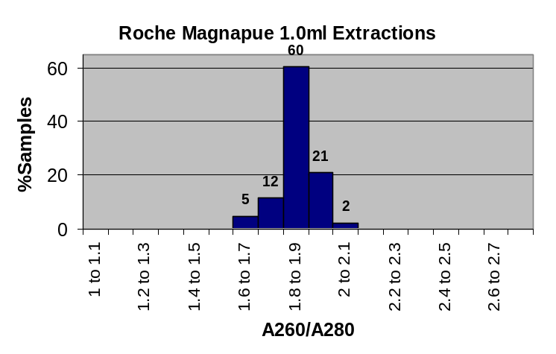
DNA Purity | Average OD260/OD280 ratio | 1.85
DNA Purity | Standard deviation | 0.08
DNA Purity | % DNA samples with OD260/OD280 1.6-2.0 | 98

PCR | % DNA samples with all five bands on PCR | 96
PCR | % DNA samples with all 1-4 bands on PCR | 0
PCR | % DNA samples with no bands on control PCR (failed) | 4
PCR | Cross contamination | 0

DNA integrity | % DNA samples with clean band >20kb on 0.8% agarose | 98

Discussion
In terms of mechanical operation the Roche MagNA pure compact is virtually identical to the Qiagen EZ1. However there are several differences between the two instruments. The MagNA pure compact can extract up to eight samples in a single run compared to six with the EZ1. The compact chemistry can deal with up to 1ml starting sample volumes compared to 350μl with the EZ1. Because the MagNA pure compact has an internal computer protocols are internally stored and can be directly accessed. This compares to the card system employed by the EZ1. The Roche instrument also has a built in bar-code system that can be used to track both samples and reagents. Details of the runs can be stored on the internal computer either for direct access of export to other systems such as a LIMS. The Roche instrument also includes a useful UV lamp in the working area that can be used for decontamination.

As with the EZ1 the Roche MagNA pure compact was very easy to use and required minimal training. Pre-preparation of the samples was limited to transfer of an appropriate volume into the system tubes for each extraction. The speed of extraction is equivalent to the EZ1, with the standard EDTA blood protocol tested here taking around 25 minutes to complete. Currently there are limited kits available for this instrument but the full range applicable the larger Roche instrument (MagNA pure LC) is promised in the near future.

Both extractions (300μl and 1ml) gave good results for all the performance measures. The 1ml extraction performed marginally better better in terms of both yield and DNA purity. This may be a result of a two stage extraction process used for the 1ml extraction to cope with the larger volume.

The Roche MagNA pure compact has a larger sample throughput capacity than the EZ1 (eight as opposed to six, which is 33% greater) and is able to cope with larger volume samples up to 1ml. Elevating the sample volume capacity up to 1ml may be enough to allow routine use of this instrument within a diagnostic laboratory for virtually all samples depending on what overall strategy is chosen (see conclusions). The average DNA yield from the 1ml extractions was 35μg, which would be enough for 3-4 Southern blots. 11% of the 1ml extractions failed to yield more than 10μg of DNA, which is nominally enough for a single Southern Blot. Of these 7% were defined as compete fails with respect to yield measured by OD260. However, the PCR failure rate was only 4% and 98% of samples gave good clear, high molecular weight bands when run out on 0.8% agarose. This suggests that some of the fails defined by OD260 were aberrant results since there was certainly DNA present.

We conclude that this instrument has great potential to meet the requirements for diagnostic laboratories although the range of protocols available is currently limited.

Performance summaries
Summary of extraction scales, throughput and ease of implementation

Instrument / chemistry | Samples <1ml | Samples >1ml | Estimated daily throughput* | Performance measures | Implementation
ABI 6100 | 150μl |  | ~300 | Very Good | Plug and play
Autogen NA-3000EU | 500μl | 2-5ml scalable | 48 | Poor | Protocols require optimisation
Chemagen Module I | 1-200μl | 1-10ml scalable with robot | ~36 large  ~300 small | Excellent | Plug and play
DRI CST 20ul | 20μl-1ml |  | ~300 | Poor. Problems not associated with chemistry. Would need further evaluation if/when system fully optimised | System requires significant further development
Macherey Nagel Nucleospin | 100-200μl |  | ~300 | Excellent | System requires further development
Promega MagnaSil | potential | 1-5ml scalable | 24 could be increased | Generally good but yield poor. Problems not associated with chemistry. Would need further evaluation if/when system fully optimised | System needs extensive redesign for diagnostic use
Qiagen EZ1 | 200, 350μl |  | ~60 | Excellent | Plug and play
Roche MagNA Pure Compact | 300μl, 1ml |  | ~80 | Very good | Plug and play

* The Estimated daily throughput figures represent a reasonable capacity in the setting of a diagnostic laboratory where a particular number of samples are received each day and one technician is responsible booking in and DNA extraction: samples require booking-in and checking before the first run of the day is started. Therefore the estimates do not necessarily represent theoretical maximum throughputs. For example, with the Chemagen system trialled, where pre-processing is required before loading the samples on to the instument, it would be possible to perform these steps whilst the previous run is in progress. ‘Nesting’ batches in this way has not been considered for the purposes of this summary.

By operating an optimal system, with unlimited samples available for extraction, the maximum it may be possible to improve daily throughput capacities by upto two times.

Conclusions

System types
Of the two main groups of extraction procedures the integrated systems gave significantly better results than the bespoke automation of chemistries on standard liquid handling robotics. These differences were clearly due to problems associated with the development of the automated protocols for the different chemistries trialled. As such the results of the evaluations for the automation kit chemistries do not give a true reflection of their performance. Optimisation was ongoing during the evaluation period for each of these chemistries and as a result performance generally improved over the duration. In conclusion we would expect that these chemistries could be optimised to a level satisfactory for diagnostic use but that such a system would require an extended lead in time to ensure good results. We can not however, make any definitive statements about the performance of these chemistries under automation.

In terms of the different extraction chemistries trialled the solid phase extractions (ABI6100 and in particular Machery Nagel) gave the best results. However we did experience some problems with blocked wells and insufficient vacuum, which are particular to these chemistries. Overall the simplest and most versatile systems appear to be based on paramagnetic bead chemistries.

Direct automation of the traditional manual salt extraction was not considered particularly successful either in terms of failure rate or the suitability of the protocol for diagnostic use.

Strategies
No one system appears to meet the wide range of requirements for DNA extraction highlighted in the survey we have carried out (NGRL extraction survey 2004). It is likely that a combination of systems and / or a change in strategy will be needed to achieve comprehensive automation of DNA extraction in a diagnostic setting. The precise nature of the system(s) chosen will depend on many factors, not least the cost of implementation when compared to the likely projected throughput requirements. Clearly lower throughputs will only justify smaller investment. Aside from cost the major factor is the overall yield requirement for the extraction and thus the sample size the system is able to cope with. One of two basic approaches could be adopted depending on the particular requirements of a lab.

Maximum yield approach
The aim of this approach is to obtain the maximum amount of DNA from all samples received. The primary issue here is the choice of an appropriate method or system that is capable of dealing with large sample volumes. There is a clear cut off between low volume and high volume extraction technologies and this is essentially a function of the liquid handling capacity on the instrumentation. Systems that will deal with samples >1ml require specialised liquid handing to cope with the reagent volumes required or a protocol that has been designed to avoid liquid handling entirely. Such systems will generally cope with samples up to 10ml.

There are a very limited number of systems capable of large scale extractions currently available. Of the integrated systems the Chemagen Module I, and PSS 8Lx (currently untested) are available. The Chemagen system certainly delivers the required quantity and quality of DNA and is flexible enough to run protocols for most of the various starting materials likely to be encountered. However for full automation (including reagent dispensation and automated sample tracking) the instrument needs to be linked to a Cartesian robot. Strictly speaking the chemistry is not completely scalable, being supplied in a 1ml, a 5ml and 10ml extraction scales. In practice each scale will deal with a range of sample sizes but the extraction may not be optimal due to differential concentration of reagents. This inconvenience can be rectified using the fully automated reagent handling option. This setup is both sizable and expensive and may be difficult to justify given the throughput most labs require. The use of this instrument with manual dispensation of the reagents was not found to be problematic and would be suitable for most applications although around 40 minutes technician time per extraction run would need to be accepted.

Another integrated system that looks promising for a maximum yield approach is the PSS 8Lx (currently untested). The instrument setup resembles the Roche MagNA Pure Compact and Qiagen EZ1 using pre-packaged reagent cartridges (Chemagen chemistry) to extract samples up to 10ml. This system is more compact and less costly than the Chemagen although the cost per extraction is not yet clear. Again the chemistry is not truly scalable although this could be dealt with by manual dispensation of bulk reagents. We are planning a full evaluation of this instrument in the near future.

A final option for a maximum yield approach that has been explored in these evaluations is the use of a Cartesian robot to automate a kit based chemistry. Specifically in this evaluation we have looked at the Promega MagneSil chemistry. Although DNA was retrieved from most samples and gene PCR worked, the yields for this extraction were low and the DNA quality was poor as assessed by OD260/OD280. These problems were essentially down to the instrument protocol not being fully optimised. In addition the use of the system tubing in this extraction would not be suitable for diagnostic use due to possible cross contamination of samples. The main point to be drawn from these evaluations regarding bespoke automation of kit chemistries is that this can be a lengthy process. We are confident that this could be done, and would certainly yield a protocol that exactly fitted requirements. However, if this approach is adopted it is prudent to allow a long lead in time for development and optimisation of the system. In some cases manufacturers have worked on the automation of their chemistry on a particular robotic platform. In theory this should alleviate the lead in time required. In these circumstances great care should be taken to ensure the system works satisfactorily and the protocol is suitable for the purpose for which it will be used. Any small deviations may require extensive work to rectify.

Minimum yield approach
In many situations a maximum yield approach will not be the most appropriate and is certainly not the most economic. With a minimum yield strategy, policy decisions regarding the required yield for each sample type will be required. These will depend upon what routine tests need to be carried out, any reflex tests that may be required, a minimum storage requirement and safety margin to cope with the proportion of extractions that will give low yield. Obviously these decisions are largely subjective but some guidance can be gained from looking at what is achievable as far as extraction methodologies are concerned. Extractions up to 1ml are relatively simple and there are a wide range of instruments capable of handling these volumes. If much more DNA is required it would probably be more favourable to purchase a system specifically designed for larger volumes. Another cut off occurs around the 200μl-300μl scale below which extractions are largely carried out on plates and can therefore be very high throughput.

As with the larger volume extractions the integrated systems performed significantly better in this evaluation. Again this may not be a reflection of the chemistries used but the limited time available to optimise the protocols before evaluation. Both the Qiagen and Roche systems produced good quality DNA and the turn around time was very fast. Neither instrument has very large batch capacity but given the speed of processing up to 10 runs could be performed in a single day. This would however require quite a large user input and if this throughput is required it would be better to purchase a larger instrument. Both Qiagen and Roche sell instruments with higher throughput capacity (M48 and LC respectively – not tested here) that would be suitable for this purpose.

The low volume integrated instruments could be used to deal with samples up to about 2ml. Although the sample volume capacity is not this big, multiple extractions could be done for samples that required the larger yield. In this respect the Roche instrument has the edge since it can handle 1ml samples compared to the 350μl capacity of the Qiagen. The down side of doing multiple extractions on this type of instrument is the cost of the reagent kits and the technician time required to sort out the samples. The simplest way to avoid this problem is to use a second extraction methodology for the samples that require a high yield. The number of samples in this group will define whether a this type of strategy is feasible. If the numbers are low (a few samples per day) they could be extracted using a manual kit based protocol. Otherwise if full automation is required one of the high volume capacity instruments would be required. If this were the case it would be more beneficial to purchase the Chemagen system and perform both the low volume and high volume extractions on the same instrument. However there may be issues of scalability and the fully automated reagent handling ‘front end’ would probably be necessary.

An alternative strategy for the minimum yield approach would be to use a Cartesian robot with bespoke automation of a proprietary chemistry. As has been discussed before this would require a much greater lead in time but has the potential to provide a very flexible system. Information regarding the yield requirements of each sample could be fed directly from a LIMS allowing the chemistry to be automatically scaled to suit. At the time these evaluations were carried out standard liquid handling robotics could not cope with more than 1ml liquid at a time. This means that larger volume extractions would need to be dealt with using a number of ‘sub-extractions’. In response to the requirements for higher volume extraction DRI have developed a new protocol (Gene Catcher - not tested) on the Tecan Freedom EVO that uses pipetting adaptors to allow 5ml liquid handling. Although DRI claim to have fully automated this protocol on the Tecan robot it is likely that an extended lead in time would still be required particularly if automated chemistry scaling and integration with a LIMS is required.

Regardless of the strategy chosen to deal with the majority of samples most labs will also receive a small number of samples other than blood. In most cases these represent less that 10% of the overall throughput of the lab (NGRL extraction survey). If full automation of all extractions is required one of the low volume integrated systems would seem a sensible choice (Qiagen EZ1 Or Roche MagNA Pure Compact). However it should be noted that these instruments (indeed most automated systems) would only be able to deal with one chemistry at a time. Thus a separate run would be required for each chemistry. The advantage of these instruments in this context is the speed of processing and the capability to extract a single sample in a run if required without reagent wastage.

It is likely that most labs will need to use more than one system to deal with the wide range of sample types and volumes that are likely to be encountered. First a decision about what overall strategy will be most suitable needs to be taken. An analysis of the projected numbers of each sample type and blood sample volume then needs to be considered. This should enable appropriate choice of instrumentation to complement the requirements. If the numbers of samples in a particular group are very low the option of using a manual kit based system should not be excluded.

Other options and further work
At the time of writing we are in the process of organising an evaluation of the PSS 8Lx system. This system looks very promising for dealing with the larger volume extractions.

Other types of extraction may also prove useful. The Whatman FTA card system is of particular interest for samples that do not need extensive testing or large quantities of DNA for storage. When a sample is directly applied to the card activating chemicals lyse the cells, inactivate proteins and immobilise genomic DNA. Infectious organisms are also inactivated in this process. A small punch can be taken from the card and after a simple washing procedure be used directly in a PCR. This system almost entirely eliminates the extraction process and cards can be stored at room temperature for long periods (14 years to date for blood), which would relieve storage problems. Another interesting possibility of the system is simple extraction and storage of RNA. We will shortly be evaluating this technology in parallel analysis of CF samples received by the Wessex Regional Genetics Laboratory.

Another system that may have potential use is a proprietary chemistry for extraction of genomic DNA from saliva. The DNA genotek oragene kit (www.dnagenotek.com) involves a simple and rapid procedure that claims to deliver an average of 100μg DNA per sample (20μg-200μgper 2ml sample). Such a system is clearly more complex to implement as collection procedure would need to be changed. Again it may have a more specialist application for example when taking a blood sample is problematic.

Isolation of DNA from buccal cells may also be an option worth considering for low yield requirements. For example the Isohelix (www.isohelix.com) buccal swab system in conjunction with a DRI CST extraction has reported yields up to 6μg DNA. We will be looking into the utility of evaluation of these extraction methodologies.

Acknowledgements
Thanks to all laboratory staff who gave advice with protocols: In particular Nick Owen and Dan Ward setup and operated the instruments trialled and Borghert Borghmans who gave advice and provided protocols for the Autogen.

We would also like to thank all the companies and their staff who participated in these trials: Andy Jones and Kevin Dunn from Labtech (Autogen distributor), Kudrat Rahman from Auto Q biosciences (Chemagen distributor), Chris Bridge fron DRI, Dr. Mike Daniels from Promega, Anthony Faulkes from Qiagen, Mark Davies and Stacey Lockyer from Roche.

Particular thanks to Graeme Daniels and Daniel Leach from Tecan for their help and support with the kit based chemistries and robot protocols.

References
Genetics White Paper June 2003: "Our inheritance, our future - realising the potential of genetics in the NHS" http://www.dh.gov.uk

DNA Extraction survey NGRL (Wessex). http://www.ngrl.co.uk/Wessex/extraction.htm

van Dongen JJ, Langerak AW, Bruggemann M, Evans PA, Hummel M, Lavender FL, Delabesse E, Davi F, Schuuring E, Garcia-Sanz R, van Krieken JH, Droese J, Gonzalez D, Bastard C, White HE, Spaargaren M, Gonzalez M, Parreira A, Smith JL, Morgan GJ, Kneba M, Macintyre EA.
Design and standardization of PCR primers and protocols for detection of clonal immunoglobulin and T-cell receptor gene recombinations in suspect lymphoproliferations: report of the BIOMED-2 Concerted Action BMH4-CT98-3936. Leukemia. 2003 Dec;17(12):2257-317. Section 10.

Useful Links

Agowa | http://www.agowa.de
AutoGen | http://www.autogen.com
Beckman | http://www.beckman.com
Biogene | http://www.biogene.com
Bioline | http://www.bioline.com
Chemagen | http://www.chemagen.de
CyBio | http://www.dewb-vc.com/en/success/cybio_ag.html
DRI | http://www.dri-dna.co.uk
Eppendorf | http://www.eppendorf.com
Gentra | http://www.gentra.com
Genotek | www.dnagenotek.com
Hamilton | http://www.hamiltoncompany.com
Isohelix | www.isohelix.com
Macherey Nagel | http://www.macherey-nagel.com
Millipore | http://www.millipore.com
MWG | http://www.THE-MWG.com/
Perkin Elmer | http://las.perkinelmer.com
Promega | http://www.promega.com
PSS Bio Instruments | http://pssbio.com
Qiagen | http://www1.qiagen.com
Roche | http://www.roche.com
Sias | http://www.sias.biz/
TECAN | http://www.tecan.com/
VH BIO LTD | http://www.vhbio.com/

ADDENDUM: JUNE 2005
This list will be periodically updated.

Since the original publication of this report many of the technologies included in the study have been substancially improved. In addition many new products have been developed in this area. The following list is a breif summary of some of the developments that were considered to be of particular interest to diagnostic laboratories. Please contact the manufacturers for further details. The list is not intended to be comprehensive but if any reader feels that a particular technology or platform has been unfairly excluded please contact the authors.

- Gentra Systems have updated their Autopure LS system (Model AP-0096 previously assessed by NGRL (Manchester) – 2004) with the new Model AP-0098 instrument. This features updated control software that adds flexability to the system

- Autogen have modified their instrument (now called AutoGenFlex 3000) to use Qiagen chemistry. This is available as a new instrument or as an upgrade to the Autogen NA3000.

- Auto Q Biosciences Limited (Distributers of Chemagen in the UK) have fully automated front end reagent and sample processing in collaboration with Perkin Elmer. The system includes fully bar coded sample tracking.

- VH BIO limited are now acting distributers for PSS instruments in the UK. The PSS Magtration range of dedicated platforms for DNA extraction are based on bead chemistries. Of particular interest with regard to large volume extractions are the 12GC (12 samples up to 500 μl) and the 8Lx (8 samples up to 10 ml).

- DRI (now part of the Invitrogen Corporation) Have developed new technology for use large volume [blood] extractions (GeneCatcher). This chemistry has been automated on a Tecan robot that features 5ml pipetting capability.

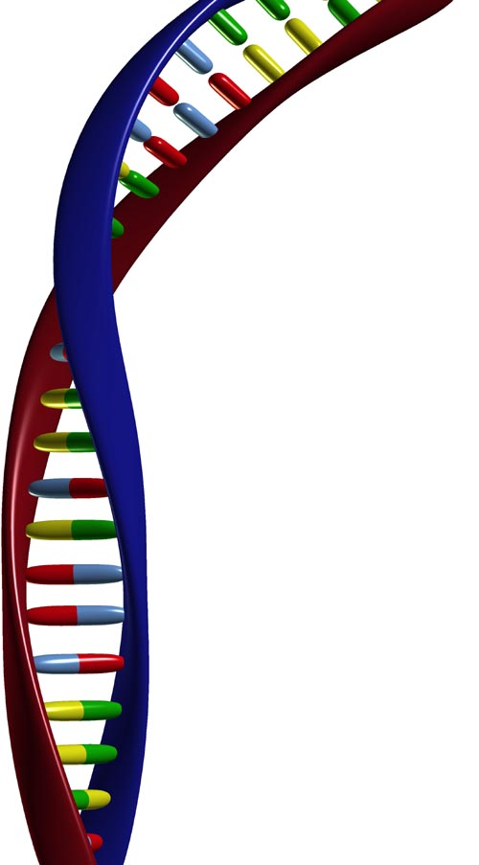
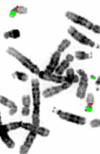

National Genetics Reference Laboratory (Wessex)
Salisbury District Hospital
Salisbury SP2 8BJ, UK

www.ngrl.org.uk

