

National Genetics Reference Laboratory
(Wessex)



Technology Assessment (preliminary report)
ChromoQuant™ (version 2)
in vitro diagnostic test kit for analysis of common chromosomal disorders

September 2005

When?

Title | ChromoQuant ™ (version 2) in vitro diagnostic test kit for analysis of common chromosomal disorders (preliminary report)
NGRL Ref | NGRLW_CQv2_1.0
Publication Date | September 2005
Document Purpose | Dissemination of information about version 2 of the ChromoQuant CE marked kit for detection of aneuploidy by QF PCR
Target Audience | Laboratories performing or setting up QF PCR testing for detection of aneuploidy in prenatal samples
NGRL Funded by | 

Contributors

Name | Role | Institution
Helen White | Author | NGRL (Wessex)
Vicky Durston | MTO | NGRL (Wessex)

Peer Review and Approval

This document has been subject to peer review and Cybergene^{AB} have been given the opportunity to comment on the content of the report.

Conflicting Interest Statement

The authors declare that they have no conflicting financial interests

How to obtain copies of NGRL (Wessex) reports

An electronic version of this report can be downloaded free of charge from the NGRL website (http://www.ngrl.co.uk/Wessex/downloads)

or by contacting

National Genetics Reference Laboratory (Wessex)
Salisbury District Hospital
Odstock Road
Salisbury
SP2 8BJ
UK

E mail: ncpc@soton.ac.uk
Tel: 01722 429016
Fax: 01722 338095

Table of Contents

Abstract…………………………………………………………………………………...1

1. Introduction 2

2. Materials and Methods 3
2.1 ChromoQuant™ (version 2) kit composition 3
2.2 DNA purification and preparation 3
2.3 Multiplex PCR amplification 3
2.4 Electrophoresis of amplified products 4
2.5 Data analysis and interpretation 4

3. Results
3.1 Marker Information 6
3.1.1 Marker Heterozygosity 6
3.1.2 Inconclusive allele ratios and individual marker failures 6
3.2 Marker specific problems 7
3.2.1 Marker B (Chr 18 – tube 1) 7
3.2.2 Marker K (Xq/Yq – tube 2) 7
3.3 Amniotic fluid samples tested using version 1 and version 2 (beta test kit) 8
3.3.1 ChromoQuant Version 1 8
3.3.1.1 ChromoQuant Results concordant with karyotype 8
3.3.1.2 ChromoQuant Result ambiguous but not necessarily discordant with karyotype 8
3.3.2 ChromoQuant Version 2 (beta test kit) 9
3.3.2.1 ChromoQuant Results concordant with karyotype 9
3.3.2.2 ChromoQuant Result ambiguous but not necessarily discordant with karyotype 9
3.4 Retrospectively collected tissue samples 9
3.4.1 ChromoQuant Results concordant with karyotype 9
3.4.2 ChromoQuant Result ambiguous but not necessarily discordant with karyotype 9
3.5 Prospectively collected amniotic fluid samples 9
3.5.1 ChromoQuant Results concordant with karyotype 10
3.5.2 ChromoQuant Result ambiguous but not necessarily discordant with karyotype 10
3.6 Inclusion of sex chromosome markers 10
3.7 Extra markers 11
3.8 Effects of DNA extraction method 11
3.9 General Comments on ChromoQuant protocol 12

4. Conclusions 12
4.1 Marker and Primer Information 12
4.2 Informativity 12
4.3 Single Marker Assays 12
4.4 Sex Chromosome Markers 12
4.5 Marker Failures 12

5. References 13

6. Appendix 1 Examples of Genotyper traces 14

ABSTRACT

At the time of writing (September 2005) ChromoQuant™ is the first and only prenatal diagnostic test kit available worldwide which is CE marked and therefore compliant with the In Vitro Medical Devices Directive (98/79/EC). This QF PCR based kit is produced and marketed by Cybergene^{AB}. NGRL (Wessex) has performed a technology assessment of version 1 of this kit and found that it was unable to cope with variable sample quality, it often produced ambiguous results which could not be resolved due to the lack of single marker assays and the kit had a high failure rate for some markers. ChromoQuant version 1 has now been withdrawn from the market.

ChromoQuant version 2 is now available and although we have only tested a small number of samples (n=126) we have found that the performance of the kit has improved significantly when compared to version 1. We have tested DNA extracted from amniotic fluid samples (n=43) (using InstaGene Matrix) with both version 1 and a beta test kit for version 2. Retrospectively collected DNA samples (n=45) from aneuploids and normal controls and DNA extracted from amniotic fluid samples using the BioRobot EZ1 Workstation (n=38) were evaluated using the commercially available ChromoQuant version 2.

Our results can be summarised as follows:

- 95% of samples had ChromoQuant results that were concordant with the sample karyotype and which could have been reported either following initial analysis or after additional analysis with extra markers to ensure that there were two informative markers for each chromosome.

- 5% of samples produced ambiguous results that would have required follow-up studies due to skewed allele ratios for individual markers. Single marker assays are not available for ChromoQuant version 2 and therefore these ambiguous results could not be resolved.

Introduction
Invasive prenatal diagnosis is offered routinely to pregnant women who have been identified as having an increased risk of foetal chromosome abnormalities. Pregnancies at high risk are identified by serum or ultrasound screening, advanced maternal age or because one parent is known to carry a chromosome abnormality. Invasive sampling takes place at either 10-12 weeks (chorionic villus sampling) or 15-20 weeks (amniocentesis) and diagnosis is usually based on karyotype analysis which can detect both numerical and structural chromosome abnormalities. The most commonly detected abnormalities are trisomies for chromosome 21 (Down syndrome), chromosome 18 (Edwards syndrome), chromosome 13 (Patau syndrome) and sex chromosome aneuploidy (leading to syndromes such as Turner (monosomy X) and Klinefelter (XXY)). Karyotype analysis of chorionic villus (CV) and amniotic fluid (AF) samples requires cell culture to obtain cells at the metaphase stage and skilled analysis of resulting banded chromosome preparations is also essential. Currently the UK average reporting times for full karyotype analysis are 13.5 days for AF (5.5% abnormality detection rate) with a range of 7.2 – 18.9 days and 14.8 days for CV (16.9% abnormality detection rate) with a range of 7.9 – 23.6 days (UK NEQAS 2002/2003). In an effort to improve pregnancy management and alleviate maternal anxiety rapid aneuploidy detection techniques are now being implemented into routine prenatal diagnosis e.g. interphase FISH, quantitative fluorescent PCR (QF PCR), multiplex ligation dependent amplification (MLPA). These tests are usually capable of delivering results within 1-3 days and are viewed as a prelude to, rather than a replacement of, full karyotype analysis.

Rapid prenatal aneuploidy tests need to fulfil certain criteria: the assay must be accurate and no false positive results should be obtained as this could result in the termination of a healthy pregnancy. The test should be robust enough to cope with variable sample quality, provide unambiguous results and have a low failure rate. Ambiguous results have the potential to increase maternal anxiety and can cause delays in reporting while additional investigations are carried out. The test should be adaptable to cope with high sample throughput and test costs should be low since rapid tests are often performed in addition to karyotyping. Ideally, the test should be able to detect maternal cell contamination (MCC), mosaicism and triploidy (Mann et al., 2004).

QF PCR analysis of short tandem repeats is being used successfully in many UK and European laboratories for the rapid diagnosis of prenatal aneuploidy (eg. Verma et al., 1998; Pertl et al., 1999; Schmidt et al., 2000; Cirigliano et al., 2001; Levett et al., 2001; Mann et al., 2001). Chromosome specific polymorphic repeat sequences, which vary in length between individuals, are amplified using fluorescent primers. The PCR amplicons are analysed using an automated genetic analyser capable of 2bp resolution and the representative amount of each allele is quantified by calculating the ratio of the peak heights or areas using appropriate software.

ChromoQuant™ is the first and only prenatal diagnostic test kit available worldwide which is CE marked and therefore compliant with the In Vitro Medical Devices Directive (98/79/EC). This QF PCR based kit is produced and marketed by Cybergene^{AB}. The kit is CE marked for the prenatal diagnosis of trisomy 13, 18, 21 and sex chromosome aneuploidy. NGRL (Wessex) performed a technology assessment of ChromoQuant version 1 by analysing retrospectively collected DNA samples (n=39) from normal controls and a variety of aneuploid samples and a prospectively collected series of amniotic fluid samples (n=81). We found that it was unable to cope with variable sample quality, it often produced ambiguous results which could not be resolved due to the lack of single marker assays and the kit had a high failure rate for some markers (NGRL Report Ref: NGRLW_CQv1_1.0). The kit is no longer on the market.

Recently, ChromoQuant version 2 was released and NGRL (Wessex) have performed a preliminary technology assessment of this kit by analysing 126 samples. Initially, we analysed DNA extracted from amniotic fluid samples (using InstaGene matrix) with both version 1 and a beta test kit for version 2 (n=43). We then used the commercially available ChromoQuant version 2 to analyse retrospectively collected DNA samples (n=45) from aneuploids and normal controls and DNA extracted from amniotic fluid samples using the BioRobot EZ1 Workstation (n=38). All samples were anonymised.

Materials and Methods

ChromoQuant™ (version 2) kit composition
ChromoQuant™ (version 2) is supplied with pre-aliquoted primer mixes frozen in a 12 x 8- strip format, PCR strip caps, 1X enzyme dilution buffer and 1X QF PCR Buffer. Taq polymerase needs to be supplied by the user and Cybergene^{AB} recommend the use of Promega Taq (#1661 or 1665). Samples are tested using a 2 tube multiplex where 17 tetra-nucleotide short tandem repeats (STRs) are analysed in total; four for each of chromosomes 13 & 18 (tube 1) and chromosome 21 (tube 2) and five for the sex chromosomes (distributed between tubes 1 and 2). Each kit will test 48 samples. Unused primer mix tubes and the QF PCR buffer can be stored in the dark at -18°C. The enzyme dilution buffer can be stored at -20°C to 8°C. The kits are marked with individual expiry dates. 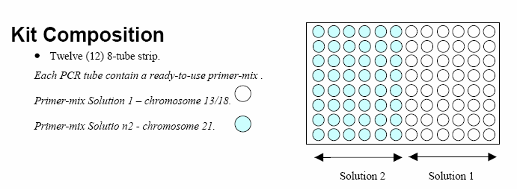

The tube layout differs between ChromoQuant versions 1 and 2. The layout in ChromoQuant version 2 is preferred since the format made it more easy to pipette DNA and master mixes into the tubes. Separating tubes 1 and 2 decreases the risk of sample mix ups and cross tube contamination.

DNA purification and preparation
Retrospectively collected DNA samples from normal controls (n=6), trisomy 18 (n=15), trisomy 13 (n=5), trisomy 21 (n=14) and sex chromosome aneuploids (n=5) and DNA samples from 1ml amniotic fluid samples (n=81) were tested using ChromoQuant version 2. Reagents for extraction of DNA from amniotic fluid samples are not supplied with the kit. For this evaluation, DNA was extracted from amniotic fluid using either InstaGene Matrix (BIORAD) or the EZ1 DNA tissue kit (QIAGEN) in conjunction with the BioRobot EZ1 Workstation (QIAGEN). No CV samples were evaluated.

The kit recommends the use of 100ng DNA at a concentration of 10 – 20ng/μl. For this evaluation the retrospectively collected DNA samples were quantified and diluted to 10ng/μl and the amniotic fluid DNA samples were tested using 10μl of the InstaGene DNA solution (not quantified). Samples extracted using the EZ1 DNA tissue kit were eluted into a final volume of 50μl and 5μl was used in each PCR reaction (not quantified).

Multiplex PCR amplification
DNA (100ng) was added to the PCR master mix (25μl final reaction volume) and amplified using the PCR conditions specified in the ChromoQuant protocol:

94°C 3 min
94°C 30 sec
57°C 1 min 26 cycles
71°C 2 min
71°C 5 min
60°C 1 hour
4°C HOLD

Samples were tested using a 2 tube multiplex where 17 tetra-nucleotide STRs were analysed in total; four for each of chromosomes 13 & 18 (tube 1) and chromosome 21 (tube 2) and five for the sex chromosomes (distributed between tubes 1 and 2, figure 1). A positive and a negative control were included in each PCR run.
a) Tube 1

Marker | Name | Location | Chromosome | Size bp | Colour | Dye
A | AMEL | Xp22.1-22.31 | X/Y | X:104-106 Y:112-114 | Green | HEX
B | D18S391 | 18pter-18p11.22 | 18 | 135-185 | Green | HEX
C2 | D18S976 | 18pter-18qter | 18 | 171-201 | Blue | 6-FAM
D | XHPRT | Xq26.1 | X | 260-304 | Blue | 6-FAM
E | D13S742 | 13q11-q21.1 | 13 | 230-326 | Green | HEX
F | D18S386 | 18q22.1-q22.2 | 18 | 330-405 | Green | HEX
G | D13S634 | 13q14.3-q22 | 13 | 380-445 | Blue | 6-FAM
H | D13S628 | 13q31-q32 | 13 | 420-475 | Yellow | NED
I | D13S305 | 13q12.1-13q14.1 | 13 | 425-470 | Green | HEX
J | D18S535 | 18q12.2-q12.3 | 18 | 450-500 | Blue | 6-FAM

b) Tube 2

Marker | Name | Location | Chromosome | Size bp | Colour | Dye
Q | DXS6854 | Xq26 | X | 93-119 | Blue | 6-FAM
R | SRY677F | Yp11.3 | Y | 206 | Blue | 6-FAM
K | X22 | (PAR 2) Xq/Yq | X/Y | 190-250 | Green | HEX
L | D21S11 | 21q21 | 21 | 220-285 | Yellow | NED
N | D21S1246 | 21q22.2-21qter | 21 | 260-305 | Green | HEX
M | D21S1444 | 21pter-21qter | 21 | 311-340 | Blue | 6-FAM
S | D21S1435 | 21q21.3 | 21 | 350-410 | Green | HEX

- STR Marker information supplied in ChromoQuant version 2. STR marker names, cytogenetic and molecular locations, amplified size ranges and fluorescent label for a) tube 1 (analysis of chromosomes 13 and 18) and b) tube 2 (analysis of chromosome 21). Markers named in red differ between ChromoQuant version 1 and ChromoQuant version 2; marker C2 replaces marker C (v1), marker M replaces marker O (v1) and marker S replaces marker P (v1).

Electrophoresis of amplified products
Instructions supplied with ChromoQuant version 2 recommend that PCR amplicons are desalted prior to analysis. However, laboratories that currently run a QF PCR service do not desalt samples and the UK Clinical Molecular Genetics Society (CMGS) best practice guidelines advise that post- PCR clean up is not required. Desalting of samples requires post-PCR tube transfers which are undesirable since this could increase the risk of PCR contamination and sample mix up. We tested 43 samples using ChromoQuant version 2 which had either been analysed directly following PCR or had been analysed after being desalted using Multiscreen PCR μ96 plates (Millipore). Overall, the desalted samples produced stronger fluorescent signals but both analyses gave identical results; all peaks fell within a suitable range for analysis and all allele ratios were accurately preserved. We therefore suggest that desalting of the samples is not required.

ChromoQuant™ is compatible for use with Applied Biosystems® Genetic Analysers that support dye set D and with the Amersham Biosciences MegaBACE™ 500 using filter set 2. These analysers support the use of 6-FAM, HEX, ROX and NED.

For this evaluation amplicons were analysed using an Applied Biosystems 3100 Genetic Analyser. A standard run module was used which allows analysis of fragments from 90 – 500 nucleotides using the ABI GeneScan – 500 [ROX] size standard.

Data analysis and interpretation
Data were analysed with Genotyper 3.7 (Applied Biosystems) using macros written by NGRL (Wessex) to analyse the markers in tubes 1 and 2 (section 2.3). Genotyper 3.7 was used to determine the size and peak height (and area) of amplicons present within the designated size range for each marker. The ratio of the peak heights (as recommended in the ChromoQuant protocol) was calculated using the macro and results were then exported into Excel. Data were analysed according to the CMGS best practice guidelines and the ChromoQuant protocol. Allele dosage ratios between 0.8 – 1.4 were defined as normal (a ratio of 1.5 was considered acceptable if the alleles were separated by more than 24bp), ratios of >1.8 or <0.65 were considered to be indicative of trisomy and the presence of three alleles of equal peak height was also considered to be indicative of trisomy (figure 2). Allele ratios that fell between the normal and abnormal ranges were termed inconclusive. A marker allele ratio was termed inconsistent if the ratio suggested the presence of three alleles when other informative markers for the same chromosome demonstrated normal di-allelic ratios. The presence of a single peak was defined as uninformative and a minimum of two informative markers were considered necessary for confident interpretation. Markers with allele peaks below 100 relative fluorescent units (rfu) or above 6000 rfu were excluded from the analysis.

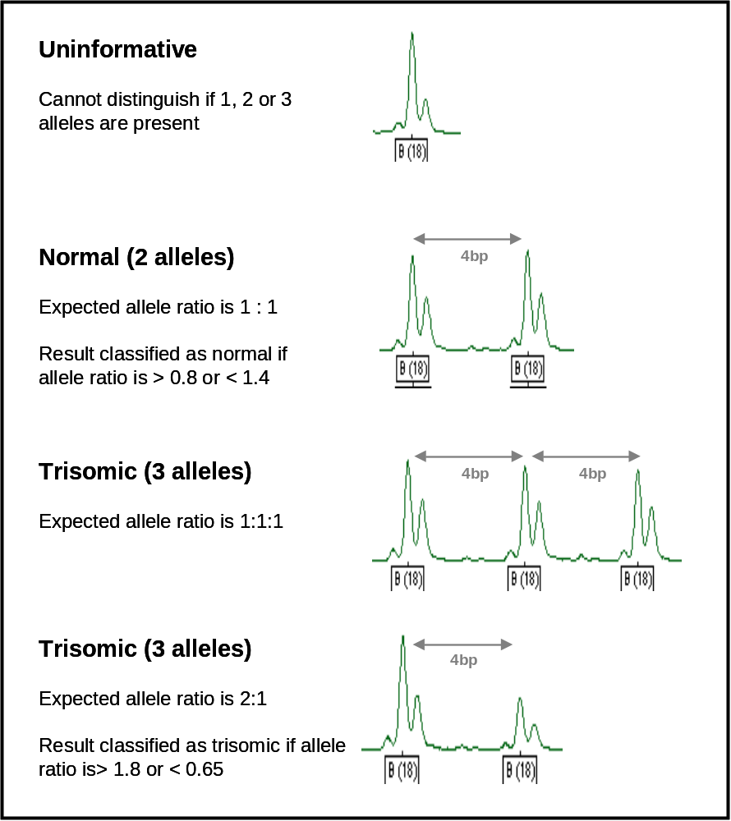

- Interpretation of Data. Allele ratios can be uninformative, normal (2 alleles with a 1:1 ratio), trisomic (3 alleles) or trisomic (3 alleles with a 2:1 ratio)

Results
DNA samples from 0.75 – 1ml of amniotic fluid (n=81) were tested using ChromoQuant™ version 1 (n=43) and version 2 (n=81). Retrospectively collected DNA samples from normal controls (n=6), trisomy 18 (n=15), trisomy 13 (n=5), trisomy 21 (n=14) and sex chromosome aneuploids (n=5) were analysed using ChromoQuant™ version 2 only. DNA had been extracted from a variety of tissues including; lymphoblastoid cell lines, skin, muscle, placenta and villi, cultured amniocytes, fibroblasts, urine, mouthbrush, blood and foetal tissue.

Marker Information

Marker Heterozygosity
The percentage heterozygosity for the autosomal markers was determined from the analysis of 126 samples. Details are shown in table 1.

 | Marker | Location | % Heterozygosity
Tube 1 | B (18) | 18pter-18p11.22 | 68
Tube 1 | C2 (18) | 18pter-18qter | 68
Tube 1 | E (13) | 13q11-q21.1 | 92
Tube 1 | F (18) | 18q22.1-q22.2 | 90
Tube 1 | G (13) | 13q14.3-q22 | 82
Tube 1 | H (13) | 13q31-q32 | 79
Tube 1 | I (13) | 13q12.1-q14.1 | 86
Tube 1 | J (18) | 18q12.2-q12.3 | 85
Tube 2 | L (21) | 21q21 | 88
Tube 2 | N (21) | 21q22.2-21qter | 78
Tube 2 | M (21) | 21pter-21qter | 77
Tube 2 | S (21) | 21q21.3 | 76

- % Heterozygosity for autosomal markers

Inconclusive allele ratios and individual marker failures
Table 2 shows the frequency of inconclusive allele ratios and individual marker failures (that occurred in more than one sample) for the beta test and marketed ChromoQuant version 2. Markers were considered as failed if they failed to amplify, were too weak/strong to analyse or for technical reasons e.g. bleedthrough, non-specific signals or electrophoretic spikes. No inconsistent allele ratios were observed.

 |  |  | Beta test version 2 (n=43) |  | Marketed version 2 (n=83)
 | Marker | Size range (bp) | Inconclusive allele ratio (%) | Fail (%) | Inconclusive allele ratio (%) | Fail (%)
Tube 1 | B | 135-185 | - | - | - | 6
Tube 1 | F | 330-405 | - | 4 | 2 | -
Tube 1 | G | 380-445 | 2 | - | - | -
Tube 1 | H | 420-475 | - | - | - | 4
Tube 2 | K | 190-250 | - | 2 | - | 18
Tube 2 | N | 260-305 | 2 | 2 | - | 5

- Percentage of inconclusive allele ratios and failed marker results for the beta test and marketed ChromoQuant version 2.

The marketed ChromoQuant version 2 appears to show some differences to the beta test version. Marker K fails to amplify in the marketed version in 18% of samples and always amplifies more weakly when compared to other markers in the multiplex. Marker B also failed in 6% of cases due to the presence of a non-specific signal within the range of analysis but this is likely to be a technical problem encountered when using the ABI 3100 Genetic Analyser.

Marker specific problems

Marker B (Chr 18 – tube 1)
A non-specific signal at 161bp often interfered with the analysis of marker B (18) (figure 3). This resulted in failure of marker B in 6% of cases. The signal was detected when analysing DNA samples extracted using both the EZ1 kit and InstaGene matrix. It is possible that this is a free dye blob caused by the fluorescent HEX label.
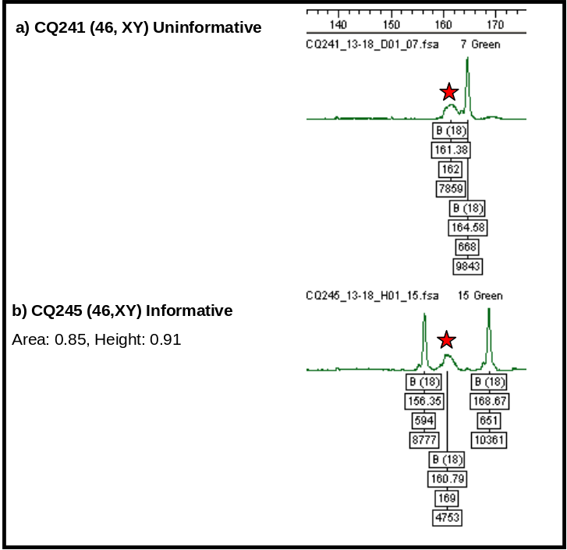

- Marker B. Genotyper traces showing examples of a) uninformative and b) informative samples with the non-specific signal at 161bp marked with a red star.

Marker K (Xq/Yq – tube 2)
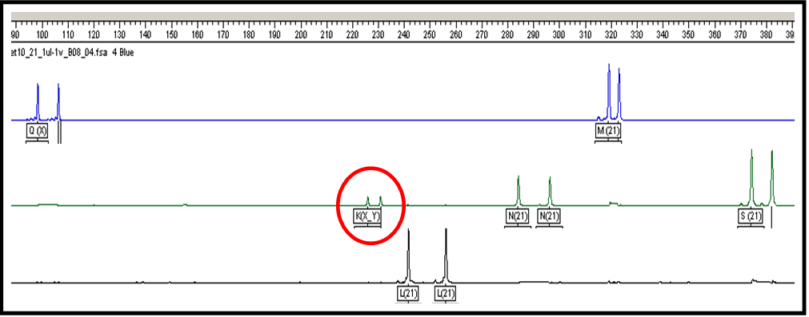
Marker K often failed to analyse or did not amplify strongly enough to be analysed (figure 4). Marker K amplifies weakly when compared to the other markers in tube 2. Alterations to electrophoresis conditions and desalting of the amplicons did not improve the detection of this marker. The marker failed to amplify in DNA samples extracted using both the EZ1 kit and InstaGene matrix.

- Marker K. Genotyper trace of tube 2 showing how marker K (circled in red) amplifies with low efficiency.

Amniotic fluid samples tested using version 1 and version 2 (beta test kit)
DNA extracted from amniotic fluid samples (n=43) using InstaGene Matrix (BIORAD) was analysed using both ChromoQuant version 1 and a beta test ChromoQuant version 2. Results are summarized in table 3.

ChromoQuant Version 1
Results for version 1 will be presented with the quantitative analysis of the sex chromosome markers included.

ChromoQuant Results concordant with karyotype
The results from ChromoQuant version 1 were concordant with the karyotype for 12 of the 43 samples (28%). 10 of the 12 (83%) could be confidently interpreted without any further testing being required. The remaining 2 samples (17%) required additional tests to be carried out for the following reasons:

- Informativity (n=2)

1 had only one informative marker for Chromosome 18
1 had only one informative marker for Chromosome 21

ChromoQuant Result ambiguous but not necessarily discordant with karyotype
31 samples (72%) would have required additional testing to clarify single marker results that either showed inconclusive or inconsistent allele ratios or for other reasons. No single marker assays (for markers in tubes 1 and 2) are available for use with ChromoQuant version 1 and therefore these ambiguous results could not be investigated further. Seven samples required additional tests for single marker anomalies, informativity and/or tube failures.

- Single Marker anomalies (n=28)

The following number of samples would require re-testing of single markers:

Marker K 10
Marker P 9
Marker C 2
Markers C and P 2
Markers P and K 2
Markers P and O 1
Markers P, O and Q 1
Markers C, P and K 1

- Informativity (n=6)

2 had only one informative marker for Chromosome 18
1 had no informative markers for Chromosome 18
2 had only one informative marker for Chromosome 21

1 sample had only one informative marker for Chromosome 21 and no informative markers for Chromosome X. Two markers were informative for chromosome 21 after testing with extra markers (section 3.7) but additional markers were unavailable for X at the time of this evaluation and therefore the absolute concordance of the ChromoQuant result with the karyotype could not be determined. (Karyotype was 46, XX)

- Reaction failures (n=4)

1 sample required tube 1 to be repeated
3 samples required tube 2 to be repeated

We were unable to obtain results for these samples on two separate occasions.

ChromoQuant Version 2 (beta test kit)
Results for ChromoQuant version 2 will be presented with the quantitative analysis of the sex chromosome markers included. To determine the effect of desalting, amplicons were analysed before and after desalting and the results were 100% concordant. Results are summarized in table 3.

ChromoQuant Results concordant with karyotype
The results from ChromoQuant version 2 were concordant with the karyotype for 41 of the 43 samples (95%). 39 of the 41 (95%) could be confidently interpreted without any further testing being required. The remaining 2 samples (5%) required additional tests to be carried out for the following reasons:

- Informativity (n=2)

1 had only one informative marker for Chromosome 18 and no informative markers for X
1 had only one informative marker for Chromosome 21

but showed two informative markers when tested with additional markers. Version 2 includes additional markers for 13, 18, 21, X and Y.

ChromoQuant Result ambiguous but not necessarily discordant with karyotype
2 samples (5%) would have required additional testing for single marker anomalies:

1 sample had an inconclusive allele ratio for marker N (21) and also had only one informative marker for chromosome 13

1 sample had an inconclusive allele ratio for marker G (13).

In the absence of single marker assays (for markers in tubes 1 and 2) in ChromoQuant version 2 it was not possible to investigate these ambiguous results further.

Retrospectively collected tissue samples
DNA from retrospectively collected samples (n=45) was analysed using the marketed ChromoQuant version 2. DNA was analysed from normal controls (n=6), trisomy 18 (n=15), trisomy 13 (n=5), trisomy 21 (n=14) and sex chromosome aneuploids (n=5). Results are summarized in table 3. Samples with mosaicism below 15% and samples with extreme maternal cell contamination were excluded.

ChromoQuant Results concordant with karyotype
The results from ChromoQuant version 2 were concordant with the karyotype for 43 of the 45 samples (96%). All of these samples could be confidently interpreted without any further testing being required. All sex chromosome aneuploids were confidently identified. One sample had a karyotype 45, X and was uninformative for all X makers in tubes 1 and 2 and also uninformative for an additional 3 extra X markers. In diagnostic practice this result would have required confirmation by interphase FISH (or karyotype analysis).

ChromoQuant Result ambiguous but not necessarily discordant with karyotype
2 samples (4.4%) had inconclusive ratios for marker F(18). The alleles were widely spaced (32bp and 40bp respectively). One case had a karyotype of 47, XX, +18 and the allele ratio for F was 0.75 for peak heights and 0.7 for peak area. The second case was a normal male sample and the allele ratio for marker F was 1.53.

Prospectively collected amniotic fluid samples
DNA was extracted from prospectively collected amniotic fluid samples (n=38) using the BioRobot EZ1 Workstation (QIAGEN). Samples were tested with version 2 of ChromoQuant (marketed version). Results are summarized in table 3.

ChromoQuant Results concordant with karyotype
The results from ChromoQuant kit (marketed version 2) were concordant with the karyotype for 37 of the 38 samples (97%). 30 of the 37 (81%) could be confidently interpreted without any further testing being required (this included a triploid sample 69, XXY). The remaining 7 samples (19%) required additional tests to be carried out for the following reasons:

- Informativity (n=7)

1 had only one informative marker for Chromosome 13
4 had only one informative marker for Chromosome 18
2 had only one informative marker for Chromosome 21

but showed two informative markers when tested with additional markers with the exception of one case which still only had one informative marker for chromosome 18. Version 2 includes additional markers for 13, 18, 21, X and Y.

ChromoQuant Result ambiguous but not necessarily discordant with karyotype

1 sample had an inconclusive allele ratio for marker C2 (18).

In the absence of single markers assays (for markers in tubes 1 and 2) in ChromoQuant version 2 it was not possible to investigate this ambiguous result further.

 | Amniotic fluid samples (n=43) |  | Retrospectively collected tissue samples (n=45) | Amniotic fluid samples (n=38)
ChromoQuant Result | Version 1 | Version 2 (beta test) | Version 2 (marketed) | Version 2 (marketed)
Concordant with karyotype  i) no additional tests required  ii) extra markers for informativity | 12/43 (28%)  10/12 (83%)  2/12 (17%) | 41/43 (95%)  39/41 (95%)  2/41 (5%) | 43/45 (96%)  43/43 (100%)  - | 37/38 (97%)  30/37 (81%)  7/37 (19%)
Ambiguous  i) single marker repeats required  ii) informativity (extra X markers)  iii) whole tube amplification failures | 31/43 (72%)  28/31 (90%)  6/28 (21%)  4/28 (14%) | 2/43 (5%)  2/2 (100%)  1/2 (50%)  - | 2/45 (4.4%)  2/2 (100%)  -  - | 1/37 (2.7%)  1/1 (100%)  -  -

- Summary of concordance of ChromoQuant results with sample karyotype.

Inclusion of sex chromosome markers
Some centres consider that it is only appropriate to test for sex chromosome aneuploidy in a subset of referrals. Such decisions are usually made at a local level after consultation with clinical colleagues. The ChromoQuant kit could not be used by laboratories where clinicians do not wish to test for sex chromosome imbalances unless agreements were made to specifically exclude sex chromosome markers from the data analysis.

UK CMGS Best practice guidelines state that:

“It is important to be aware that the QF-PCR sex chromosome assay (Donaghue et al., 2003) is a highly stringent screen for monosomy X but not a diagnostic test. A result consistent with monosomy X, where all polymorphic markers have only a single allele peak and no Y sequences are present, may represent a normal female homozygous for all markers tested. Therefore it is recommended that the result is either confirmed using another technique, or that it is reported as being consistent with monosomy X with the caveat that there remains a possibility that a normal female could give the same genotype.”

ChromoQuant version 2 only includes the amelogenin marker, a Y specific marker and 3 polymorphic X and Y chromosome markers in tubes 1 and 2. However, unlike ChromoQuant version 1, extra sex chromosome markers are available for additional studies which improves the detection of some sex chromosome imbalances. We were unable to determine the likelihood of a sample being monosomy X (where all X markers are uninformative and no Y markers amplified) since we have not ascertained the % heterozygosity of the additional polymorphic X markers.

Problems were encountered with marker K which failed to amplify in 18% of cases and often amplified more weakly than other markers in tube 2. Although the failure of this marker to amplify may not affect whether a case can be reported, it does mean that sex chromosome imbalances are more difficult to diagnose unambiguously. As for ChromoQuant version 1, we feel that it may be more appropriate to remove the sex chromosome markers from version 2 and make them available (with the additional markers) as a separate test to use independently of autosomal aneuploidy testing.

Extra markers
The extra markers supplied with ChromoQuant version 2 performed well. Table 4 shows details of the extra markers which are supplied in 4 tubes; chromosome 13, chromosome 18, chromosome 21 and chromosomes X and Y

Marker | Location | Size Range (bp) | Label
Chromosome 13  D13S252  D13S762 | 13q12.1  13q31-q32 | 330 – 360  270 – 320 | 6-FAM  HEX
Chromosome 18  D18S1002  D18S878 | 18q11-q11  18pter-18qter | 280 – 370  164 – 188 | 6-FAM  HEX
Chromosome 21  21E1  21E2  21E3 | 21q11  21q22.3  21q21 | 198-219  292-337  316-381 | HEX  6-FAM  HEX
Chromosomes X/Y  XE1  XE2  XE3  YE4 | Xq21  Xq27-Xq28  Xq21  Yq11.22 | 106-125  203-245  242-280  333 | HEX  HEX  6-FAM  HEX
- Extra marker information for Chromosomes 13, 18, 21, X and Y.

Effects of DNA extraction method
We extracted DNA from 6 amniotic fluid samples using the InstaGene matrix (BIORAD) and the BioRobot EZ1 Workstation (QIAGEN). There appeared to be no difference in the amplification efficiency or production of non-specific peaks when using ChromoQuant version 2 (unlike version 1). Therefore, for cost efficiency and to minimise tube transfers the InstaGene matrix is likely to remain the preferred method of DNA extraction from amniotic fluid and CVS samples.

General Comments on ChromoQuant protocol
A 12 page protocol is supplied with ChromoQuant version 2. In general this was easy to follow but there were some ambiguous instructions which we felt could be clarified. The amplification protocol is over complex with no PCR master mix being prepared in advance. This requires that 2μl of diluted Taq polymerase is added to each tube which could lead to pipetting error, possible contamination and variation in the overall composition of individual PCR reactions. The interpretation section of the protocol has improved from version 1 but there is still no advice given about what additional follow-up studies should be undertaken when an ambiguous result is obtained. As for version 1, there is also no troubleshooting section or recommended electrophoresis conditions.

Conclusions
ChromoQuant™ version 2 is technically easy to use, CE marked and therefore IVD compliant. Although we have only tested a small number of samples, we have shown that significant improvements have been made to ChromoQuant since the release of version 1. Replacement of markers C, P and O from version 1 with markers C2, M and S, and improvements in amplification efficiency of all markers means that 95% of samples can be confidently reported using version 2 compared with 59% using version 1. Because of the low sample numbers tested we are unable to comment on the effects of primer site polymorphisms and the detection of sub microscopic duplications for individual markers or on the ability of ChromoQuant version 2 to detect mosaicism and maternal cell contamination.

Marker and Primer Information
Information concerning the markers amplified in tubes 1 and 2 is now supplied with the kit. This information was not supplied with version 1. Primer sequences are not available.

Informativity
Markers C (chromosome 18) and O (chromosome 21) had low heterozygosity (60 and 56% respectively) in ChromoQuant version 1. These markers have been replaced with markers C2, M and S which have higher heterozygosity (67%, 77% and 76% respectively). 7% of samples required testing with additional markers for 13, 18, 21, X and Y (section 3.7) so that there were at least two informative markers present for these chromosomes compared with 18.5% of samples in version 1.

Single Marker Assays
Primer pairs for individual markers are currently not available for use with ChromoQuant version 2. UK CMGS best practice guidelines recommend that single marker assays should be performed for markers exhibiting inconclusive allele ratios. Where the skewed ratios are caused by primer site polymorphisms the inconclusive result can usually be resolved by retesting the single marker with a lower annealing temperature in the PCR. 5% of cases would have required additional testing to resolve the cause of ambiguous allele ratios in comparison to 35% of samples using version 1.

Sex Chromosome Markers
The inclusion of sex chromosome markers in the kit may be problematic for some labs for the reasons discussed in section 3.6. The availability of additional markers for chromosomes X and Y improved the detection of sex chromosome aneuploidy although samples which have uninformative X markers should still be tested by another appropriate technique to determine the presence of monosomy X.
As commented for ChromoQuant version 1, we feel that in future versions of ChromoQuant the sex chromosome markers could be made available as a separate PCR and that additional autosomal markers could then be added to tubes 1 and 2 to improve overall autosome informativity.

Marker Failures
Markers K and B failed in 18% and 6% of samples respectively. It is hoped that the problems with these markers will be resolved in future versions of ChromoQuant.

References

Cirigliano V, Ejarque M, Canadas M P, Lloveras E, Plaja A, Perez M M, Fuster C, Egozcue J (2001) Clinical application of multiplex quantitative fluorescent polymerase chain reaction (QF-PCR) for the rapid prenatal detection of common chromosome aneuploidies. Mol Hum Reprod 7(10): 1001-6.

Clinical Molecular Genetics Society (UK) Best Practice Guidelines for QF PCR for the diagnosis of aneuploidy. (http://www.cmgs.org/BPG/Guidelines/2004/QFPCR.htm)

Donaghue C, Roberts A, Mann K, Mackie Ogilvie C (2003) Development and targeted application of rapid QF PCR test for sex chromosome imbalance. Prenat Diagn 23: 201-210.

Levett L J, Liddle, S Meredith R (2001) A large-scale evaluation of amnio-PCR for the rapid prenatal diagnosis of fetal trisomy. Ultrasound Obstet Gynecol 17(2): 115-8.

Mann K, Donaghue C, Fox SP, Mackie Ogilvie C (2004) Strategies for the rapid prenatal diagnosis of chromosomal aneuploidy. Eur J Hum Genet 12(11): 907-15

Mann K, Fox S P, Abbs S J, Yau S C, Scriven P N, Docherty Z, Ogilvie C M (2001) Development and implementation of a new rapid aneuploidy diagnostic service within the UK National Health Service and implications for the future of prenatal diagnosis. Lancet 358(9287): 1057-61.

NGRL Technology Assessment Report (2005) ChromoQuant™ (version 1) in vitro diagnostic test kit for analysis of common chromosome disorders. (http://www.ngrl.co.uk/Wessex/downloads)

Pertl B, Kopp S, Kroisel P M, Tului L, Brambati B, Adinolfi M (1999) Rapid detection of chromosome aneuploidies by quantitative fluorescence PCR: first application on 247 chorionic villus samples. J Med Genet 36(4): 300-3.

Schmidt W, Jenderny J, Hecher K, Hackeloer B J, Kerber S, Kochhan L, Held K R (2000) Detection of aneuploidy in chromosomes X, Y, 13, 18 and 21 by QF-PCR in 662 selected pregnancies at risk. Mol Hum Reprod 6(9): 855-60.

Verma L, Macdonald F, Leedham P, Mcconachie M, Dhanjal S, Hulten M (1998). Rapid and simple prenatal DNA diagnosis of Down's syndrome. Lancet 352(9121): 9-12.

APPENDIX 1

Examples of genotyper traces from chromoquant version 2

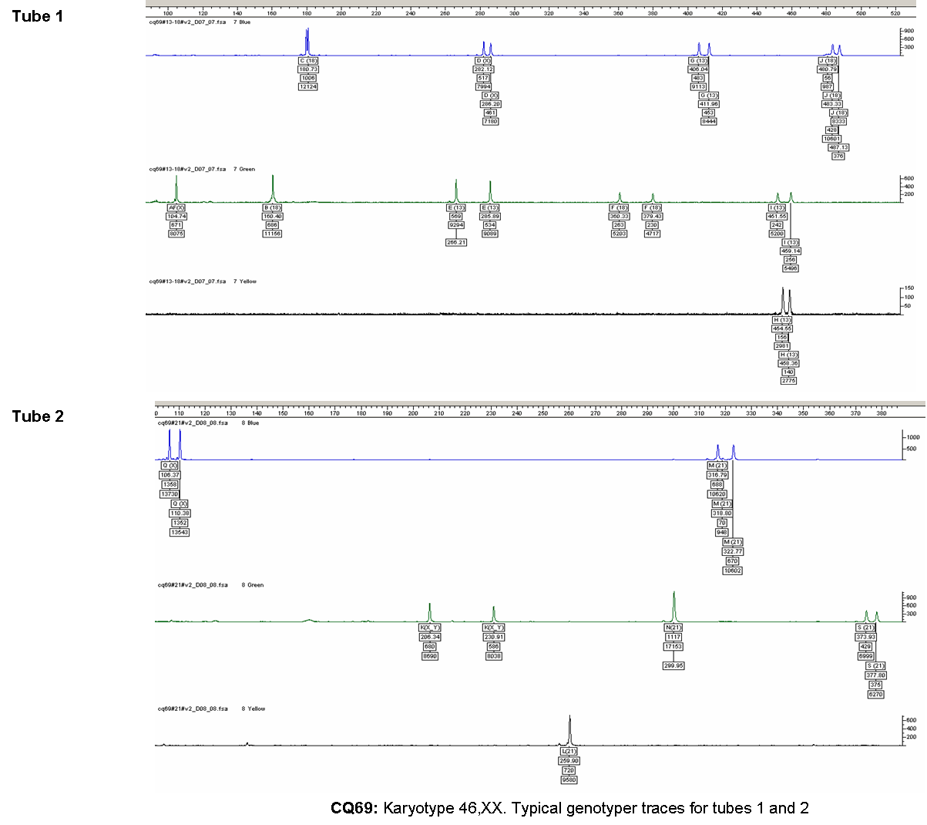

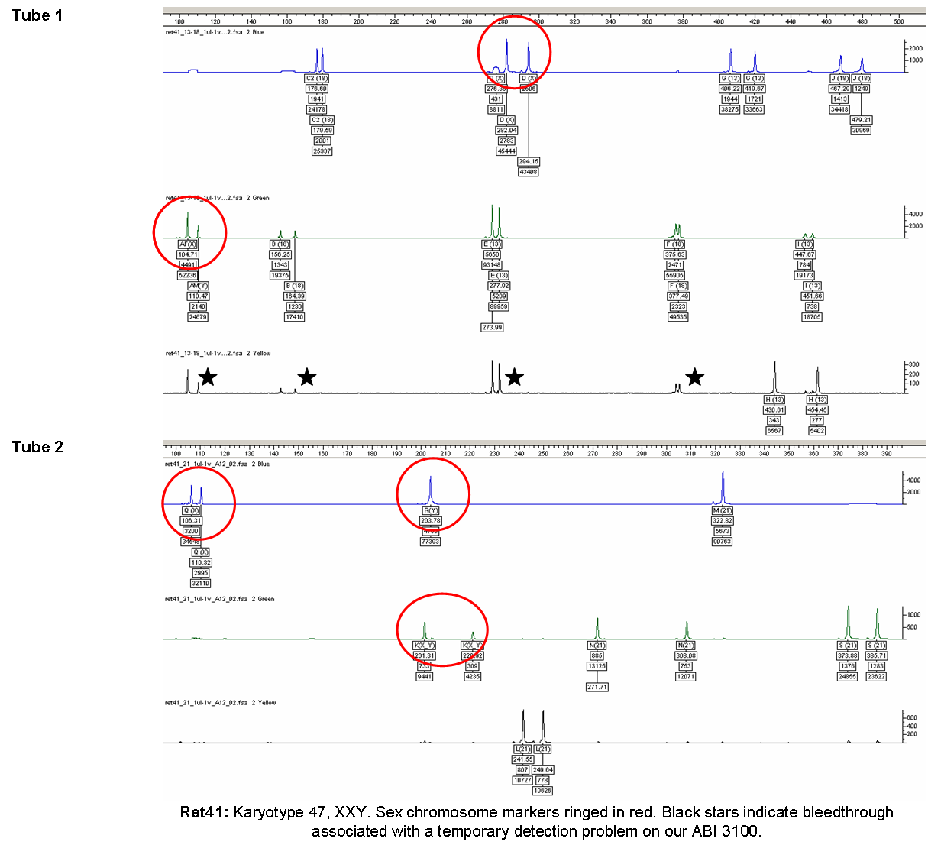
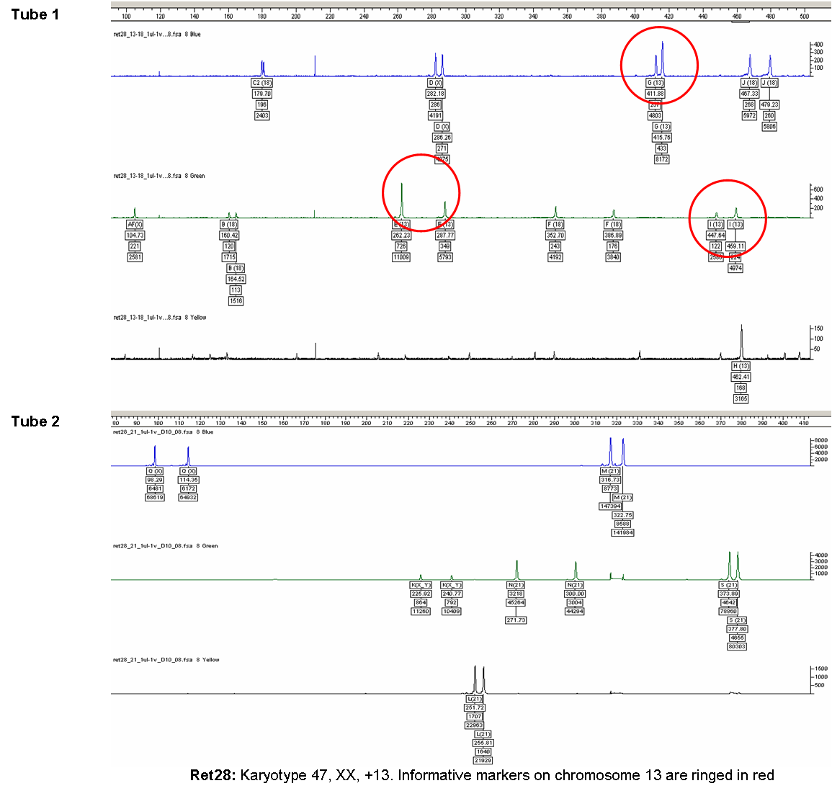
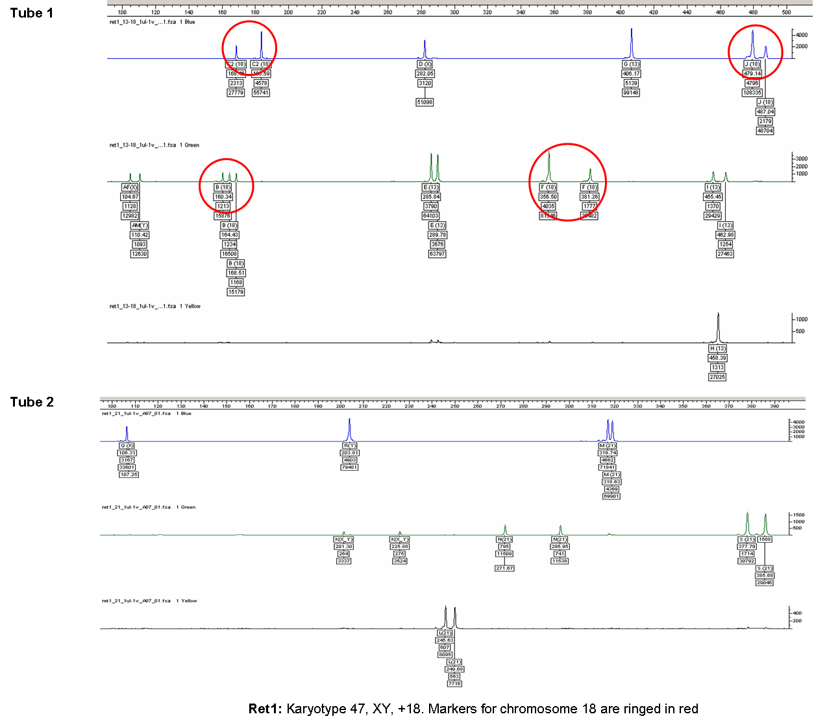
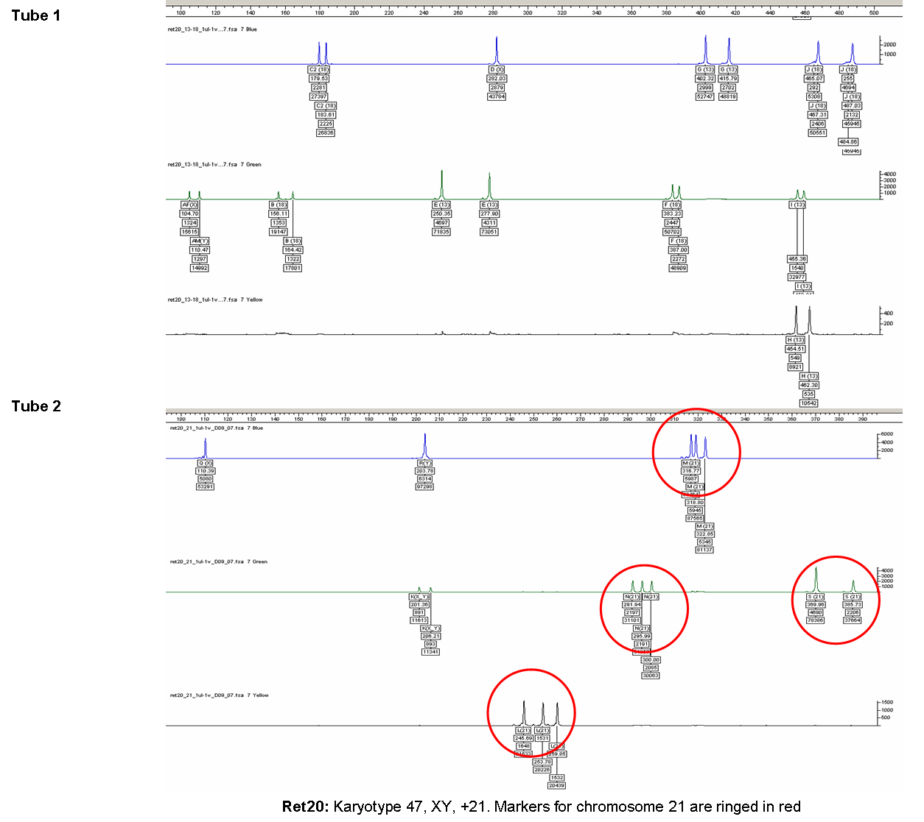
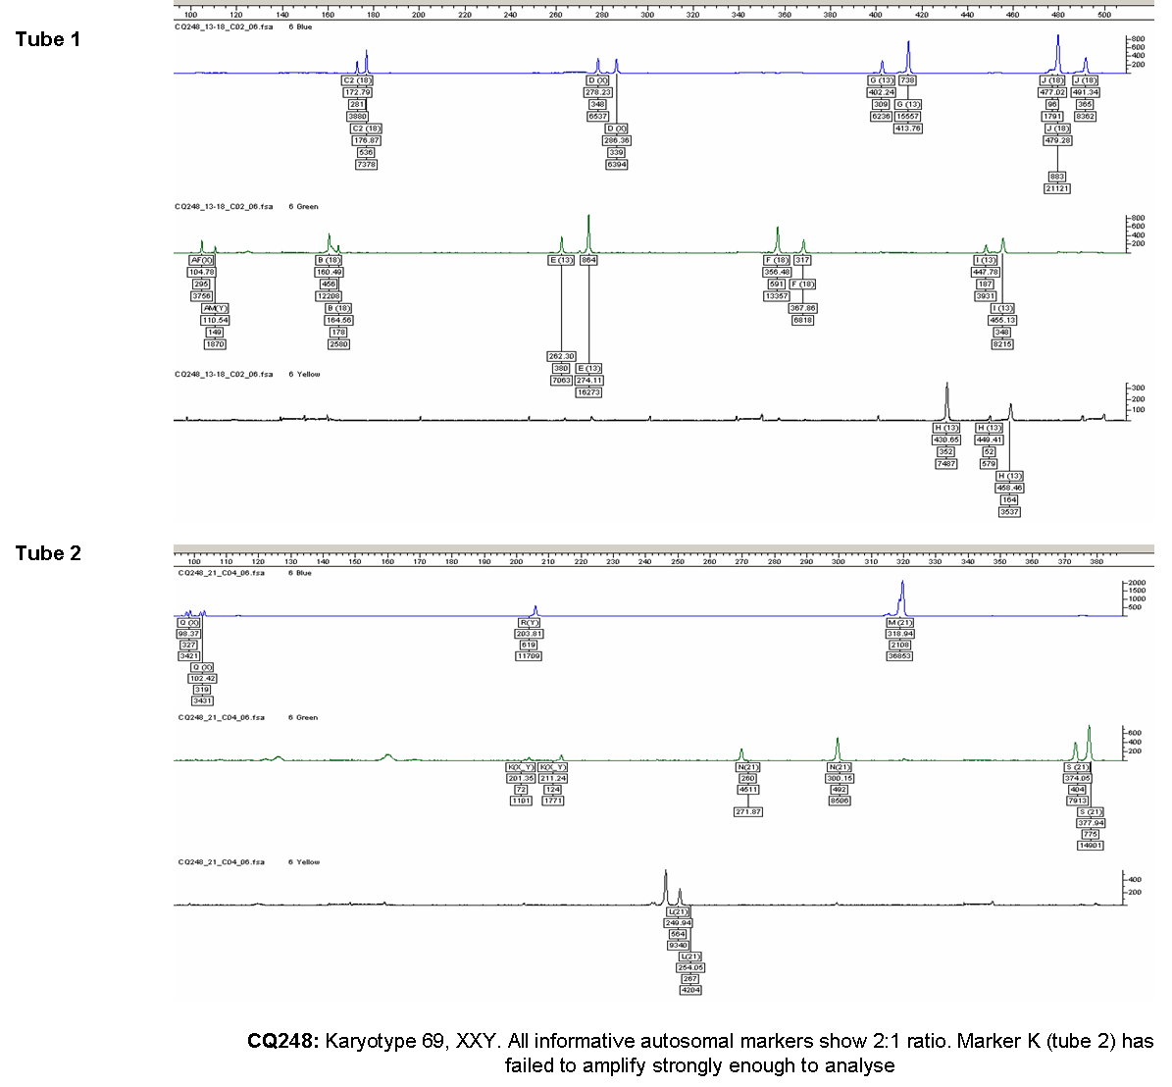

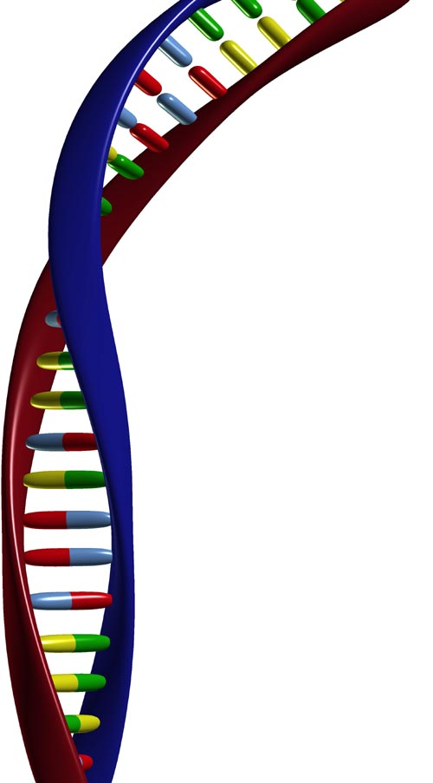
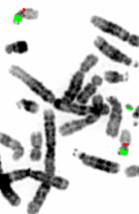

National Genetics Reference Laboratory (Wessex)
Salisbury District Hospital
Salisbury SP2 8BJ, UK

www.ngrl.org.uk

