

National Genetics Reference Laboratory
(Wessex)



Technology Assessment
Mutation scanning by high resolution melt analysis.

Evaluation of Rotor-Gene™ 6000 (Corbett Life Science), HR-1™ and 384 well LightScanner™ (Idaho Technology)

June 2006

When?

Title | Mutation scanning by high resolution melt analysis.  Evaluation of Rotor-Gene™ 6000 (Corbett Life Science), HR-1™ and 384 well LightScanner™ (Idaho Technology)
NGRL Ref | NGRLW_HRM_1.0
Publication Date | June 2006
Document Purpose | Dissemination of information about mutation scanning by high resolution melt analysis
Target Audience | Laboratories performing or setting up mutation scanning
NGRL Funded by | 

Contributors

Name | Role | Institution
Helen White | Clinical Scientist | NGRL (Wessex)
Gemma Potts | MTO | NGRL (Wessex)

Peer Review and Approval

This document has been reviewed by two experts. Corbett Life Science and Idaho Technology have also been given the opportunity to comment on the content of the report. A letter from Corbett Life Science is attached in appendix 7. Idaho Technology did not provide comments.

Conflicting Interest Statement

The authors declare that they have no conflicting financial interests

How to obtain copies of NGRL (Wessex) reports

An electronic version of this report can be downloaded free of charge from the NGRL website (http://www.ngrl.org.uk/Wessex/downloads)

or by contacting

National Genetics Reference Laboratory (Wessex)
Salisbury District Hospital
Odstock Road
Salisbury
SP2 8BJ
UK

E mail: hew@soton.ac.uk
Tel: 01722 429016
Fax: 01722 338095

Table of Contents
Summary…...…………………………………………………………………………….…1

1. Introduction 2
1.1 Use of dsDNA dyes 2
1.2 Melt curve analysis 3
1.3 NGRL Evaluation 3

2. Materials and Methods 5

2.1 Amplicons Analysed 5
2.1.1 Plasmid based template DNA (Figure 4) 5
2.1.2 Genomic DNA (Figure 5) 5
2.2 PCR optimisation 8
2.2.1 Real Time PCR Amplification 8
2.2.2 Effect of DNA Quality 8
2.3 HRM Machine specifications 8
2.4 HRM Analysis 8
2.5 Data Analysis 9

3. Results 9

3.1 PCR optimisation, real time amplification and effect of DNA quality 9
3.2 HRM Analysis 9

4. Discussion 9

4.1 Effect of DNA quality and amplicon quality 10
4.2 Effect of Amplicon Length 10
4.3 Effect of mutation type or local sequence context surrounding mutation 10
4.4 Effect of position of mutation in fragment 13
4.5 Mutation scanning in polymorphic exons 13
4.6 Detection of homozygous mutations 13
4.7 Software 14
4.8 Sensitivity and Specificity compared to other techniques 14
4.9 Costings 14

5. Overall Summary 14
6. Future Work 15

6.1 Detection of homozygous mutations 15
6.2 Simultaneous SNP detection and mutation scanning 15
6.3 Software developments 15
6.4 dsDNA binding dyes 15
6.5 Amplicon design 15
6.6 Batching of different amplicons 15
6.7 Evaluation of other HRM platforms 15

7. Acknowledgments 15

8. References 16
Appendix 1: Randomisation of DNA Samples 17
Appendix 2: PCR Primers and amplification conditions 19
Appendix 3: HRM machine specification …………………………………………. ...21
Appendix 4: PCR amplification plots and agarose gel images…………………..23
Appendix 5: Data analysis………………………………………………………………26
Appendix 6: High resolution melt curves………………………………………........39
Appendix 7: Company comments

SUMMARY

- Recently, with the development of a new family of saturating double stranded DNA binding dyes, high resolution melt curve analysis (HRM) has been identified as a new and potentially useful method of high throughput mutation scanning.

- Recent publications suggest that HRM has a mutation detection sensitivity which is comparable or superior to currently available pre-screening techniques

- We have evaluated three machines that are specialised for HRM analysis: Rotor-Gene™ 6000 (Corbett Life Science), HR-1™ and 384 well LightScanner™ (Idaho Technology)

- Eleven different amplicons were analysed. Seven amplicons were generated from the NGRL (Wessex) panel of generic mutation detection control plasmids and 4 were generated from genomic DNA: hMLH1 Exons 1, 7 & 13 and hMSH2 Exon 10.

- The amplicons varied in size from 139 to 449bp and had GC contents ranging from 22 – 79% and the types of mutations analysed included all possible point mutation base substitutions and 1 and 2bp insertions and deletions.

- A total of 624 blinded samples (including controls) were amplified in the presence of the saturating ds DNA binding dye LCGreen® Plus (Idaho Technology) using the Rotor-Gene™ 6000 (Corbett Life Science).

- Identical PCR products were analysed using HRM on the Rotor-Gene™ 6000, HR-1™ and 384 well LightScanner™ platforms. Analysis of the Rotor-Gene™ 6000 and HR-1™ melt curves was undertaken manually by two operators and the LightScanner™ data was analysed with the software supplied using both high and normal sensitivity settings.

- Data were unblinded and the sensitivity and specificity of mutation detection were determined for each amplicon and platform.

- The overall sensitivity and specificities for each machine were 100% and 95% (Rotor-Gene™ 6000, Corbett Life Science), 98.4 % and 95% (HR-1™, Idaho Technology) and 99% and 88% (384 well LightScanner™, Idaho Technology).

- We conclude that HRM is an extremely sensitive and specific technique for mutation scanning which could be easily integrated into clinical diagnostic pre-screening strategies.

- The technique has the potential to allow large genes to be screened and reported within 6-8 weeks although further work is required to determine the feasibility of analysing many different exons for small batches of patients within the same HRM run.

Introduction

High resolution melt curve analysis (HRM) is a simple and cost effective post-PCR technique which can be used for high throughput mutation scanning and genotyping. The technique requires the use of standard PCR reagents only and the dsDNA binding dye LC Green® Plus. This closed tube pre-screening method has advantages over current mutation scanning techniques since it requires no post-PCR handling (minimising the risk of PCR contamination) and no separation step, which improves analysis time.

In the past, the success of heteroduplex detection from whole amplicon fluorescent melting curve analysis was limited due to technical constraints with data acquisition capabilities and sensitivity of temperature control of instruments as well as inadequacies of the fluorescent chemistry. However, with improvements in high resolution melt instrumentation and the development of a new family of double strand specific DNA (dsDNA) binding dyes that can be used at high enough concentrations to saturate all double stranded sites produced during PCR amplification, HRM has now become an extremely promising method for mutation scanning. Recent studies suggest that HRM has a mutation detection sensitivity which is comparable or superior to currently available scanning techniques (Wittwer et al., 2004)

Many recent publications have documented the successful use of HRM on several platforms (Herrmann et al., 2006) for mutation scanning / genotyping (e.g. Wittwer et al., 2003; Liew et al., 2004; Reed and Wittwer, 2004; Graham et al., 2005; Willmore-Payne et al., 2005 Dufresne et al., 2006; Margraf et al., 2006), simultaneous mutation scanning and genotyping (Zhou et al., 2005), methylation profiling (Worm et al., 2001) and genotyping with unlabeled probes (Zhou et al., 2004).

Use of dsDNA dyes
The process of HRM relies on performing the PCR in the presence of DNA binding dyes that have the ability to distinguish double stranded DNA from single stranded DNA by a change in fluorescent signal intensity. Traditionally dyes such as SYBR® Green were used for melt analysis, but these inhibit PCR when used at concentrations sufficient to saturate the number of dsDNA molecules generated during the amplification reaction. It has been suggested that this can result in ‘dye jumping’ during amplicon melting which decreases the sensitivity of heteroduplex detection. Recently a new family of LCGreen® dyes have been developed that can be used at saturating concentrations without inhibiting PCR thereby increasing the sensitivity and specificity of mutation detection (figure 1; Wittwer et al., 2003; Herrmann et al., 2006).
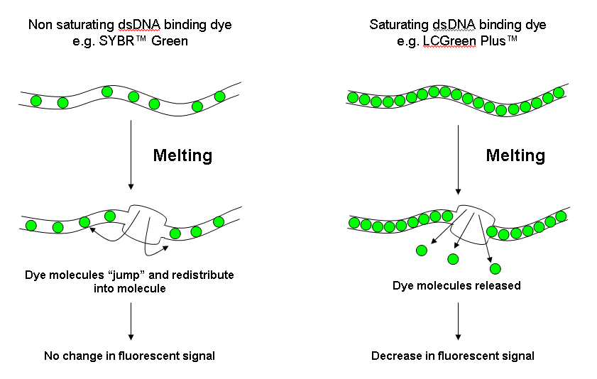
- Dye saturation model. Use of non saturating dsDNA binding dyes such as SYBR Green may cause the redistribution of dye molecules (‘dye jumping’) from melted regions back into the dsDNA amplicon being analysed potentially resulting in no change in fluorescent signal even in the presence of a heteroduplex. Use of saturating dsDNA binding dyes such as LC Green® Plus eliminates this problem and increases the sensitivity of mutation detection allowing theoretical detection of all sequence changes.

Melt curve analysis
For a heterozygous sample, a PCR amplicon will be comprised of four molecular species: two heteroduplexes and two homoduplexes. However, a wild-type or homozygous mutant amplicon will comprise a single homoduplex species. When melted, each duplex will exhibit characteristic melting (disassociation) behavior. HRM instrumentation can monitor this melting behavior by plotting the changes in fluorescence that occur as amplicons disassociate with increasing temperature from dsDNA to ssDNA . This analysis produces high resolution melt curves that can reflect the particular combination of heteroduplex and homoduplex DNA species in a sample. The presence of a heteroduplex causes a change in the shape of the melt curve compared to a homozygous reference sample (Figure 2). However homoduplexes (resulting from homozygous samples from either wild-type or mutant samples) generally exhibit a simple Tm shift as opposed to an alteration in melt curve shape. Differences in melt curves arise from variations in an amplicons sequence, length, and GC content (assuming salt and buffer conditions as well as the volume of each tested sample remains constant). Overall changes in fluorescence intensity are small and need to be monitored efficiently over a tightly controlled temperature ramp. It is therefore necessary to use instrumentation specifically designed for high resolution melt analysis to ensure maximum sensitivity and specificity (Herrmann et al. 2006). This study investigates each of the instrument systems developed specifically for HRM analysis that are currently available.
Wild type curves (59 samples)
Heterozygous mutation 62C>G
Double stranded DNA
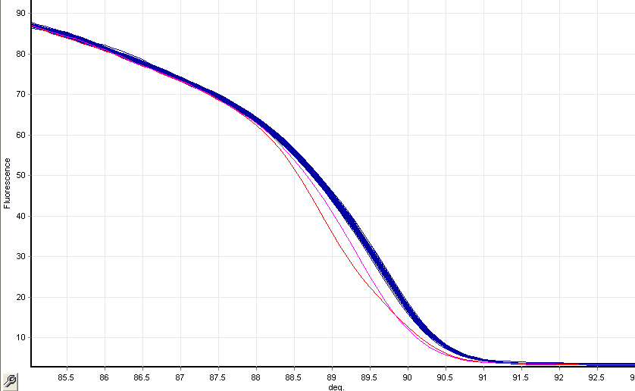
Heteroduplexes melt at lower temperatures than homoduplexes
Single stranded DNA
Homozygous mutation (62GG)
- Example of high resolution melt curve for hMLH1 Exon 1 generated using the Rotor-Gene™ 6000 (Corbett Life Science). The blue lines are melt curves for wild type samples, the red line is the melt curve for a heterozygous samples 62C>G and the pink line is the melt curve for homozygous sample for the same mutation.

NGRL Evaluation
In this study we have evaluated the sensitivity and specificity of mutation detection for three machines capable of HRM analysis: Rotor-Gene™ 6000 (Corbett Life Science), HR-1™ and 384 well LightScanner™ (Idaho Technology). We have analysed amplicons generated from plasmid reagents and genomic DNA to assess how effectively HRM can be used for genetic diagnostic testing. The amplicons analysed varied in size from 139 to 449bp and had GC contents ranging from 22 – 79% The types of mutations analysed included all possible point mutation base substitutions and 1 and 2bp insertions and deletions. The flow chart in figure 3 shows the experimental design.

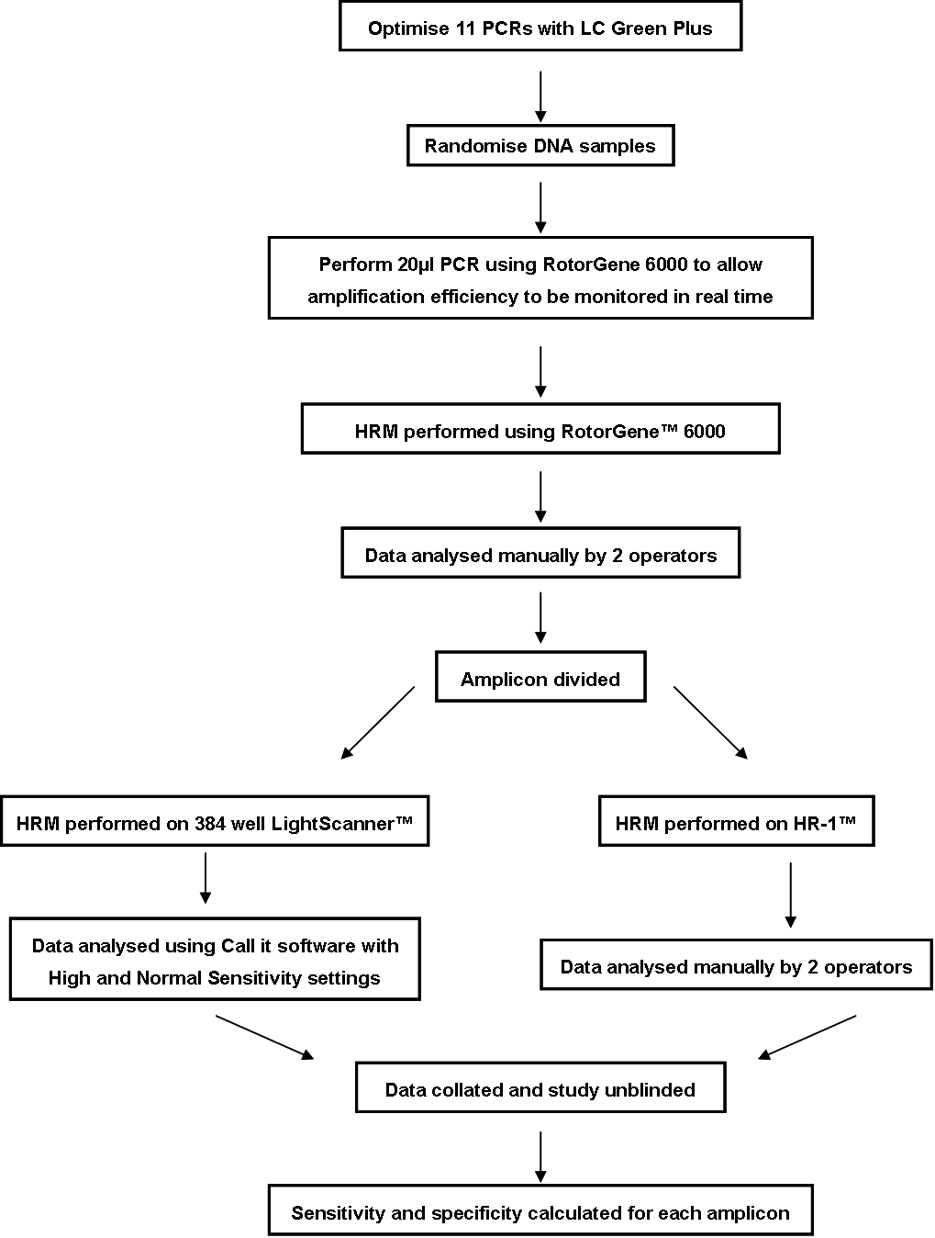

- Flow chart of NGRL (Wessex) HRM Evaluation. All amplicons generated in this study were also verified by sequencing.

Materials and Methods

Amplicons Analysed

Plasmid based template DNA (Figure 4)
Seven amplicons were derived from plasmid based DNA templates, details of which can be found in the NGRL (Wessex) reference reagent report “Plasmid based generic mutation detection reference reagents; production and performance indicator field trial” (www.ngrl.org.uk/Wessex/downloads.htm). Four wild type plasmids were constructed which contain inserts with 20%, 40%, 60% and 80% GC content. Each of the wild type plasmids has been mutated at either P1, P2 or P3 (figure 4) to introduce the changes shown in table 1. When the mutated plasmids are mixed 1:1 with the corresponding wild type plasmid the resulting 48 samples can be used to validate mutation detection techniques by analysing how effectively each of the possible heteroduplex configurations are detected at three different positions within amplicons of varying GC content.

Plasmid templates with GC contents of 20%, 40%, and 60% were amplified to produce products of 449, 437 and 433 bp respectively. We were unable to optimize the PCR conditions for the 80% GC rich 424bp amplicon in the presence of LC Green® Plus. Shorter amplicons derived from the same plasmid templates with GC contents of 20%, 40%, 60% and 80% were also produced: 272, 259, 260 and 258 bp respectively. Figure 4 shows a diagrammatical representation of the seven amplicons: GC and AT rich regions within the amplicons are represented by black and white shading respectively. The position of the mutations in the fragments are indicated by the pink (P1), blue (P2) and green bars (P3) the black and white shading shows the local sequence context surrounding each mutation.
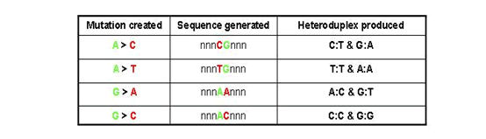

- Four wild type plasmids have been constructed which contain inserts with a 20%, 40%, 60% and 80% GC content. Each of these plasmids has been mutated at three positions within the amplicon (Figure 4) to introduce the base changes listed in the table.
48 samples were analysed for each amplicon. These were randomised as shown in appendix 1a.

Genomic DNA (Figure 5)
Although the plasmid reagents are useful for studying the effects of GC content, base changes and positions of mutation in fragments they largely test the mutation scanning system rather than factors such as PCR optimisation which can be more problematic for genomic DNA targets. Use of genomic DNA also allows investigation of mutations which are more complex than point mutations. Four amplicons were generated from genomic DNA samples. For the purpose of this evaluation we selected three exons from hMLH1 (Exons 1, 7 and 13) one exon from hMSH2 (exon 10) for analysis. Figure 5 shows a diagrammatical representation of the four amplicons: GC and AT rich regions within the amplicons are represented by black and white shading respectively. The mutation types analysed are also indicated. We analysed DNA from patients who had previously characterized mutations for the HNPCC exons to be tested (n=35) and normal controls (n=32). We also analysed plasmid mutations controls for each exon with the mutation in both a heterozygous and homozygous form. Details of the plasmids controls can be found in the NGRL (Wessex) reference reagent report “Production and field trial evaluation of reference reagents for mutation screening of BRCA1, BRCA2, hMLH1 and MHS2” (www.ngrl.org.uk/Wessex/downloads.htm). hMSH2 exon 10 was selected as a representative polymorphic exon as it contains a common G/A polymorphism (dbSNP 3732183) with genotype frequencies of 0.13 (AA), 0.42 (GA) and 0.45 (GG).

DNA samples were randomised as shown in appendix 1b.

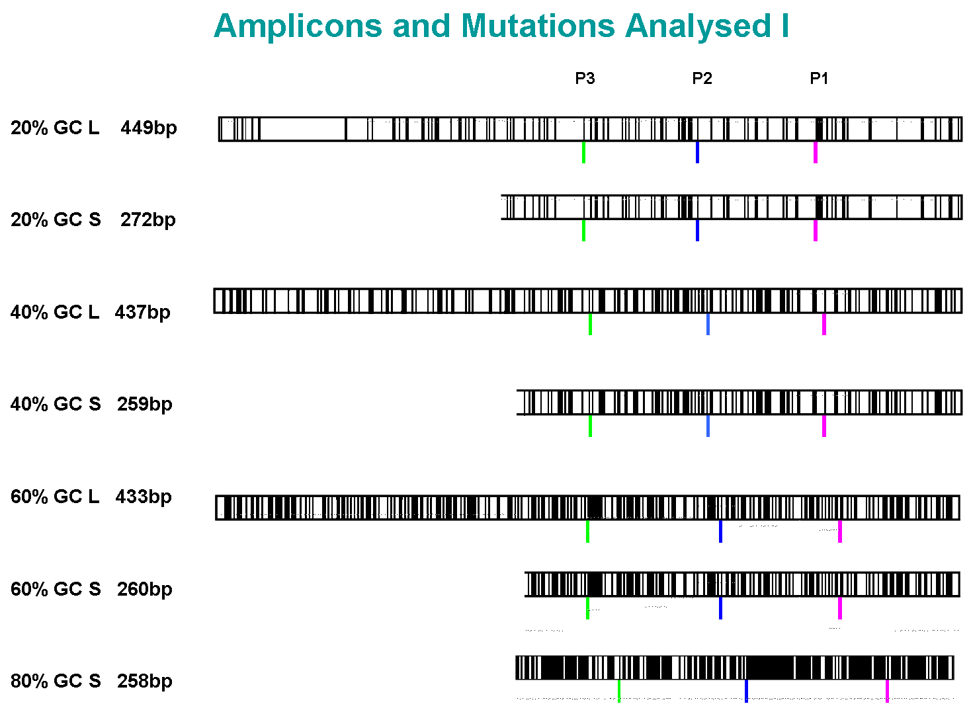

- Diagrammatical representation of the seven amplicons produced from plasmid DNA templates: G/C and A/T bases within the amplicons are represented by black and white bars respectively. The position of the point mutations in the fragments are indicated by the pink (P1), blue (P2) and green bars (P3) the black and white shading shows the local sequence for each mutation. Key S = short amplicon, L = long amplicon, x% GC = percentage GC content of amplicon and indicates from which plasmid construct the amplicon was derived.
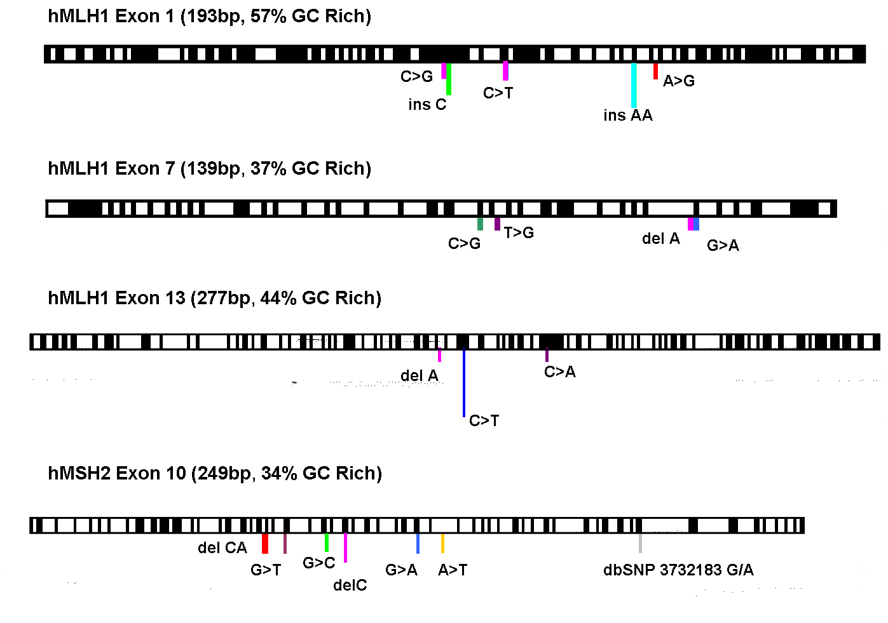

- Diagrammatical representation of the four amplicons produced from genomic DNA templates G/C and A/T bases within the amplicons are represented by black and white bars respectively. The coloured bars indicate the position of the different types of mutations analysed within the different amplicons.

PCR optimisation
Successful HRM is almost entirely dependent on meticulous optimisation of PCR conditions as the presence of non-specific bands and primers dimers can significantly reduce HRM performance. In general the following guidelines may be applied to help achieve a robust amplification in the presence of LC Green® Plus:
Template DNA 5-10 ng
MgCl₂ 2 mM
Primer concentration 0.2 / 0.3 μM Final concentration
LC Green® Plus 1X

The PCR can be optimised using a 10-12°C gradient to determine optimal annealing conditions using 45 cycles. The annealing temperature of the reaction may have to be raised significantly (2-10°C) above that used in the absence of LC Green® Plus. The NGRL evaluation did not specifically cover an analysis of different Taq polymerases however we did observe that reactions performed using AmpliTaq Gold (Applied Biosystems) were more subject to PCR inhibition whereas those performed using Platinum Taq (Invitrogen) were more robust. Optimisation of more troublesome PCR templates can be achieved by using the LC Green® Plus master mix (Idaho Technology) although this is a more expensive option (£1 / 10μl PCR).

Real Time PCR Amplification
To help optimize PCR conditions and to monitor amplification efficiency in real time, all amplifications were carried out using the Rotor-Gene™ 6000 (Corbett Life Science). Eleven amplicons (20μl reaction volume) were generated using the primer sequences and amplification conditions shown in appendix 2.

Effect of DNA Quality
To determine the effect of DNA quality on HRM analysis we analysed hMLH1 Exon 1 using DNA samples of variable DNA quality (n=70). We assessed the quality and amplifiability of the DNA samples using a multiplexed control gene primer set which amplifies products of 100, 200, 300, 400 and 600bp with equal intensity (White et al., 2003). Loss of the higher molecular weight products indicates that the DNA sample is of poor quality. HRM data was correlated with the DNA quality and amplification plot data (see figure 6).

HRM Machine specifications
The Rotor-Gene™ 6000 is a real time PCR machine which also has HRM capability. The HR-1™ and 384 well LightScanner™ have HRM capability only. More detailed machine specifications are given in Appendix 3. Further details can be obtained from the respective company websites:

Corbett Life Science: http://www.corbettlifescience.com
Idaho Technology: http://www.idahotech.com

HRM Analysis
HRM was performed on the same PCR reactions using three HRM platforms. Melting conditions are shown in table 2.
Amplicon | Melting conditions |  | Amplicon | Melting conditions
20L | 73°C – 83°C |  | hMLH1x1 | 85°C – 95°C
20S | 73°C – 83°C |  | hMLH1x7 | 75°C – 85°C
40L | 77°C – 87°C |  | hMLH1x13 | 82°C – 89°C
40S | 78°C – 88°C |  | hMSH2x10 | 76°C – 86°C
60L | 85°C – 95°C
60S | 85°C – 95°C
80S | 84°C – 95°C
- Melting temperatures ranges used to analyse PCR amplicons on the Rotor-Gene™ 6000, HR-1™ and 384 well LightScanner™
The rate of melting for the HR-1™ and 384 well LightScanner™ were 0.15°C / sec and 0.3°C / sec respectively. The Rotor-Gene™ 6000 melting conditions can be altered by the user. Our reactions were melted using 0.1°C increments with a 2 second hold at each step. Denatuation was performed before analysis on all machines but cooling parameters were not standardized.

Data Analysis
HRM data from the Rotor-Gene™ 6000 and HR-1™ were analysed manually by two independent operators. HR-1™ data were normalised and temperature shifted prior to analysis by each operator independently. LightScanner™ data were analysed by one operator using the software provided with high and normal sensitivity settings. Manual analysis of the LightScanner data was not performed and therefore results may not be directly comparable with manual analysis data from the Rotor-Gene™ 6000 and HR-1™.

Once all data analysis was complete the samples were unblinded and the sensitivity and specificity of mutation detection for each amplicon was determined.

results

PCR optimisation, real time amplification and effect of DNA quality
PCR optimisation plays a critical role in successful HRM analysis. We found that variable amplification resulting either from DNA quality or sub-optimal amplification increased the number of false positive results and in some cases analysis was not possible as the data became too noisy to reliably discriminate wild type and mutated samples. The use of real-time PCR amplification meant that PCR optimisation was more easily achieved as detailed information about the dynamics of amplification for each sample could be monitored. This enabled detection of poor quality samples before HRM analysis and also allowed the efficiency of each PCR to be determined. The real time amplification plots and agarose gel images for all amplicons are shown in appendix 4.

Figure 6 shows the amplification plot, agarose gel of the PCR products and the control gene PCR analysis for the DNA samples of variable quality. The agarose gel of the control gene PCR products (figure 6a) shows that samples C1, C4, D6, C8, D11, F9, H4, H8 and G10 amplified products between 100 and 200bp only and are thus of poor quality. When these samples were amplified using the hMLH1 exon 1 assay the PCR products, when viewed on an agarose gel, all appeared to have amplified successfully (figure 6b). However, the amplification plot (figure 6c) shows that there was considerable variation in amplification efficiency between samples. The 9 poor quality DNA samples only reached plateau at above 35 cycles and when HRM data were analysed these 9 samples were identified as false positive results (data not shown). Therefore poor DNA quality may result in increased false positive rates when using HRM.

HRM Analysis
The sensitivity and specificity of mutation detection for each amplicon on each platform are shown in table 3. Full details of the data analysis are given in Appendix 5. The Rotor-Gene™ 6000 had a sensitivity of 100% for all amplicons with specificities ranging from 82.6 – 100% and the HR-1™ had a sensitivity range of 89.6 – 100% with specificities ranging from 84.4 – 100%. The LightScanner™ data were analysed using normal and high sensitivity software settings. Using the normal sensitivity setting the sensitivity ranged from 50% - 100% with specificities of 73.7 – 100%. However, using the high sensitivity setting the sensitivity improved to 100% for all amplicons (except 20%GC long) with specificities ranging from 80 to 100%. All melt curves are shown in appendix 6.

discussion
As can be seen from table 3, HRM is a mutation detection technique which has high sensitivity and specificity. The amplicons used for this evaluation were not designed specifically for HRM and time constraints meant that PCR conditions for some amplicons could have been improved. It is possible that the false positive rates observed for some amplicons could be lowered following further optimisation. Overall it appears that HRM has a mutation detection sensitivity which is comparable or superior to currently available pre-screening techniques and that each of the platforms evaluated produced comparable results.

Effect of DNA quality and amplicon quality
DNA and amplicon quality appear to have the most significant effect on HRM data quality. Figure 6 shows the control gene PCR results for a panel of DNA samples. Samples which only amplified products up to 200bp (using the DNA quality multiplex assay) were detected as false positive results when analysed by HRM. However, poor quality samples can be readily identified and excluded from further analysis if the PCR is monitored in real time. DNA extracted using different methods may produce melt curves which have subtle differences and which in some cases may results in increased false positive rates (Idaho Technology, personal communication). It is important to be aware of this when analysing archival samples or samples from other laboratories.

PCR optimisation is critical as the presence of primer dimers or non specific products may alter the melt curve characteristics causing the generation of false positive results. Amplicon design is also important to ensure that maximum information can be obtained from the melt curve data. Complex melt curves which have two or more melting domain may be more difficult to analyse. In this evaluation the 60% GC long amplicon, which had two melting domains, was difficult to analyse and could not be analysed successfully using automated mutation calling with either high or normal sensitivity settings. It appears that single melting domains, as seen in the shorter amplicon, are more easily analysed. Optimal amplicon design and subsequent optimisation are therefore crucial to the success of HRM.

Effect of Amplicon Length
The length of the amplicon does appear to have an effect on the sensitivity and specificity of mutation detection. In general, we observed that mutations were more difficult to detect in amplicons which were greater than 400bp which is concordant with a previous study (Reed and Wittwer, 2004). The shorter amplicons tended to have less complex melt profiles as compared with longer amplicons and therefore data could be more easily analysed. Mutations were generally more easy to discriminate in smaller amplicons as the overall change in fluorescent intensity for mutated samples was greater than that observed in the longer amplicons.

The effect of amplicon length was particularly evident for the 20% GC rich plasmid based amplicon (table 3). The P1 mutations, located 84bp from the end of the amplicon, were difficult to detect in the long amplicon (449bp) but were successfully detected in the shorter form of the amplicon (272 bp). Mutated plasmid templates were amplified in duplicate for each mutation for both the long and short forms of the 20%GC amplicon (appendix 5). When data from the Rotor-Gene™ 6000 were analysed, the P1 A-T mutation in the 449bp amplicon was identified as ambiguous in both cases by operator 1 and in one case by operator 2. However both operators detected the mutation unequivocally in the shorter amplicon. Using the HR-1, the P1 A-T and P1 G-C mutations were not detected by either operator for one replicate in the 449bp amplicon but were detected successfully in the shorter amplicon (both replicates). When the LightScanner™ data for the 449bp amplicon were analysed using normal sensitivity software settings the P1 A-T, G-C and G-A mutations were not detected using normal sensitivity conditions (both replicates). Using high sensitivity settings single replicates of the P1 A-T, G-C and G-A mutations were not called as mutated. However, all mutations were successfully called with normal and high sensitivity settings for the shorter amplicon. Examples of melt curves for each platform for the long and short forms of the 20% GC amplicons are shown in appendix 6.

Effect of mutation type or local sequence context surrounding mutation
In some amplicons the type of mutation or perhaps more plausibly the local sequence context surrounding the mutation appeared to have an effect on mutation detection. For example, when analysing the short and long amplicons generated from the 40% GC rich plasmid based template the P3 mutations were most subtle and the difficult to detect (appendix 6). The resolution of detection of the mutations at this position did not significantly improve when the amplicon length was shortened and therefore we assume that the context of sequence surrounding the mutation may be contributing to this effect. For the long amplicon (437bp) the P3 A-C mutation was called as ambiguous by one operator for one replicate when analysed using the Rotor-Gene™ 6000 and for the shorter amplicon (259bp) mutations P3 A-C and P3 A-T were called as ambiguous by operator 2 for both replicates. When the amplicons were analysed using the HR-1™ the P3 A-T was undetected by both operators for one replicate and called as ambiguous by both operators for the second replicate in the long amplicon. When data from the shorter amplicon were analysed the P3 A-T mutation was detected successfully but P3 G-C was called as ambiguous by operator 1 for both replicates and was undetected by operator 2 for one replicate; P3 G-A was also undetected by both operators for one replicate. When data from the LightScanner™ were analysed using the normal sensitivity settings P3
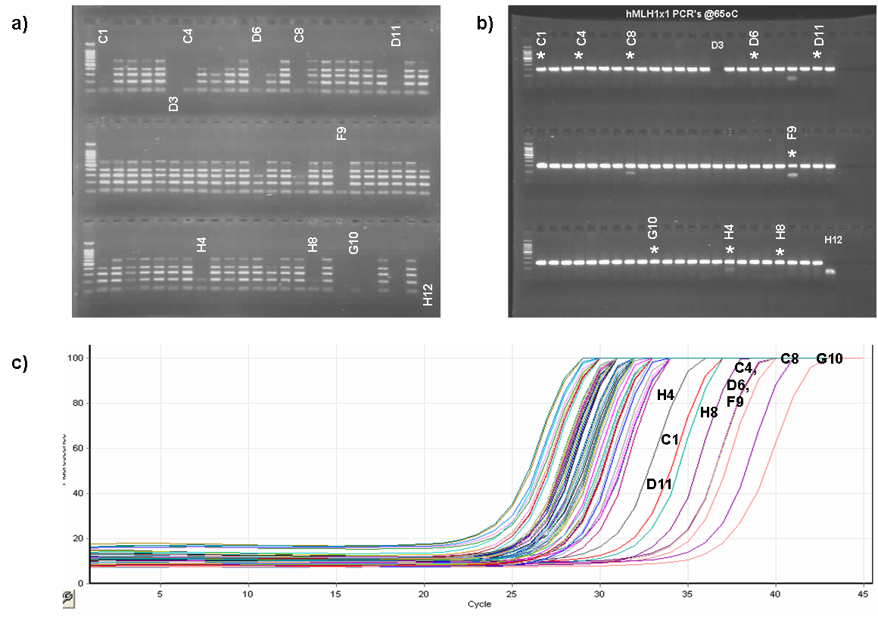

- Effect of DNA quality. a) Agarose gel of control gene PCR products for DNA samples of variable quality. Good quality DNA samples amplify bands of 100, 200, 300, 400 and 600bp. Low quality samples (labeled in white) have only amplified products of 100-200bp. b) Agarose gel of hMLH1 Exon 1 products for the variable quality DNA samples. All samples appear to have amplified well. Samples marked with an asterisk are those of poor DNA quality. c) the PCR amplification plot shows that the asterisked samples have amplified poorly with samples only reaching plateau at 36 cycles. These samples were called as false positives when analysed with HRM (data not shown). Samples D3 and H12 are water controls.

 |  |  |  |  | Rotor-Gene™ 6000  (Corbett Life Science) |  | HR-1™  (Idaho Technology) |  | LightScanner™ 384 well  (Idaho Technology)
 |  |  |  |  |  |  |  |  | High Sensitivity |  | Normal Sensitivity
Amplicon | No. of wild type samples | No. of mutated samples |  | No. of unique mutations | Sensitivity (%) | Specificity (%) | Sensitivity (%) | Specificity (%) | Sensitivity (%) | Specificity (%) | Sensitivity (%) | Specificity (%)
20L | 23 | 24 |  | 12 | 100 | 82.6 | 89.6 | 97.8 | 87.5 | 100 | 75 | 100
20S | 23 | 24 |  | 12 | 100 | 100 | 100 | 91.3 | 100 | 100 | 100 | 100
40L | 23 | 24 |  | 12 | 100 | 100 | 95.8 | 97.8 | 100 | 100 | 75 | 100
40S | 23 | 24 |  | 12 | 100 | 100 | 95.8 | 97.8 | 100 | 100 | 71 | 100
60L | 23 | 24 |  | 12 | 100 | 90.9 | 95.8 | 84.4 | Not analysed | Not analysed | Not analysed | Not analysed
60S | 23 | 24 |  | 12 | 100 | 100 | 100 | 97.7 | 100 | 100 | 69.6 | 100
80S | 23 | 24 |  | 12 | 100 | 87 | 100 | 93.5 | 100 | 87 | 98.5 | 87
hMLH1 x1 | 60 | 9 |  | 5 | 100 | 96.7 | 100 | 94.2 | 100 | 80 | 80 | 90
hMLH1 x7 | 62 | 7 |  | 5 | 100 | 100 | 100 | 95.2 | 100 | 90.5 | 71.4 | 96.8
hMLH1 x13 | 55 | 14 |  | 5 | 100 | 98.2 | 100 | 85.5 | 100 | 96.4 | 50 | 100
hMSH2 Combined | 55 | 14 |  | 6 | 100 | 96.4 | 100 | 96.3 | 100 | 80 | 100 | 90.9

- % Sensitivity (true positive/ (true positive + false negative)) and specificity (true negative / (true negative + false positive)) of mutation detection for eleven amplicons analysed using the three HRM platforms. LightScanner™ figures are given for the two software settings: high sensitivity and normal sensitivity. Homozygous mutations have been excluded from the analysis. Full details of data analysis can be found in appendix 5.

A-T, G-A and G-C were undetected for both replicates in both the long and short forms of the amplicon. However, when the data were analysed with the high sensitivity settings the P3 mutations were successfully detected in all cases.

The overall GC content of the amplicon did not appear to have a significant effect on the sensitivity of mutation detection as mutations were detected successfully in amplicons with a wide range of global GC content: 20 -79%.

For the genomic DNA samples the most subtle (but detectable) mutations were :

hMLH1 Exon 1: Rotor-Gene™ 6000 110 A>G
HR-1 110 A>G
LightScanner 110 A>G

hMLH1 Exon 7: Rotor-Gene™ 6000 588 del A
HR-1 588 del A
LightScanner 588 del A (not detected with normal sensitivity)

hMLH1 Exon 13: Rotor-Gene™ 6000 All detected unambiguously
HR-1 1451 del A, 1459 C>T
LightScanner 1451 del A, 1409+14G>A polymorphism

The fact that the 110A>G and 588delA mutations in exons 1 and 7 respectively were subtle for each platform suggests that these mutations are intrinsically difficult to detect by HRM e.g. they are sited in regions which, when melted, produce only subtle overall changes in fluorescent intensity. Apparently, differences in data handling between the platforms meant that the 1459 C>T, 1451 delA and 1409+14G>A sequence variants in exon13 were subtle when analysed using the HR-1™ and LightScanner™ but were easily detected using the Rotor-Gene™ 6000. Data from the HR-1™ and LightScanner™ is first normalised and then temperature shifted. It appears that mutations such as 1451 delA changes the temperature at which the amplicon melts rather than altering the overall shape of the melt curve. When the data are temperature shifted these curves become superimposed on the wild type samples making detection difficult. Data from the Rotor-Gene™ 6000 is normalized, but not temperature shifted, and therefore such mutations can be more easily detected as the melt curves do not become overlaid on the wild type curve. Melt curves are shown in appendix 6.

Effect of position of mutation in fragment
The position of a mutation within a fragment did not appear to have a significant effect on mutation detection. Mutations were detected successfully in positions close to the end of the amplicon e.g. 24bp (delA and G>A mutations in hMLH1 Exon 7) and 23bp (G/A polymorphism hMLH1 Exon 13) from the end of the fragment; central positions e.g. 551 C>G in hMLH1 Exon 7, 1601 G>A in hMSH2 Exon 10 and intermediate positions between the middle and end of the amplicon e.g. 1551_2 delCA in hMSH2 Exon 10 and 105ins AA in hMLH1 Exon 1. Examples of melt curves can be seen in appendix 6.

Mutation scanning in polymorphic exons
To determine whether polymorphic exons could be analysed by mutation scanning using HRM, hMSH2 exon 10 was included in the analysis. hMSH2 exon 10 was selected as a representative polymorphic exon as it contains a common G/A polymorphism (dbSNP 3732183) with genotype frequencies of 0.13 (AA), 0.42 (GA) and 0.45 (GG). For this study the genotype of each sample was determined by sequencing. Several diagnostic labs that use mutation scanning approaches for analysis of large genes are beginning to investigate the use of polymorphism screens e.g. SNPlex (Applied Biosystems) so that samples with defined non-pathogenic polymorphisms and no pathogenic mutation can be reported as normal without the need for confirmatory sequencing. In this evaluation the genotype at the polymorphic site was characterized and melt curves were then analysed in genotype groups (using genotype specific controls for reference). Mutations were successfully discriminated for all three genotype groups on each HRM platforms. Therefore HRM may be suitable for mutation scanning polymorphic exons (also see section 6.2).

Detection of homozygous/ hemizygous mutations
Plasmid control samples were included as positive controls for the analysis of hMLH1 Exons 1, 7, 13 and hMSH2 Exon 10. Three controls were included: a wild type control, a heterozygous mutation control and a homozygous mutation control. Data from the homozygous controls were not included in the final analysis shown in table 3. The Rotor-Gene™ 6000 detected the homozygous mutations for all exons whereas only the homozygous controls for hMLH1 Exons 1 and 13 were detected using the HR-1™ and LightScanner™ (see melt curves in appendix 6). The detection of homozygous controls using the HR-1™ and LightScanner™ is more difficult as the data produced is first normalised and then temperature shifted. Homozygous changes appear to alter the temperature at which the amplicon melts rather than altering the shape of the melt curve. When the data is temperature shifted the homozygous curves become superimposed on the wild type samples making detection difficult in some cases. Data from the Rotor-Gene™ 6000 is normalized but not temperature shifted and therefore homozygous mutations appear to be more easily detected as the melt curves do not become overlaid on the wild type curve.

Software
For automated calling it is important that wild type samples cluster very tightly to allow the unambiguous detection of subtle mutations and reduce the number of false positive calls. Software is continually developing and improving and this should ultimately allow the full automation of data analysis. During the evaluation period the LightScanner™ was the only platform equipped with mutation calling software and data were analysed using normal and high sensitivity settings. For diagnostic use it appears that the high sensitivity setting is most appropriate to use since this gave 100% sensitivity i.e. no false negative results. In some cases the false positive rate was high (e.g. hMLH1 exon 1) however this is most likely due to sub optimal assay optimisation as this exon shows primer dimers in some samples (appendix 4). The hMLH1 exon 1 samples were more successfully analysed using the Rotor-Gene™ 6000 and HR-1™ where calls were made manually and operators were able to discriminate ‘noise’ from true variation.

When using the HR-1™ and LightScanner™ certain operator interventions are required during the data analysis. To normalize the data vertical cursors can be moved and placed in a linear region of the melting curve prior to and following the melting transition. The cursors are initially paced at default positions and then require moving by the operator to generate normalised melt curves which have horizontal regions before and after the melt. Positioning of the cursors can alter the appearance of the normalized curves and cause differences in both qualitative manual calling and automated mutation calling. This led to variation in the scoring of samples by different operators. In a diagnostic setting criteria for positioning the cursors for different amplicons would need to be incorporated into standard operating procedures to ensure that there was no variability in data analysis between operators.

Sensitivity and Specificity compared to other techniques
Data from this evaluation and published studies suggest that HRM has a mutation detection sensitivity which is comparable or superior to currently available pre-screening techniques. In our recent field trial of the generic mutation detection controls the sensitivity and specificity of mutation detection of existing mutation detection techniques ranged from 75% - 100% and 68 – 100% respectively (NGRLW report: (www.ngrl.org.uk/Wessex/downloads.htm). In this evaluation the sensitivity and specificity of HRM was 98 - 100% and 88 - 95% respectively.

Costings
HRM is a cost effective technique which requires the use of standard PCR reagents and a dsDNA binding dye. The cost price of LC Green® Plus is 22.5p per 10μl reaction (Cadama Medical). HRM machine prices are available from company representatives or distributors:

www.corbettlifescience.com
www.cadama.co.uk
www.idahotech.com

Overall Summary
We conclude that HRM melt analysis is a simple and cost effective post-PCR technique which can be used for high throughput mutation scanning and genotyping. The technique requires the use of only PCR reagents and the dsDNA binding dye LCGreen® Plus and reactions requires no post-PCR handling (which reduces post-PCR contamination risk) and no separation step, which improves analysis time.

HRM has a mutation detection sensitivity and specificity which is comparable or superior to currently available pre-screening techniques although good amplicon design and PCR optimisation are essential. In this study, the overall sensitivity and specificities for each HRM machine platform evaluated were highly comparable at 100% and 95% (Rotor-Gene™ 6000, Corbett Life Science), 98 % and 95% (HR-1, Idaho Technology) and 99% and 88% (384 well LightScanner, Idaho Technology).

HRM is capable of detecting some homozygous/hemizygous mutations and appears to be useful for mutation scanning fragments with defined non-pathogenic sequence variants. Although further work is required to determine the feasibility of analysing many different exons for small batches of patients within the same HRM run the technique has the potential to allow large genes to be screened and reported within the 6-8 weeks recommended in the Genetics White Paper (2003) "Our inheritance, our future - realising the power of genetics in the NHS".

Future Work

Detection of homozygous/hemizygous mutations
To investigate how effectively homozygous / hemizygous mutations can be detected using HRM on the Rotor-Gene™ 6000 and 384 well LightScanner™ we will analyse the NGRL (Wessex) panel of generic mutation detection controls. The controls will be amplified as homozygous samples and will be analysed in a blinded fashion.

Simultaneous SNP detection and mutation scanning
HRM has the potential to be used for mutation scanning polymorphic exons as has been outlined in section 4.5. However, using HRM it may also be possible to simultaneously type a known polymorphism and mutation scan in a single reaction using asymmetric PCR and unlabeled oligo probes (Zhou et al., 2005). We will investigate whether this approach could be used in clinical diagnostic practice to reliably exclude samples containing only non-pathogenic sequence variants from further analysis.

Software developments
As new versions of software become available for automated calling of samples we will evaluate these using our panel of generic mutation controls.

dsDNA binding dyes
Other saturating dsDNA binding dyes are now available for use in HRM e.g. EvaGreen™ (Biotum), SYTO®9 (Invitrogen). We will investigate their utility for HRM analysis on two platforms: Rotor-Gene™ 6000 and 384 well LightScanner™.

Amplicon design
Good amplicon design is essential to obtain robust and reproducible HRM assays. At present it is difficult to predict the quality of the melt curve that will be produced from DNA sequence alone. We hope to work with other labs using HRM to develop amplicon design criteria.

Batching of different amplicons
In this evaluation many samples were analysed for a few amplicons. However, in diagnostic labs it is usually the case that fewer samples are analysed for many exons. Further investigation is now required to determine whether analysis of many exons in the same HRM run is feasible and to determine whether this has an effect on the overall quality of data produced.

Evaluation of other HRM platforms
We will evaluate other HRM platforms as they become available.

Acknowledgments
We would like to thank Dr Graham Taylor (Head of Cancer Research UK Genomic
Services, St James's University Hospital, Leeds) and Dr Claire Taylor (CR-UK Mutation Detection Facility, St. James’s University Hospital, Leeds) for help and advice with this evaluation; Lawrence Murphy and Greg Nowak (Corbett Life Science) for technical support and loan of the Rotor-Gene™ 6000; David Harris (Cadama Medical) for loan of the HR-1™ instrument; Ian Day (Dept. Human Genetics, University of Southampton) for use of the 384 well LightScanner™; Jason McKinney (Idaho Technology) for technical support.

References
Dufresne SD, Belloni DR, Wells WA, Tsongalis GJ. BRCA1 and BRCA2 Mutation Screening using SmartCyclerII high-resolution melt curve analysis. Arch Pathol Lab Med 2006; 130: 185-187

Graham R, Liew M, Meadows C, Lyon E, Wittwer CT. Distinguishing different DNA heterozygotes by high resolution melting. Clinical Chemistry 2005; 51: 1295-1298

Hermann MG, Durtschl JD, Bromley K, Wittwer CT, Voelkerding KV. Amplicon DNA melting analysis for mutation scanning and genotyping: cross-platform comparison of instruments and dyes. Clinical Chemistry 2006; 52: 494-503

Liew M, Pryor R, Palais R, Meadows C, Erali M, Lyon E, Wittwer C. Genotyping of single nucleotide polymorphisms by high resolution melting of small amplicons. Clinical Chemistry 2004; 50: 1156-1164.

Margraf RL, Mao R, Highsmith WE, Holtegaard LM, Wittwer CT. Mutation Scanning of the RET protooncogene using high resolution melting analysis. Clinical Chemistry 2006; 52: 138-141

NGRL (Wessex) Reference Reagent Report January 2006. “Plasmid based generic mutation detection reference reagents; production and performance indicator field trial” (www.ngrl.org.uk/Wessex/downloads.htm).

NGRL (Wessex) Reference Reagent Report January 2006. “Production and field trial evaluation of reference reagents for mutation screening of BRCA1, BRCA2, hMLH1 and MHS2” (www.ngrl.org.uk/Wessex/downloads.htm).

Reed GH, Wittwer CT. Sensitivity and specificity of single-nucleotide polymorphism scanning by high resolution melting analysis. Clinical Chemistry 2004; 50: 1748-1754

White HE, Lavender FL, Delabesse E, Macintyre EA, HarrisS, Hodges E, Jones DB, Smith JL. Section 10 of report of the BIOMED-2 Concerted Action BMH4-CT98-3936. Use of Biomed-2 protocols with DNA extracted from paraffin-embedded tissue biopsies and development of control gene primer set. Leukemia 2003; 17: 2301-2304.

Willmore-Payne C, Holden JA, Tripp S, Layfield LJ. Human malignant melanoma: detection of BRAF- and c-kit-activating mutations by high-resolution amplicon melting analysis. Human Pathology 2005; 36: 486-493

Wittwer CT, Reed GH, Gundry CN, Vandersteen JG, Pryor RJ. High-resolution genotyping by amplicon melting analysis using LCGreen. Clinical Chemistry 2003; 49: 853-860

Worm J, Aggerholm A, Guldberg P. In-tube DNA methylation profiling by fluorescence melting curve analysis. Clinical Chemistry 2001; 47: 1183-1189.

Zhou L, Myers AN, Vandersteen JG, Wang L, Wittwer CT. Closed-tube genotyping with unlabeled oligonucleotide probes and a saturating DNA dye. Clinical Chemistry 2004; 50: 1328-1335

Zhou L, Wang L, Palais R, Pryor R, Wittwer CT. High-resolution DNA melting analysis for simultaneous mutation scanning and genotyping in solution. Clinical Chemistry 2005; 51: 1770-1777.

Appendix 1: Randomisation of DNA SAMPLES

Appendix 1a: 96 well plate map showing randomisation of 20, 40, 60 and 80% template plasmid DNA samples and NTC
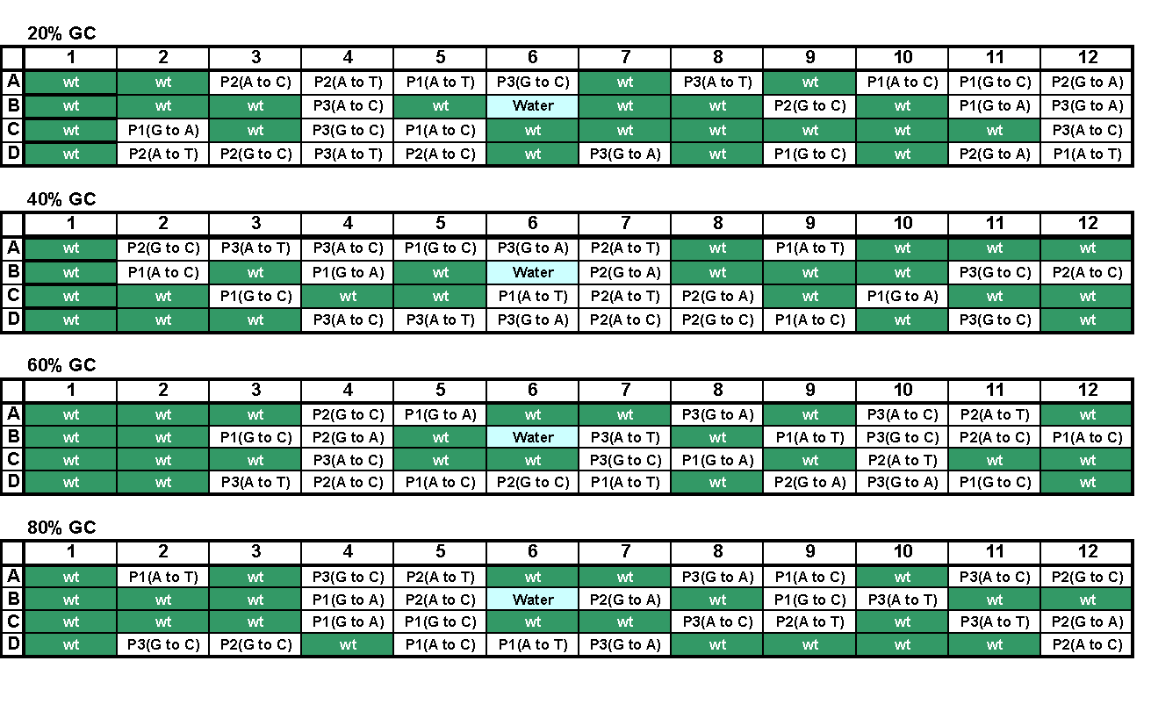

Appendix 1b: 96 well plate map showing randomisation of genomic DNA samples and NTCs
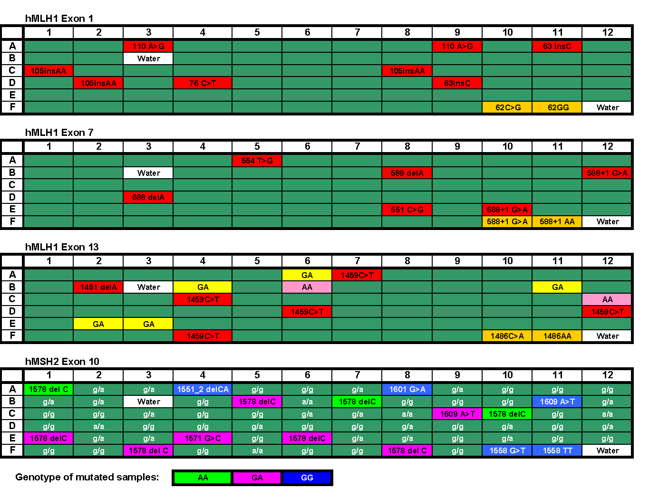

Appendix 2: PCR PRIMERS AND AMPLIFICATION CONDITIONS

Primer sequences

Amplicon Name | Size (bp) | %GC content | PCR primers
20L | 449 | 22 | F: TGATAAAATGAGTTGAGTATCTTTC  R: ACTATCCTTTTGTTGTTAATACCTTA
20S | 272 | 24 | F: TTCAGACATTTTTCTTTAGTT  R: ACTATCCTTTTGTTGTTAATACCTTA
40L | 437 | 39 | F: TGAGATGATGGGGTTTTCTA  R: GGATGCAAGGCTGGTTC
40S | 259 | 42 | F: TGAGATGATGGGGTTTTCTA  R: AATAATAAGAGCTATCTATGACAA
60L | 433 | 60 | F: AATTTGGCCTCTGGGATGAA  R: CCCTTTCTCCTTTGGCAATG
60S | 260 | 56 | F: AATTTGGCCTCTGGGATGAA  R: CACATTGTCCCACAGGAAGTC
80S | 258 | 77 | F: GCTGTCGGTGCTGTTGG  R: CTAGCGCCCAGCGAGAG
hMLH1x1 | 193 | 57 | F: GACGTTTCCTTGGCTCTTCTG  R: CCGTTAAGTCGTAGCCCTTAAGT
hMLH1x7 | 148 | 37 | F: AAAAGGGGGCTCTGACATCT  R: AAACAAAACCATCCCCCATA
hMLH1x13 | 247 | 44 | F: CAAGAATAATAATGATCTGCACTTCC  R: CAAAACCTTGGCAGTTGAGG
hMSH2x10 | 249 | 34 | F: TGGAATACTTTTTCTTTTCTTCTT  R: CACATCATGTTAGAGCATTTAGGG

Amplification conditions

1. Plasmid DNA Templates

All PCRs were performed using 1X LightScanner™ PCR Master mix (Idaho Technology), 0.2μM each primer, 10⁵ copies plasmid template DNA. The 80%S amplicon required the addition of 10% DMSO.

Cycling conditions: 94°C 1 min
94°C 10 sec
x°C 20 sec 40 cycles
72°C 20 sec

Annealing temperatures (x°C):

60°C 20%GC L
65°C 20%GC S
40%GC S
40%GC L
68°C 60%GC L
80%GC S
70°C 60%GC S (two step PCR 30 sec anneal and extend)

2. Genomic DNA Templates

PCR Reaction components | hMLH1 Exon 1 | hMLH1 Exon 7 | hMLH1 Exon 13 | hMSH2 Exon 10
Platinum Taq Buffer (Invitrogen) | 1X | 1X | 1X | 1X
MgCl₂ | 2mM | 1.5mM | 2mM | 2mM
dNTPs | 0.2mM | 0.2mM | 0.2mM | 0.2mM
Platinum Taq (Invitrogen) | 1 Unit | 1 Unit | 1 Unit | 1 Unit
LC Green® Plus (Idaho Technology) | 1X | 1X | 1X | 1X
F Primer | 0.2μM | 0.2μM | 0.2μM | 0.2μM
R primer | 0.2μM | 0.2μM | 0.2μM | 0.2μM
DNA | 10ng | 10ng | 10ng | 10ng

Cycling conditions: 94°C 1 min
94°C 10 sec
x°C 20 sec 40 cycles
72°C 20 sec

Annealing temperatures (x°C):

60°C hMLH1 Exon 7
63°C hMLH1 Exon 1
hMSH2 Exon 10
65°C hMLH1 Exon 13
APPENDIX 3: HRM MACHINE SPECIFICATIONS

1. Rotor-Gene™ 6000 (Corbett Life Science)

Instrument Options | P/N 62H0: 2-Plex (Green, Yellow) + HRM (High Res. Melt)  P/N 65H0: 5-Plex (Green, Yellow, Orange, Red, Crimson) + HRM (High Res. Melt)
Rotor Configurations | 30 µL x 100-wells: GeneDisc™ 100 (heat-sealed plate) (AVAILABLE SOON)  0.1 mL x 72-wells: GeneDisc™ 72 (heat-sealed plate)  0.1 mL x 72-wells: 0.1 mL strip tubes (strips of 4 with matching caps)  0.2 mL x 36-wells: 0.2 mL tubes with attached cap (flat or domed)
Channel Information
  Colors  Blue  Green  Yellow  Orange  Red  Crimson  HRM | Excite/Detect  365/470  470/510  530/555  585/610  625/660  670/710  460/510 | Some Example Fluorophores Detected  BiosearchBlue™, Marina Blue®, Bothell Blue®, Alexa Fluor® 350…  FAM™, SYBR® Green 1, Fluorescein, EvaGreen™, Alexa Fluor® 488…  JOE™, VIC™, HEX™, TET™, Yakima Yellow®, CAL Fluor® Gold 540...  ROX™, Cy®3.5, Redmond Red®, Alexa Fluor®568, CAL Fluor®Red 610…  Cy®5, Quasar®670, LCRed650®, Texas Red®, CAL Fluor® Red 635…  Quasar705™, LCRed705®, Alexa Fluor® 680  SYTO®9, LC Green®, LC Green® Plus+, EvaGreen™...
Thermal Performance | Uniformity: ± 0.01°C  Resolution: ± 0.02°C  Range: ambient–99°C  Maximum Ramp Rate: 10°C/sec (air)
Optical System | Fixed path length  Separate color high-intensity LED (light-emitting diode) excitation source per channel  Separate emission filter per channel
Detector | Photomultiplier (PMT) detector with variable or automatic gain setting (sensitivity control), user selected
Dimensions | H 275 mm (10.8") , W 370 mm (14.6") , D 420 mm (16.5") door closed, 560 mm (22") door open
Weight | 14 kg (31 lbs)
Electrical | 100-120VAC @ 60Hz, 200-240VAC @ 50Hz  Power consumption: 8 VA (idle/standby), 560 VA (peak)
Communications | USB or RS232 Serial Port
Computer | Pentium™ IV, 2 GHz, 512 MB RAM , Windows XP® operating system
Software | Extensive analysis, graphing and statistical functions built-in  Unlimited use software license included  Free upgrades (by web download)
40 Cycle Run | Typically 40 minutes to 1.5 hours (protocol dependant)
Supported Volumes | 5 µL to 100 µL (protocol dependant)  Typical reaction volume 20 µL
Instrument Color | Outback Red high-gloss metallic  Bondi Blue high-gloss metallic
High-Resolution Melt | Dedicated high-performance optical subsystem, additional hardware and specific HRM analysis software (fully integrated).  Thermal uniformity ±0.01°C, Resolution ±0.02°C, Range ambient–99°C  HRM data acquisition (read) rate: 20 reads for each 0.02°C increment (=1000 reads/°C)
Concentration Measurement | For direct measurement of nucleic acid concentration using fluorescent dyes (e.g. PicoGreen®, RiboGreen®, etc). Comprises dedicated analysis software (standard on all models

2. HR-1™ (Idaho Technology)

Linear Ramp Rate | 0.01ºC to 1ºC per second
Temperature Range | Ambient to 100ºC
Data Acquisition | 24 bit temperature and fluorescence analogue to digital conversion
Sample Volume | 5-20 µl
Capacity | Single sample melting using glass capillary tubes.  Typical Throughput: 35 samples per hour with a 0.3°C ramp rate
Laptop Computer | Dell Notebook Computer with Ethernet capabilities
Software | Windows based software includes control and analysis modules
Size | 4 x 5.5 x 12 inch / 10.2 x 14 x 30.5 cm (w x h x d)
Weight | 5.8 lbs. / 2.65 kg
Power Supply | 100 to 240 VAC, 1.3 Amp, 50/60 Hz universal power

3. LightScanner™ (Idaho Technology)

Linear Ramp Rate | 0.15 °C per second
Temperature Range | Ambient to 100 °C
Sample Volume | Standard 96 or 384 microtitre plate
Capacity/Throughput | 15 minutes per run, over 20,000 samples per 8 hour day (96 wells)
Melting Cycles | 1 to 100
Desktop Computer | Windows XP, Pentium 4 Computer with 17” Monitor
Software | Windows based software includes control and analysis modules
Size (w x h x d) | 7 x 31 x 16.5 inch / 20 x 81 x 42 cm
Weight | 55.1 lbs / 25 kg
Power Supply | 100 to 240 VAC, 2.5 Amp, 50/60 Hz

APPENDIX 4: AMPLIFICATION PLOTS AND AGAROSE GEL IMAGES
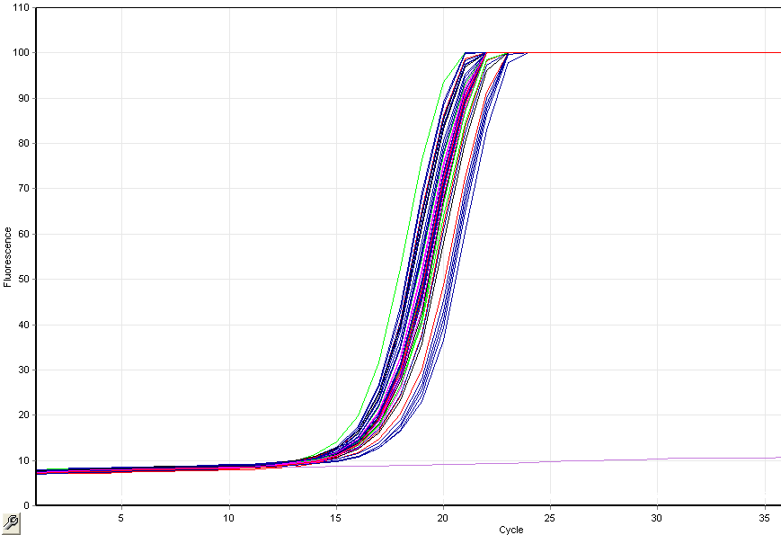
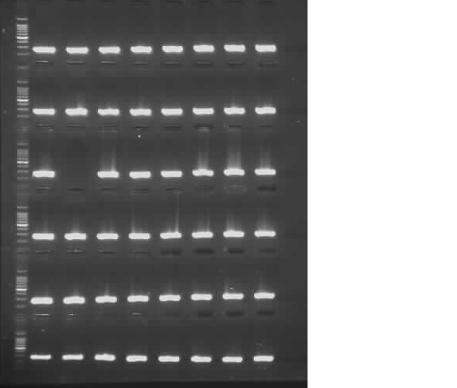
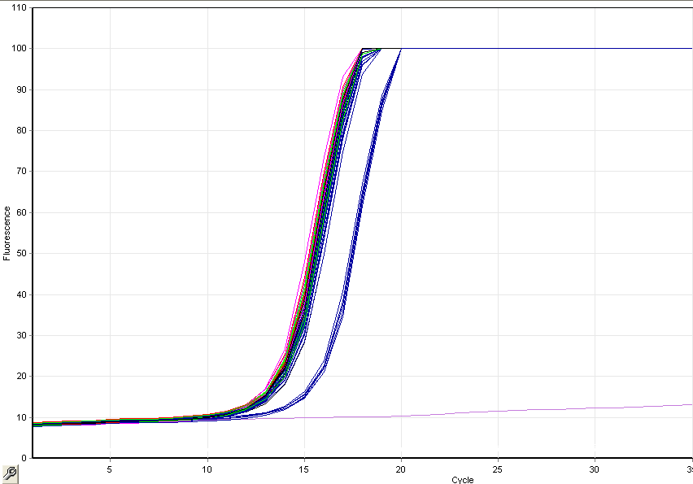
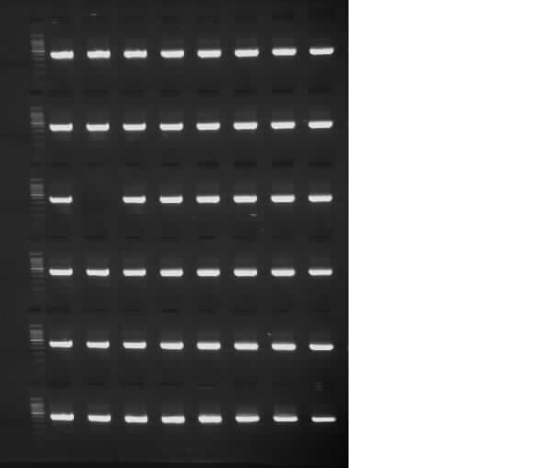
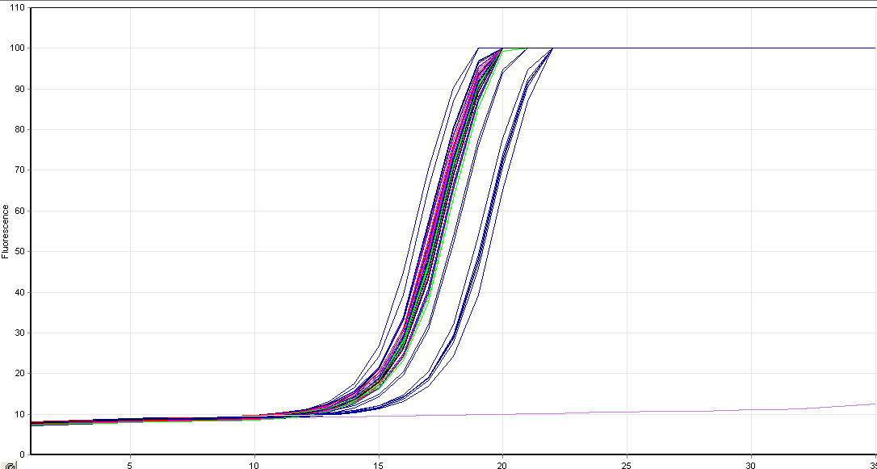
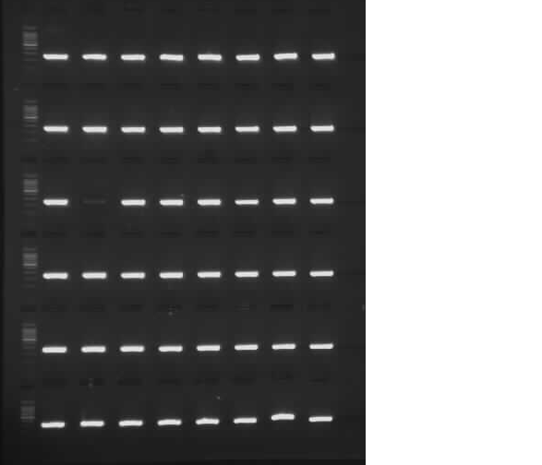
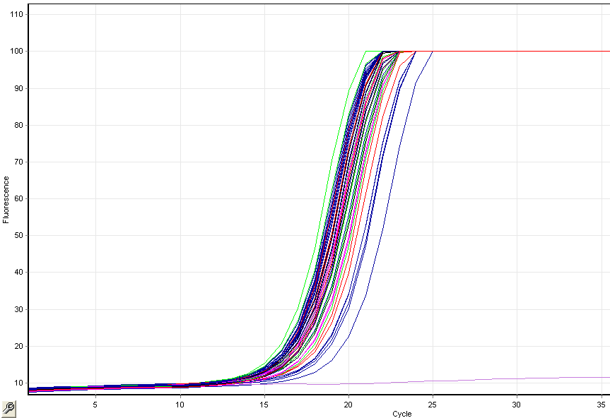
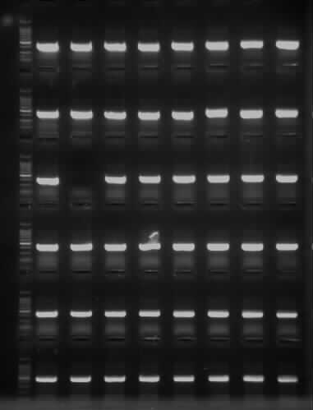
20% GC S
40% GC L
40% GC S
20% GC L
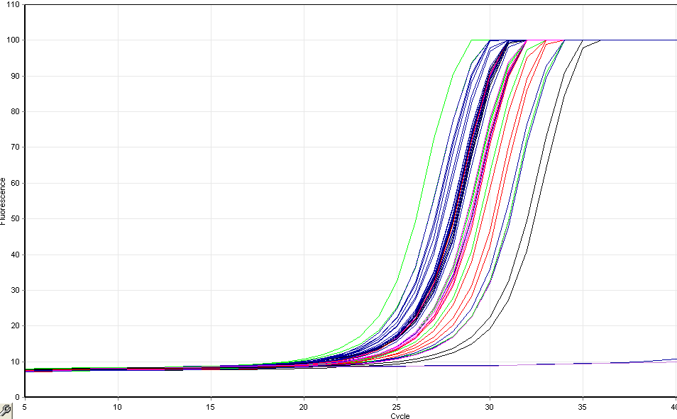
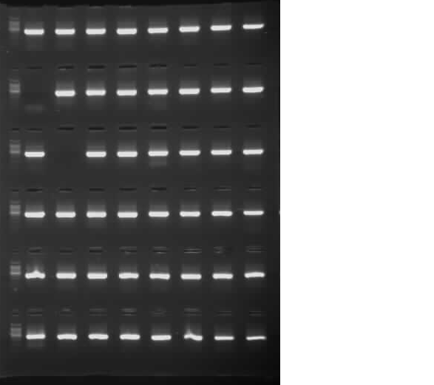
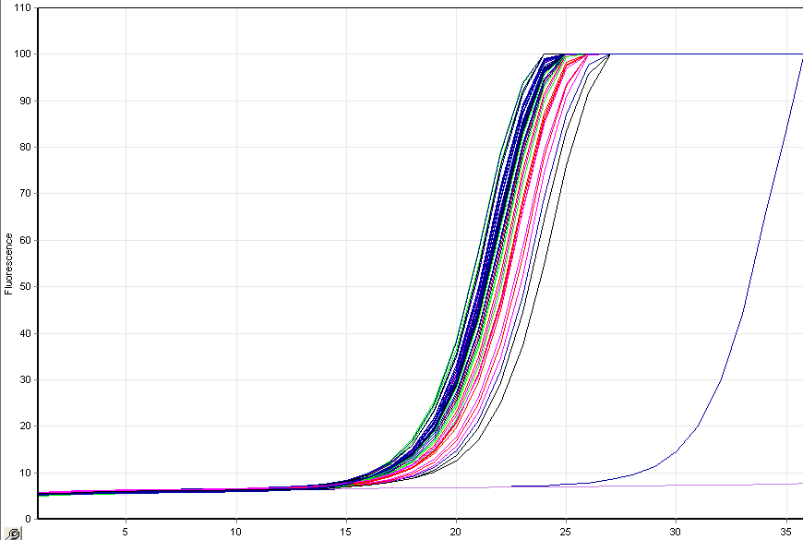
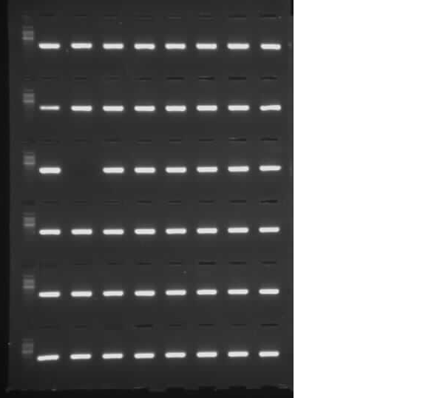
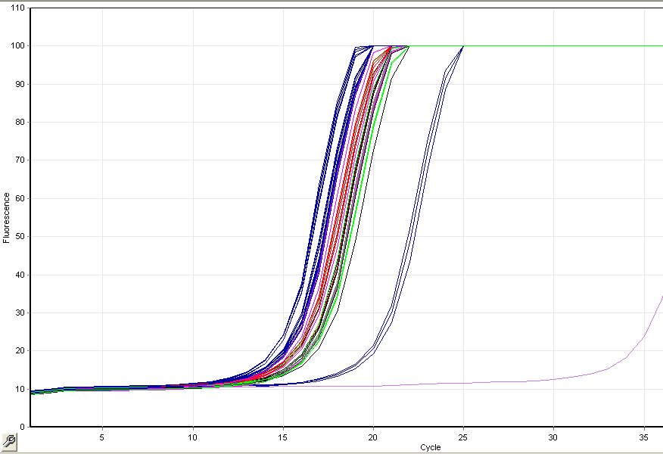
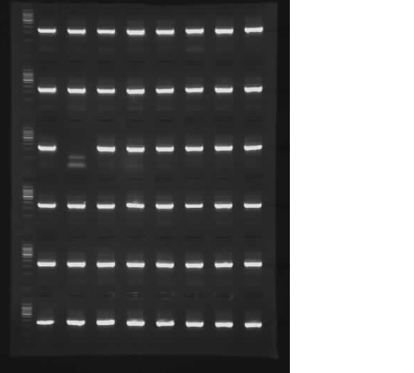
60% GC L
60% GC S
80% GC S
20%GC S
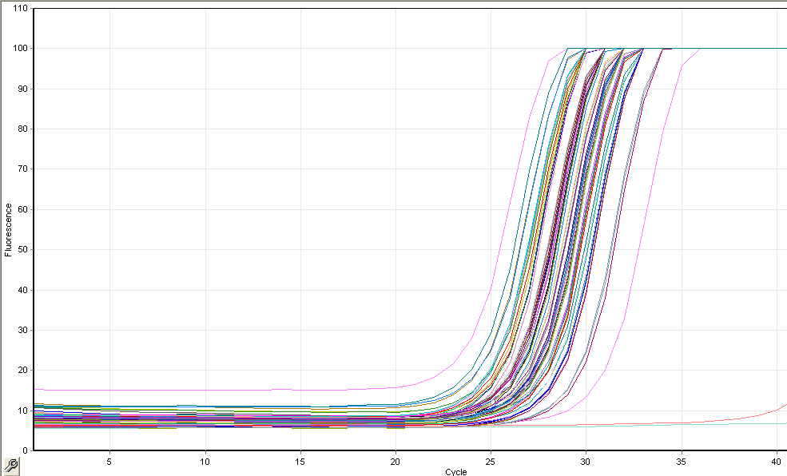
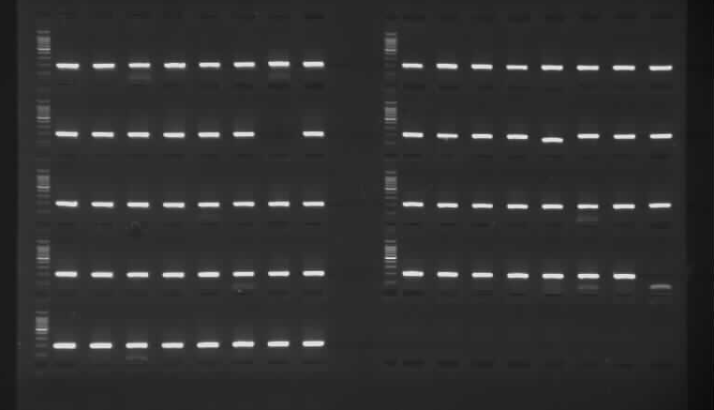
hMLH1 Exon 1
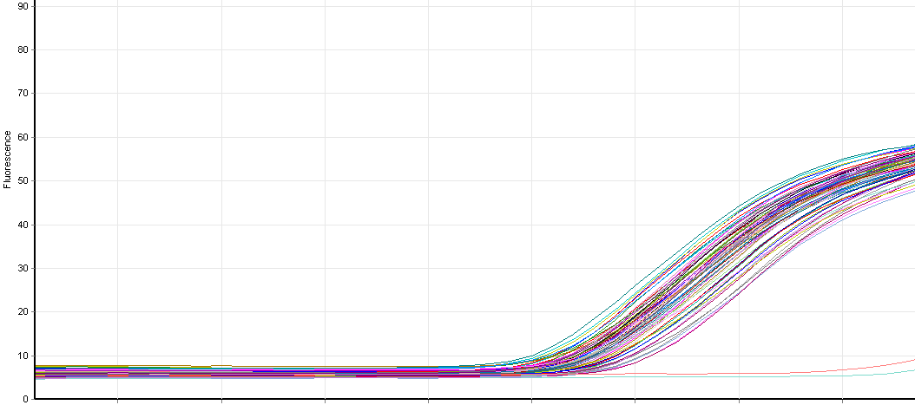
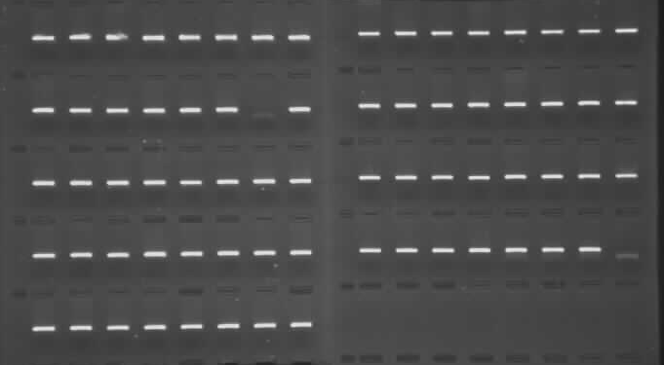
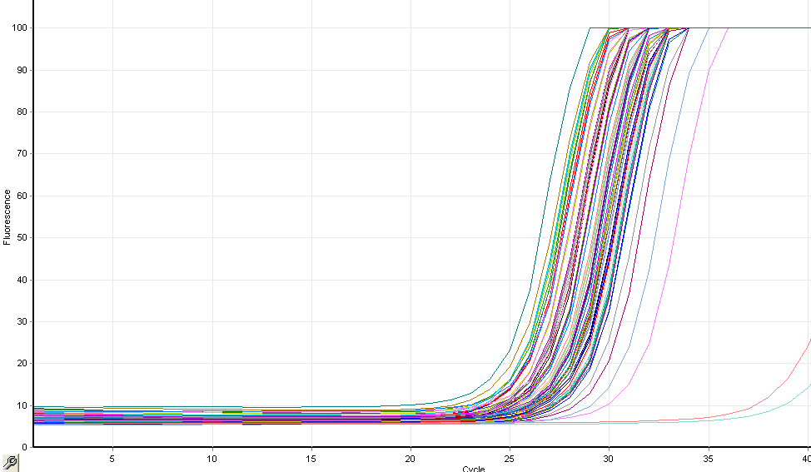
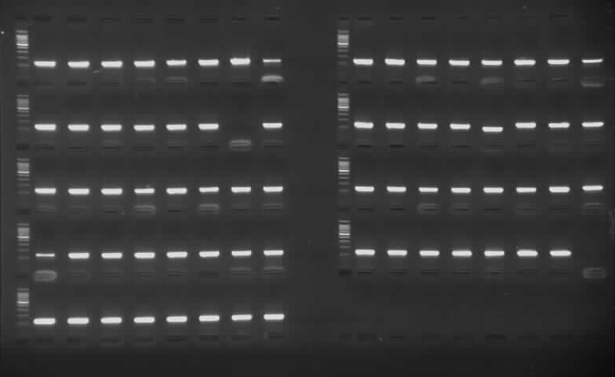
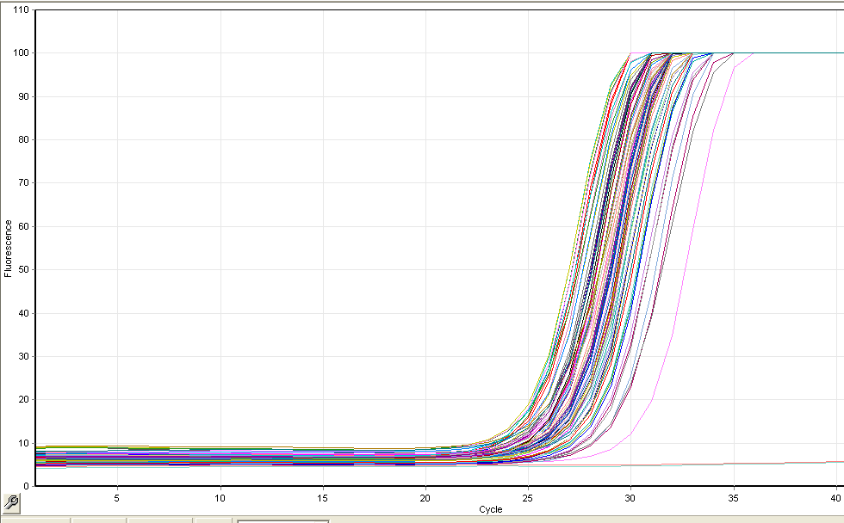
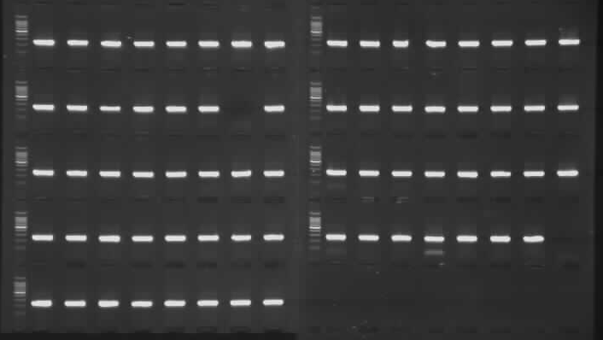
hMLH1 Exon 7
hMLH1 Exon 13
hMSH2 Exon 10
APPENDIX 5: Data Analysis
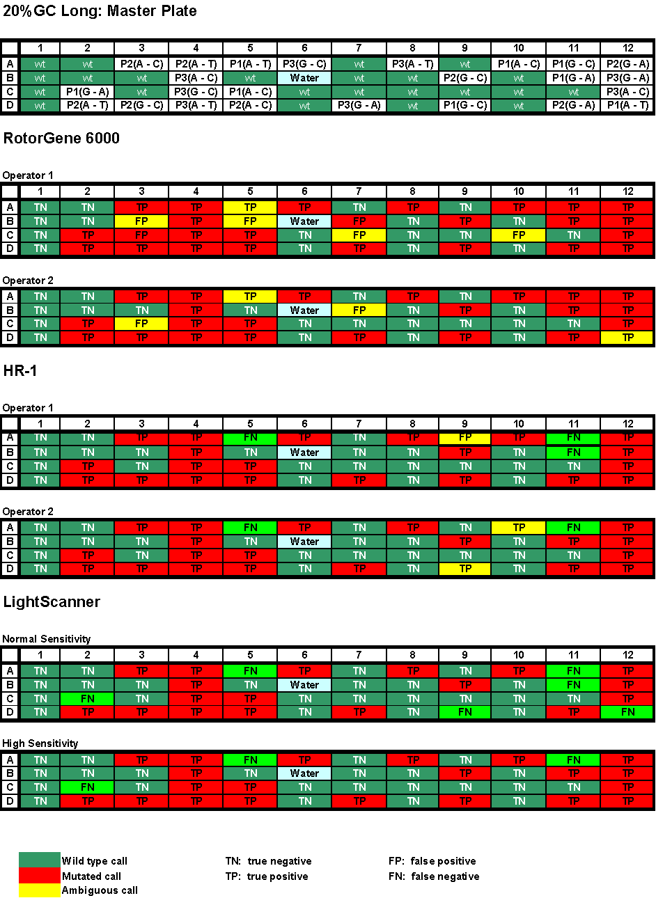
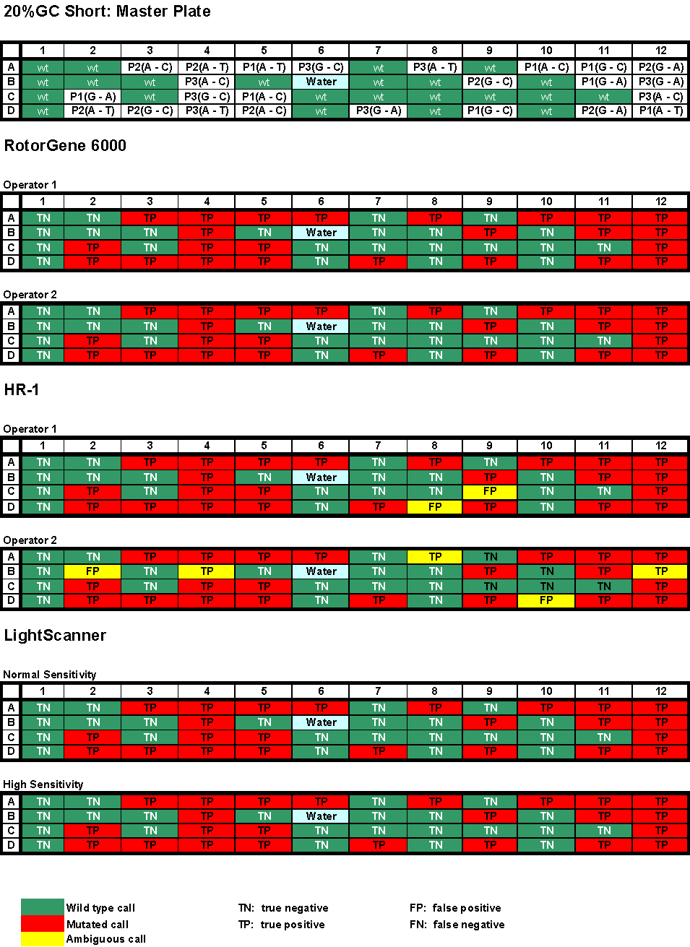
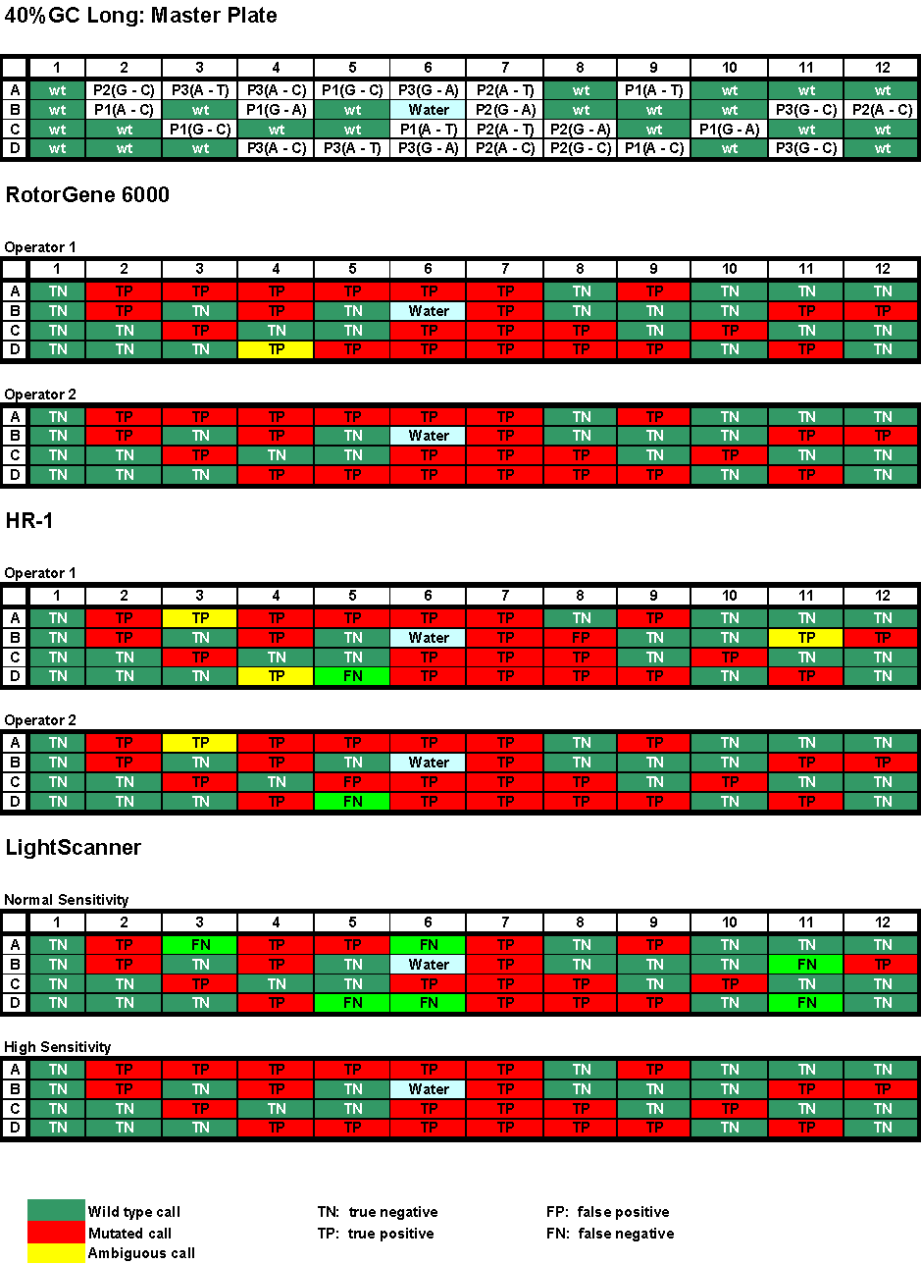
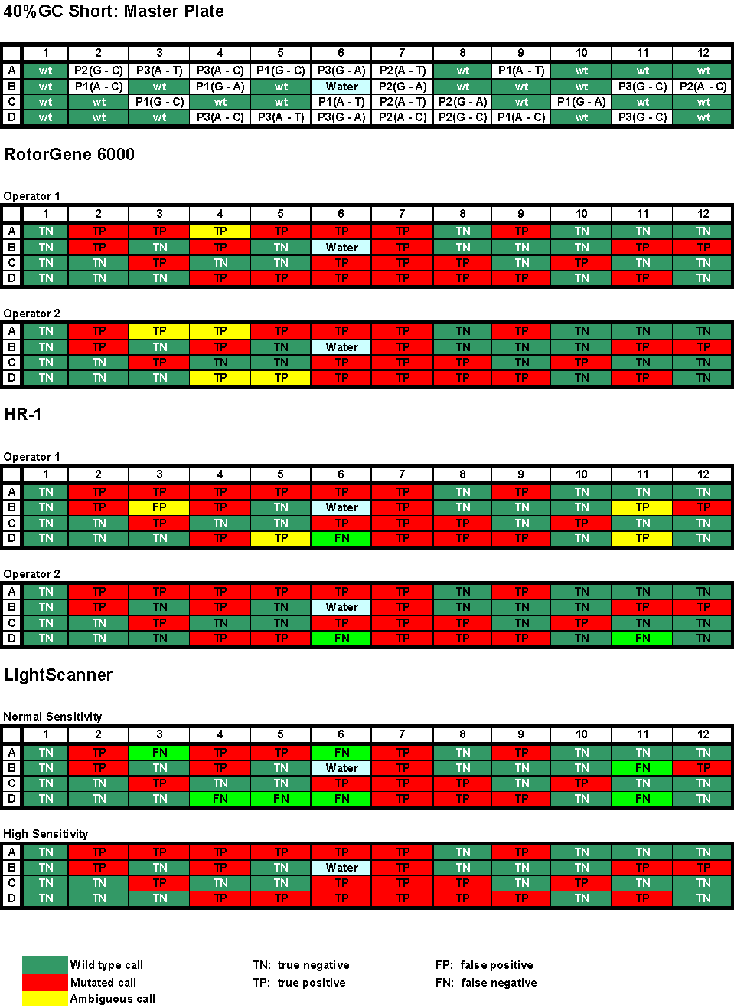
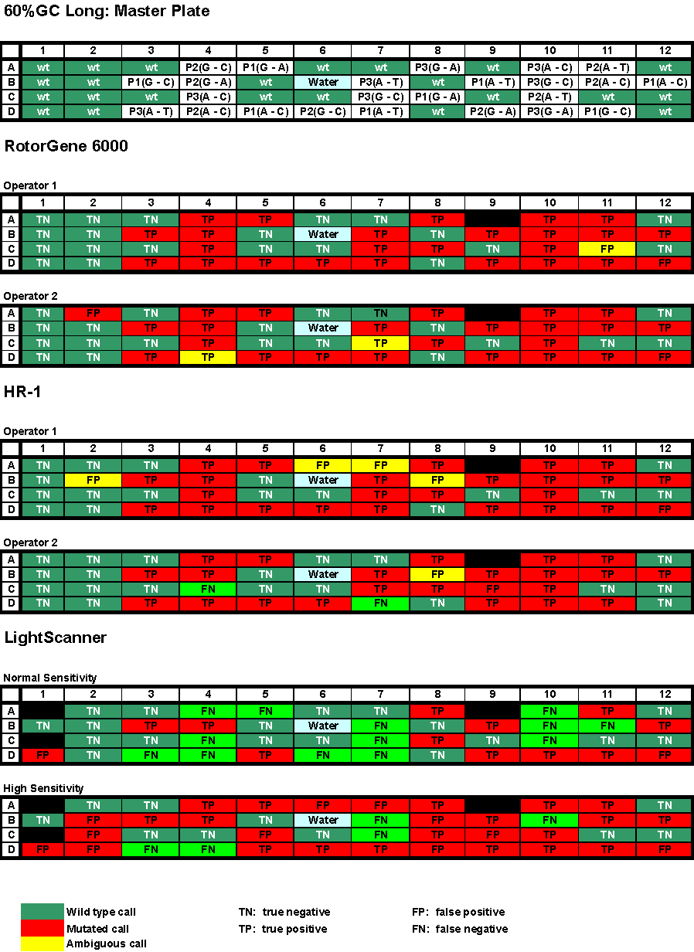
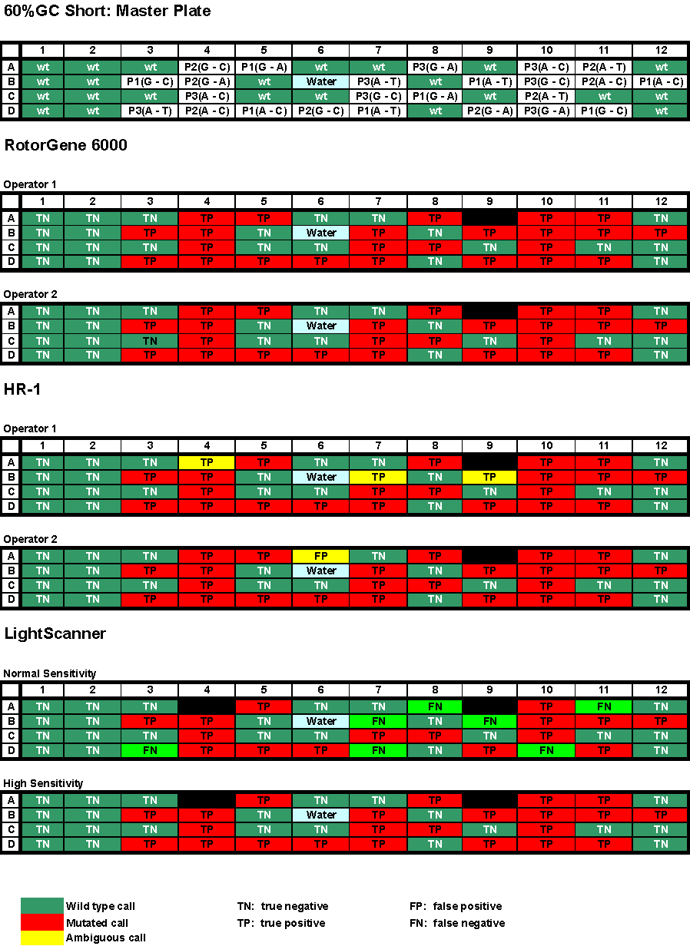
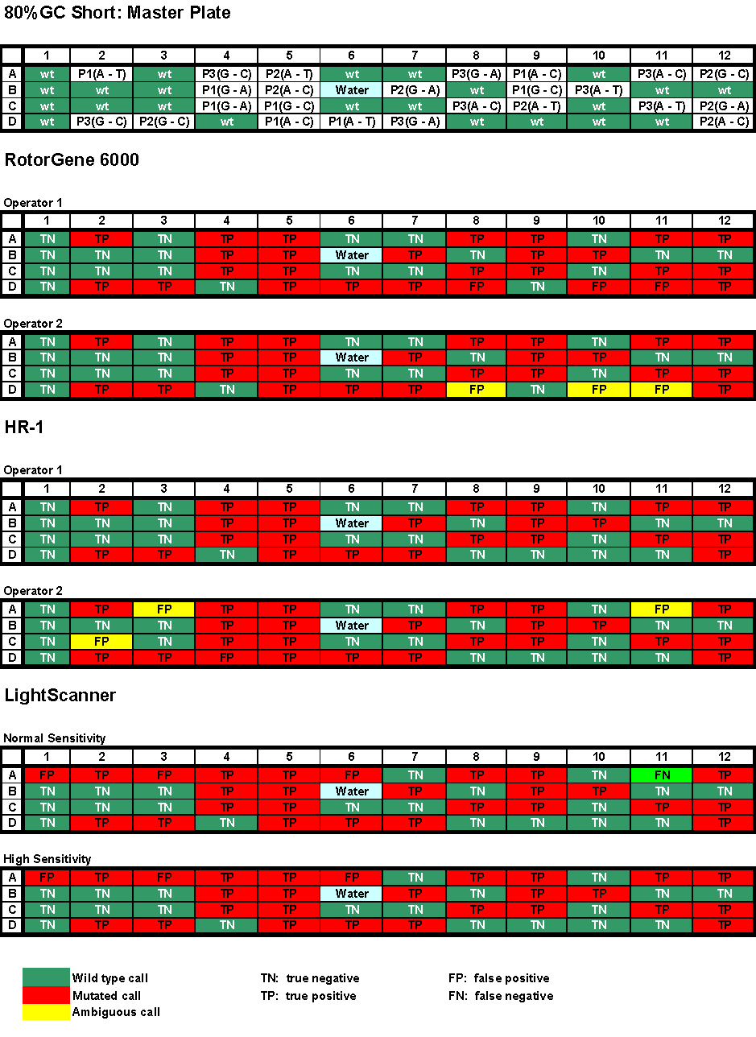
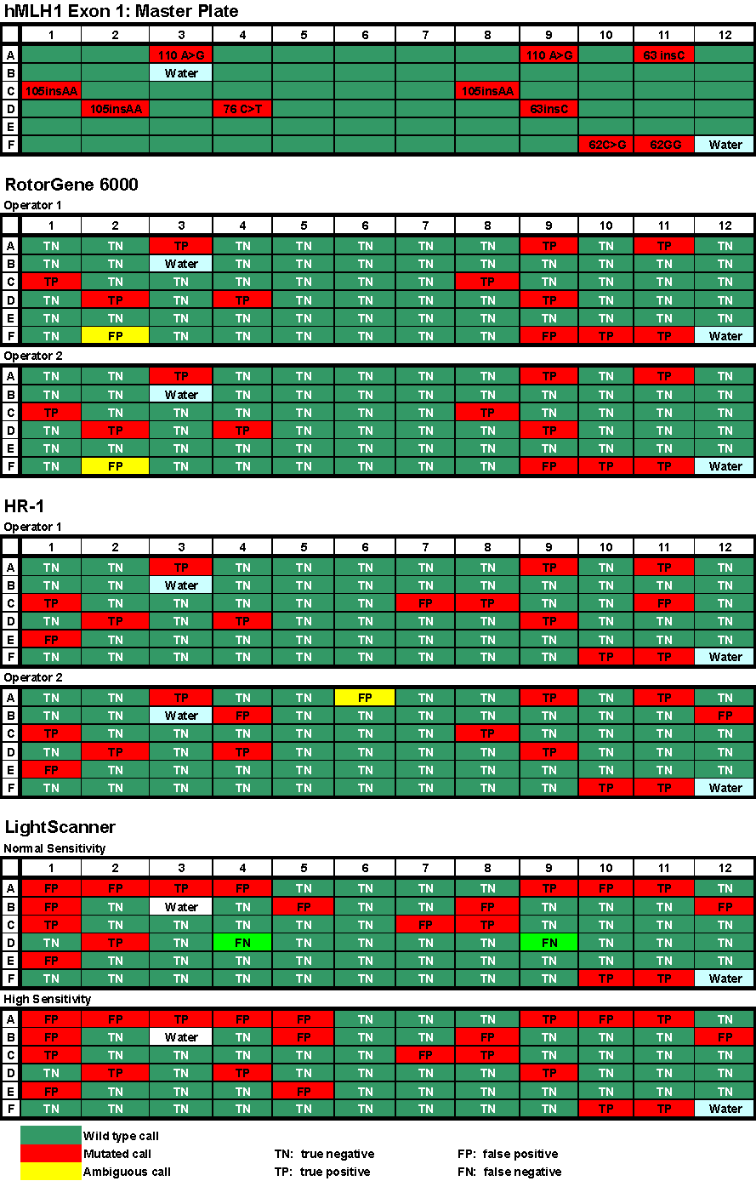
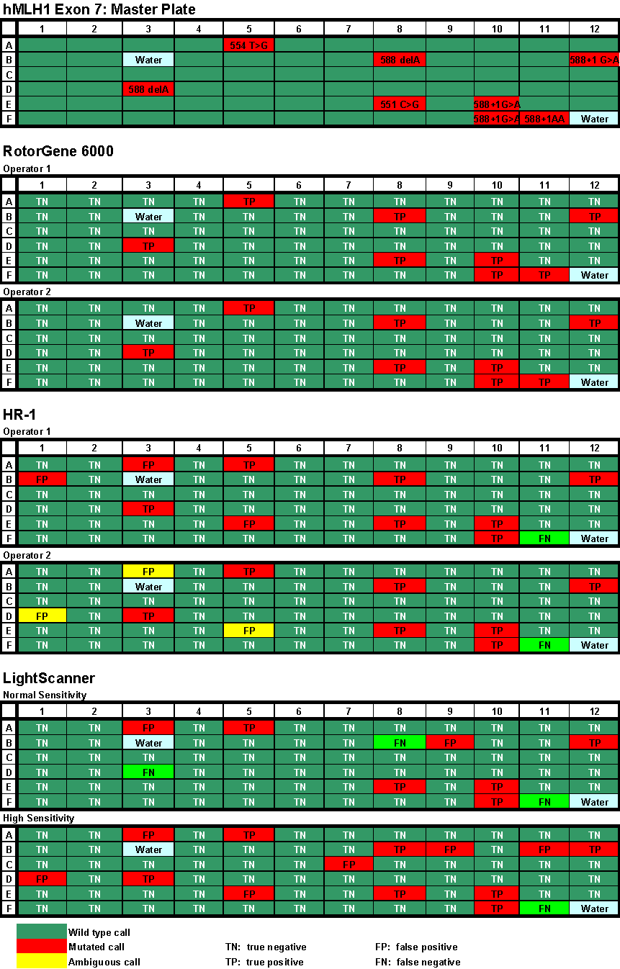
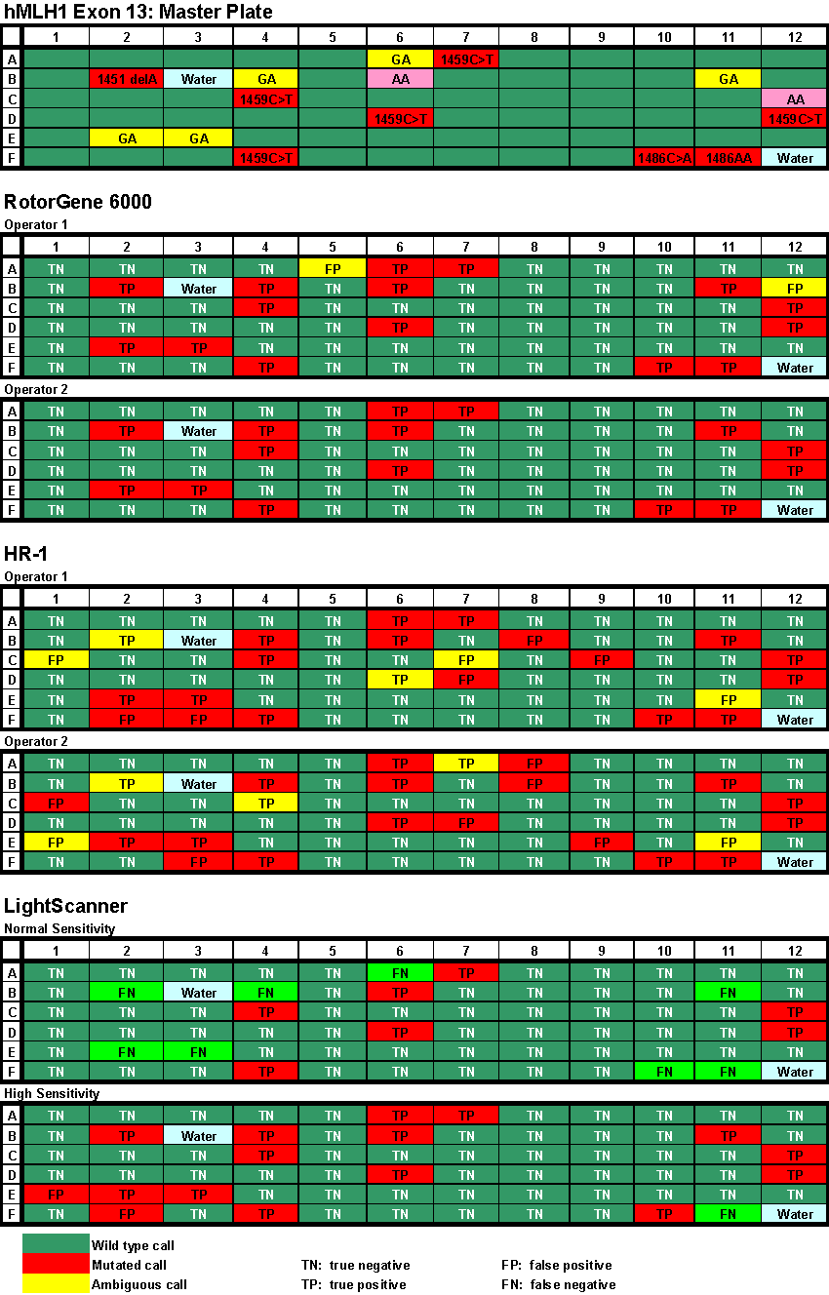
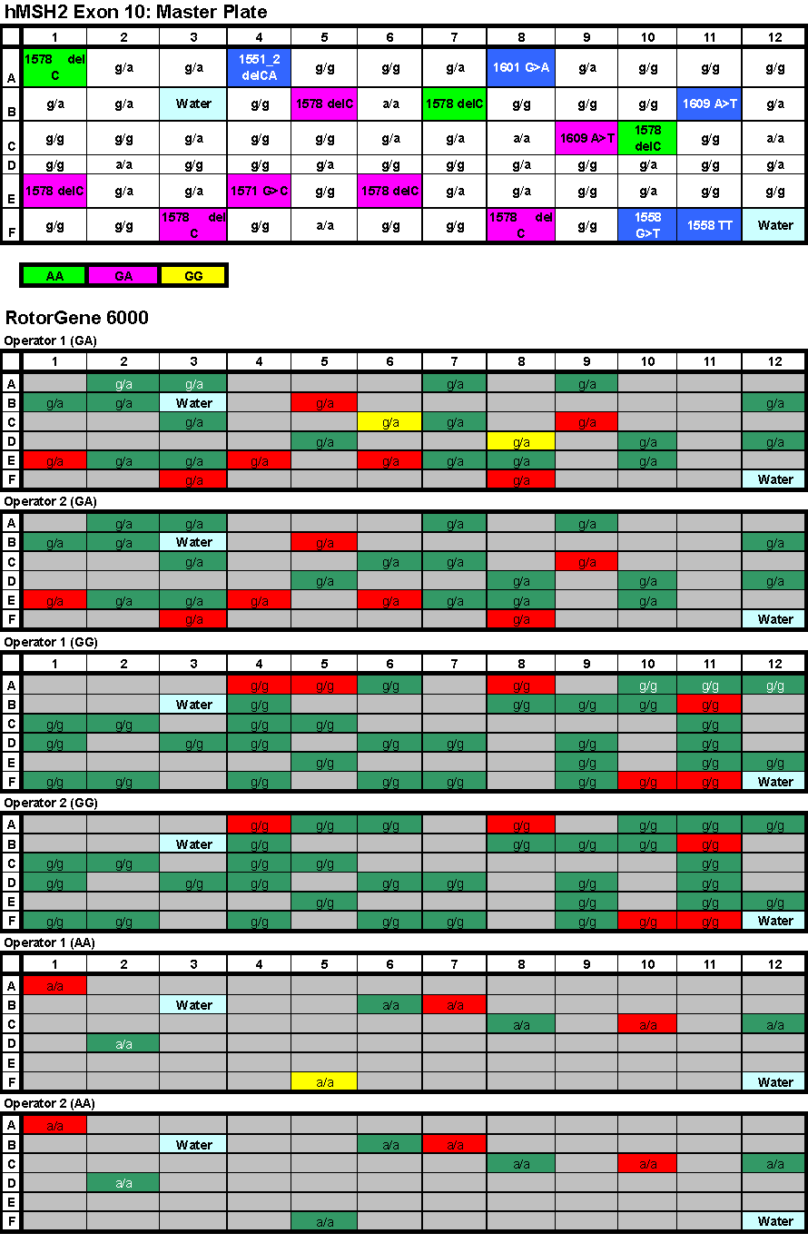
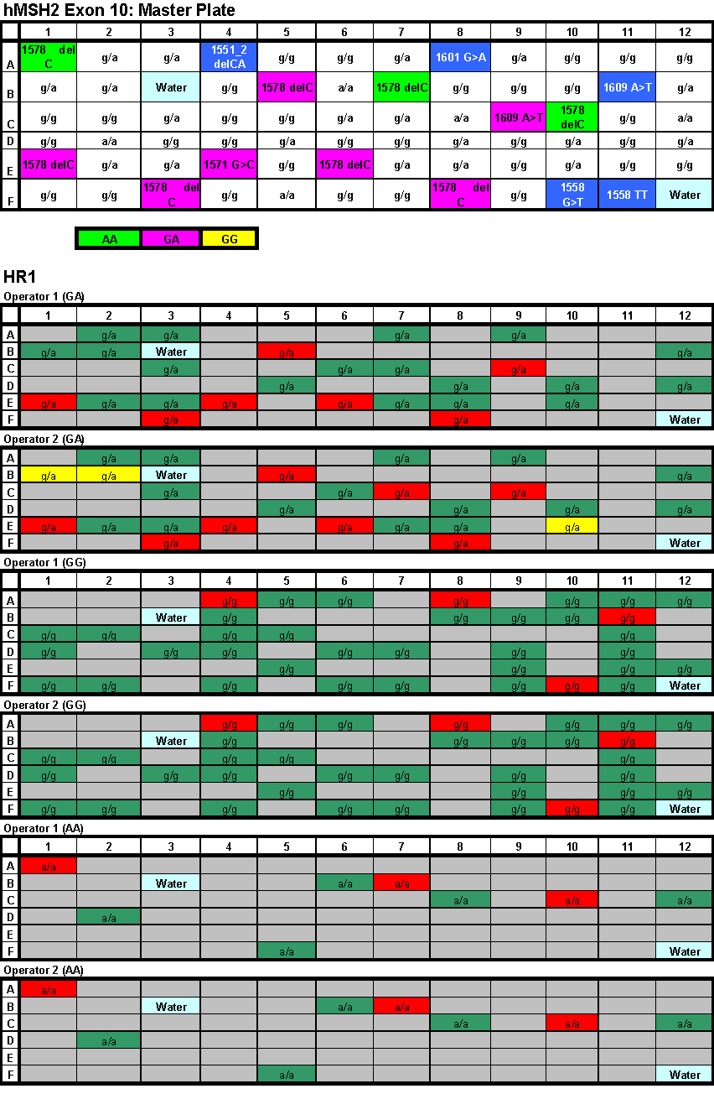
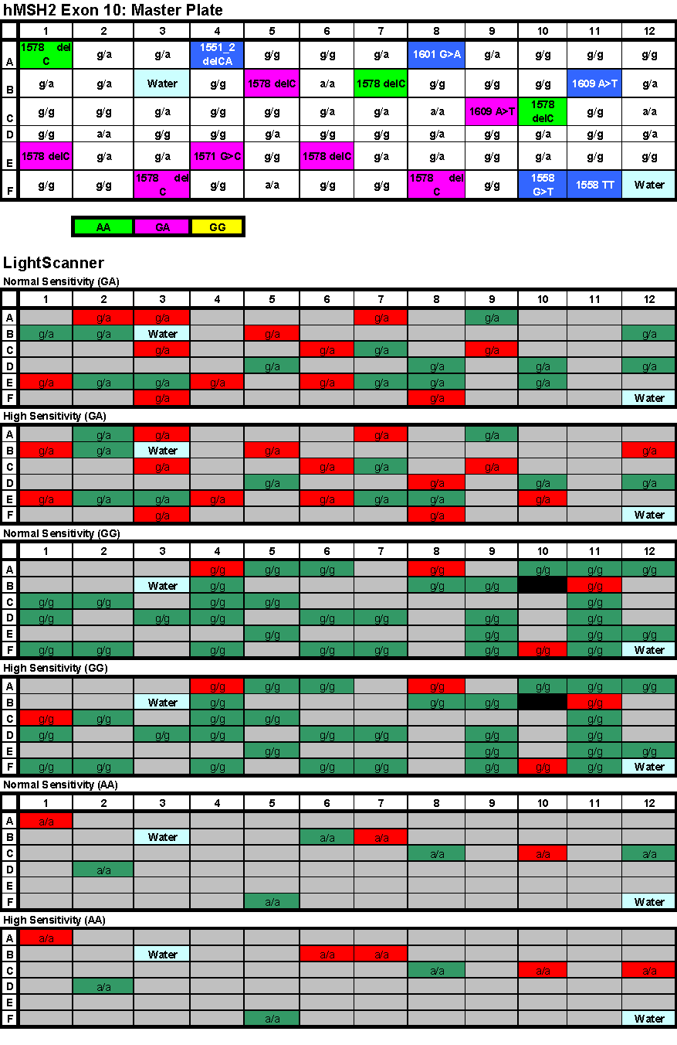

APPENDIX 6:
High Resolution Melt Curves

(file can be downloaded from www.ngrl.org.uk/Wessex)

APPENDIX 7:

Company comments

Letter from Corbett Life Science can be downloaded or viewed at www.ngrl.org.uk/Wessex


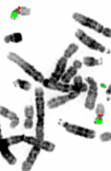

National Genetics Reference Laboratory (Wessex)
Salisbury District Hospital
Salisbury SP2 8BJ, UK

www.ngrl.org.uk

