

National Genetics Reference Laboratory (Wessex) & National Institute of Biological Standards and Control



Reference Reagents
Freeze Dried Cell Lines as reference materials for standardisation of BCR-ABL RQ-PCR methods: report of field trial evaluation

May 2008

Title | Freeze Dried Cell Lines as reference materials for standardisation of BCR-ABL RQ-PCR methods: report of field trial evaluation
NGRL Ref | NGRLW_NIBSC_BCR_ABL_1.0
Publication Date | May 2008
Document Purpose | Dissemination of information about production and field trial evaluation of reference materials for BCR-ABL RQ PCR methods
Target Audience | Laboratories performing BCR-ABL RQ-PCR and participants of NGRL (Wessex) / NIBSC field trial.
NGRL Funded by | 

Contributors to report writing

Name | Role | Institution
Dr Helen White | Senior Scientist | NGRL (Wessex)
Prof Nick Cross | Director | NGRL (Wessex)

Peer Review and Approval

This document has been reviewed by the field trial participants.

Conflicting Interest Statement

The authors declare that they have no conflicting financial interests

How to obtain copies of NGRL (Wessex) reports

An electronic version of this report can be downloaded free of charge from the NGRL website (http://www.ngrl.org.uk/Wessex/downloads)

or by contacting

Dr Helen White
National Genetics Reference Laboratory (Wessex)
Salisbury District Hospital
Odstock Road
Salisbury
SP2 8BJ
UK

E mail: hew@soton.ac.uk
Tel: 01722 429016
Fax: 01722 338095

Table of Contents

Summary…...…………………………………………………………………………….…1

1. Introduction 2

2. Materials and Methods 3
2.1 Cell lines and preparation of reference materials 3
2.2 Pilot field trial (27th April – 1st June 2007) 3
2.2.1 Freeze dried cell mixtures 3
2.2.1.1 Resuspension protocol A 4
2.2.1.2 Resuspension protocol B 4
2.2.2 Pre-freeze dried material 4
2.2.3 Analysis of samples 4
2.3 Large field trial evaluation (29th June – 7th September 2007) 4
2.4 Accelerated degradation studies 5

3. Results of Pilot field trial 6
3.1 Amount of RNA Extracted 6
3.2 RQ-PCR for BCR-ABL and control genes 6
3.2.1 Absolute copy numbers (b3a2 and control gene transcripts) 6
3.2.1.1 ABL 6
3.2.1.2 BCR 6
3.2.1.3 GUSB 6
3.2.2 % BCR-ABL / control gene(s) 9

4. Results of Large Field trial 11
4.1 Methodologies used 11
4.1.1 Control genes analysed 11
4.1.2 RQ-PCR machines used 11
4.1.3 RQ-PCR methods 11
4.1.3.1 RNA Extraction methods 11
4.1.3.2 RT-PCR method cited 11
4.1.3.3 RT-PCR method and primers used 11
4.1.3.4 Standard type and source 11
4.2 Field trial data analysis 11
4.2.1 RNA Extraction 11
4.2.2 Mean copy numbers obtained for control genes 12
4.2.3 Mean, standard deviation and coefficient of variation for % BCR-ABL / Control gene 13
4.2.4 Linear regression 16
4.3 Use of prototype reference materials for standardisation 20
4.3.1 Correct Y to scale of X by inverting the regression 20
4.3.2 Using IS conversion factor method from Adelaide 21
4.3.3 Converted % BCR-ABL / ABL data (HL60) 22
4.3.3.1 Un- transformed data 22
4.3.3.2 Log transformed data 22

5. Conclusions 23
5.1 Pilot field trial 23
5.2 Large Field trial 23

6. Future Work 24

7. Acknowledgments 24

8. References 25

Appendix A Field trial participants 26
Appendix B Linear regression plots for individual labs 27

SUMMARY

- An international scale (IS) for quantitative measurement of BCR-ABL mRNA has been established that is anchored to two key points defined in the IRIS trial: a common baseline (100% BCR-ABL^{IS}) and major molecular response (0.1% BCR-ABL^{IS}). Definition of the IS currently relies on relating results directly or indirectly to the Adelaide international reference laboratory. A more robust definition of the IS requires the development of internationally accredited reference reagents.

- The aim of this collaborative study was to produce and assess the use of freeze dried cell lines as candidate reference materials for the standardisation of BCR-ABL RQ-PCR protocols.

- Eight reference standards were prepared by diluting K562 cells (b3a2 expressing cell line) into two BCR-ABL negative cell lines: HL60 and KG1. Cell mixtures with four levels of BCR-ABL in each negative cell line were produced and freeze dried at 3x10⁶ cells/vial.

- The performance of the freeze dried cells was assessed by an international field trial (June - October 2007) that involved 14 laboratories (7 EU, 4 USA, 3 Asia/Australasia) using 7 different protocols and 9 different RQ-PCR platforms.

- RNA (median 30μg/vial) was successfully extracted from freeze dried cell mixtures shipped worldwide at ambient temperature.

- The median number of copies obtained for ABL, BCR and GUSB for the HL60 material were 1.16E+05, 2.60E+05 and 1.70E+05 respectively and for the KG1 material were 1.02E+05, 5.85E+05 and 1.13E+05 respectively.

- The coefficient of variation for % BCR-ABL / control gene values obtained from all labs were comparable to those obtained in the IS conversion factor rounds administered by the Mannheim laboratory using primary patient samples. There was no statistical difference between the CVs obtained from either cell line for any of the control genes.

- Linear regression plots were produced for log transformed lab data plotted against the log transformation of the reference standard values. The resulting regression equations were used to successfully standardize / convert the data to the reference material values.

- Both freeze dried cell line mixes appear to be suitable for development of BCR-ABL reference reagents and accelerated degradation studies of the material are ongoing.

- A medium scale pilot freeze dry study using the HL60 / K562 cell mixture is planned for mid-2008 in collaboration with NIBSC and the European Collection of Cell Cultures (ECACC).

- If this pilot is successful, a large scale culture of the two cell lines will be performed to enable the production of 3000 vials for each level of BCR-ABL (12,000 vials total).

Introduction
Reverse-transcription real-time quantitative PCR (RQ-PCR) is routinely used to quantify levels of BCR-ABL mRNA transcripts in peripheral blood and bone marrow samples from chronic myeloid leukaemia (CML) patients. The technique can determine accurately the response to treatment and is particularly valuable for patients who have achieved complete chromosomal remission. Despite efforts to establish standardised protocols for BCR-ABL fusion transcript quantitation¹ there is still substantial variation in the way in which RQ-PCR for BCR-ABL is carried out and how results are reported in different laboratories worldwide². In particular, the use of different control genes for normalisation of results means that there are several different units of measurement worldwide, e.g. BCR-ABL/ABL; BCR-ABL/BCR; BCR-ABL/GUSB, BCR-ABL/G6PD, BCR-ABL/β2M etc.

The CML meeting at the National Institutes of Health in Bethesda in October 2005 made several recommendations for the harmonisation of RQ-PCR for BCR-ABL including the use of one of three control genes (ABL, BCR or GUSB) ^{3,4}. Most importantly, a new international scale (IS) for BCR-ABL RQ-PCR measurements was proposed which is anchored to two key levels used in the IRIS study ⁵, namely a standardised baseline defined as 100% BCR-ABL^{IS}, and major molecular response (3 log reduction relative to the standardised baseline) defined as 0.1% BCR-ABL^{IS}. Laboratories interested in using the IS should derive a laboratory-specific conversion factor to relate values obtained in their laboratory to IS values. The converted value from a given laboratory should then be equivalent to an analogous converted value obtained in any other collaborating laboratory. The strength of this approach is that (i) laboratories can continue to use their existing assay conditions (provided their assay is linear on analysis of the reference samples), and (ii) that they can continue to express results according to local preferences in addition to expressing results on the international scale. The concept of the international scale is analogous to established procedures for other quantitative assays, for example the International Normalised Ratio (INR) for prothrombin time.

The original standards used for the IRIS trial are no longer available, however traceability to the IRIS scale is provided by the extensive quality control data generated by the Adelaide laboratory over a period of several years. Establishment of the IS therefore requires the alignment of local test results either directly or indirectly with those obtained in Adelaide. Currently, this can be achieved by exchange of a series of patient samples with either the Adelaide or Mannheim international reference laboratories. Although this system works well, it is very laborious and consequently only open to a limited number of laboratories at any given time. The availability of internationally accredited reference reagents should in principle help to make the IS more accessible, as well providing a more robust framework for the scale itself.

Ideally, the formulation for reference reagents should be as close as possible to the usual analyte, should cover the entire analytical process, i.e. from RNA extraction to result and should be applicable to methods in use throughout the world. However it is essential that the formulation is stable over a period of several years and that it is physically possible to produce batches of sufficient size to satisfy demand over a similar period of time. It has been shown previously that good quality RNA can be extracted from freeze dried K562 cells⁶ and therefore one possible solution is the use of freeze dried cell line mixtures.

The aim of this collaborative study was to produce and perform a preliminary assessment of the use of freeze dried cell line mixtures as universal reference materials. As an initial step we identified cell lines in which the relative ratio of the three recommended control genes – BCR, ABL and GUSB – was similar to that seen in normal leucocytes. We surveyed 26 haemopoietic cell lines (ACC42, Jurkat, JVM2, Loucy, MOLT3, NALM76, PEER, REH, RS4-11, T-ALL1, THP1, HeLa, MV4-11, Karpas, Caco2, ML-1, ML-2, 1E8, ALLPo, NB4, KG1, KG1a, HL60, Kasumi1, NOMO1, SKM1) in up to 4 different centres and identified KG1 and HL60 as the best candidates to take forward for detailed evaluation. This report details the preparation of pilot reference materials and their evaluation in an international field trial that involved 14 laboratories (7 EU, 4 USA, 3 Asia/Australasia) using 7 different protocols and 9 different RQ-PCR platforms

Materials and Methods

Cell lines and preparation of reference materials
HL60 and KG1 cell lines were obtained from DSMZ and the K562 cell line was obtained from the Hammersmith Hospital, London, UK. All cell lines were grown in RPMI 1640 medium supplemented with 10% fetal bovine serum (Sigma Aldrich). For evaluation purposes we aimed to produce four dilutions of K562 in both HL60 and KG1 that corresponded roughly to 10% (Level 1), 1% (Level 2), 0.1% (Level 3) and 0.01% (Level 4) BCR-ABL-ABL.

9 x 10⁸ HL60 and KG1 cells harvested from cultures in exponential phase were centrifuged at 1300rpm (Centra CL3, 243 Rotor, Thermo IEC) for 5 minutes and resuspended in 150ml ice cold 2X PBS (6 x 10⁶ cells / ml). The Level 1 HL60 / K562 cell mix was prepared by resuspending 1.2 x 10⁷ K562 cells in 2.4 x 10⁸ HL60 cells (40ml of HL60 cell solution in 2X PBS). The Level 1 KG1 / K562 cell mix was prepared by resuspending 2.4 x 10⁷ K562 cells in 2.4 x 10⁸ KG1 cells (40ml of KG1 cell solution in 2X PBS). Level 2, 3 and 4 cell mixes for each of the two BCR-ABL negative cell lines HL60 and KG1 were prepared by performing 10 fold serial dilutions of the Level 1 samples in the 2X PBS cell suspensions. Aliquots from each dilution were lysed directly into Trizol (Invitrogen) for subsequent comparison with the freeze dried cells.

2.1 x 10⁸ cells (35ml at 6 x 10⁶ cells / ml in 2X ice cold PBS) for each of the four BCR-ABL level dilutions for each cell line were transferred to the National Institute for Biological Standards and Control (NIBSC) on ice within 6 hours after processing. On the same day, 5ml glass vials were filled with 3 x 10⁶ cells (0.5ml) for freeze drying. The drying process took 65-67 hours and a total 475 vials were produced.

K-562 Cells in HL-60 cells Level 1 PM-07-011-A (60 vials)
K-562 Cells in HL-60 cells Level 2 PM-07-011-B (58 vials)
K-562 Cells in HL-60 cells Level 3 PM-07-011-C (60 vials)
K-562 Cells in HL-60 cells Level 4 PM-07-011-D (60 vials)

K-562 Cells in KG-1 cells Level 1 PM-07-012-A (57 vials)
K-562 Cells in KG-1 cells Level 2 PM-07-012-B (60 vials)
K-562 Cells in KG-1 cells Level 3 PM-07-012-C (60 vials)
K-562 Cells in KG-1 cells Level 4 PM-07-012-D (60 vials)

Pilot field trial (27th April – 1st June 2007)
A pilot analysis of freeze dried reagents was carried out by the Mannheim, Marseilles and NGRL (Wessex) laboratories. The aims of the pilot study were to:

(i) test two different resuspension protocols.

(ii) perform an initial assessment to determine if the freeze dried cells were suitable for more detailed analysis, ie. that RNA could be extracted by different centres, that BCR-ABL and the three control genes could be amplified at levels comparable to normal leukocytes, that the level of BCR-ABL corresponded roughly to the dilutions.

(iii) test if the protocol was comprehensible and unambiguous

Freeze dried cell mixtures
Sixteen 5ml glass vials containing the freeze dried cell mixtures were supplied to each lab. These were labelled as follows:

K562 Cells in HL60 cells Level 1 PM-07-011-A (2 vials)
K562 Cells in HL60 cells Level 2 PM-07-011-B (2 vials)
K562 Cells in HL60 cells Level 3 PM-07-011-C (2 vials)
K562 Cells in HL60 cells Level 4 PM-07-011-D (2 vials)

K562 Cells in KG1 cells Level 1 PM-07-012-A (2 vials)
K562 Cells in KG1 cells Level 2 PM-07-012-B (2 vials)
K562 Cells in KG1 cells Level 3 PM-07-012-C (2 vials)
K562 Cells in KG1 cells Level 4 PM-07-012-D (2 vials)

Eight samples (1 vial each of PM-07-011-A to D & PM-07-012-A to D) were resuspended using protocol A and the remaining 8 samples were resuspended using protocol B.

Resuspension protocol A
- Carefully open the glass vial trying to minimise the dispersion of any freeze dried material that has adhered to the rubber cap of the vial during transit.
- Gently resuspend freeze dried cells in 300μl nuclease free water
- Incubate for 20 min at room temperature
- Transfer the suspension to a 1.5ml tube
- Centrifuge at 15000g for 30min
- Discard the supernatant
- Resuspend the pellet in 1ml Trizol

Resuspension protocol B
- Carefully open the glass vial trying to minimise the dispersion of any freeze dried material that has adhered to the rubber cap of the vial during transit.
- Resuspend freeze dried cells directly in 1ml Trizol. Ensure that the material is fully lysed by repetitive pipetting.
- Transfer Trizol lysate to 1.5ml tube

Pre-freeze dried material
In addition to the freeze dried cells, a further eight samples were also analysed. These were prepared directly from the cell dilutions supplied to NIBSC but were lysed directly into Trizol prior to freeze drying. The samples were labelled as follows:

K562/ HL60 Level 1 Pre freeze dried
K562/ HL60 Level 2 Pre freeze dried
K562/ HL60 Level 3 Pre freeze dried
K562/ HL60 Level 4 Pre freeze dried

K562/ KG1 Level 1 Pre freeze dried
K562/ KG1 Level 2 Pre freeze dried
K562/ KG1 Level 3 Pre freeze dried
K562/ KG1 Level 4 Pre freeze dried

Analysis of samples
RNA was extracted from the pre-freeze dried samples and the samples resuspended using protocols A and B (24 samples total). The entire 1ml Trizol lysate was used for each RNA extraction. cDNA synthesis and RQ-PCR for BCR-ABL and the control gene(s) were performed for all samples using the laboratory’s established method and standards to give absolute copy number and %BCR-ABL / control gene values.

The following data were recorded: date of RNA extraction, total µg of RNA, A₂₆₀ / A₂₈₀, A₂₆₀ / A ₂₃₀, date of cDNA synthesis, final volume of cDNA reaction, volume of cDNA added to RQ-PCR, date of RQ-PCR, BCR-ABL transcript value (Ct value and copy number) control gene(s) transcript value (Ct value and copy number), BCR-ABL / control gene(s) (%) before conversion to IS, BCR-ABL / control gene(s) (%) converted to IS.

Large field trial evaluation (29th June – 7th September 2007)
Following the pilot analysis, laboratories participating in the International BCR-ABL Standardization Group were emailed to ask if they would like to participate in the full evaluation. Fourteen laboratories responded (see Appendix 1) from Europe (n=7), USA (n=4), Australia (n=1), Hong Kong (n=1) and Korea (n=1). Vials were distributed to all laboratories by courier at ambient temperature.

Twenty four 5ml glass vials were supplied labelled as follows:

K-562 Cells in HL-60 cells Level 1 PM-07-011-A (3 vials)
K-562 Cells in HL-60 cells Level 2 PM-07-011-B (3 vials)
K-562 Cells in HL-60 cells Level 3 PM-07-011-C (3 vials)
K-562 Cells in HL-60 cells Level 4 PM-07-011-D (3 vials)

K-562 Cells in KG-1 cells Level 1 PM-07-012-A (3 vials)
K-562 Cells in KG-1 cells Level 2 PM-07-012-B (3 vials)
K-562 Cells in KG-1 cells Level 3 PM-07-012-C (3 vials)
K-562 Cells in KG-1 cells Level 4 PM-07-012-D (3 vials)

The cells were resuspended using the following protocol:

- Carefully open the glass vial trying to minimise the dispersion of any freeze dried material that has adhered to the rubber cap of the vial during transit.
- Resuspend freeze dried cells in either 1ml Trizol or 600µl RLT Buffer (QIAGEN) depending on the RNA extraction method used in your laboratory.
- Ensure that the material is fully lysed by repetitive pipetting.
- Transfer lysate to 1.5ml tube

RNA was extracted in 3 batches on different days. For each batch, one vial of each BCR-ABL level for both KG1 and HL60 were used (figure 1). The entire 1ml Trizol or 600µl RLT lysate was used for each RNA extraction. Two cDNA reactions were performed for each of the 3 extracted RNA samples at each BCR-ABL level. These were performed on different days, giving a total of 48 cDNA samples. RQ-PCR for BCR-ABL and the control gene(s) was performed on each of the 6 cDNA samples for each BCR-ABL level in separate quantitative runs. Samples and data were analysed using the laboratory’s established methods.

The following data were recorded: date of RNA extraction, total µg of RNA, A₂₆₀ / A₂₈₀, A₂₆₀ / A₂₃₀, date of cDNA synthesis, final volume of cDNA reaction, volume of cDNA added to RQ-PCR, date of RQ-PCR, BCR-ABL transcript value (Ct value and copy number) control gene(s) transcript value (Ct value and copy number), BCR-ABL / control gene(s) (%) before conversion to IS, BCR-ABL / control gene(s) (%) converted to IS.
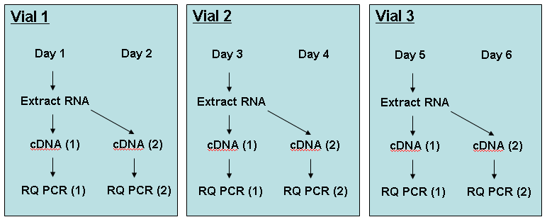
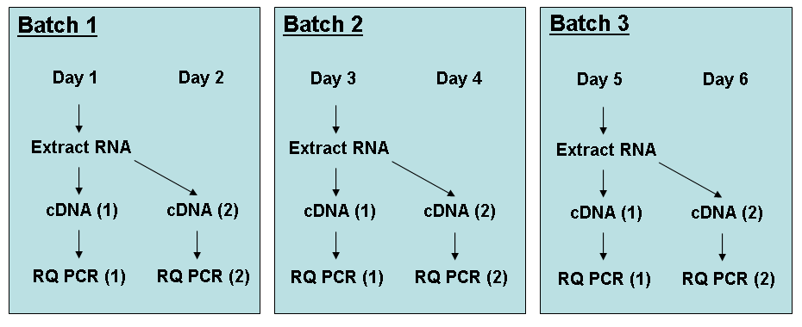
- Schematic flow diagram showing suggested order of analysis for the minimal number of reverse transcription reactions and RQ-PCR runs.

Accelerated degradation studies
For accelerated degradation studies, 2 vials of each reference material were stored at 56°C, 45°C and 37°C and 4 vials of each material were stored at -20ºC. These samples will be analysed at 6 months post freeze drying.

results of Pilot field trial

Amount of RNA Extracted
The total amount of RNA extracted from all samples was assessed by optical density and the mean and median for each resuspension protocol are shown in table 1. Extraction of RNA from samples stored for 2 months at room temperature was repeated by lab C to make a preliminary assessment of the stability of the samples.

Sample type | HL60  µg RNA (Mean) | HL60  µg RNA (Median) | KG1  µg RNA  (Mean) | KG1  µg RNA  (Median)
PBS reconstitution | 8.4 | 8.0 | 4.6 | 2.9
Trizol resuspension | 31.6 | 31.3 | 33.5 | 35.0
Pre freeze dried | 33.6 | 32.6 | 40.5 | 41.1
2 months at room temp PBS reconstitution | 8.3 | 8.7 | 3.4 | 1.8
2 months at room temp Trizol resuspension | 36.0 | 36.1 | 39.1 | 39.5
2 months at room temp Pre freeze dried | 35.5 | 35.3 | 44.5 | 43.5

- Mean amount of total RNA extracted from each cell line prior to freeze drying, when resuspended in water and lysed directly into Trizol.

The amount of RNA extracted using resuspension protocol A was significantly lower than either the amount of RNA extracted when the cells were lysed directly in Trizol (protocol B) or from the amount of RNA extracted from the pre-freeze dried material. There was no significant difference between the amount of RNA extracted using protocol B (direct Trizol lysis) and the amount of RNA extracted from the pre-freeze dried material (p=0.551, 2 sample T-test).

RQ-PCR for BCR-ABL and control genes

Absolute copy numbers (b3a2 and control gene transcripts)
The absolute copy numbers obtained from the RQ-PCR analysis of each control gene and b3a2 in the three testing labs are shown in table 2 (HL60) and table 3 (KG1). Results are shown for the freeze dried cells resuspended using protocol A (PBS), protocol B (Trizol), prior to freeze drying and for freeze dried cells tested at 2 months after storage at ambient temperature (ABL only).

ABL
There was no significant difference in the absolute ABL copies obtained using protocol A and B for HL60 or KG1 (p=0.284, p=0.777, respectively). The number of ABL copies in the pre-freeze dried material were not significantly different to sample prepared using protocols A and B (HL60: p= 0.174 and p= 0.072 respectively; KG1: p= 0.464 and p= 0.377, respectively)

BCR
There was no significant difference in the absolute BCR copies obtained using protocol A and B for HL60 or KG1 (p=0.127, p=0. 0.108, respectively). The number of BCR copies in the pre-freeze dried material were not significantly different to sample prepared using protocols A and B (HL60: p= 0.186 and p= 0.401 respectively; KG1: p= 0.190 and p= 0.250, respectively)

GUSB
There was no significant difference in the absolute GUSB copies obtained using protocol A and B for HL60 or KG1 (p= 0.259, p= 0.827 respectively). The number of GUSB copies in the pre-freeze dried material were not significantly different to sample prepared using protocols A and B for KG1 and protocol B for HL60 (KG1: p= 0.443 and p= 0.537, respectively; HL60 p=0.216). There was a statistically different number of copies of GUSB determined when comparing the pre freeze dried HL60 material and HL60 samples prepared using protocol A (p= 0.026).

a)
Lab ID | ABL (PBS) | ABL (Trizol) | ABL (Pre freeze dry)
Lab A | 8.58E+04 | 1.86E+05 | 1.12E+05
Lab B | 6.51E+04 | 2.06E+04 | 1.26E+04
Lab C | 9.71E+04 | 1.18E+05 | 4.88E+04
Lab C 2 months | 4.01E+04 | 5.86E+04 | 1.01E+05
b)
Lab ID | BCR (PBS) | BCR (Trizol) | BCR (Pre freeze dry)
Lab B | 1.97E+05 | 8.36E+04 | 6.44E+04
Lab C | 2.94E+04 | 2.21E+04 | NT
c)
Lab ID | GUSB (PBS) | GUSB (Trizol) | GUSB (Pre freeze dry)
Lab A | 3.66E+05 | 3.78E+05 | 2.77E+05
Lab B | 3.94E+05 | 2.19E+05 | 1.95E+05
Lab C | 1.31E+05 | 1.16E+05 | 7.20E+04
d)

Lab ID | Lab A | Lab B | Lab C | Lab C 2 months
Level 1 PBS | 2.05E+04 | 4.01E+04 | 2.70E+04 | 1.14E+04
Level 1 Trizol | 4.71E+04 | 1.58E+04 | 4.34E+04 | 1.69E+04
Level 1 (Pre freeze dry) | 3.06E+04 | 1.16E+04 | 7.23E+03 | 3.09E+04
Level 2 PBS | 2.23E+03 | 2.58E+03 | 2.89E+03 | 1.03E+03
Level 2 Trizol | 5.36E+03 | 1.28E+03 | 3.32E+03 | 1.57E+03
Level 2 (Pre freeze dry) | 3.14E+03 | 7.59E+02 | 6.67E+02 | 3.26E+03
Level 3 PBS | 2.15E+02 | 1.66E+02 | 4.23E+02 | 1.40E+02
Level 3 Trizol | 4.75E+02 | 7.10E+01 | 3.95E+02 | 1.25E+02
Level 3 (Pre freeze dry) | 3.00E+02 | 5.06E+01 | 1.06E+02 | 2.90E+02
Level 4 PBS | 1.10E+01 | 2.15E+01 | 2.95E+01 | 1.36E+01
Level 4 Trizol | 3.60E+01 | 7.43E+00 | 5.96E+01 | 1.04E+01
Level 4 (Pre freeze dry) | 3.70E+01 | 2.33E+00 | 5.60E+01 | 3.70E+01
- Absolute copy number of control gene transcripts obtained for the HL60 / K562 cell line mixes a) ABL, b) BCR, c) GUSB and d) b3a2. NT= not tested.

a)
Lab ID | ABL (PBS) | ABL (Trizol) | ABL (Pre freeze dry)
Lab A | 1.64E+05 | 2.18E+05 | 1.48E+05
Lab B | 5.53E+04 | 1.18E+04 | 1.17E+04
Lab C | 5.78E+04 | 7.48E+04 | 5.68E+04
Lab C 2 months | 2.74E+04 | 9.01E+04 | 1.11E+05
b)
Lab ID | BCR (PBS) | BCR (Trizol) | BCR (Pre freeze dry)
Lab B | 5.24E+05 | 1.79E+05 | 1.51E+05
Lab C | 4.80E+04 | 4.84E+04 | NT
c)
Lab ID | GUSB (PBS) | GUSB (Trizol) | GUSB (Pre freeze dry)
Lab A | 1.96E+05 | 2.47E+05 | 1.98E+05
Lab B | 2.62E+05 | 1.63E+05 | 1.58E+05
Lab C | 3.50E+04 | 5.83E+04 | 5.23E+04
d)
Lab ID | Lab A | Lab B | Lab C | Lab C 2 months
Level 1 PBS | 6.34E+04 | 5.31E+04 | 8.11E+03 | 3.32E+04
Level 1 Trizol | 6.98E+04 | 7.60E+03 | 3.04E+04 | 2.78E+04
Level 1 (Pre freeze dry) | 6.87E+04 | 9.58E+03 | 3.44E+04 | 7.84E+04
Level 2 PBS | 8.22E+03 | 4.72E+03 | 1.21E+03 | 2.56E+02
Level 2 Trizol | 1.11E+04 | 1.12E+03 | 3.43E+03 | 3.65E+03
Level 2 (Pre freeze dry) | 7.85E+03 | 8.23E+02 | 1.28E+03 | 9.49E+03
Level 3 PBS | 6.00E+02 | 4.61E+02 | 6.64E+02 | 2.67E+01
Level 3 Trizol | 9.10E+02 | 1.23E+02 | 2.95E+02 | 3.39E+02
Level 3 (Pre freeze dry) | 3.50E+02 | 9.17E+01 | 3.01E+02 | 7.14E+02
Level 4 PBS | 7.00E+01 | 5.32E+01 | 3.25E+01 | 2.89E+00
Level 4 Trizol | 1.10E+02 | 1.34E+01 | 3.73E+01 | 3.28E+01
Level 4 (Pre freeze dry) | 7.50E+01 | 9.61E+00 | 2.98E+01 | 3.82E+01

- Absolute copy number of control gene transcripts obtained for the KG1 / K562 cell line mixes a) ABL, b) BCR, c) GUSB and d) b3a2. NT= not tested.

% BCR-ABL / control gene(s)
Table 4 (HL60) and table 5 (KG1) show the % BCR-ABL / control gene levels for each reference material after testing in the three laboratories. Mean values are shown for the freeze dried cells resuspended using protocol A (PBS), protocol B (Trizol) and prior to freeze drying and for freeze dried cells tested at 2 months after storage at ambient temperature.

 | ABL |  |  |  | BCR |  | GUSB
 | Lab A | Lab B | Lab C | Lab C 2 mths | Lab B | Lab C | Lab A | Lab B | Lab C
L1 PBS | 18.430 | 35.907 | 34.929 | 24.204 | 15.771 | 45.421 | 5.778 | 10.92 | 13.869
L2 PBS | 2.520 | 3.689 | 3.537 | 3.344 | 1.320 | 5.704 | 0.547 | 0.517 | 1.237
L3 PBS | 0.251 | 0.374 | 0.430 | 0.283 | 0.092 | 0.377 | 0.056 | 0.039 | 0.116
L4 PBS | 0.019 | 0.063 | 0.023 | 0.041 | 0.014 | 0.041 | 0.003 | 0.008 | 0.010
L1 Trizol | 21.258 | 47.884 | 31.679 | 22.624 | 17.086 | 92.308 | 13.183 | 7.962 | 11.240
L2 Trizol | 2.596 | 5.223 | 3.132 | 2.565 | 1.203 | 8.168 | 1.289 | 0.459 | 1.011
L3 Trizol | 0.273 | 0.473 | 0.411 | 0.220 | 0.097 | 0.665 | 0.128 | 0.033 | 0.065
L4 Trizol | 0.025 | 0.076 | 0.044 | 0.025 | 0.012 | 0.066 | 0.010 | 0.004 | 0.008
L1  Pre FD | 27.586 | 60.933 | 42.035 | 32.605 | 16.044 | NT | 12.288 | 6.058 | 10.688
L2  Pre FD | 2.892 | 6.467 | 4.904 | 2.991 | 1.144 | NT | 1.076 | 0.289 | 0.903
L3  Pre FD | 0.286 | 0.518 | 0.373 | 0.241 | 0.088 | NT | 0.107 | 0.026 | 0.027
L4  Pre FD | 0.030 | 0.024 | 0.041 | 0.029 | 0.004 | NT | 0.013 | 0.002 | 0.006

- % BCR-ABL / control gene mean values obtained for the HL60 / K562 cell line mixes pre freeze drying and following the two different resuspension protocols for labs A, B and C (NT= not tested; Pre FD = pre freeze dry; L1 – L4 = levels 1 -4 BCR-ABL)

 | ABL |  |  |  | BCR |  | GUSB
 | Lab A | Lab B | Lab C | Lab C 2 mths | Lab B | Lab C | Lab A | Lab B | Lab C
L1 PBS | 28.655 | 110.23 | 44.807 | 34.837 | 12.069 | 33.216 | 31.418 | 21.14 | 33.587
L2 PBS | 4.717 | 8.661 | 6.173 | 5.300 | 0.926 | 3.956 | 3.914 | 1.913 | 5.068
L3 PBS | 0.459 | 0.820 | 0.458 | 0.485 | 0.078 | 0.402 | 0.325 | 0.187 | 0.765
L4 PBS | 0.054 | 0.085 | 0.067 | 0.075 | 0.010 | 0.039 | 0.037 | 0.018 | 0.077
L1 Trizol | 29.910 | 71.174 | 33.115 | 24.174 | 4.739 | 78.592 | 31.193 | 4.701 | 32.415
L2 Trizol | 4.939 | 10.402 | 4.592 | 4.320 | 0.666 | 4.543 | 3.871 | 0.736 | 4.487
L3 Trizol | 0.422 | 1.013 | 0.500 | 0.428 | 0.061 | 0.839 | 0.389 | 0.070 | 0.564
L4 Trizol | 0.055 | 0.100 | 0.051 | 0.040 | 0.007 | 0.083 | 0.045 | 0.008 | 0.070
L1  Pre FD | 34.813 | 52.772 | 35.796 | 36.129 | 5.395 | NT | 31.727 | 6.589 | 39.431
L2  Pre FD | 5.292 | 11.114 | 5.818 | 5.717 | 0.752 | NT | 3.676 | 0.552 | 4.487
L3  Pre FD | 0.460 | 0.961 | 0.565 | 0.428 | 0.065 | NT | 0.336 | 0.054 | 0.612
L4  Pre FD | 0.044 | 0.083 | 0.053 | 0.061 | 0.005 | NT | 0.029 | 0.006 | 0.045

- % BCR-ABL / control gene mean values obtained for the KG1 / K562 cell line mixes pre freeze drying and following the two different resuspension protocols for labs A, B and C (NT= not tested; Pre FD = pre freeze dry; L1 – L4 = levels 1 -4 BCR-ABL)

Results of Large Field trial
14 laboratories participated in the field trial and all labs returned data; 7 participants from Europe, 4 from the United States of America, 2 from Asia and 1 from Australasia (Appendix A).

Methodologies used

Control genes analysed
Four control genes were analysed in this study: ABL (12 labs), BCR (6 labs), GUSB (8 labs) and G6PD (1 lab). Eight labs tested the samples using more than one control gene.

RQ-PCR machines used
Nine different type of RQ-PCR machines were used in this study: ABI 7000 (3 labs), ABI 7500 (2 labs), ABI 7700 (1 lab), ABI 5700 (1 lab), Corbett RotorGene 6000 (1 lab), Roche LightCycler 1.5 (1 lab), Roche LightCycler 2.0 (3 labs), Roche LightCycler 480 (1 lab), Stratagene MX3000P (1 lab).

RQ-PCR methods

RNA Extraction methods
Two RNA extraction methods were used; 9 labs used Trizol (Invitrogen) and 5 used RNeasy kits (QIAGEN).

RT-PCR method cited
Eight of the participants cited Gabert et al. (2003)¹ as one of the references used as their RQ-PCR protocol. Other references cited are listed in the reference section ^{7 – 13}.

RT-PCR method and primers used
Twelve labs reported the use of random hexamers for reverse transcription. The final concentrations ranged from 6µM - 125µM. One lab used a proprietary method and another lab did not provide information. The amount of RNA added to the cDNA reactions varied from 0.3 – 10 µg.

Standard type and source
12 labs used plasmid DNA as standards and these were either made in house or obtained from another lab (10) or purchased from Ipsogen (3). One lab used cDNA standards derived from the K562 cell line and another did not run standards but used a ΔΔCt method for calculating % BCR-ABL.

Field trial data analysis

RNA Extraction
The mean and median amount of RNA extracted from each reference material is shown in table 6.

Reagent | Mean µg RNA | Median µg RNA
HL60 Level 1 | 30.30 | 28.21
HL60 Level 2 | 31.03 | 31.39
HL60 Level 3 | 31.90 | 31.17
HL60 Level 4 | 28.87 | 27.74
HL60 Combined | 30.53 | 29.61
KG1 Level 1 | 33.52 | 33.09
KG1 Level 2 | 29.84 | 30.31
KG1 Level 3 | 30.61 | 31.26
KG1 Level 4 | 29.92 | 30.89
KG1 Combined | 30.92 | 31.37

- Mean and median amounts of RNA extracted for each reference material (n=14)

Mean copy numbers obtained for control genes
The mean copy number values obtained for each control gene in each lab are given in table 7. The values have not been corrected for variation in the amount of RNA extracted and used in the cDNA reaction or amount of cDNA added to the RQ-PCR and therefore the data are not comparable between labs. For the labs that tested more than one control gene the relative amount of each control gene in relation to ABL are shown in figure 2.
Lab ID | Cell line mix | ABL | BCR | GUSB
1 | HL60 | NT | 5.78E+05 | NT
1 | KG1 | NT | 1.25E+06 | NT
2 | HL60 | 1.16E+05 | NT | NT
2 | KG1 | 9.87E+04 | NT | NT
3 | HL60 | 1.77E+04 | NT | 3.92E+04
3 | KG1 | 2.00E+04 | NT | 2.40E+04
4 | HL60 | 3.49E+04 | NT | 1.06E+05
4 | KG1 | 4.09E+04 | NT | 6.41E+04
5 | HL60 | 2.84E+05 | NT | NT
5 | KG1 | 4.78E+05 | NT | NT
6 | HL60 | 5.63E+05 | 4.53E+05 | 8.20E+05
6 | KG1 | 6.74E+05 | 1.03E+06 | 5.65E+05
7 | HL60 | 3.30E+05 | NT | NT
7 | KG1 | 4.26E+05 | NT | NT
8 | HL60 | 2.70E+05 | NT | 5.21E+05
8 | KG1 | 2.94E+05 | NT | 3.45E+05
9 | HL60 | 3.38E+04 | 6.71E+04 | 2.34E+05
9 | KG1 | 3.61E+04 | 1.36E+05 | 1.62E+05
10 | HL60 | 1.56E-01 | 8.30E-01 | 8.81E-01
10 | KG1 | 1.67E-01 | 1.73E+00 | 5.39E-01
11 | HL60 | 1.00E+05 | NT | NT
11 | KG1 | 1.02E+05 | NT | NT
12 | HL60 | 4.13E+05 | NT | NT
12 | KG1 | 5.20E+05 | NT | NT
13 | HL60 | 6.10E+04 | 2.16E+04 | 7.15E+04
13 | KG1 | 6.15E+04 | 5.14E+04 | 4.28E+04

- Mean copy number values obtained for each control gene in each lab (NT = not tested). Copy numbers for G6PD were not given.
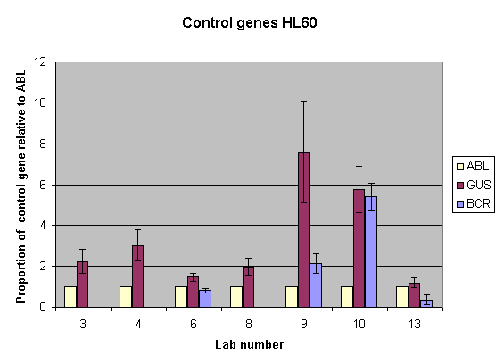

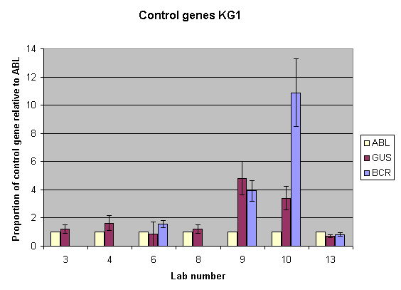

- The relative amounts of each control gene in relation to ABL for laboratories who tested more than one control gene

Mean, standard deviation and coefficient of variation for % BCR-ABL / Control gene
The mean, standard deviation (SD) and coefficient of variation (CV) for the % BCR-ABL / control gene values for each reference material in each lab are shown in tables 8 (ABL and G6PD) and 9 (BCR and GUSB). There was no statistical difference between the CVs obtained for HL60 and KG1 at any level of BCR-ABL (2-sample t-test).

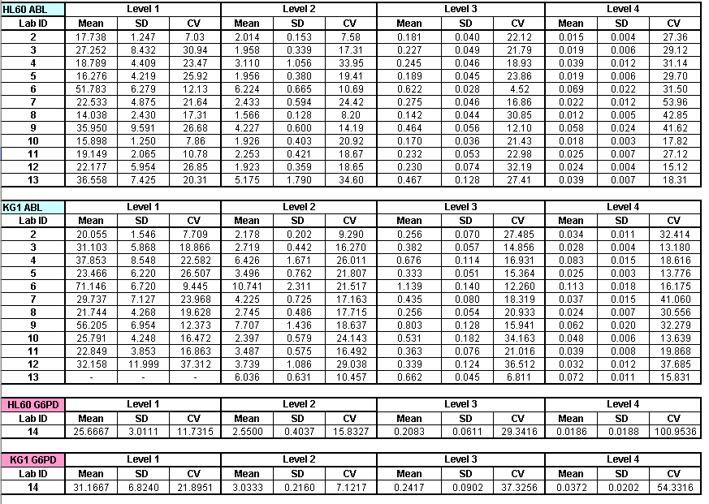

- Mean, SD and CV values for %BCR-ABL / ABL and %BCR-ABL / G6PD for each laboratory for the HL60 / K562 and KG1 / K562 reference materials. There was no statistical difference between CVs for the HL60 and KG1 cell line mixes. (2 sample t-test: HL60 CV vs KG1 CV for ABL Level 1, 2, 3 and 4: p=0.999, 0.999, 0.724, 0.142).

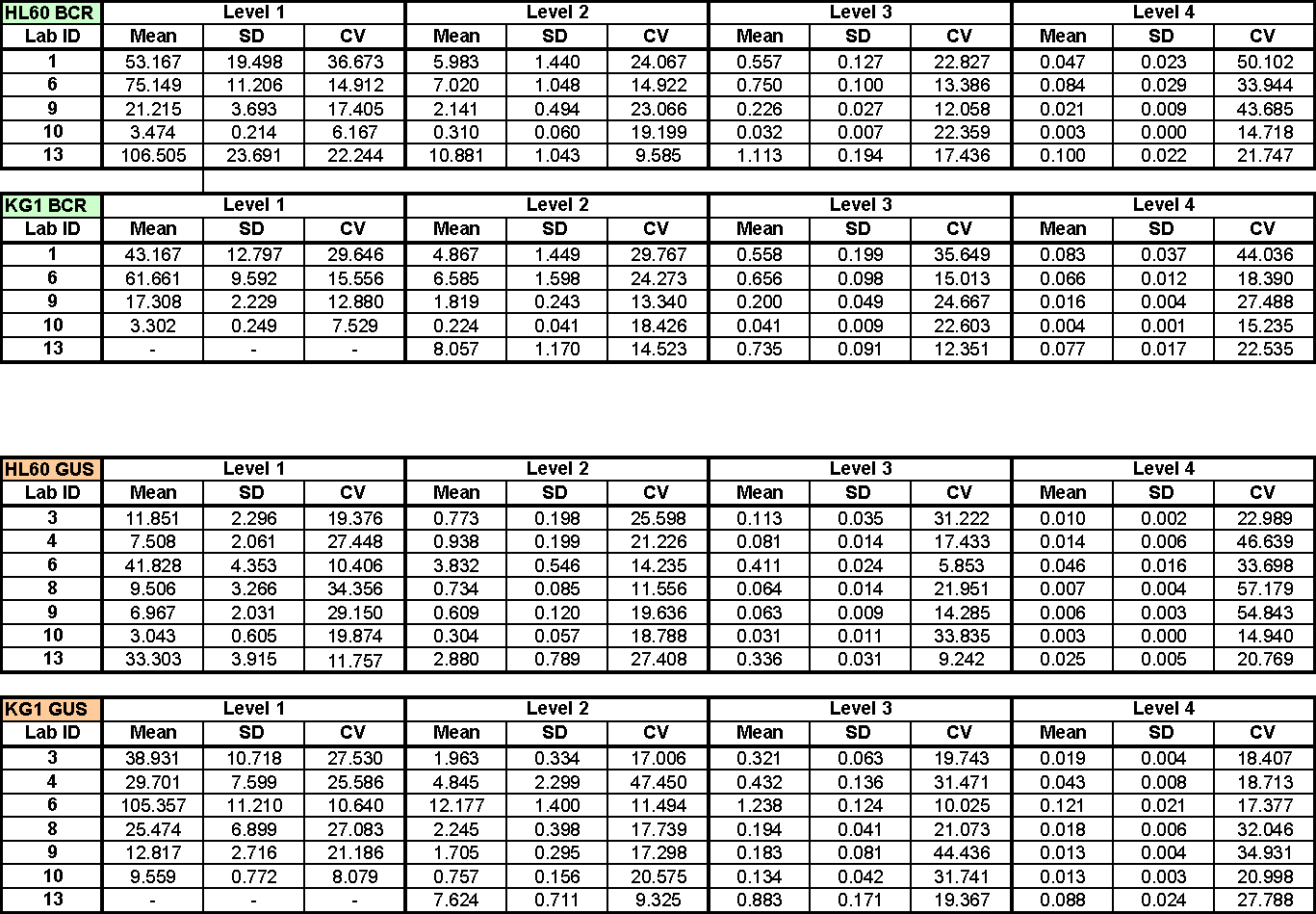

- Mean, SD and CV values for %BCR-ABL / BCR and %BCR-ABL / GUSB for each laboratory for the HL60 / K562 and KG1 / K562 reference materials There was no statistical difference between CVs for the HL60 and KG1 cell line mixes. (2 sample t-test: HL60 CV vs KG1 CV for BCR Level 1, 2, 3 and 4: p=0.671, 0.657, 0.377, 0.409; HL60 CV vs KG1 CV for GUSB Level 1, 2, 3 and 4: p=0.728, 0.949, 0.305, 0.139).

Linear regression
The linear regression of the log transformed data obtained from all labs are summarised in figures 3 (ABL), 4 (BCR) and 5 (GUSB). Data were plotted against reference material values which were assigned as 10% (level 1), 1% (level 2), 0.1% (level 3) and 0.01% (level 4) BCR-ABL / Control Gene (this is an arbitrary designation to illustrate the principal that these reagents can be used to normalize variables between laboratories. It does not mean that these reagents were actually 10%, 1% etc. on the IS). The regression equations for the log transformed data for each cell line and each control gene are given in table 10 and the individual regression plots for each lab are shown in appendix B.

Lab ID | HL60 ABL | KG1 ABL
2 | Log(y)= 0.2596 + 1.025 log(x) | Log(y)= 0.3545 + 0.9295 log(x) ♠
3 | Log(y)= 0.3564 + 1.041 log(x) | Log(y)= 0.4863 + 0.9988 log(x)
4 | Log(y)= 0.3915 + 0.9168 log(x) ♠ | Log(y)= 0.7261 + 0.8953 log(x) ♠
5 | Log(y)= 0.2494 + 0.9786 log(x) | Log(y)= 0.4440 + 0.9881 log(x)
6 | Log(y)= 0.7644 + 0.9677 log(x) | Log(y)= 0.9645 + 0.9373 log(x) ♠
7 | Log(y)= 0.3748 + 0.9993 log(x) | Log(y)= 0.5590 + 0.9726 log(x)
8 | Log(y)= 0.1507 + 1.031 log(x) | Log(y)= 0.3821 + 0.9939 log(x)
9 | Log(y)= 0.6129 + 0.9359 log(x) ♠ | Log(y)= 0.8228 + 0.9884 log(x)
10 | Log(y)= 0.2353 + 0.9884 log(x) | Log(y)= 0.4835 + 0.8856 log(x) ♠
11 | Log(y)= 0.3294 + 0.9650 log(x) | Log(y)= 0.4757 + 0.9296 log(x) ♠
12 | Log(y)= 0.3290 + 0.9766 log(x) | Log(y)= 0.5100 + 1.005 log(x)
13* | Log(y)= 0.6084 + 0.9891 log(x) | Log(y)= 0.7813 + 0.9615 log(x) ♠

Lab ID | HL60 BCR | KG1 BCR
1^ | Log(y)= 0.7267 + 1.031 log(x) | Log(y)= 0.6970 + 0.9103 log(x) ♠
6 | Log(y)= 0.8674 + 0.9881 log(x) | Log(y)= 0.8030 + 0.9912 log(x)
9 | Log(y)= 0.3288 + 1.003 log(x) | Log(y)= 0.2495 + 1.012 log(x)
10 | Log(y)= -0.4852 + 1.002 log(x) | Log(y)= -0.5089 + 0.9528 log(x)
13* | Log(y)= 1.028 + 1.007 log(x) | Log(y)= 0.8962 + 1.012 log(x)

Lab ID | HL60 GUSB | KG1 GUSB
3 | Log(y)= 0.00401 + 1.005 log(x) | Log(y)= 0.4511 + 1.069 log(x)
4 | Log(y)= -0.07129 + 0.9300 log(x) ♠ | Log(y)= 0.5730 + 0.9570 log(x)
6 | Log(y)= 0.6092 + 0.9902 log(x) | Log(y)= 1.060 + 0.9813 log(x)
8 | Log(y)= -0.1189 + 1.062 log(x) | Log(y)= 0.3483 + 1.055 log(x) ♠
9 | Log(y)= -0.1999 + 1.025 log(x) | Log(y)= 0.1706 + 1.001 log(x)
10 | Log(y)= -0.5144 + 0.9880 log(x) | Log(y)= -0.01101 + 0.9329 log(x) ♠
13* | Log(y)= 0.4990 + 1.035 log(x) | Log(y)= 0.8904 + 0.9693 log(x)

Lab ID | HL60 G6PD | KG1 G6PD
14 | Log(y)= 0.3725 + 1.052 log(x) | Log(y)= 0.4687 + 0.9926 log(x)

- Linear regression equations of log transformed %BCR-ABL / Control gene data for each lab and cell line. * Level 1 KG1 not tested. ^ Analysis of repeat samples. ♠ Gradient statistically different to reference (CI 95%)
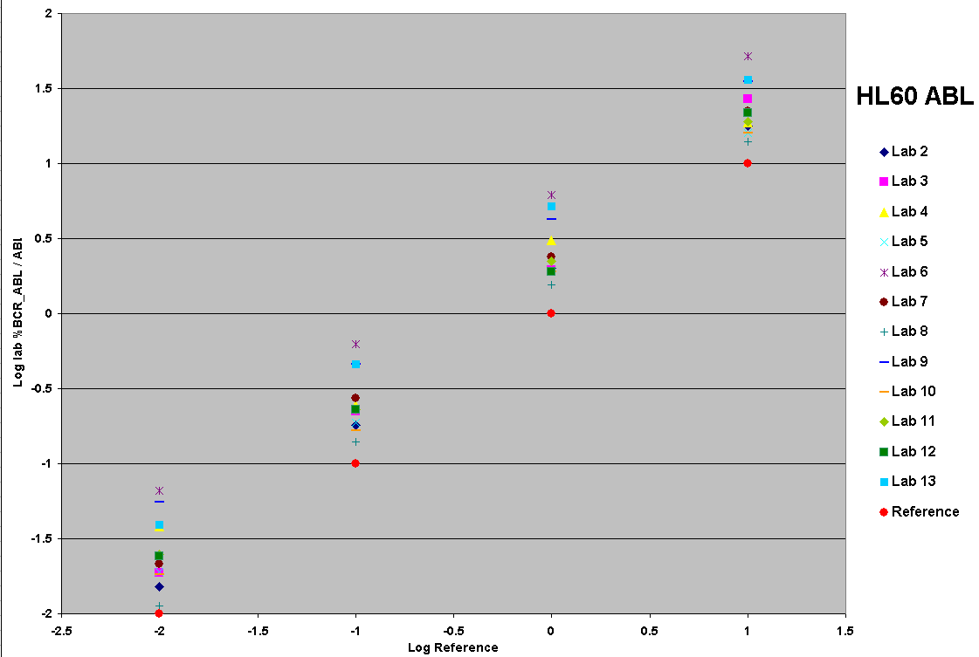

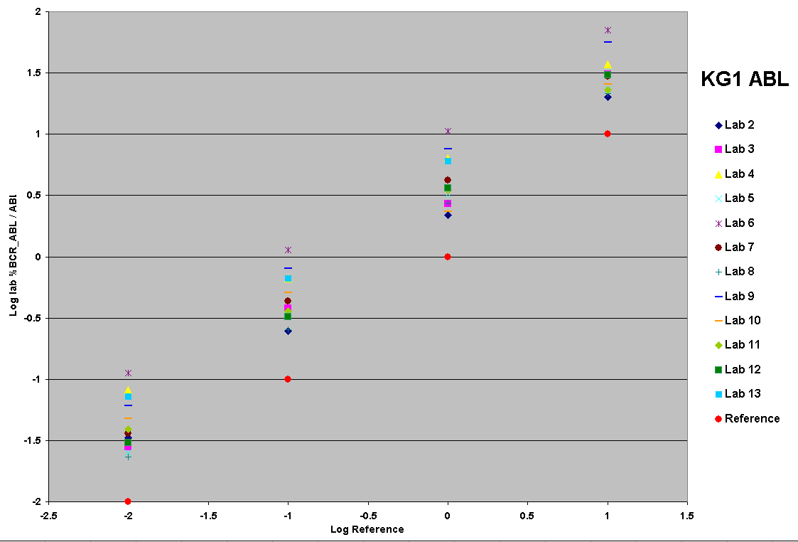

- Summary of the linear regressions of the log transformed data obtained from all labs testing BCR-ABL / ABL in HL60 and KG1 reference material. The reference materials have been assigned values of 10%, 1%, 0.1% and 0.01% BCR-ABL / ABL.

BCR
BCR
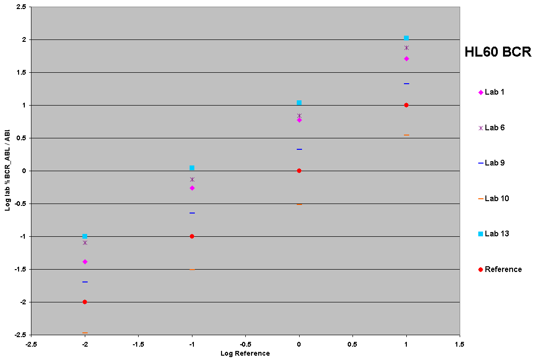
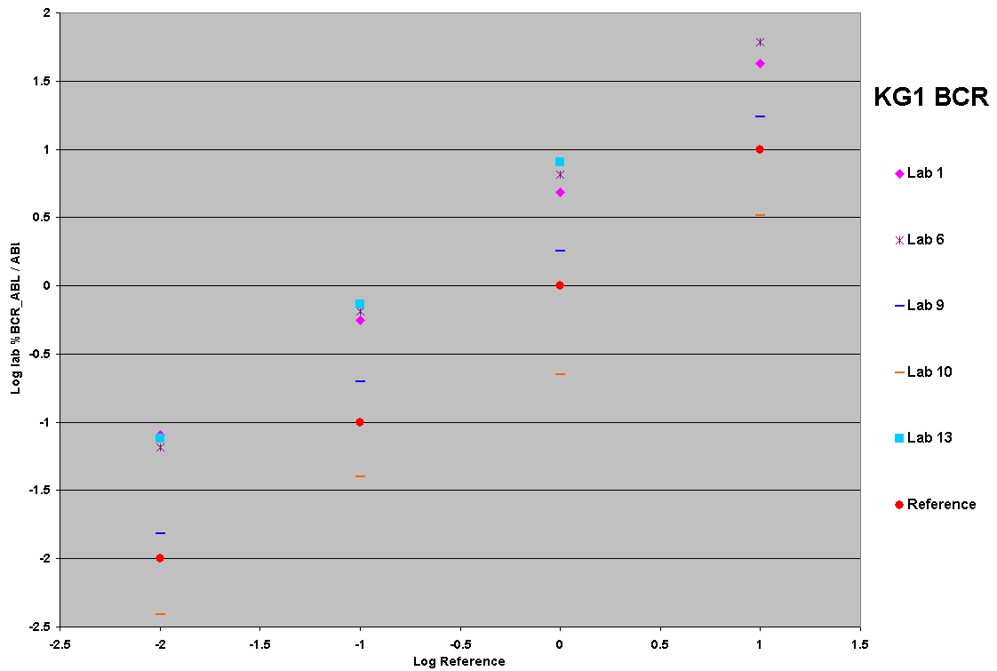

- Summary of the linear regressions of the log transformed data obtained from all labs testing BCR-ABL / BCR in HL60 and KG1 reference material. The reference materials have been assigned values of 10%, 1%, 0.1% and 0.01% BCR-ABL / BCR.

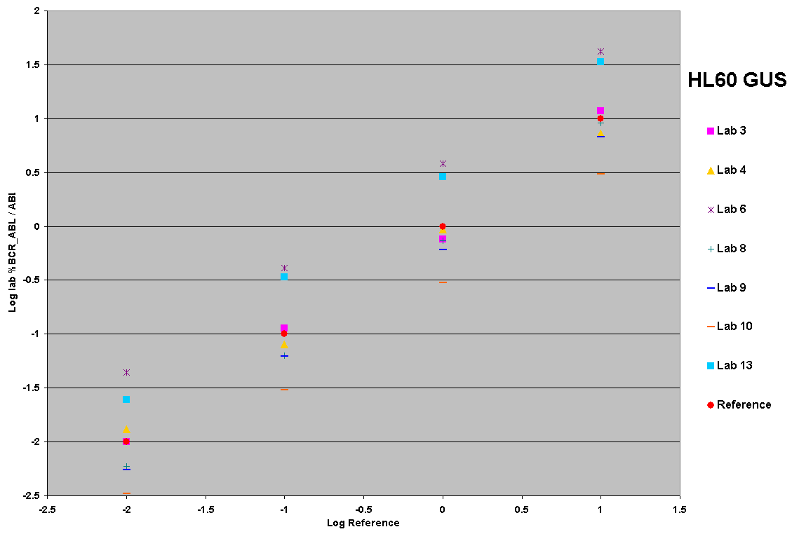
GUS
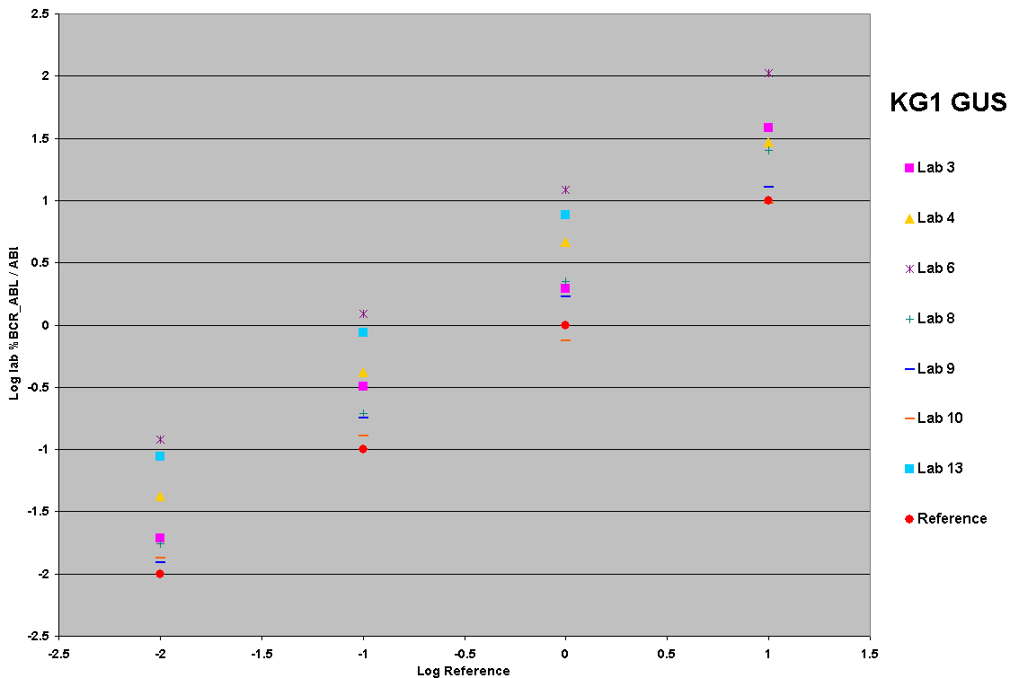
GUS

- Summary of the linear regressions of the log transformed data obtained from all labs testing BCR-ABL / GUSB in HL60 and KG1 reference material. The reference materials have been assigned values of 10%, 1%, 0.1% and 0.01% BCR-ABL / GUSB.

Use of prototype reference materials for standardisation
Using the linear regression equations shown in table 10 it is possible to use the reference material to generate a conversion / calibration factor which would allow all laboratories to report %BCR-ABL / control gene results on a uniform scale.

Using the HL60 ABL data as an example the data have been standardised using two methods:

Correct Y to scale of X by inverting the regression
Log transformed data from twelve laboratories were calibrated to the reference standards using the slope and intercepts from the regression equations for HL60 ABL. The equation used to correct the lab data to the standards or ‘reference data set’ was:

Y_{corrected} = (Y - a) / b

Where a = intercept
b = slope

The graph of all the corrected lab results for log transformed data of %BCR-ABL / ABL (HL60) are shown in figure 6 (uncorrected data can be seen in figure 3, top panel)

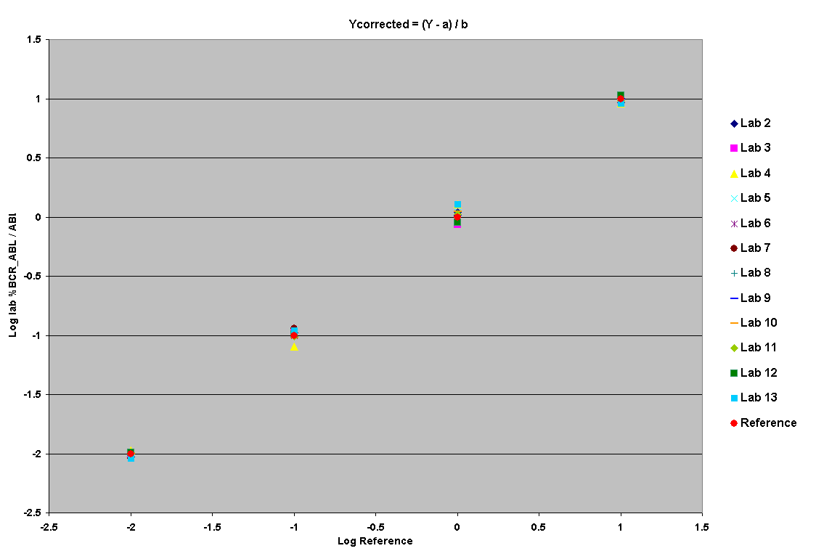
- Log transformed data for HL60 %BCR-ABL / ABL calibrated to reference standards using the slope and intercepts from the regression equations.

Using IS conversion factor method from Adelaide
Log transformed data from twelve laboratories were calibrated to the reference standards using the slope and intercepts from the regression equations for HL60 ABL. The process used to correct the lab data to the standards or ‘reference data set’ was:

log y = (b x log MMR_{IS}) + a

Conversion factor = MMR_{IS} / antilog y

Where MMR_{IS} = 0.1
a = intercept
b = slope

The graph of all the corrected lab results for log transformed data of %BCR-ABL / ABL (HL60) is shown in figure 7 (uncorrected data can be seen in figure 3, top panel).

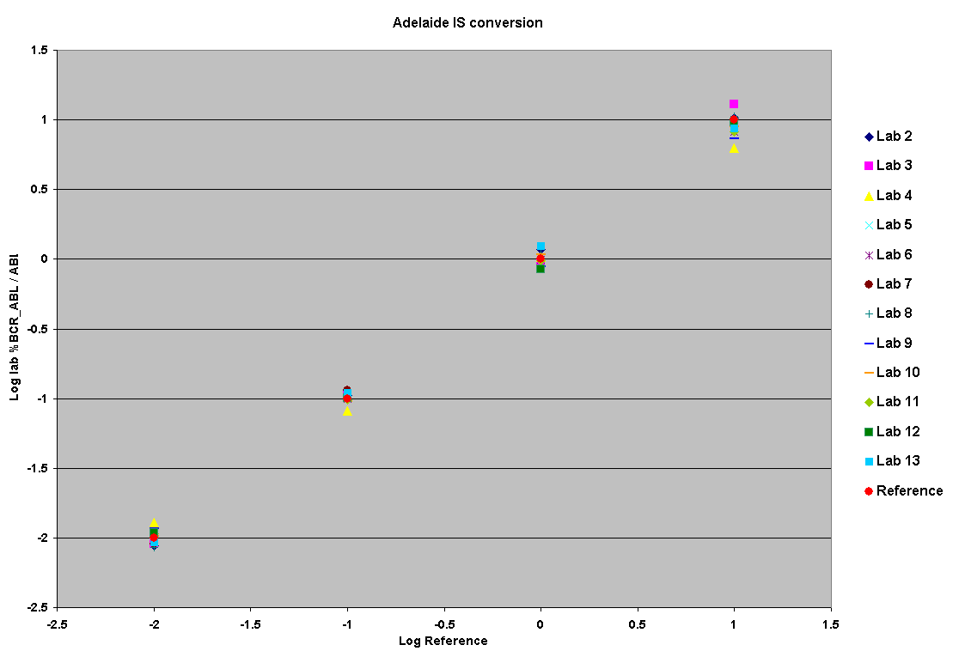

- Log transformed data for HL60 %BCR-ABL / ABL calibrated to reference standards using the IS conversion factor as calculated by the Adelaide laboratory

Converted % BCR-ABL / ABL data (HL60)
The laboratory data and resulting log transformed and unconverted data for each standardisation method are shown below:

Un- transformed data
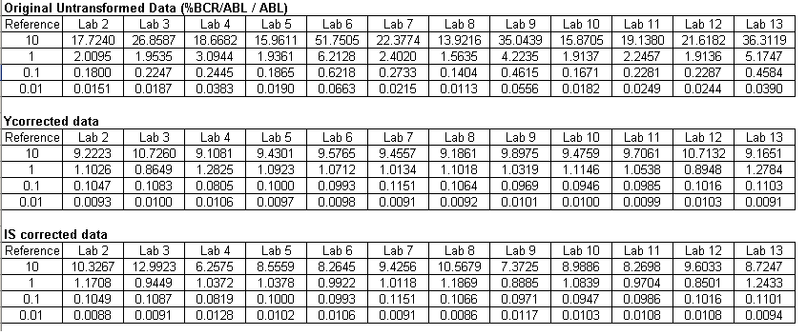

Log transformed data
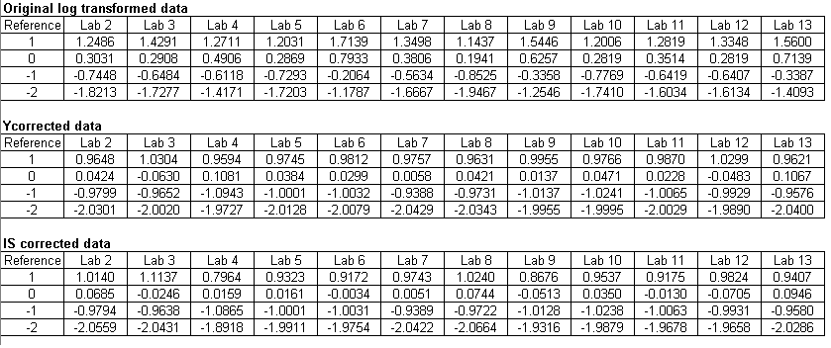

COnclusions

Pilot field trial
The aims of the initial pilot trial were to (i) test two different resuspension protocols, (ii) perform an initial assessment to determine if the freeze dried cells were suitable for more detailed analysis, ie. that RNA could be extracted by different centres, that BCR-ABL and the three control genes could be amplified at levels comparable to normal leukocytes, that the level of BCR-ABL corresponded roughly to the dilutions and (iii) test if the protocol was comprehensible and unambiguous.

Given that the amount of RNA extracted was significantly lower using protocol A, compared to both protocol B (direct Trizol lysis) and the pre-freeze dried material, protocol B was selected for the large field trial.

Although, as expected, there was variation in absolute numbers between the three centres all three control genes (ABL, BCR and GUSB) were detected at high level. The b3a2 BCR-ABL transcript was detected at four levels in both the HL60 and KG1 cell lines and the % BCR-ABL / control gene values showed 10 fold reductions between levels. The level 4 standard (assigned as 0.01% BCR-ABL / control gene) was detected by all three laboratories.

Minor modifications to the protocol were made in response to the feedback that was received.

Large Field trial
The aims of the large field trial were to (i) assess the performance of KG1/K562 and HL60/K562 across a wide variety of platforms and assay protocols and, if successful, (ii) provide data for the selection of one combination to take forward for the development of accredited reference reagents.

Fourteen laboratories took part in the field trial. Two RNA extraction protocols were used and over half of the laboratories cited Gabert et al. (2003) as their RT-PCR method ¹. Random hexamers were used for reverse transcription by all labs who returned the methodology forms.

The mean and median amount of RNA extracted per vial from the HL60 reference material were 30.5 and 29.6µg respectively. The mean and median amount of RNA extracted per vial from the KG1 reference material were 30.9 and 31.4µg respectively. This is much higher than that obtained from typical clinical samples suggesting that the number of cells per vial could be reduced and / or the contents of each vial could be used for several independent tests once resuspended in Trizol.

It was not possible to directly compare the absolute copy numbers obtained from the different labs as many different protocols were used and sufficient information to standardize these results was not available. However, the median copies obtained for ABL, BCR and GUSB (lab 10 excluded) for the HL60 material were 1.16E+05, 2.60E+05 and 1.70E+05, respectively, and for the KG1 material 1.02E+05, 5.85E+05 and 1.13E+05, respectively. For labs who tested more than one control gene the relative amounts of ABL : BCR and ABL : GUSB were calculated. As can be seen from figure 2, the ratios varied quite substantially between labs. In general, GUSB appears to be the control gene with the highest relative level of expression in HL60 cells and in most labs the amount of ABL and GUSB expressed in KG1 cells were comparable.

The coefficient of variation for % BCR-ABL / control gene values obtained from all labs were comparable to those obtained in the IS conversion factor rounds administered by the Mannheim laboratory (M.Muller, Mannheim, personal communication) and other studies². There was no statistical difference between the CVs obtained from either cell line for any of the control genes.

For the purpose of this field trial and to demonstrate how this type of reference material could be used to standardize reporting, values of 10%, 1%, 0.1% and 0.01% BCR-ABL / control gene were arbitrarily assigned to the level 1, level 2, level 3, and level 4 material respectively. Linear regression plots were produced for log transformed lab data plotted against the log transformed reference standard values. The resulting regression equations obtained by least squares analysis were used to standardize / convert the data to the reference material values by solving the equation for the MMR value (0.1%). As can be seen in figures 6 and 7 the reference material can be used in this way to greatly improve the comparability of the data between labs. It is important to emphasise that this analysis was designed to illustrate the way that reference reagents could be used. Other methods of transforming the raw laboratory data are possible that may be superior. This is an area that needs further work in future trials and / or when accredited reagents are available for use.

Some of the linear regression plots showed statistically significant variation in the slope of the line when compared to the reference standard suggesting that the assays may not be linear for this reference material (Method Validator software, CI 95%). These were most prevalent in the KG1 ABL analyses (6 labs, 46%).

Overall, it appears that both freeze dried cell line mixes could be suitable for development of BCR-ABL reference reagents. RNA (median 30μg/vial) was successfully extracted from freeze dried cell mixtures shipped worldwide at ambient temperature. The HL60/K562 and KG1/562 cell mixes performed equally well producing CVs that were comparable to those expected for primary patient samples.

Future Work
Accelerated degradation studies with this batch of freeze dried material are ongoing and results will be reported in due course. A further medium scale pilot freeze dry study using the HL60 / K562 cell mixture is planned for mid-2008 in collaboration with NIBSC and the European Collection of Cell Cultures (ECACC). We will assess the use of 1.5 x 10⁶ cells freeze dried into glass ampoules, plus the logistics of growing up and processing large scale cell cultures. ECACC will be responsible for the large scale grow up of the two cell lines, staff from NGRL (Wessex) will prepare the cell line mixes and dilutions at ECACC and transfer them to NIBSC for freeze drying within 24 hours.

If the pilot is successful, a large scale grow up of the two cell lines will be performed to enable us to produce 3000 vials for each level of BCR-ABL (12,000 vials total). ECACC will grow 40 litres HL60 (c. 1.8 x 10¹⁰ cells) and 3 litres K562 (1.5 x 10⁹). NGRL staff will prepare cell mixes and dilutions and freeze drying of the cells will take place at NIBSC. At the time of writing this large scale production is scheduled for Autumn 2008, with performance evaluation and the accreditation process to commence shortly afterwards.

How exactly these reference reagents will be used remains to be established, but this scale of production is small compared to the requirements of testing labs worldwide. An informal survey of opinions from the International BCR-ABL Standardization Group suggests that there are probably at least 300 laboratories worldwide performing RQ-PCR for BCR-ABL, with many more keen to establish this methodology. The planned large scale grow up would only enable 10 vials at each dilution to be distributed to each laboratory, or 2 vials per annum over a 5 year period. Currently it is uncertain how often laboratory calibration needs to be performed, but clearly it is not feasible to scale up production of freeze dried cell lines to enable calibration to be performed by all laboratories on a frequent basis. A more likely scenario is that the freeze dried cell lines will be accredited as primary reference reagents that will define the IS. These reagents will be made available on a limited basis to companies, reference laboratories etc. who are engaged in the production of secondary reference reagents. Such secondary reagents will be calibrated against the primary reagents and generally available to testing laboratories.

Acknowledgments
We would like to thank

- all field trial participants for their assistance with this project
- Dr Andy Chase, Wessex Regional Genetics Laboratory for assistance with cell culture
- Elaine Gray, Ross Hawkins, Paul Metcalfe and Paul Matejtschuk (NIBSC) for freeze drying the reagents and their assistance with the field trial design

References
1. Gabert J, Beillard E, van der Velden VH, Bi W, Grimwade D, Pallisgaard N, Barbany G, Cazzaniga G, Cayuela JM, Cavé H, Pane F, Aerts JL, De Micheli D, Thirion X, Pradel V, González M, Viehmann S, Malec M, Saglio G, van Dongen JJ. (2003) Standardization and quality control studies of 'real-time' quantitative reverse transcriptase polymerase chain reaction of fusion gene transcripts for residual disease detection in leukemia - a Europe Against Cancer program. Leukemia 17(12):2318-57.

2. Müller MC, Saglio G, Lin F, Pfeifer H, Press RD, Tubbs RR, Paschka P, Gottardi E, O'Brien SG, Ottmann OG, Stockinger H, Wieczorek L, Merx K, König H, Schwindel U, Hehlmann R, Hochhaus A. An international study to standardize the detection and quantitation of BCR-ABL transcripts from stabilized peripheral blood preparations by quantitative RT-PCR. Haematologica. 2007 Jul;92(7):970-3.

3. Hughes T, Deininger M, Hochhaus A, Branford S, Radich J, Kaeda J, Baccarani M, Cortes J, Cross NC, Druker BJ, Gabert J, Grimwade D, Hehlmann R, Kamel-Reid S, Lipton JH, Longtine J, Martinelli G, Saglio G, Soverini S, Stock W, Goldman JM (2006) Monitoring CML patients responding to treatment with tyrosine kinase inhibitors: review and recommendations for harmonizing current methodology for detecting BCR-ABL transcripts and kinase domain mutations and for expressing results. Blood 108(1):28-37.

4. Branford S, Cross NC, Hochhaus A, Radich J, Saglio G, Kaeda J, Goldman J, Hughes T (2006) Rationale for the recommendations for harmonizing current methodology for detecting BCR-ABL transcripts in patients with chronic myeloid leukaemia. Leukemia 20(11):1925-30.

5. Hughes TP, Kaeda J, Branford S, Rudzki Z, Hochhaus A, Hensley ML, Gathmann I, Bolton AE, van Hoomissen IC, Goldman JM, Radich JP; International Randomised Study of Interferon versus STI571 (IRIS) Study Group (2003) Frequency of major molecular responses to imatinib or interferon alfa plus cytarabine in newly diagnosed chronic myeloid leukemia. N Engl J Med. 349(15):1423-32.

6. Saldanha J, Silvy M, Beaufils N, Arlinghaus R, Barbany G, Branford S, Cayuela JM, Cazzaniga G, Gonzalez M, Grimwade D, Kairisto V, Miyamura K, Lawler M, Lion T, Macintyre E, Mahon FX, Muller MC, Ostergaard M, Pfeifer H, Saglio G, Sawyers C, Spinelli O, van der Velden VH, Wang JQ, Zoi K, Patel V, Phillips P, Matejtschuk P, Gabert J. Characterization of a reference material for BCR-ABL (M-BCR) mRNA quantitation by real-time amplification assays: towards new standards for gene expression measurements. Leukemia. 2007 Jul;21(7):1481-7.

7. Branford S, Hughes TP, Rudzki Z. (1999) Monitoring chronic myeloid leukaemia therapy by real-time quantitative PCR in blood is a reliable alternative to bone marrow cytogenetics.Br J Haematol 107(3):587-99.

8. Emig M, Saussele S, Wittor H, Weisser A, Reiter A, Willer A, Berger U, Hehlmann R, Cross NC, Hochhaus A (1999) Accurate and rapid analysis of residual disease in patients with CML using specific fluorescent hybridization probes for real time quantitative RT-PCR. Leukemia 13(11):1825-32.

9. Wang YL, Lee JW, Cesarman E, Jin DK, Csernus B (2006) Molecular monitoring of chronic myelogenous leukemia: Identification of the most suitable internal control gene for real-time quantification of BCR-ABL transcripts. J. Mol. Diagn. 8: 231-9.

10. Lee JW, Chen Q, Knowles DM, Cesarman E Wang YL (2006) ß-glucoronidase is an optimal normalization control gene for molecular monitoring of chronic myelogenous leukemia. J. Mol. Diagn. 8: 385-9.

11. Kantarjian HM, Cortes JE, O'Brien S, Luthra R, Giles F, Verstovsek S, Faderl S, Thomas D, Garcia-Manero G, Rios MB, Shan J, Jones D, Talpaz M (2004) Long-term survival benefit and improved complete cytogenetic and molecular response rates with imatinib mesylate in Philadelphia chromosome-positive chronic-phase chronic myeloid leukemia after failure of interferon-alpha. Blood 104(7):1979-88.

12. Luthra R, Sanchez-Vega B, Medeiros LJ (2004) TaqMan RT-PCR assay coupled with capillary electrophoresis for quantification and identification of BCR-ABL transcript type Mod Pathol 17(1):96-103.

13. Press RD, Love Z, Tronnes AA, Yang R, Tran T, Mongoue-Tchokote S, Mori M, Mauro MJ, Deininger MW, Druker BJ (2006) BCR-ABL mRNA levels at and after the time of a complete cytogenetic response (CCR) predict the duration of CCR in imatinib mesylate-treated patients with CML. Blood 107(11):4250-6.
Appendix A: Field Trial Participants

Asia:

Dr Edmond S. K. Ma, Specialist in Haematology, Director of Clinical and Molecular Pathology, Hong Kong Sanatorium & Hospital, 1/F, Li Shu Fan Block, 2 Village Road, Happy Valley, HONG KONG

Dr Harriet Goh, Prof. Dong-Wook Kim, Sahee Park, Catholic Research Institute of Medical Science, The Catholic University of Korea, #505 Banpo-dong, Seocho-gu, Seoul 137-701, Republic of Korea

Australia:

Dr Susan Branford, Linda Fletcher and Prof Tim Hughes, Division of Molecular Pathology, Institute of Medical and Veterinary Science, Frome Road, Adelaide, South Australia 5000

Europe:

Dr Dolors Colomer, Unitat D' hematopatologia, Hospital Clinic, Villarroel 170, 08036 Barcelona, SPAIN

Prof Jean Gabert and Nathalie Beaufils, IFR Jean Roche, Faculté de médecine NORD, Bd. Dramard, 13916 Marseille cedex 20, FRANCE

Dr Veli Kairisto, Turku University Hospital Laboratories, TYKSLAB, Dept. 931, Kiinamyllynk. 4-6 FIN-20520 Turku, FINLAND

Prof Andreas Hochhaus and Dr Martin C. Mueller, Wissenschaftliches Labor, III. Medizinische Klinik, Wiesbadener Str. 7-11, D-68305 Mannheim, GERMANY

Dr Lihui Wang, Department of Haematology, Royal Liverpool University Hospital, Prescot Street, Liverpool, L7 8XP, UK

Dr Helen White, National Genetics Reference Laboratory (Wessex), Salisbury District Hospital, Salisbury, Wiltshire, SP2 8BJ, UK

Dr Katerina Zoi, Haematology Research Laboratory, Foundation of Biomedical Research, Academy of Athens, 4, Soranou tou Efessiou St,115 27 Athens, GREECE

United States of America:

Dr Y. Lynn Wang, Director, Molecular Hematopathology Laboratory, Dept. of Pathology and Laboratory Medicine, Box 69, Weill Medical College of Cornell University, 525 East 68th Street, New York, NY 10021-4873, USA

Dr. Emmanuel Beillard and Courtney Fuller, MolecularMD, 2611 SW 3rd Ave - Suite 280A, Portland, Oregon 97201, USA

Seema Hai / Dan Jones, Molecular Diagnostics Laboratory, The University of Texas M. D. Anderson Cancer Center, Room NA01.075, 8515 Fannin Street Houston, Texas 77054, USA

Dr Richard Press and Sarah Evonuk, OHSU Molecular Diagnostics Center, 2525 SW 3rd Ave, Suite 350, Portland, Oregon 97201 USA.

Appendix B: Linear regression plots

Summary of data

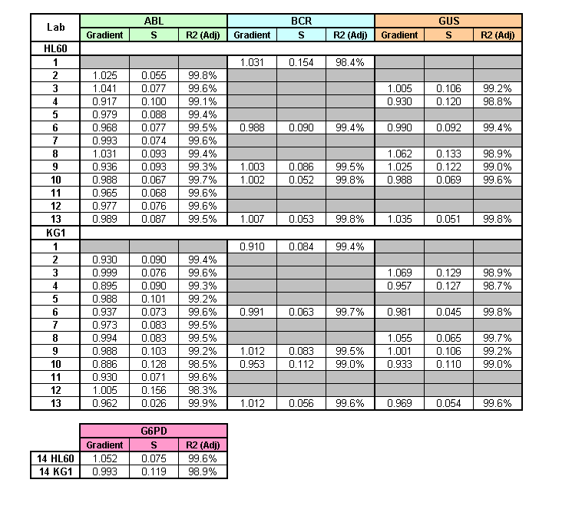
Lab 1

a) HL60 BCR

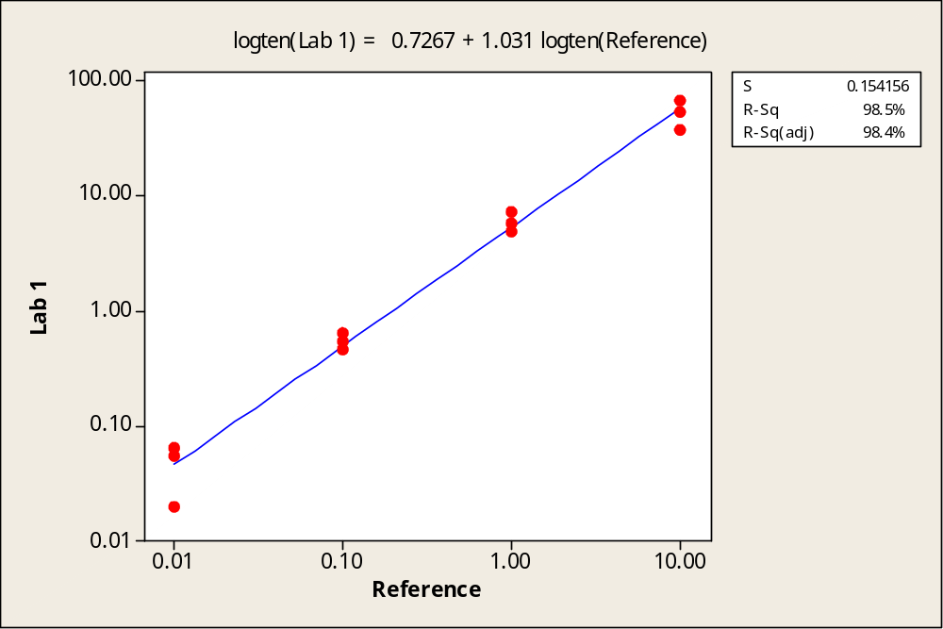

b) KG1 BCR

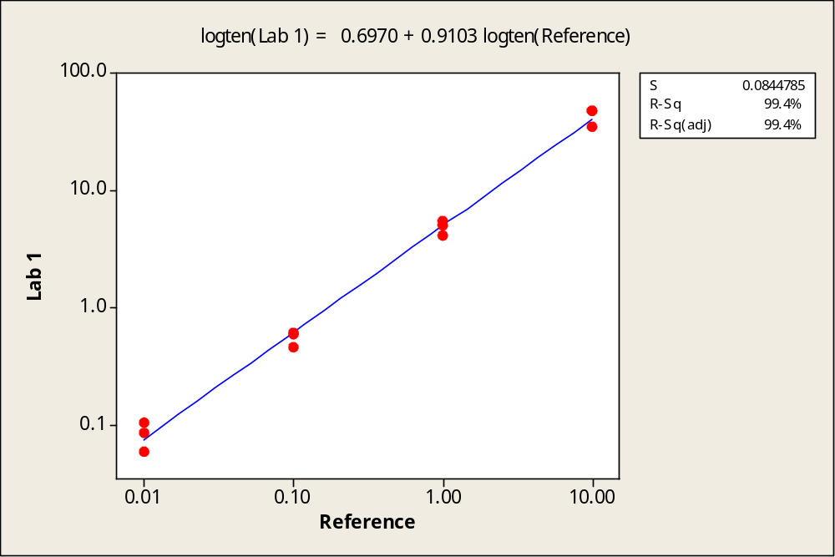
Lab 2

a) HL60 ABL

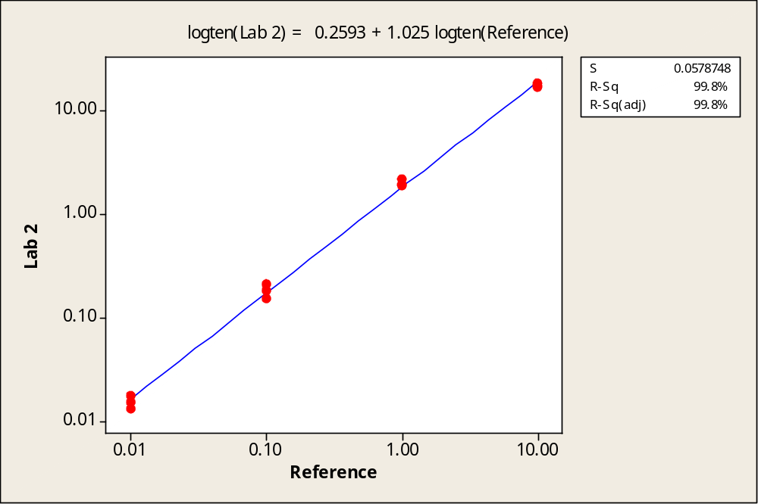

b) KG1 ABL

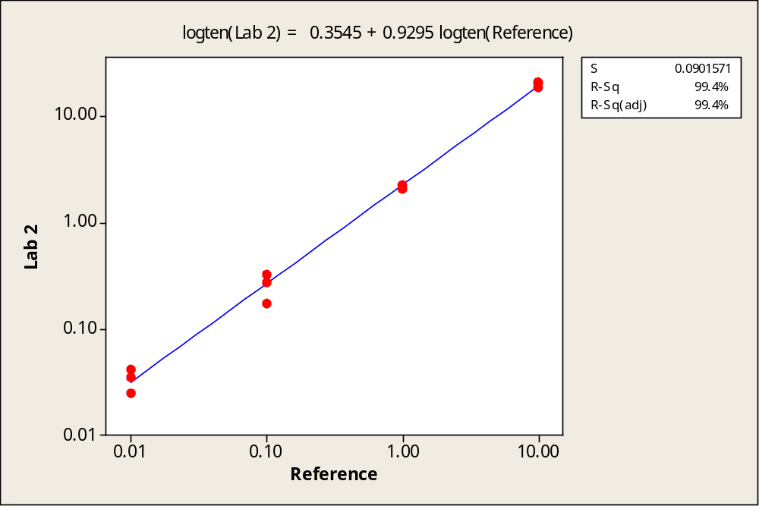
Lab 3

a) HL60 ABL

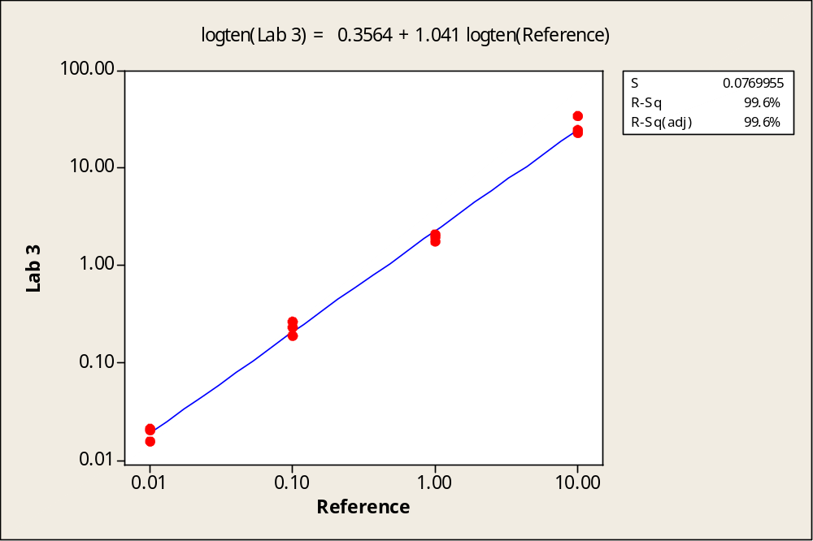

b) KG1 ABL

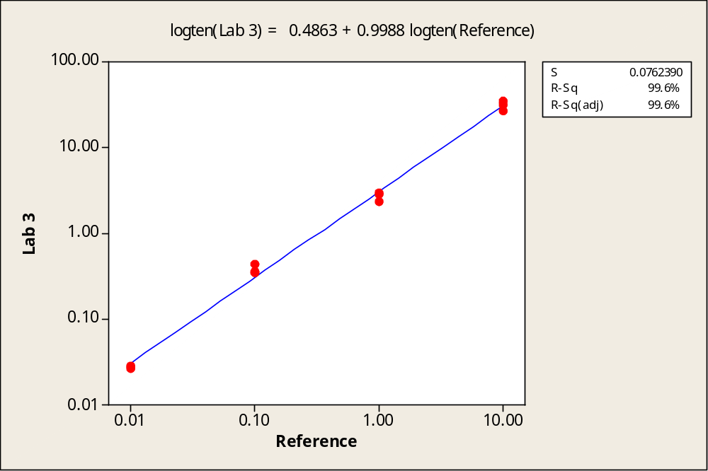
Lab 3

a) HL60 GUSB

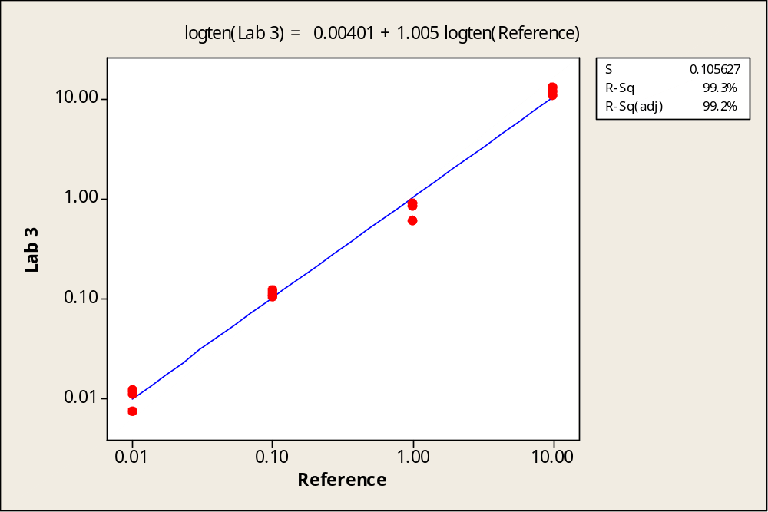

b) KG1 GUSB

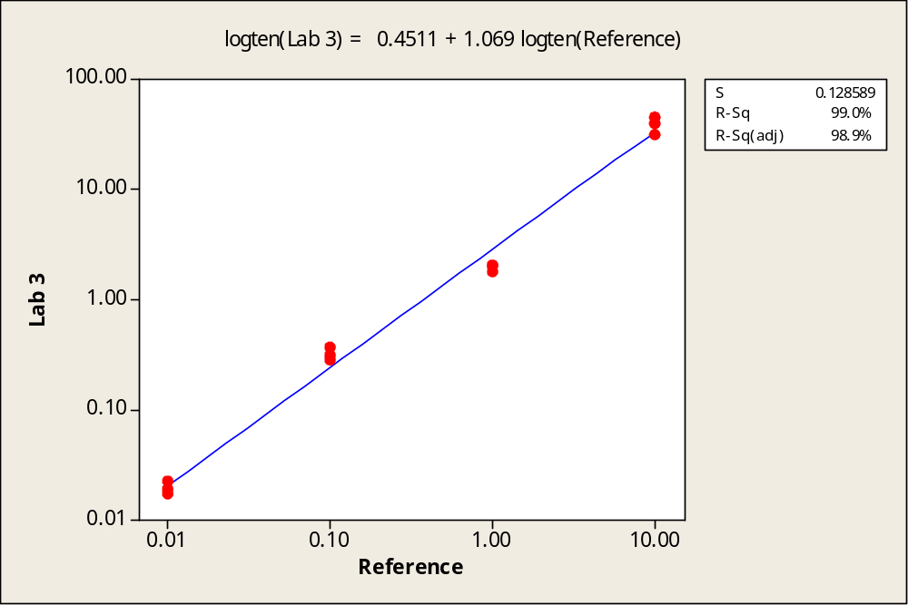
Lab 4

a) HL60 ABL

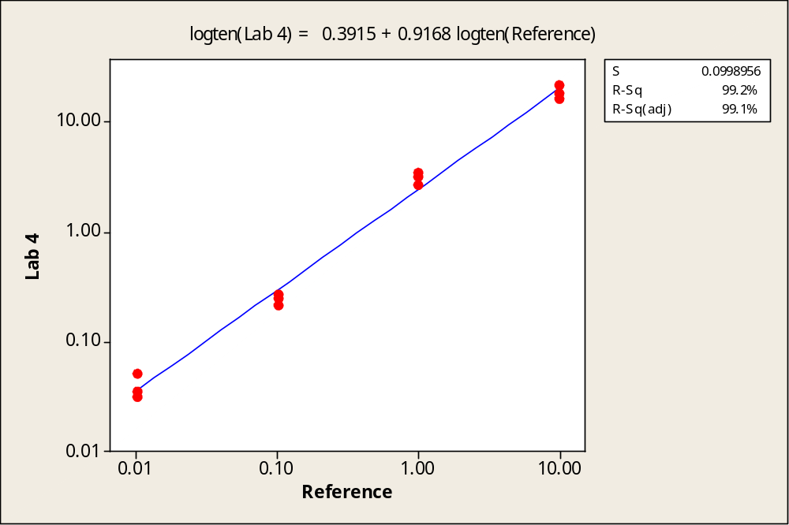

b) KG1 ABL

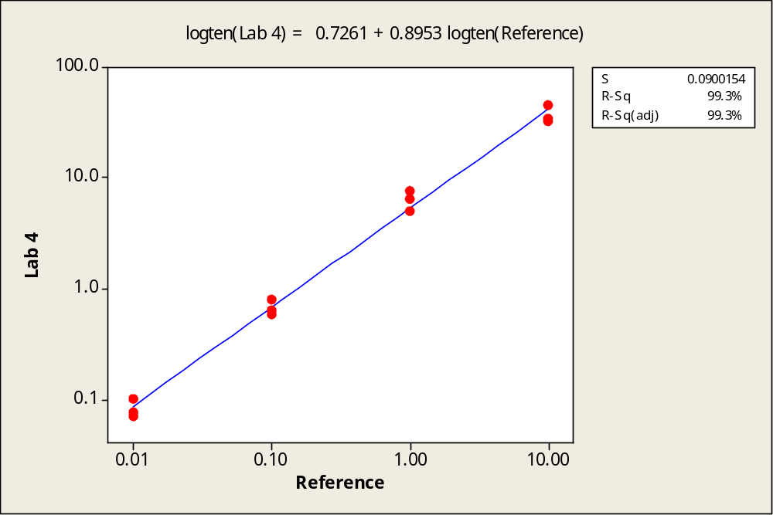

Lab 4

a) HL60 GUSB

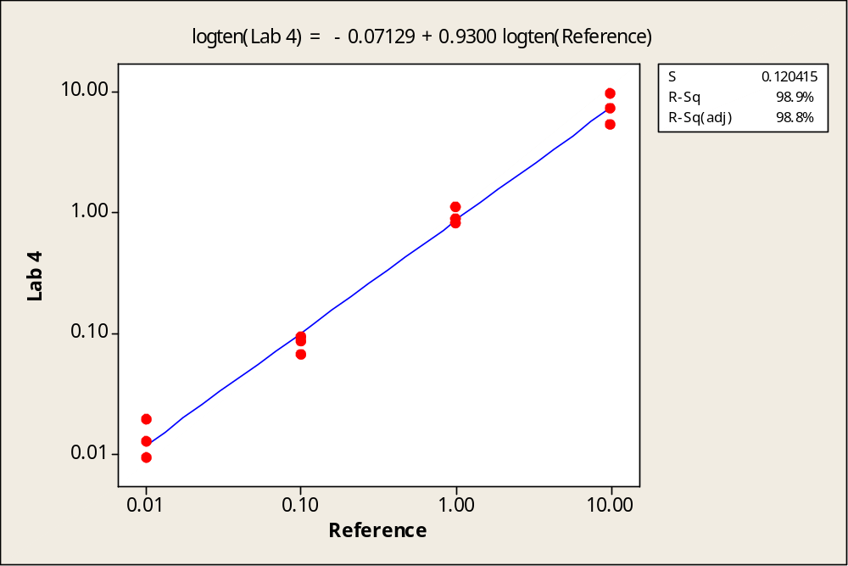

b) KG1 GUSB

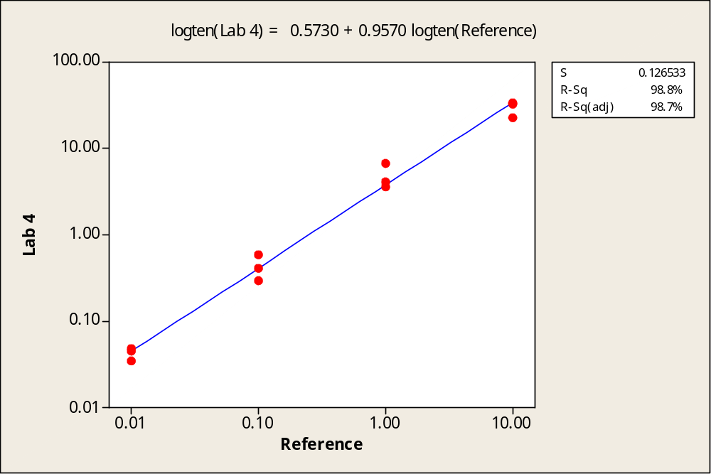
Lab 5

a) HL60 ABL

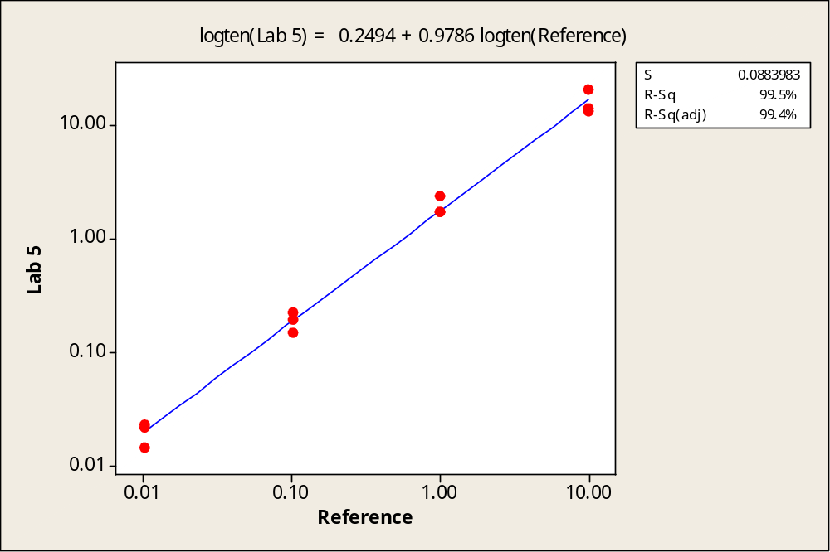

b) KG1 ABL

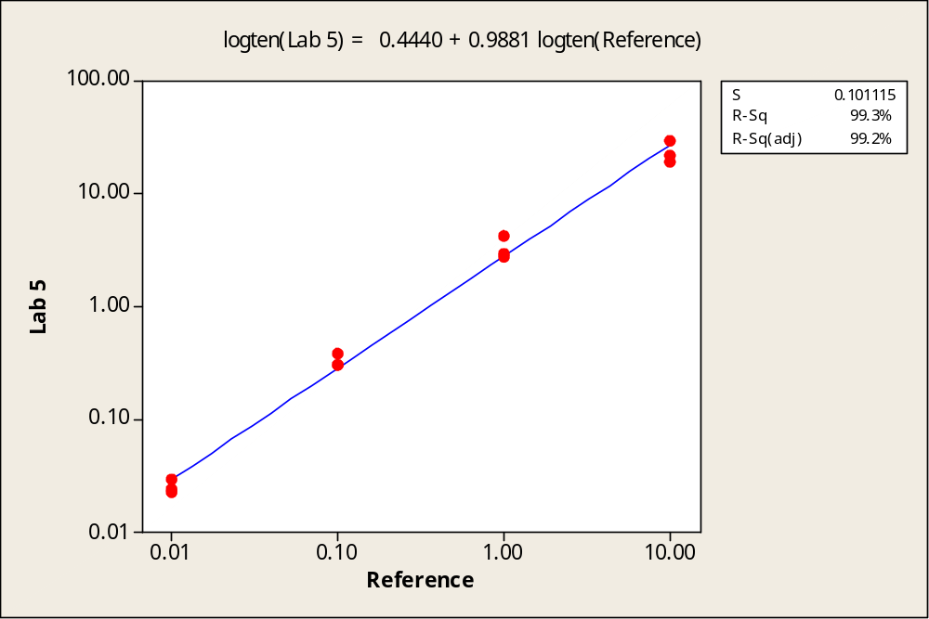

Lab 6

a) HL60 ABL
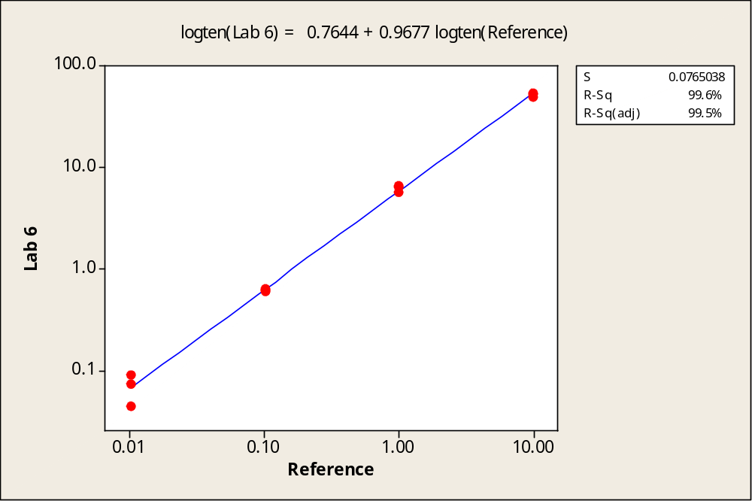

b) KG1 ABL

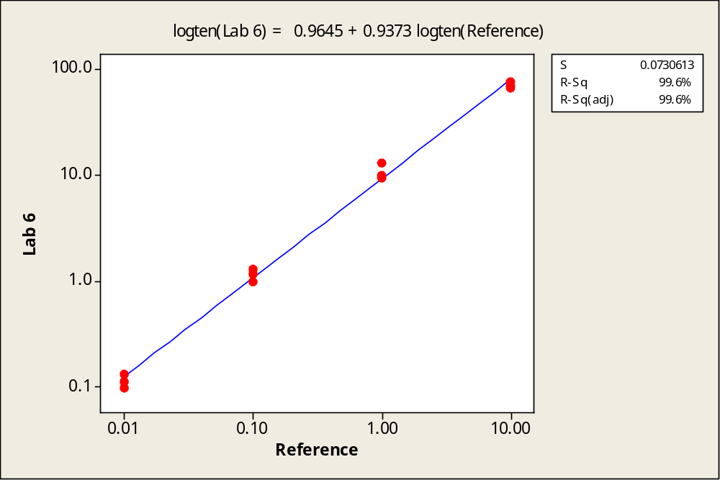
Lab 6
a) HL60 BCR

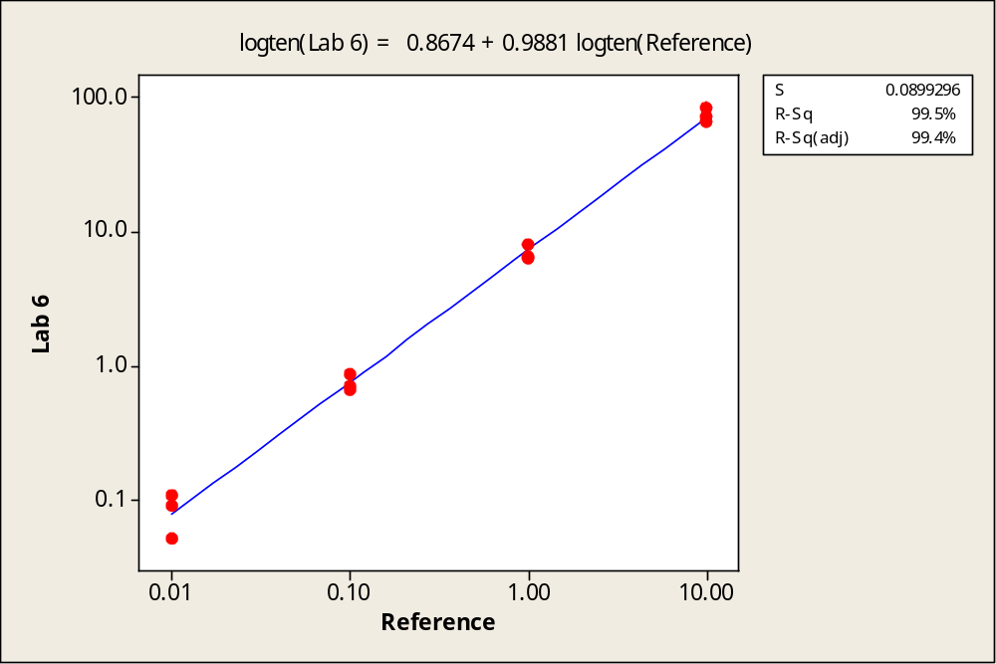

b) KG1 BCR

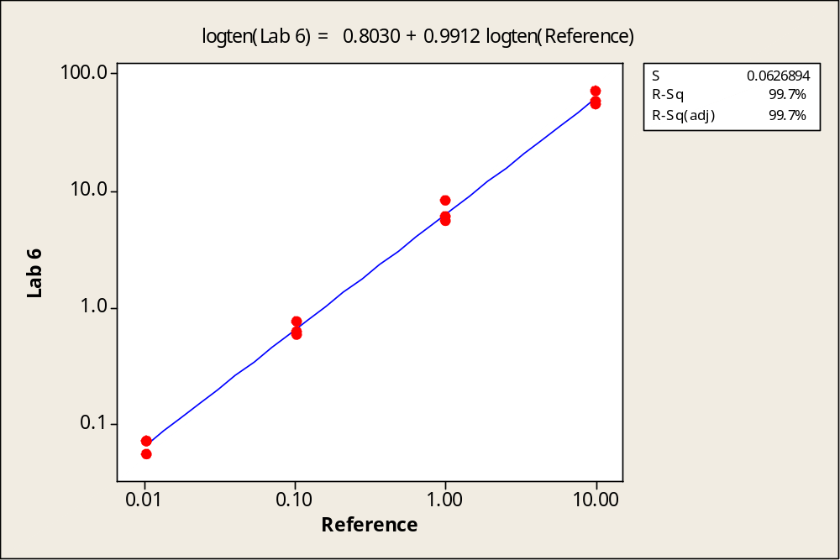
Lab 6

a) HL60 GUSB

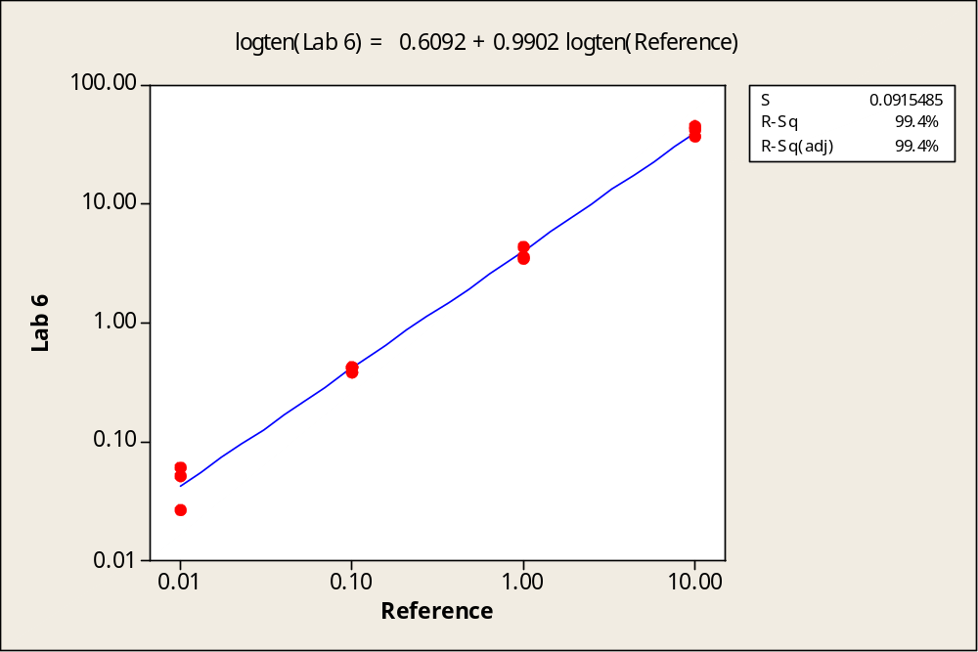

b) KG1 GUSB

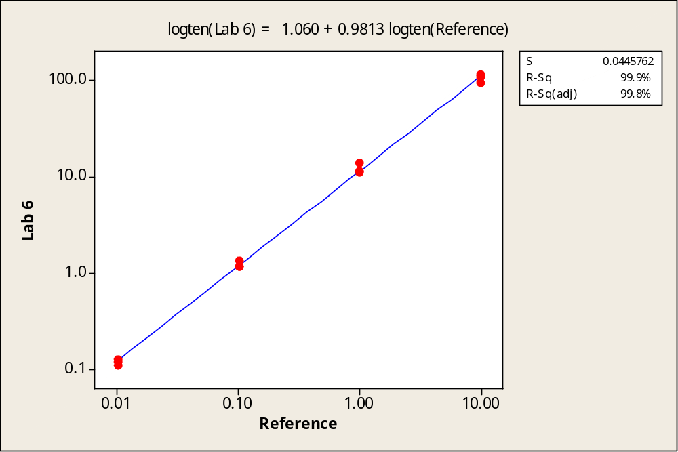
Lab 7

a) HL60 ABL

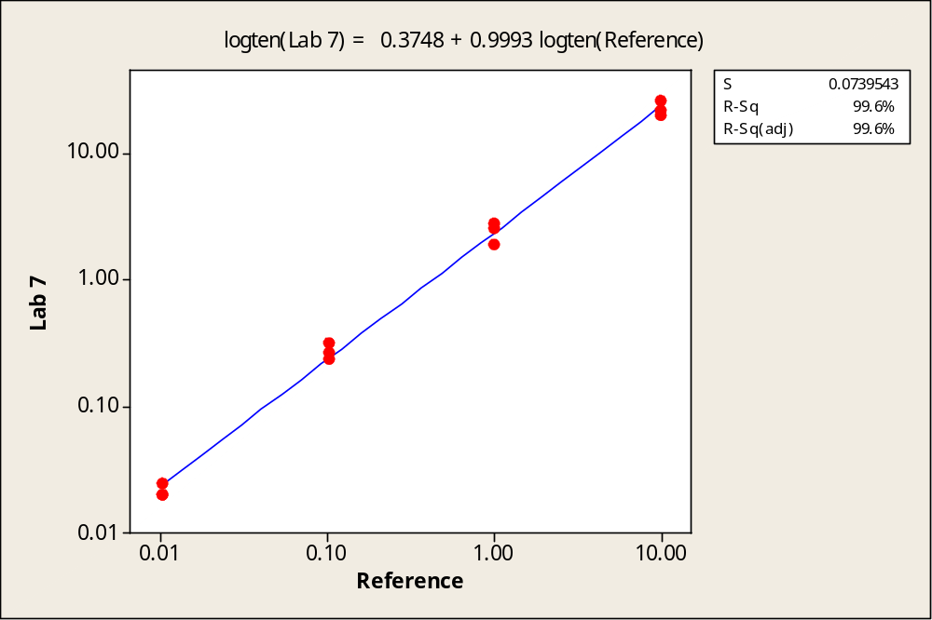

b) KG1 ABL

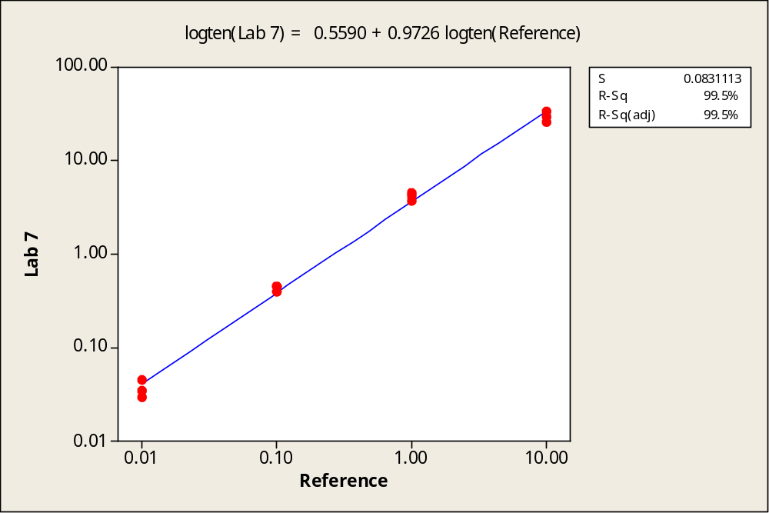
Lab 8

a) HL60 ABL

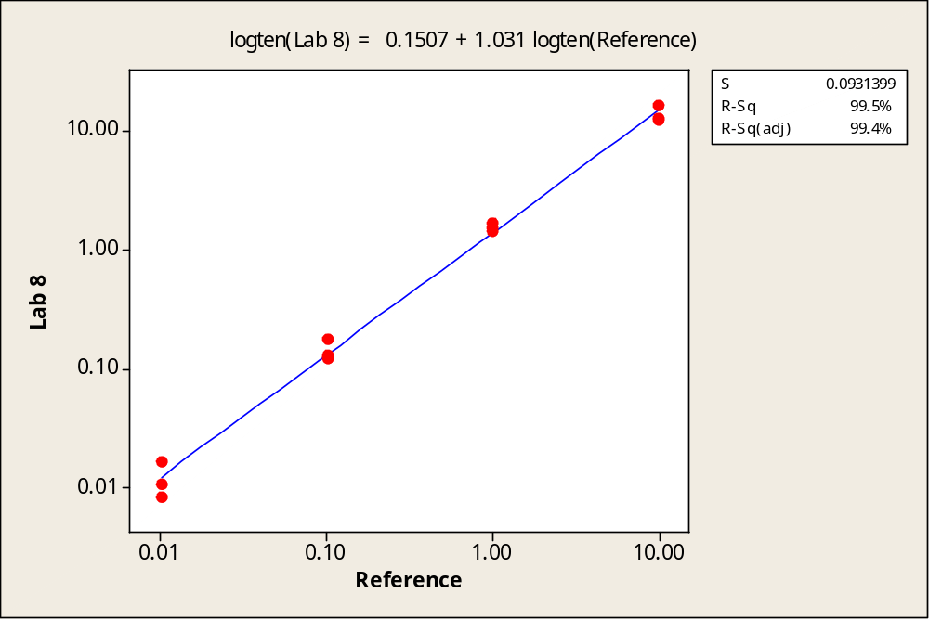

b) KG1 ABL

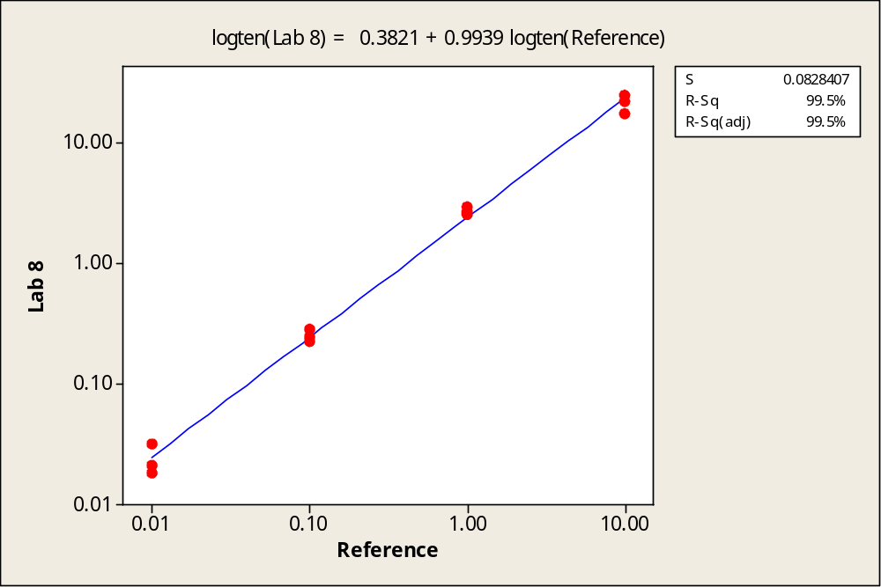
Lab 8

a) HL60 GUSB

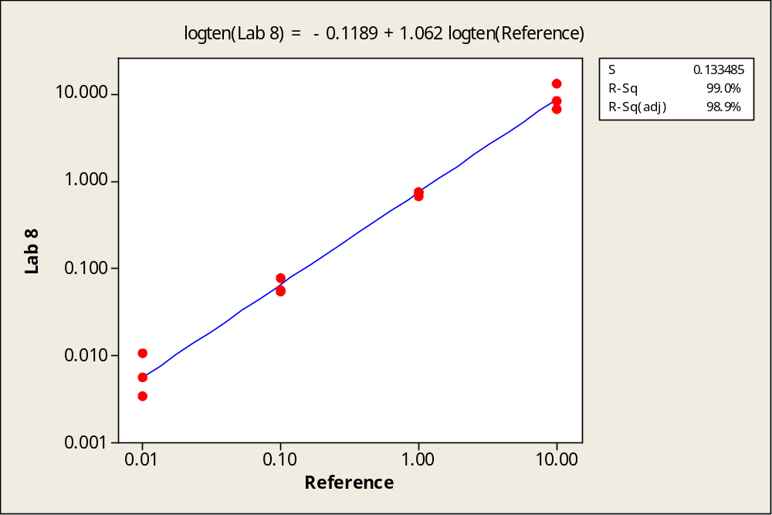

b) KG1 GUSB

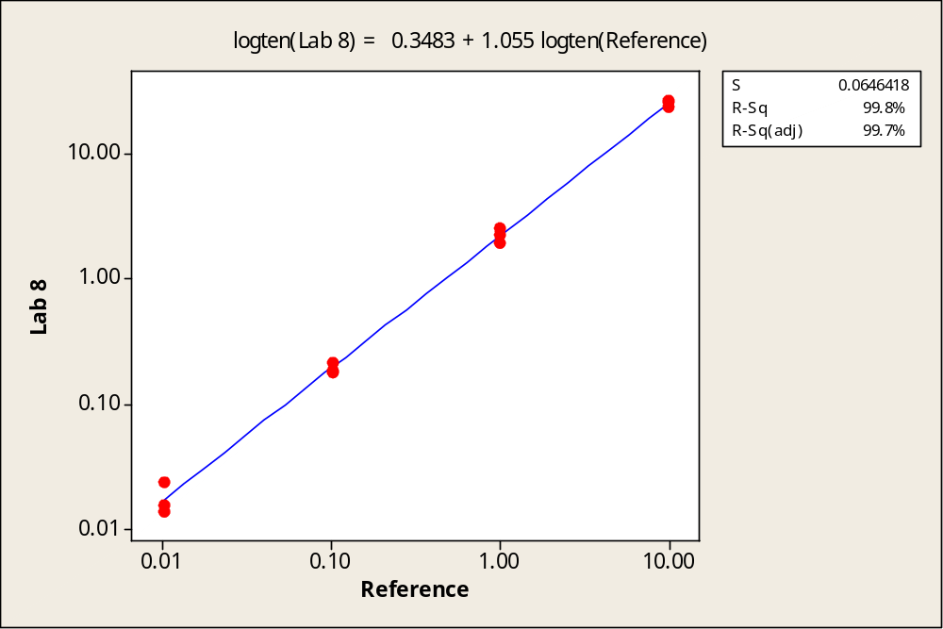
Lab 9

a) HL60 ABL

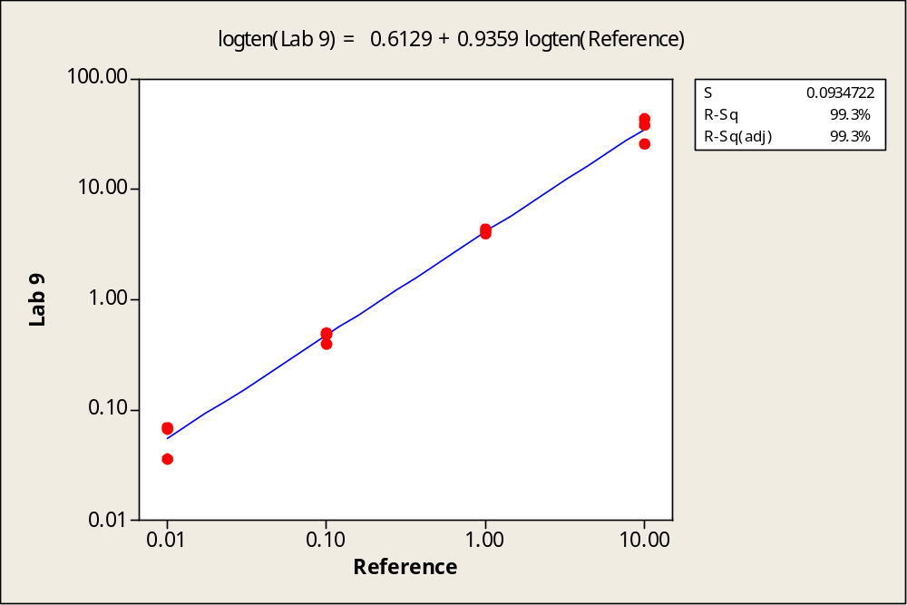

b) KG1 ABL

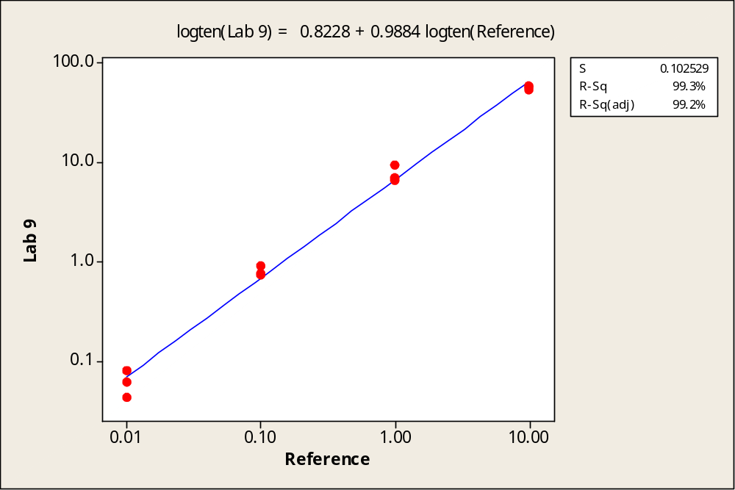
Lab 9
a) HL60 BCR

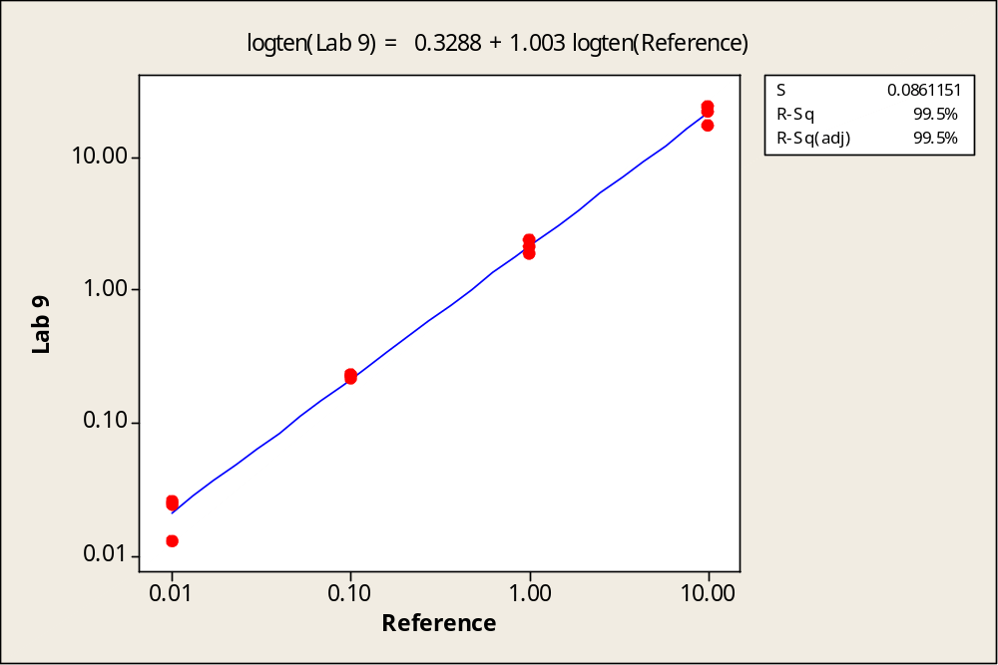

b) KG1 BCR

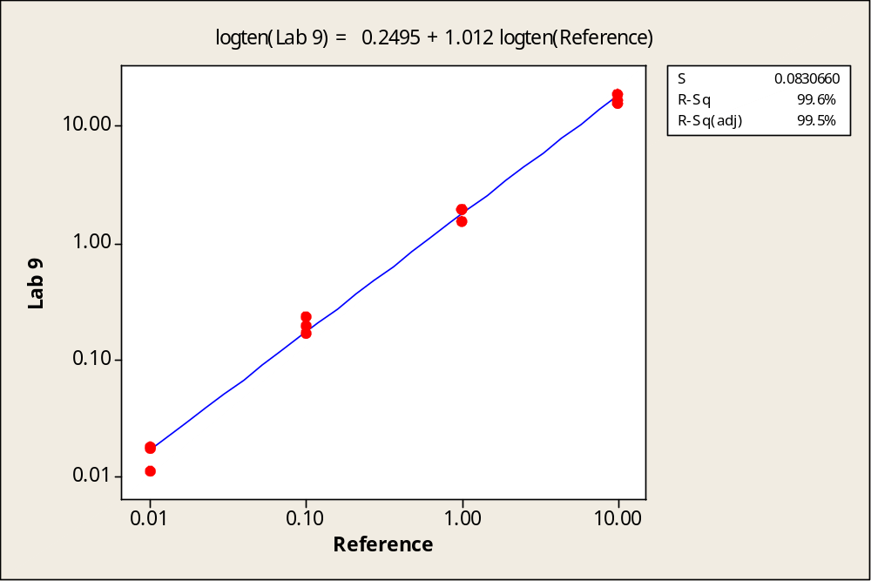
Lab 9

a) HL60 GUSB

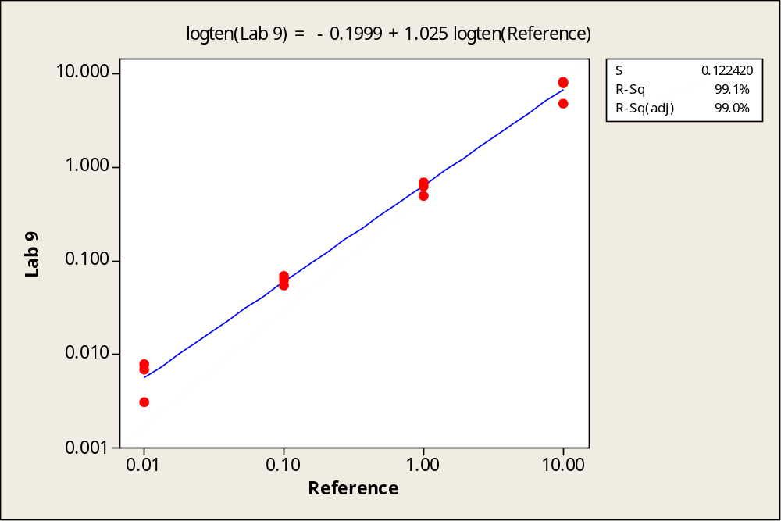

b) KG1 GUSB

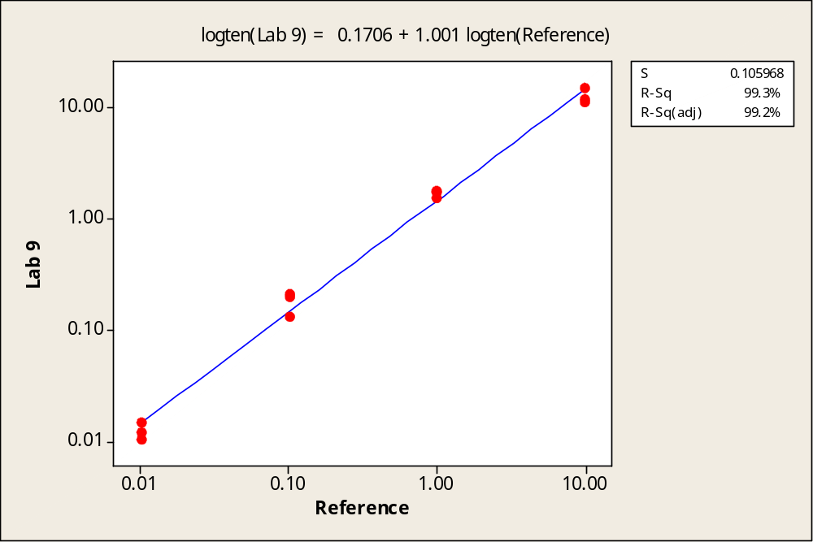
Lab 10

a) HL60 ABL

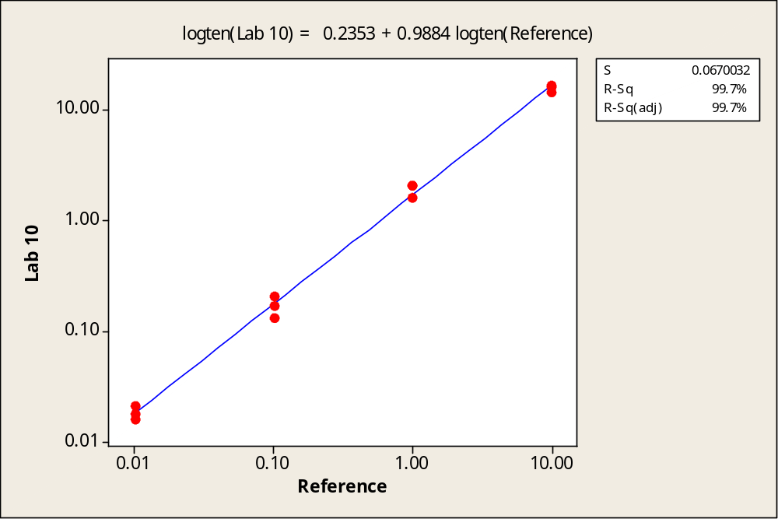

b) KG1 ABL

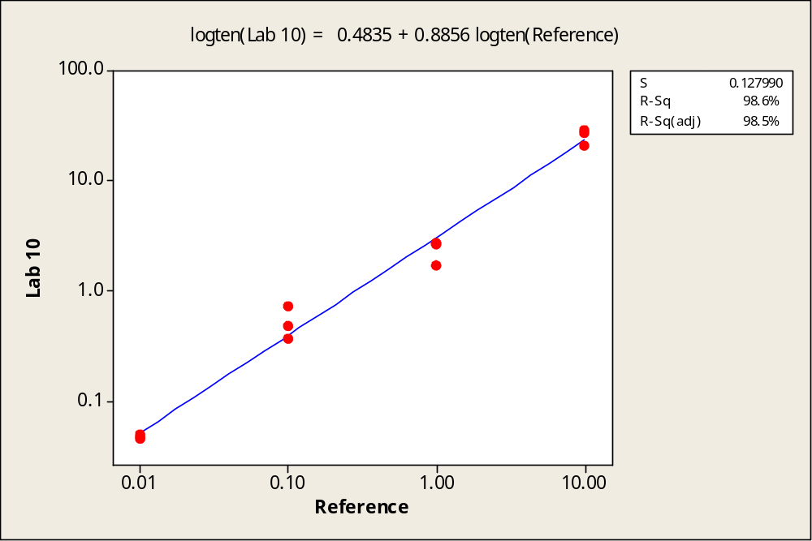
Lab 10
a) HL60 BCR

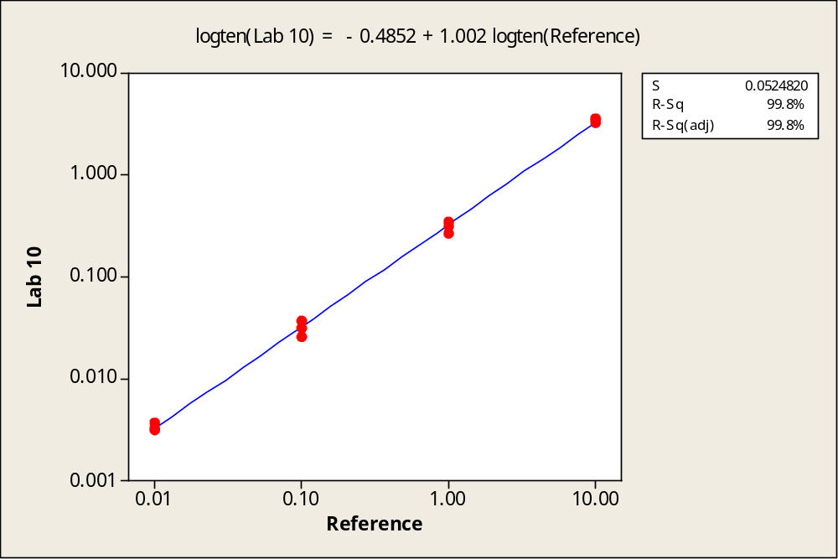

b) KG1 BCR

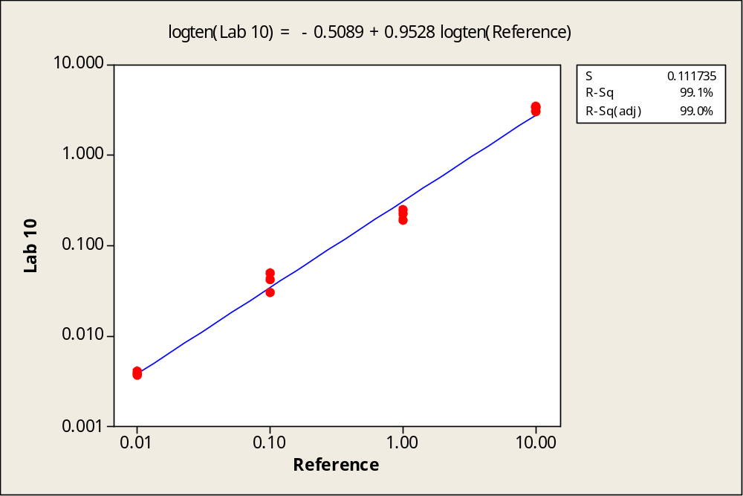
Lab 10

a) HL60 GUSB

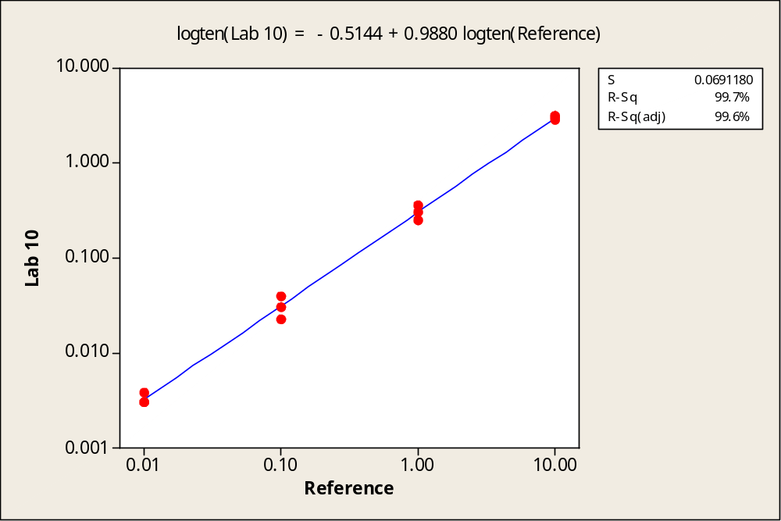

b) KG1 GUSB

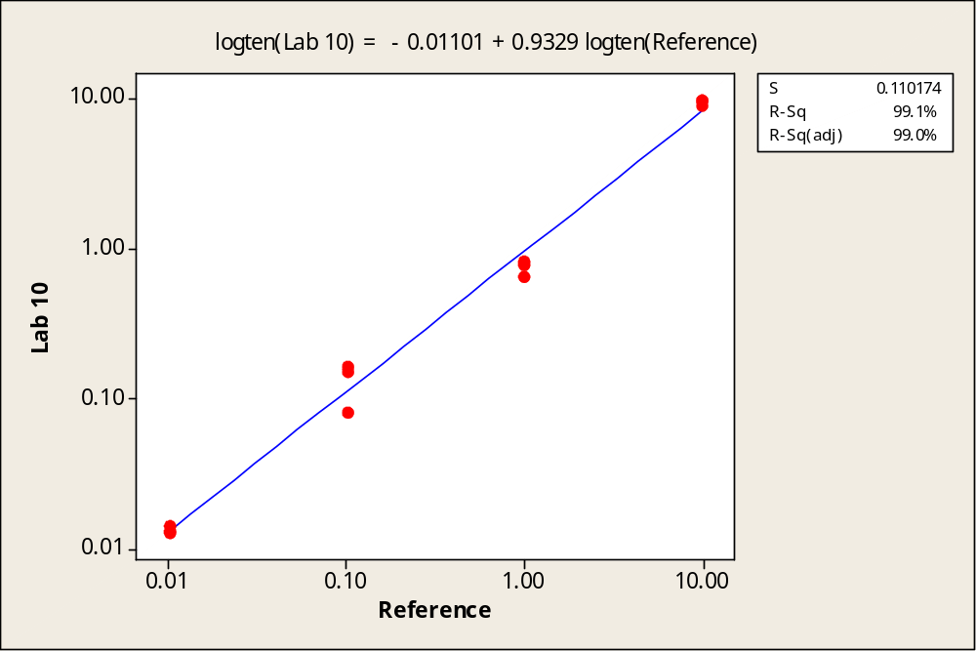
Lab 11

a) HL60 ABL

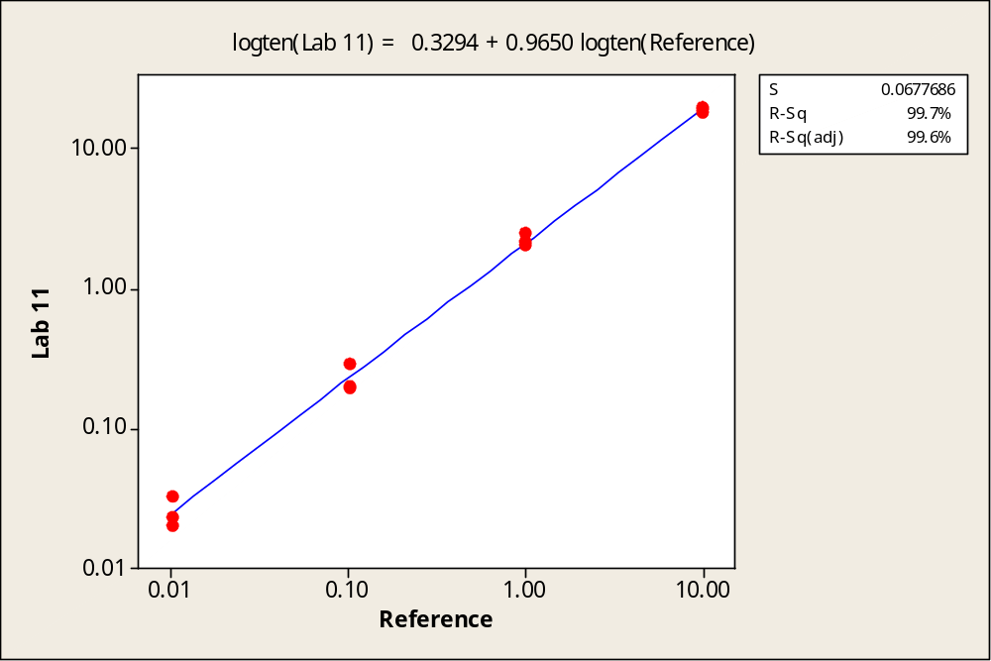

b) KG1 ABL

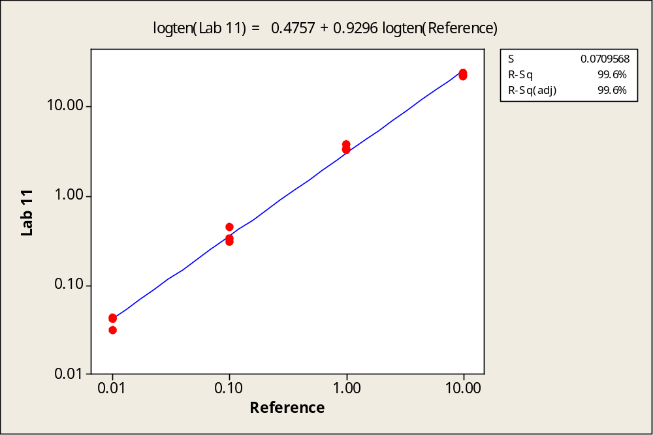
Lab 12

a) HL60 ABL

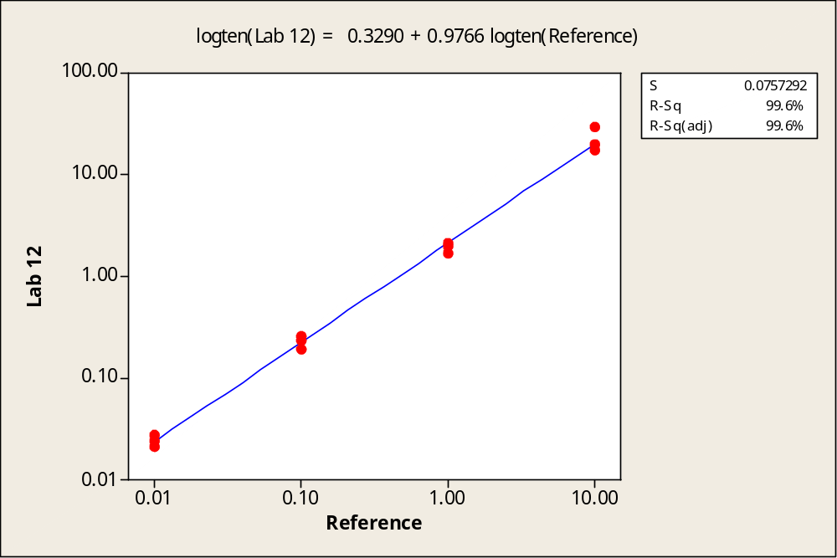

b) KG1 ABL

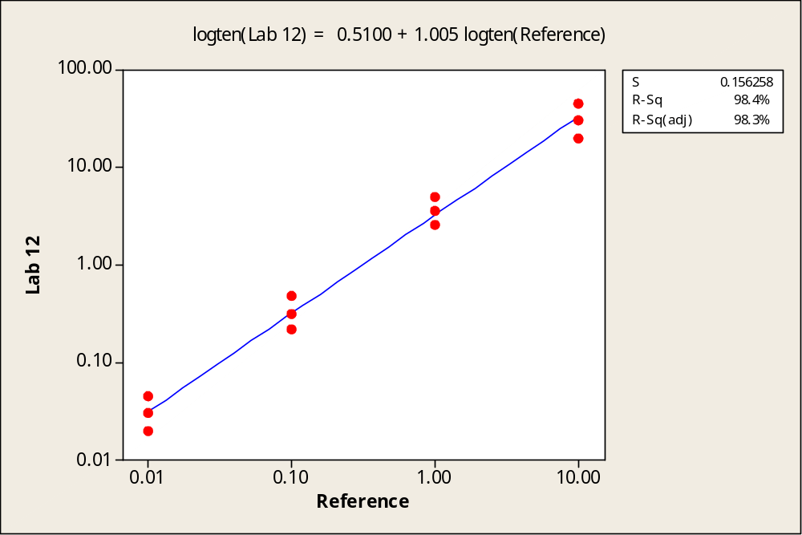
Lab 13

a) HL60 ABL

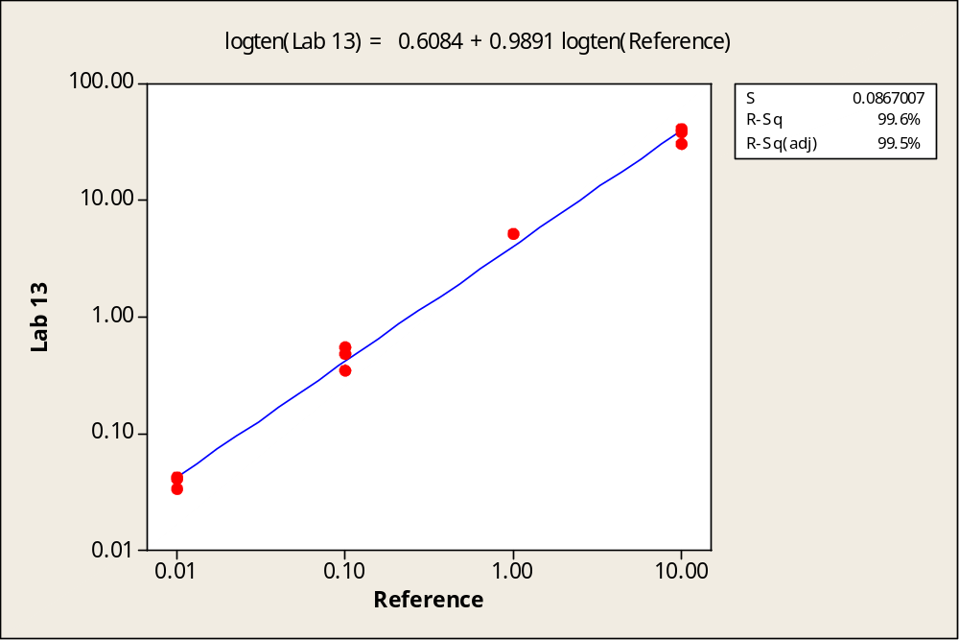

b) KG1 ABL

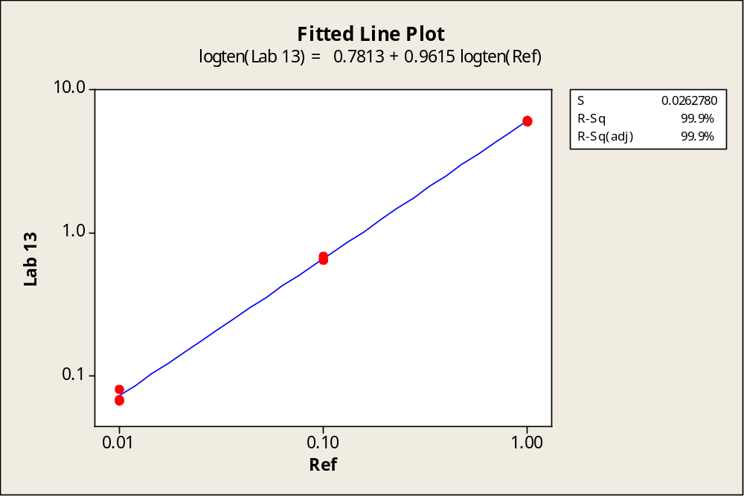
Lab 13
a) HL60 BCR

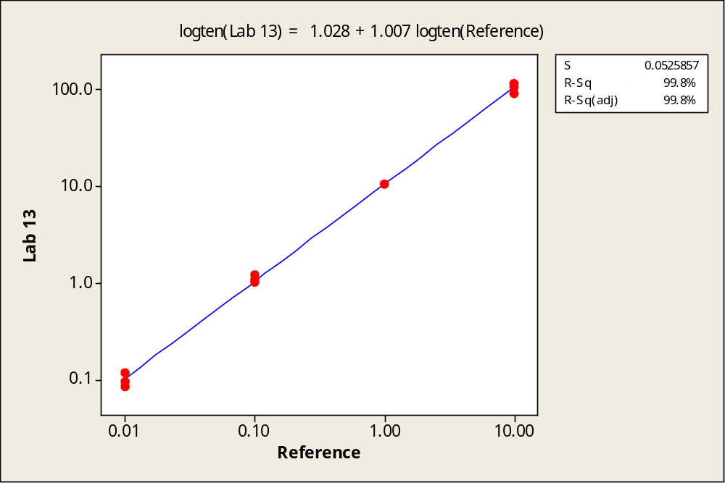

b) KG1 BCR

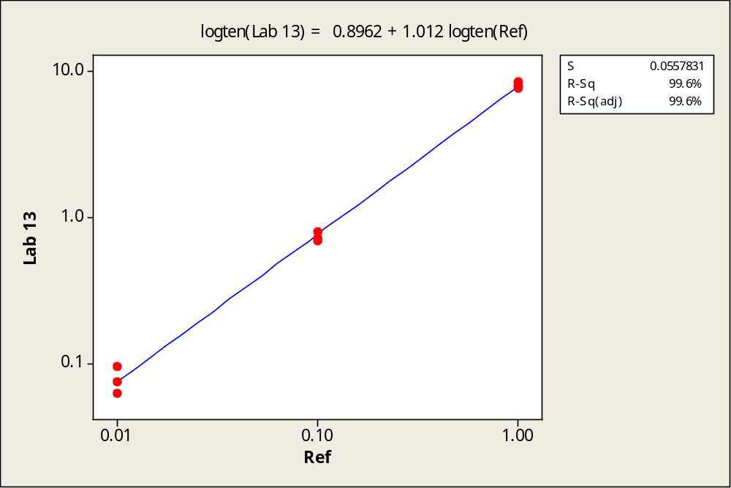

Lab 13

a) HL60 GUSB

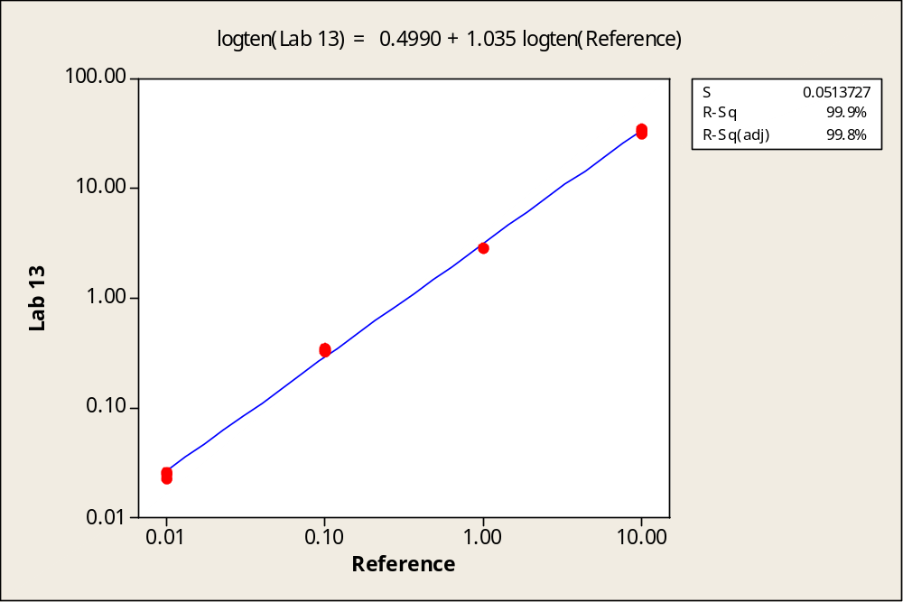

b) KG1 GUSB

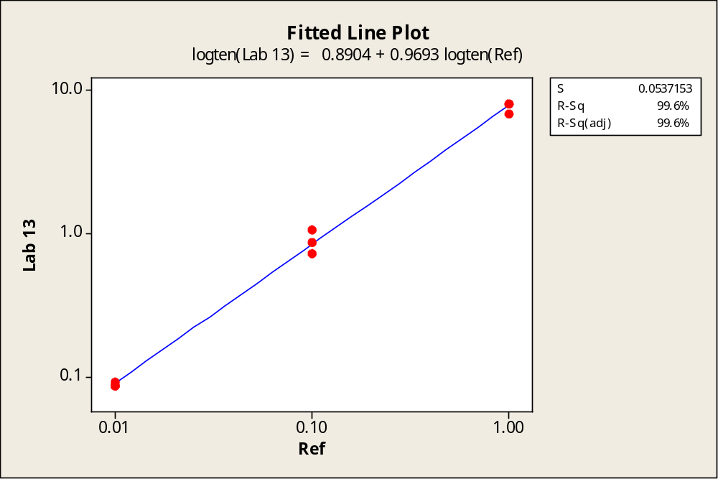

Lab 14

a) HL60 G6PD

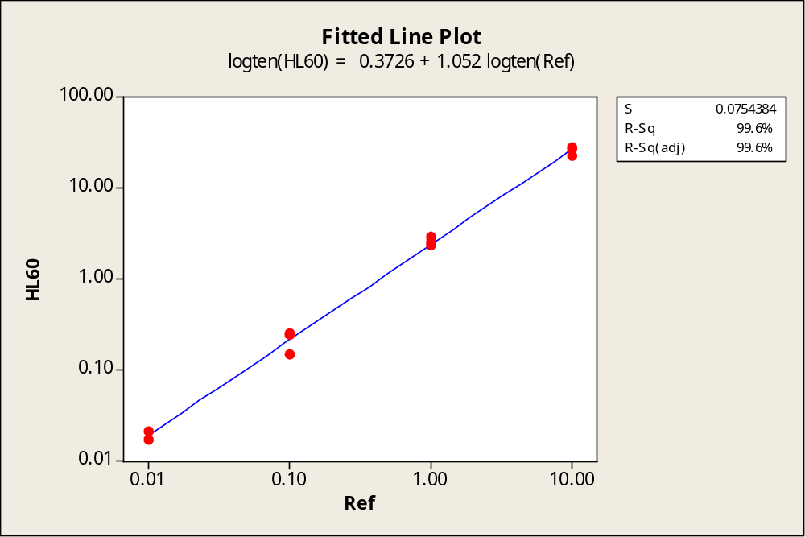

b) KG1 G6PD

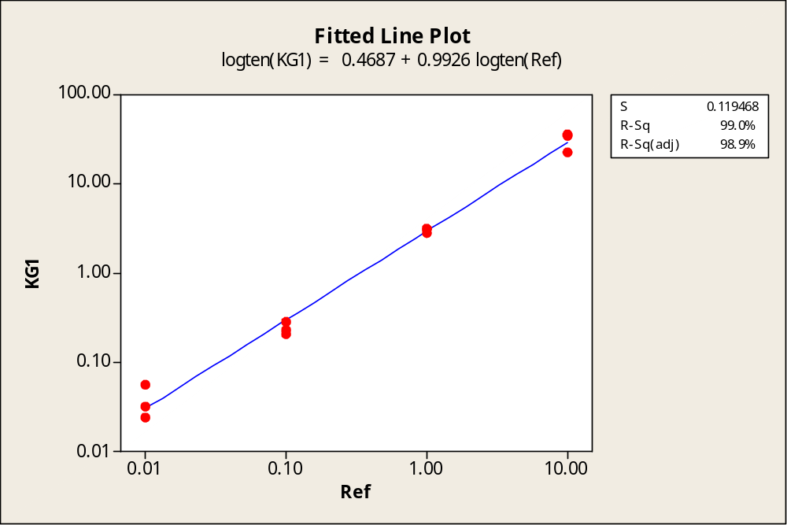


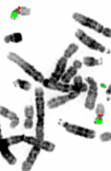

National Genetics Reference Laboratory (Wessex)
Salisbury District Hospital
Salisbury SP2 8BJ, UK

www.ngrl.org.uk

