

National Genetics Reference Laboratory
(Wessex)





Production and Field Trial Evaluation of Reference Reagents for Mutation Screening of BRCA1, BRCA2, hMLH1 and MSH2

January 2006

Reference Reagents

NGRL WESSEX

Title | Production and Field Trial Evaluation of Reference Reagents for Mutation Screening of BRCA1, BRCA2, hMLH1 and MSH2
NGRL Ref | NGRLW_Ref_1.0
Publication Date | January 2006
Document Purpose | Dissemination of information about production and field trial evaluation of reference materials for mutation screening of BRCA1, BRCA2, hMLH1 and MSH2
Target Audience | Laboratories performing mutation screening and participants of NGRL (Wessex) field trial.
NGRL Funded by | 

Contributors

Name | Role | Institution
Helen White | Clinical Research Scientist | NGRL (Wessex)
Gemma Potts | MTO | NGRL (Wessex)
Vicky Durston | MTO | NGRL (Wessex)

Conflicting Interest Statement

The authors declare that they have no conflicting financial interests

How to obtain copies of NGRL (Wessex) reports

An electronic version of this report can be downloaded free of charge from the NGRL website (http://www.ngrl.co.uk/Wessex/downloads)

or by contacting

National Genetics Reference Laboratory (Wessex)
Salisbury District Hospital
Odstock Road
Salisbury
SP2 8BJ
UK

E mail: ncpc@soton.ac.uk
Tel: 01722 429016
Fax: 01722 338095

Table of Contents

Summary….……………………………………………………………………………….1

1. Introduction 2

2. Production of plasmid based reference material 2

3. Field Trial Evaluation 4

3.1 Overall Evaluation 4
3.2 BRCA1 plasmid performance evaluation 10
3.3 BRCA2 plasmid performance evaluation 12
3.4 BRCA1 and BRCA2 Exon 11 plasmid performance evaluation 14
3.5 hMLH1 plasmid performance evaluation 16
3.6 MSH2 plasmid performance evaluation 17

4. Overall Conclusions from field trial 19

5. Future Work 19

5.1 Redesign of BRCA and HNPCC plasmids 19
5.2 Production of polymorphism controls 19
5.3 Quantification of controls 19

6. Acknowledgements 19

Appendix 1: Laboratories who returned evaluation questionnaires………………………………….20
Appendix 2: Details of cloned fragments in mutant mixes…………………………………………....21

SUMMARY

- NGRL (Wessex) has produced sets of plasmid constructs that harbour defined sequence changes in all exons of BRCA1, BRCA2, hMLH1 and MSH2. These can be used as controls for a wide range of mutation scanning assays.

- Plasmid controls were sent out to 34 individuals in 26 laboratories from May 2003 – October 2005 for a performance indicator field trial.

- To assess reagent performance, laboratories were asked to fill in and return monthly questionnaires to monitor whether the plasmid reagents amplified efficiently and whether the mutations could be detected successfully. Questionnaires were collected over an 18 month period and a final follow-up questionnaire was distributed in January 2005

- 20 individuals from 15 laboratories returned questionnaires

- Reagents were analysed using six mutation scanning techniques: dHPLC, sequencing, SSCP/HD, CSCE, PTT and MALDI-TOF

- Analysis of the data collected from the 20 field trial participants who returned questionnaires showed that:

- 80% have used the controls in routine testing

- 65% have used the reagents to develop new assays or validate existing screens

- 30% have altered diagnostic protocols as a results of using the controls

- 95% found plasmid DNA to be an acceptable alternative to genomic DNA

- 100% thought that the reagents were a useful resource

- 85% agreed that the reagents should be produced as reference material

- Generally the reagents performed well in most laboratories although several labs commented that the plasmid controls amplified more weakly than genomic DNA samples

- The plasmids are currently undergoing modification to be compatible with the standardised primer sets developed by NGRL (Wessex)

Introduction
NHS genetic diagnostic laboratories perform thousands of tests every month using a variety of technologies. Laboratories generally utilise locally developed controls as standards to confirm that the assay is working correctly. Consequently there is a degree of variation in the number and type of controls employed in different laboratories which could potentially compromise quality assurance. To address this problem NGRL (Wessex) has produced sets of plasmid constructs that harbour defined sequence changes and which can be used as controls for a wide range of mutation assays. A set of constructs for the analysis of all exons of BRCA1, BRCA2, hMLH1 and MSH2 were sent to interested UKGTN laboratories and other collaborating laboratories worldwide for performance evaluation from May 2003 – November 2005 (Appendix 1). This report details how the reference material was produced, summarises the results of the performance evaluation field trial and addresses the future work planned to improve these reagents.

Production of Plasmid based reference material
Plasmid based reference material was produced as outlined in Figure 1.

Blood taken from 8 consented volunteers
DNA extracted and pooled
Normal DNA sequences amplified using PCR
PCR products cloned into T-tailed vector
Verification of mutant sequence
Evaluation of constructs by mutation screening method
Verification of normal sequence
Mutations introduced using site directed mutagenesis

- Flow diagram outlining the production strategy for plasmid based reference material for mutation screening

Essentially, 10ml peripheral blood was collected from 8 consenting healthy volunteers. DNA was extracted and pooled and wild type exonic sequences flanked by at least 100bp intronic sequence were amplified using PCR. Amplicons were designed to contain the region in
which most diagnostic primer sets anneal. The resulting amplicons were cloned into pCR2.1 (Invitrogen) and mutations were introduced using targeted site directed mutagenesis (QuikChange® Multi Site-Directed Mutagenesis Kit, Stratagene). The mutations were either selected because they were reported as being pathogenic or were selected to be placed in regions predicted to be difficult to screen using dHPLC i.e. they were in problematic melt domains (e.g. Figure 2).

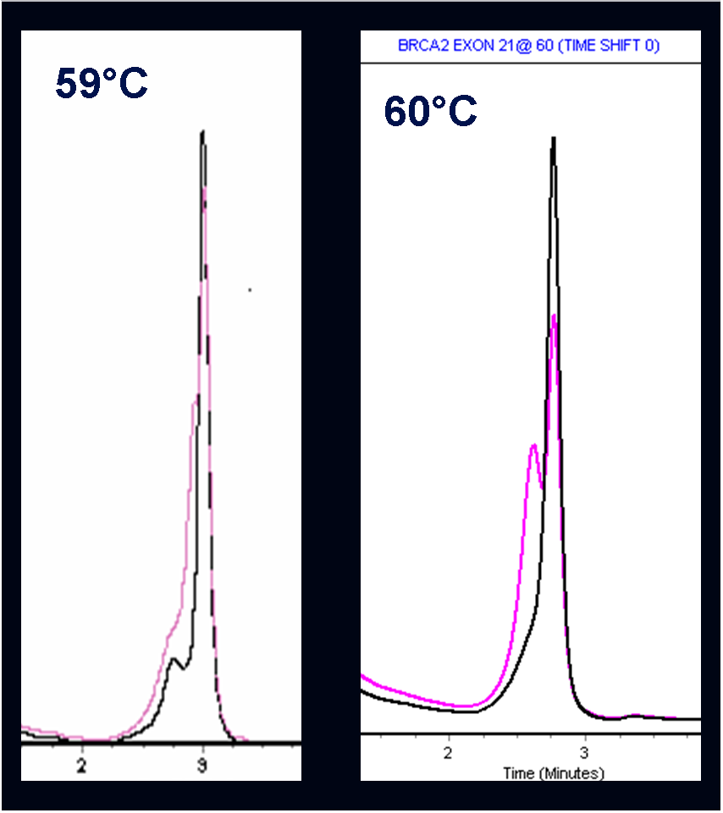
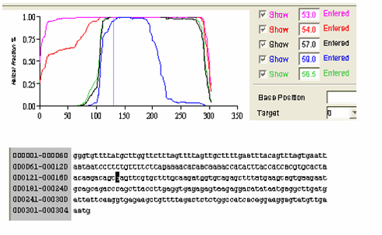

- WAVE melt profile for BRCA2 Exon 21 generated using WAVE MD Software. The mutation A8909G in highlighted in the sequence and the position of the base in the melt profile is indicated by the vertical blue line. From the melt profile it was predicted that the mutation would be difficult to detect since it was in a problematic melt domain. The WAVE traces show that at 59°C the detection of the mutation (pink line) was very subtle (compared to the wild type trace) but could be resolved more clearly at 60°C.

Prior to the field trial the reference reagents were tested by NGRL (Wessex) using dHPLC, sequencing and the protein truncation test (for BRCA1 and 2, exon 11). Examples of dHPLC traces are shown on our website (http://www.ngrl.org.uk/Wessex/brca2mt.htm). The plasmid reagents were supplied to field trial participants as wild type and mutant plasmid mixes (Appendix 2) with each linearised plasmid diluted to 10⁴ copies/µl in 0.1XTE containing 50µg/ml tRNA as a carrier. This dilution is equivalent to the copy number found in 100ng genomic DNA and therefore the plasmids should not pose a contamination threat greater than patient DNA samples. Laboratories receiving the reagents were advised that the reagents should be handled using plugged aerosol resistant tips and that the usual precautions should be taken to ensure that stocks did not contaminate pre PCR areas.

We recommended that the 1ml plasmid stocks should be centrifuged for 1 minute at 14,000rpm (to eliminate aerosols), aliquoted (100µl) and stored at -20°C. It was suggested that working aliquots were kept at 4°C. We recommended that amplification of the wild type and mutant mixes should be performed independently and that the products should be checked on a gel to ensure that equivalent amplification efficiency was achieved. The products could then be mixed prior to heteroduplex analysis. Once laboratories were confident that the mixes were producing amplicons of equivalent intensity it was suggested that the plasmids could be mixed prior to PCR to mimic a heterozygous sample.

Figure 3 shows a time line of construction and distribution of the various plasmid mixes.

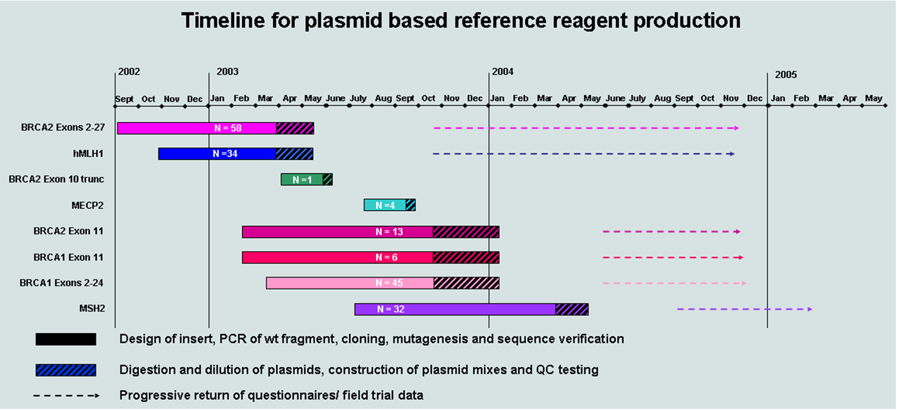

- NGRL (Wessex) has produced 193 plasmids controls for mutation screening of BRCA1, BRCA2, hMLH1 and MSH2. Reagents were designed, developed, produced and field trialled from August 2002 – November 2005. Evaluation forms were collected until December 2005

Field Trial Evaluation
Reference reagents were sent out to 34 individuals in 26 laboratories. To assess reagent performance, laboratories were asked to fill in and return monthly questionnaires to monitor whether the plasmid reagents amplified efficiently and whether the mutations could be detected successfully. Questionnaires were collected over an 18 month period and a final follow-up questionnaire was distributed in January 2005. 20 individuals from 15 laboratories returned questionnaires (Appendix 1) and the data collected from all questionnaires are summarised below.

Overall Evaluation
Participants provided the following responses to 13 questions in the final follow-up questionnaire:

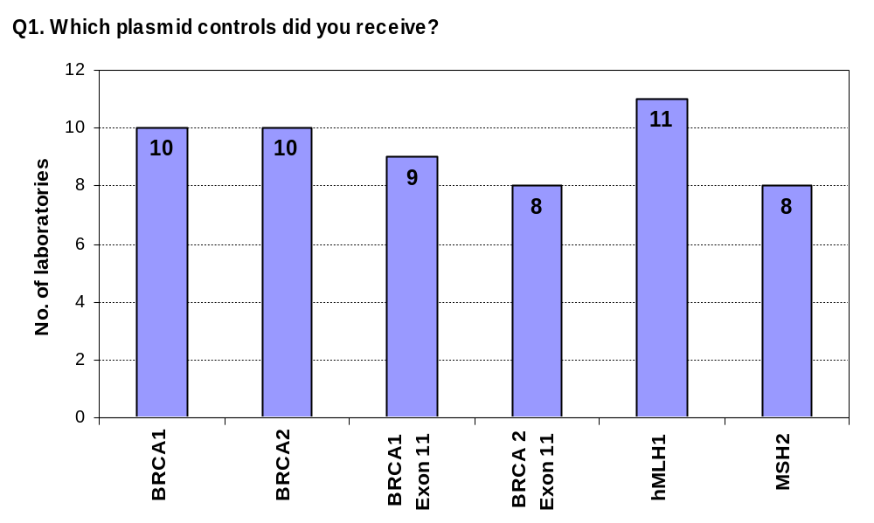
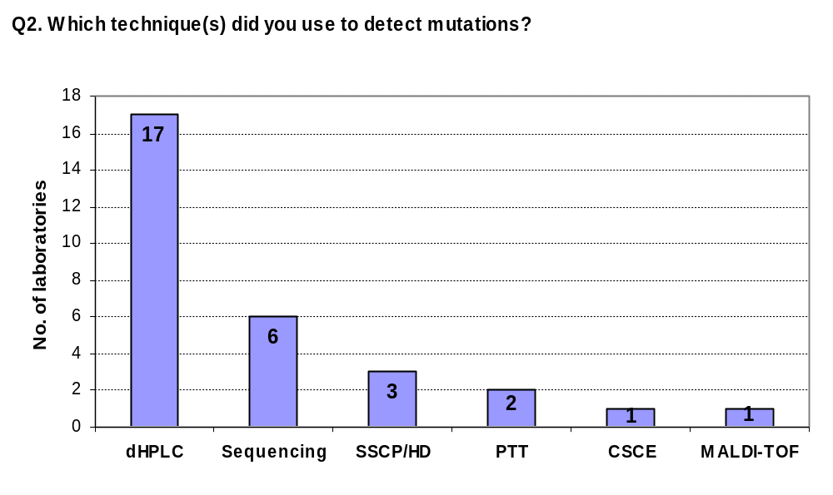
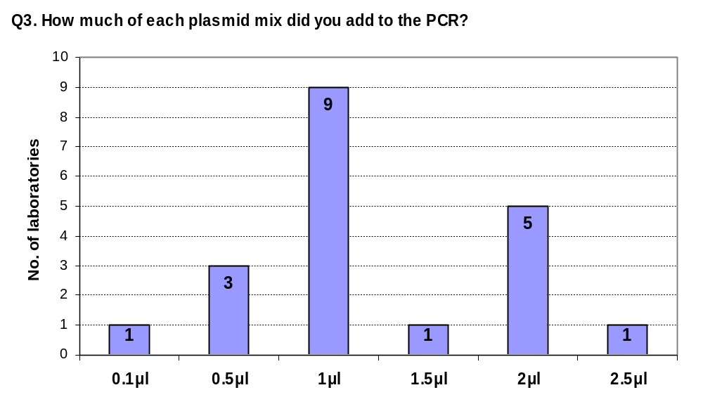

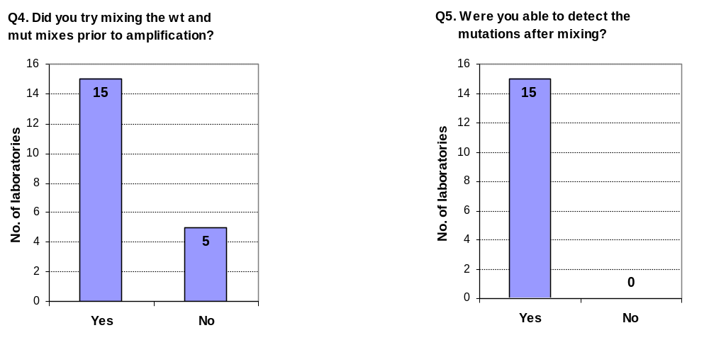
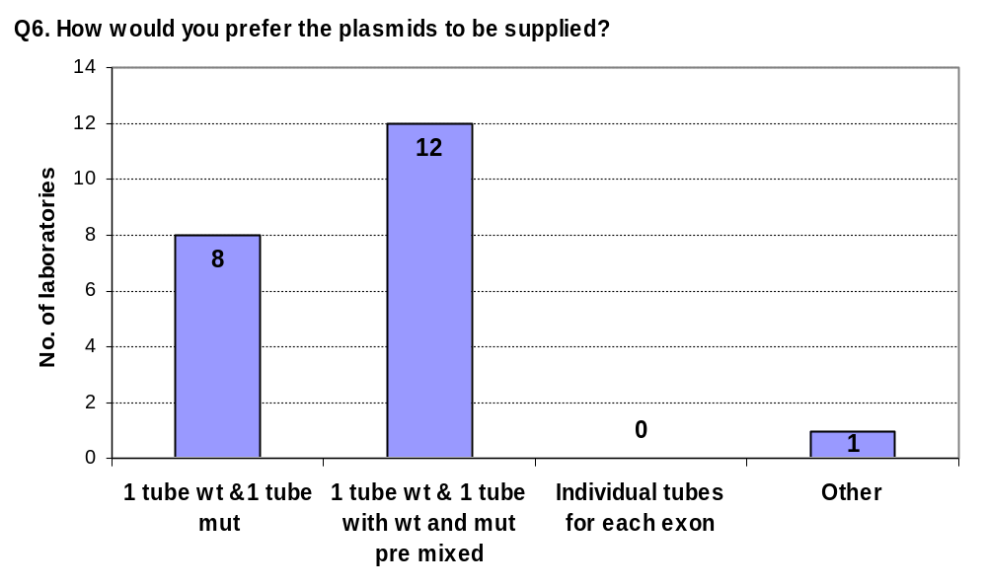

Q7. Do you use the controls in routine testing?

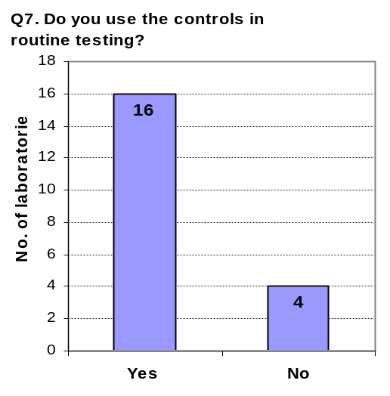

Q8. If you answered No to Q7, what is your main reason for not using the controls on a regular basis?

Lab 1: Altering screening procedure. Will be sequencing and therefore won’t use controls

Lab 2: Yields were lower than genomic DNA or plasmids failed to amplify

Lab 3: Backlog screening means that there is no room on plates for controls

Lab 4: Will be using once we have finalised primer sets

Q9. Have you used the controls to help develop new assays or validate existing screens?
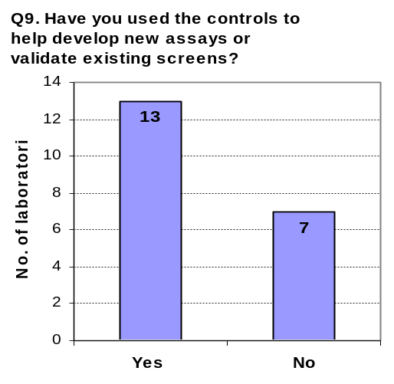

If yes, please give details:

1: Needed a specific exon control as no patient controls were available to validate assay.

2: Most of the ‘small exon’ screening for BRCA1 and BRCA2 was either developed after receiving the plasmid controls or existing protocols using SSCP/HAD gels were in the process of being redesigned for dHPLC.

3: Didn’t have control DNA for all exons of hMLH1 so especially useful for these to check that we could detect a shift by dHPLC. Trainee is setting up CSCE for MLH1 and is including the plasmid controls in her workup.

4: Controls were run in every batch used to validate hMHL1 mutation detection by Discovery. Many samples were tested blind.

5: Controls were used for optimising dHPLC conditions for the detection of mutations and/or polymorphisms

6: We had purchased a new dHPLC oven with 0.1°C sensitivity. Used plasmid mixes to re-optimise methods to detect all mutations.

7: Used on every run to confirm that variant could be detected

8: Used to set up screens for BRCA1 Exons 2, 3, 5, 6, 7, 8, 9 and 10

9: Used to validate dHPLC conditions

10: Used for any BRCA1/2 exons where new mutations were identified but no in house control sample was available. Used for any new exon sequencing work up and dHPLC screen.

11: To validate existing screens

12: To validate our dHPLC analysis

13: Primer set and dHPLC validation

Q10. Have you altered any protocols as a results of using these controls?

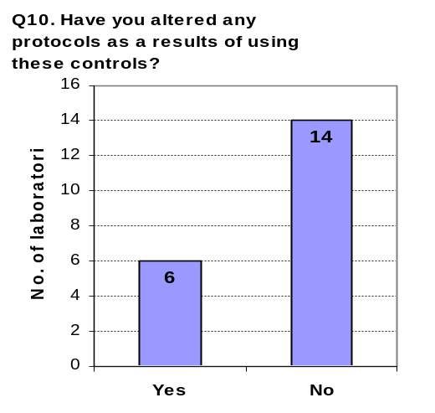

If yes, please give details:

1: Mostly fine tuning of dHPLC temperatures.

2: Introduced new screening temperatures and extra screening temperatures.

3: Re optimised assays after up grades of equipment

4: Redesigned primers and changed dHPLC temperatures.

5: Added temperatures for dHPLC and redesigned exon 11 to analyse by dHPLC because missing small proteins using PTT

6: Redesigned primer sets

Q11. Do you find plasmid DNA an acceptable alternative to genomic DNA?

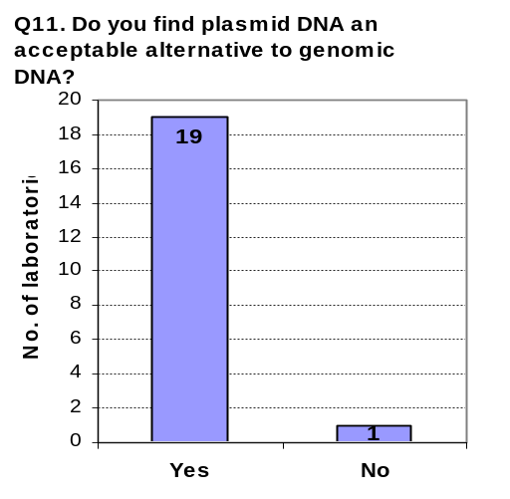
If no, please give details

1: Plasmids amplify more weakly than genomic DNA - especially MSH2.

Q12. Do you think the controls are a useful resource?

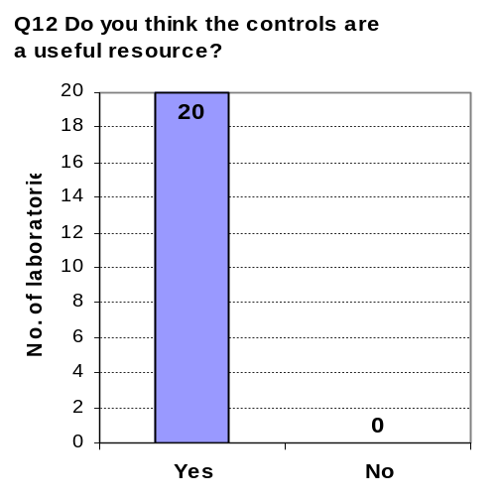

Q13. Do you think the controls should be developed further as certified reference materials?

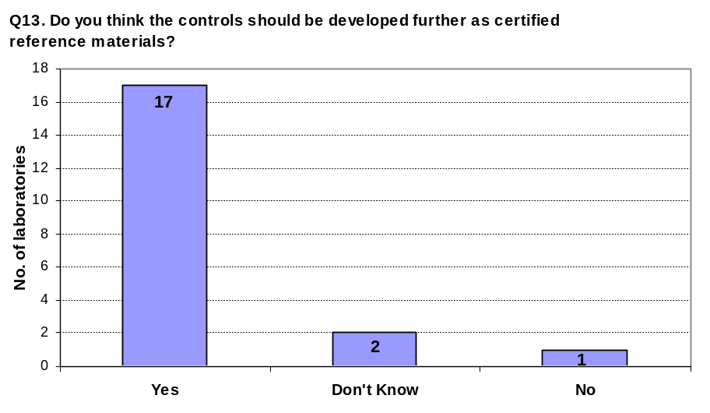

If no, please give details:

1: They work already and are useful, why do you need to develop them further?

General Comments from Evaluation Questionnaires:

1. We were interested to notice after you published some of the dHPLC temperature conditions for BRCA2 on the web that results didn’t always match our findings. We assume that this is largely due to do with primer design so it would be very interesting to have this assumption verified.

With this experience we have not always been very confident about the number of temperatures that we need to run for each exon (we use the older algorithm and it’s sometimes far out) so it was particularly useful to see the melt curves you published. Are you going to do the same for BRCA1 too?

All in all the controls have been invaluable. Even with the ‘how many temps’ rider above it has given us so much more confidence in the results we are obtaining.

2. We add 2μl of the controls to PCR reactions but this can be quite weak still for some exons.

3. Controls were really useful for validating our dHPLC conditions

4. On the whole a useful product we would like to continue using them

5. I have found the plasmid control mixes a very useful resource during our BRCA and HNPCC test developments. I find the DNA amplifies very consistently in our lab and gives good clean sequence. I feel very confident about using these control plasmids as a reliable source of control DNA for the further development of our service alongside our known family controls.

6.This testing has been really very useful to realise that some temperatures were missing in our dHPLC tests.

7. The plasmids are great controls after the primer sets are developed and validated with genomic DNA. A clean amplification with the plasmids does not necessarily mean a clean amplification with genomic DNA.

8. The plasmid controls have been very useful. They have provided me with confidence to know that the WAVE machine is detecting mutations in all my fragments and indicates that the solutions, temperatures etc are calibrated and correct. More Exon 11 controls would be useful

BRCA1 plasmid performance evaluation
Figure 4 shows the performance evaluation data for the BRCA1 wild type and mutant mixes.

- The data show that all diagnostic primer sets bind within the cloned fragments.

- The wild type and mutated exons amplified successfully for most exons with the exception of exon 15 which failed to amplify in one laboratory.

- The mutations were detected successfully for all plasmid controls with the exception of:

Exon 6: One laboratory was unable to detect the mutation in this plasmid and noted that the amplification was prone to poor amplification.

Exon 7: One laboratory was unable to detect the mutation in this plasmid and noted that the amplification was prone to poor amplification.

Exon 10: Two laboratories were unable to detect the mutation in this plasmid. One lab commented that although the plasmids had amplified, the dHPLC run for this sample had failed.

Exon 18: One laboratory was unable to detect the mutation in this plasmid and commented that although the plasmids had amplified the dHPLC run for this sample had failed.

Specific comments from individual labs:

- Plasmid controls became difficult to amplify after several weeks at 4°C

- Yield tends to be lower than when using genomic DNA and the plasmids frequently fail to amplify. This lab suggested that plasmids should be supplied at a higher concentration.

- BRCA1 Exon 2 mutation was only detected at the highest dHPLC temperature analysed and was very melted.

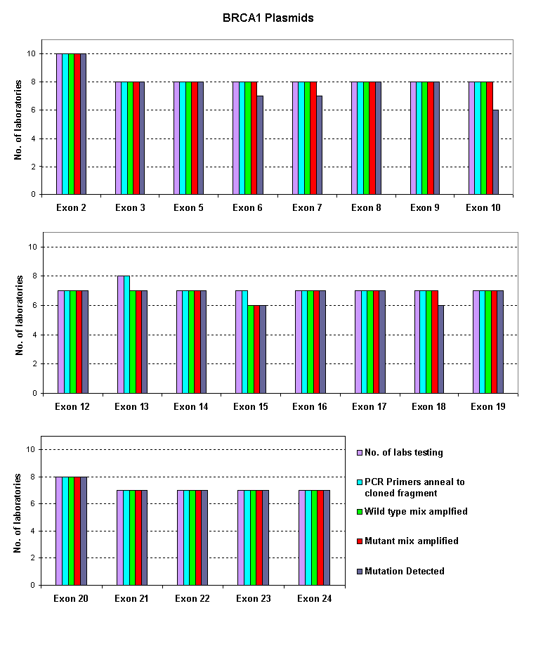

- Performance evaluation data for the BRCA1 wild type and mutant plasmid mixes

BRCA2 plasmid performance evaluation
Figure 5 shows the performance evaluation data for the BRCA2 wild type and mutant mixes.

- The data show that all diagnostic primer sets bind within the cloned fragments with the exception of exon 10 since labs used many different primer sets and PCR screening strategies for this exon.

- The wild type and mutated exons amplified successfully for most exons with the exception of exon 4 where the wild type exon failed to amplify in one laboratory.

- The mutations were detected successfully for all plasmid controls with the exception of:

Exon 2: Initially, one laboratory failed to detect the mutation in this plasmid. However, once the dHPLC temperature was altered the mutation could be detected

Exon 4: Two labs were unable to detect the mutation in this plasmid.

Exon 6: One lab was unable to detect the mutation in this plasmid due to poor amplification of the plasmid DNA

Exon 15: One lab was unable to detect the mutation in this plasmid at three dHPLC temperatures (52, 55 and 59°C). NGRL (Wessex) detected the mutation at 61°C.

Specific comments from individual labs:

- Sometimes the controls could be temperamental and were weak when compared to genomic DNA.

- Controls for the larger exons weren’t compatible with primer sets used.

- Plasmids work well when freshly diluted but do not last and do not amplify as well as patient samples.

- Plasmid controls for exon 9, 10A, 10E, 11A and 11Z produced very clear heteroduplex analysis band shifts.

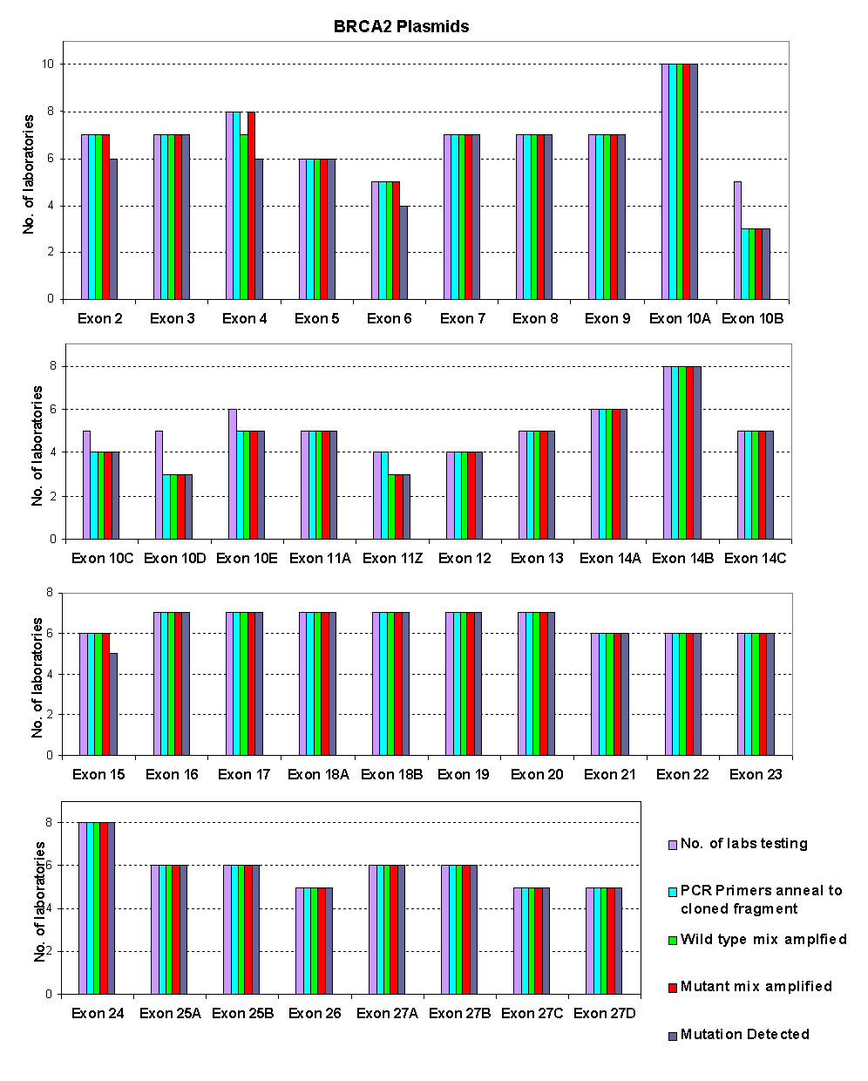

- Performance evaluation data for the BRCA2 wild type and mutant plasmid mixes

BRCA1 and BRCA2 Exon 11 plasmid performance evaluation
Labs use many different screening strategies for BRCA1 and 2 exon 11 including dHPLC, SSCP and PTT. Also, many different primer sets and combinations of amplicons are used to analyse these large exons. Therefore, we supplied the exon 11 plasmids individually so that labs could prepare their own mixes to suit local screening conditions.

Figure 6 shows the performance evaluation data for the BRCA1 and BRCA2 exon 11 plasmids.

- Data show that the cloned fragment was suitable for use with all the primers sets used by the diagnostic labs

- The plasmids amplified in all cases except BRCA2 trc12.2 which failed to amplify in one lab.

- Mutation were detected for all plasmids except:

BCRA1 trc1: One lab failed to detect this mutation by dHPLC

BRCA2 trc1: Two labs failed to detect this mutation using PTT

BRCA2 trc2: Three labs failed to detect this mutation (2 testing using PTT, 1 using dHPLC). The dHPLC lab commented that the mutation was extremely subtle and was easily missed.

BRCA2 trc5: One lab tested this plasmid using dHPLC and PTT. The mutation was detected using dHPLC but was missed when using PTT

Specific Comments from individual labs:

1. Good range of truncations provided for analysis with PTT

2. More exon 11 controls would be helpful

3. Primers for BRCA1 exon 11 in our lab are distributed over 12 fragments and the exon 11 plasmid controls did not cover all these amplicons. More frequently distributed mutations along exon 11 would be useful

4. For one plasmid where the mutation was not detected using PTT we added a new dHPLC test to cover this region (the truncated protein was too small to detect).

.

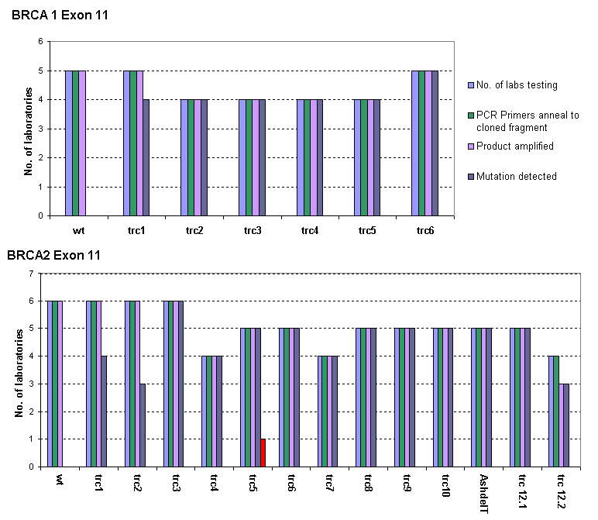

- Performance evaluation data for the BRCA1 and 2 exon 11 plasmids

hMLH1 plasmid performance evaluation

Figure 7 shows the performance evaluation data for the hMLH1 wild type and mutant mixes.

- The data show that there was variation in the primer sets used for hMLH1 mutation screening. Four labs were unable to use the exon 1 plasmids control as their primers did not bind to the cloned fragment. One lab could not use the exon 11 plasmid controls, another lab was unable to use the controls for exons 15, 16 and 19. One other lab reported that their primers could not be used with the exon 19 plasmid.

- The wild type and mutated exons amplified successfully for all exons.

- The mutations were detected successfully for all plasmid controls with the exception of:

Exon 12: The mutation was not detected in five laboratories. At NGRL (Wessex) we could only detect the mutation by sequencing although an extremely subtle shift could sometimes be observed using dHPLC. The laboratories that detected the mutation used sequencing and dHPLC.

Specific Comments from individual labs:

1. We add 2μl of DNA to the PCR but this can still be weak for some exons. We could not detect the exon 12 mutation by dHPLC or sequencing.

2. Exon 12 MLH1 mutation undetectable. In this exon a 5’ splice site mutation would be most useful as it is hard to PCR the 5’ end of this exon because of an extensive poly A tract.

3. Most exons amplified more weakly than genomic DNA

4. Exon 4 mutation was subtle on dHPLC and the exon 5 mutation was not always clearly detected although this improved with fresh plasmid stock. We switched to sequencing exon 8 as we had problems detecting plasmid control mutation and other variants using dHPLC. Exon 10 mutation was subtle.

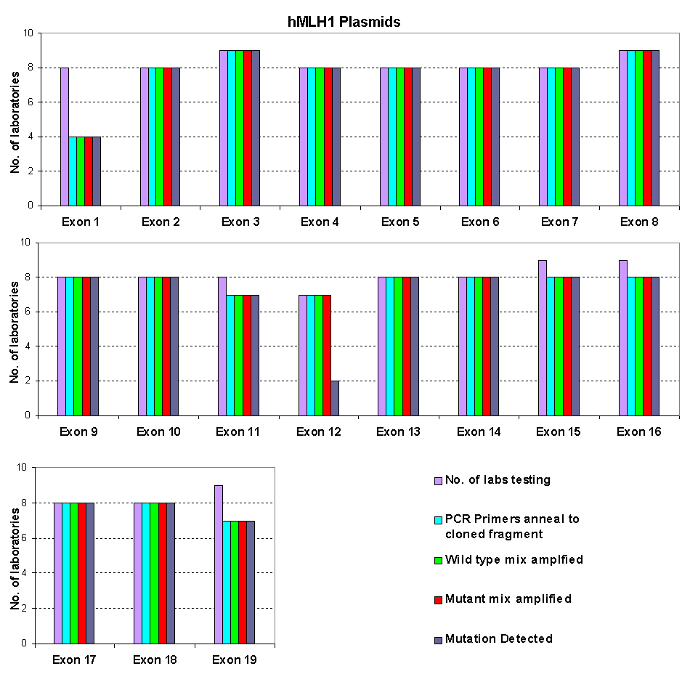

- Performance evaluation data for hMLH1 wild type and mutant plasmid mixes

MSH2 plasmid performance evaluation
Figure 8 shows the performance evaluation data for the MSH2 wild type and mutant mixes.

- Data show that the cloned fragment was suitable for use with all the primers sets used by the diagnostic labs

- The wild type and mutated exons amplified successfully for all exons although one lab experienced many amplification failures.

- The mutations were detected successfully for all plasmid controls.

Specific Comments from individual labs:

1. Consistently found that the quality of amplification from the plasmid mixes was a lot poorer than from genomic DNA samples.

2. Exon 2 and 7 mutations only just detectable using dHPLC

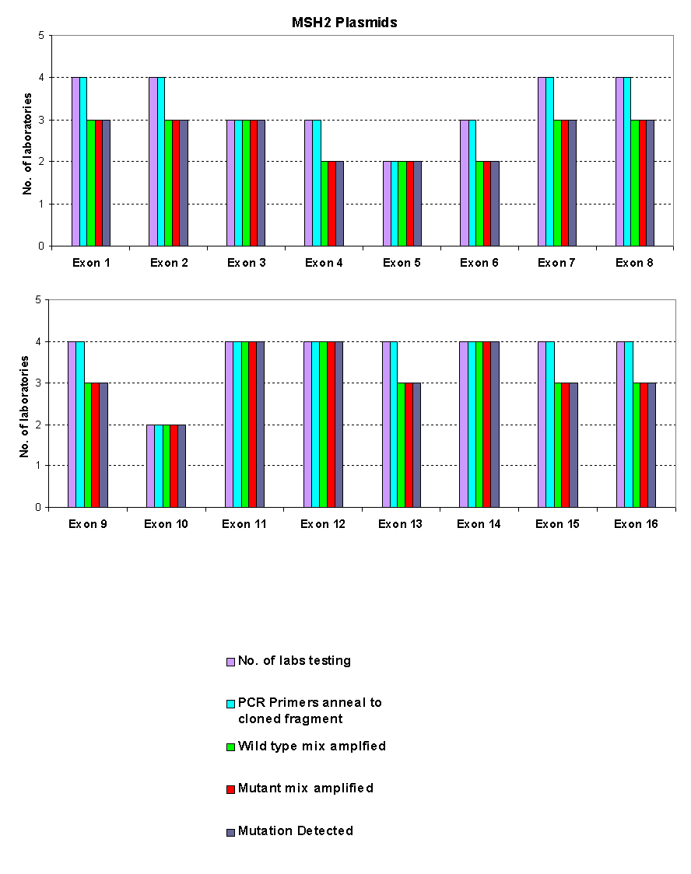

- Performance evaluation data for MSH2 wild type and mutant plasmid mixes

Overall Conclusions from field trial
Plasmid controls were sent out to 34 individuals in 26 laboratories from May 2003 – October 2005 for a performance indicator field trial. Monthly evaluation questionnaires were collected over an 18 month period and a final follow-up questionnaire was distributed in January 2005. 20 individuals from 15 laboratories returned the final follow-up questionnaires. Reagents were analysed using six mutation scanning techniques: dHPLC, sequencing, SSCP/HD, CSCE, PTT and MALDI-TOF.

Analysis of the data collected from the 20 field trial participants who returned questionnaires showed that:

  - 80% have used the controls in routine testing

  - 65% have used the reagents to develop new assays or validate existing screens

  - 30% have altered diagnostic protocols as a results of using the controls

  - 95% found plasmid DNA to be an acceptable alternative to genomic DNA

  - 100% thought that the reagents were a useful resource

  - 85% agreed that the reagents should be produced as reference material

Generally the reagents performed well in most laboratories although several labs commented that the plasmid controls amplified more weakly than genomic DNA samples. The plasmids are currently undergoing modification to be compatible with the standardised primer sets developed by NGRL (Wessex).

Future Work

Redesign of BRCA and HNPCC plasmids
Plasmid controls are currently being redesigned to be compatible with the standardized primer sets produced by NGRL (Wessex). Please contact Chris Mattocks (Chris.Mattocks@salisbury.nhs.uk) or Dan Ward (Daniel.Ward@salisbury.nhs.uk) for primer sequences.

Production of polymorphism controls
Sets of polymorphism controls for BRCA1 and BRCA2 are being produced which can be used as controls in SNP screens which are being employed by many laboratories using pre-screening mutation scanning techniques. For more details please contact Helen White (hew@soton.ac.uk).

. Quantification of controls
The most common comment about the plasmid controls was that they failed to amplify as strongly as genomic DNA. We have recently purchased a Nanodrop 1μl spectrophotometer (LabTech) which will enable more accurate quantification of the plasmid DNA. This should enable us to supply the plasmid controls at copy numbers which are true genomic equivalents.

ACKNOWLEDGEMENTS

We would like to thank all the labs who helped to evaluate these reagents.

Appendix 1

a) Laboratories who returned final follow-up evaluation questionnaires

David Bunyan, Esta Wilkins & Julie Sillibourne, Wessex Regional Genetics Laboratory, Salisbury District Hospital, Salisbury, SP2 8BJ, UK

Caroline Bunn, Molecular Genetics Diagnostic Laboratory, Medical Genetics Unit, St George’s Hospital Medical School, Cranmer Terrace, London,SW17 0RE, UK

Nicola Marchbank, NGRL (Manchester), St Mary’s Hospital, Hathersage Road, Manchester, M13 0JH, UK

Pat Bond & Lisa Strain, Northern Genetics Service, Institute of Human Genetics, International Centre for Life, Central Parkway, Newcastle Upon Tyne, NE1 3BZ, UK

Nicola Andrew, Human Genetics Unit, Level 6, Ninewells Hospital, Dundee, DD1 9SY, UK

Helen Field, LGC Ltd, Life Sciences, Queen’s Road, Teddington, Middlesex, TW11 0LY, UK.

Andrew Purvis, Diane Cairns, Emma McCarthy & Julie Sibbring, Regional Molecular Genetics Lab, Liverpool Women’s Hospital, Crown Street, Liverpool, L8 7SS, UK

Rebecca Barnetson, Colon Cancer Genetics Group, MRC Human Genetics Group Western General Hospital, Edinburgh EH4 2XU, UK

Cara Reith, Molecular Diagnostics Laboratory, London Health Sciences Centre, Ontario, Canada

Spiros Tavandzis, P and R Lab s.r.o., Máchová 30, Nový Jičín 74101, Czech Republic.

Peter Logan, Regional Molecular Genetics Lab, Northern Ireland Genetics Service, Belfast City Hospital, Lisburn Road, Belfast, BT9 7AB, UK

Carl Fratter, Oxford Medical Genetics Laboratories, The Churchill, Old Road, Headington, Oxford, OX3 7LJ, UK

Christine Bell, Medical Genetics, Medical School, Foresterhill, Aberdeen, AB25 2ZD, UK

Pascale Hilbert, Institut de Pathologie et de Génétique, Département de Biologie Moléculaire, 41 Allée des Templiers, 6280 Gerpinnes, Belgium

Ben Legendre, Transgenomic, 12325 Emmet Street, Omaha, NE 68164, USA

b) Laboratories who returned monthly evaluation questionnaires

Gillian Stevens, Molecular Genetics, Yorkhill NHS Trust, Yorkhill, Glasgow, G3 8SJ, UK

Moira MacDonald, DNA Laboratory, Institute of Medical Genetics, University Hospital of Wales, Heath Park, Cardiff, CF4 4XW

Karen Carpenter, Molecular Genetics, Nottingham City Hospital, Hucknall Road, Nottingham, NG5 1PB, UK
Appendix 2

Details of cloned fragments in mutant mixes

BRCA1

The BRCA1 mut plasmid mix contains 22 plasmids which contain mutated coding regions of exons 2-24 as shown below:
Exon | Cloned fragment * | Nucleotide Change * | Exon Amino Acid Change*
2 | IVS1 –226 to IVS2 +195 | 153 C>T | Q12X
3 | IVS2 –207 to IVS3 +288 | 200 -1 G>A | Splice
4 | IVS3 –157 to IVS4 +168 | IVS3-1G-T | Splice
5 | IVS4 –181 to IVS5 +180 | 300 T>G | C61G
6 | IVS5 –167 to IVS6 +168 | 342 -11 T>G | Splice
7 | IVS6 –188 to IVS7 +168 | 433 A>G | Y105C
8 | IVS7 –173 to IVS8 +115 | 624 C>T | Q169X
9 | IVS8 –178 to IVS9 +165 | 676 C>A | S186Y
10 | IVS9 –218 to IVS10 +104 | 731 G>C | L204F
12 | IVS11 –148 to IVS12 +170 | 4236 G>T | E1373
13 | IVS12 –175 to IVS13 +149 | 4446 C>T | R1443X
14 | IVS13 –167 to IVS14 +206 | 4508 C>A | Y1463X
15 | IVS14 –142 to IVS15 +251 | 4737 G>T | E1540X
16 | IVS15 –142 to IVS16 +116 | 4808 C>G | Y1563X
17 | IVS16 –125 to IVS17 +202 | 5106 -1 G>A | Splice
18 | IVS17 –108 to IVS18 +280 | 5228 T>G | Y1703X
19 | IVS18 –172 to IVS19 +184 | 5298 A>T | K1727X
20 | IVS19 –143 to IVS20 +278 | 5350G>C | R1744R
21 | IVS20 –149 to IVS21 +204 | 5397 -1 G>A | Splice
22 | IVS21 –141 to IVS22 +237 | 5465 G>A | W1782X
23 | IVS22 –151 to IVS23 +200 | 5563 G>A | W1815X
24 | IVS23 –157 to 5909 | 5622 C>T | R1835X

*GenBank Accession Number : | U14680 according to BIC database (http://research.nhgri.nih.gov/bic/)  Nucleotide 1 = base 1 of U14680, Amino acid 1 = Met

BRCA2

The BRCA2 mutant plasmid mix contains 31 plasmids which contain mutated coding regions of exons 2-27 as shown below:
Exon | Cloned fragment* | Nucleotide Change* | Amino Acid Change*
2 | IVS1-192 to IVS2+207 | 260 T>C | F11S
3 | IVS2-211 to IVS3+228 | 429 G>A | R67R
4 | IVS3-151 to IVS4+192 | 594 T>A | T122T
5 | IVS4-210 to IVS5+213 | 672 T>A | C148X
6 | IVS5-242 to IVS6+225 | 730 C>A | P168T
7 | IVS6-205 to IVS7+186 | 783 A>T | G185G
8 | IVS7-172 to IVS8+238 | 868 G>A | E214K
9 | IVS8-228 to IVS9+173 | 951 G>A | K241K
10A | IVS9-148 to 1451 | 1093 A>C | N289H
10B | 1230 to 1704 | 1342 C>T | H372Y
10C | 1364 to 1853 | 1593 A>G | S455S
10D | 1641 to 2093 | 1817 A>T | K530I
10E | 1790 to IVS10+143 | 1990 A>G | N588Y
11A | IVS10-164 to 2442 | 2217 T>G | F663L
11Z | 6724 to IVS11+168 | 7046 G>A | R2273K
12 | IVS11-248 to IVS12+213 | 7084 A>T | K2286X
13 | IVS12-203 to IVS13+218 | 7208 T>G | L2327X
14A | IVS13 -211 to IVS14 +161 | 7272 T>A | N2348K
14B | IVS13 -211 to IVS14 +161 | 7481 G>C | R2418T
14C | IVS13 -211 to IVS14 +161 | 7649 A>T | E2474V
15 | IVS14-75 to IVS15+172 | 7768 A>T | K2514X
16 | IVS15-270 to IVS16+276 | 7909 C>T | Q2561X
17 | IVS16-228 to IVS17+228 | 8115 G>A | W2629X
18A | IVS17-235 to IVS18+217 | 8260 A>G | R2678G
18B | IVS17-235 to IVS18+217 | 8536 G>C | A2770P
19 | IVS18-235 to IVS19+265 | 8636 T>C | L2803P
20 | IVS19-216 to IVS20+209 | 8809 A>T | R2861X
21 | IVS20-195 to IVS21+151 | 8909 A>G | Q2894R
22 | IVS21-154 to 9211 | 9082 A>G | M2952V
23 | IVS22-231 to IVS23+253 | 9269 C>A | S3014X
24 | IVS22-28 to IVS24+205 | 9431 C>T | S3068F
25A | IVS24-211 to IVS25+280 | 9489T>C | L3087L
25B | IVS24-211 to IVS25+280 | 9729+2 T>G | Splice
26 | IVS25-215 to IVS26+187 | 9827 C>G | S3200X
27A | IVS26-230 to 10792 | 9968 A>C | Q3247P
27B | IVS26-230 to 10792 | 9968 A>C | Q3247P
27C | IVS26-230 to 10792 | 10258 C>G | L3344V
27D | IVS26-230 to 10792 | 10422 G>A | Q3398Q
*Numbering as for GenBank Accession Number : | U43746 according to BIC database (http://research.nhgri.nih.gov/bic/)  Nucleotide 1 = base 1 of U43746, Amino acid 1 = Met
BRCA1 Exon 11
These are supplied as individual tubes so that users can use the most appropriate controls for their assay.
Exon | Cloned fragment | Nucleotide Change | Amino Acid Change*
11wt | IVS10 –294 to IVS11 +75 | N/A | N/A
11trc1 | IVS10 –294 to IVS11 +75 | 999 A>T | K294X
11trc2 | IVS10 –294 to IVS11 +75 | 1626 A>T | K503X
11trc3 | IVS10 –294 to IVS11 +75 | 2187 A>T | K690X
11trc4 | IVS10 –294 to IVS11 +75 | 2765 T>A | C882X
11trc5 | IVS10 –294 to IVS11 +75 | 3339 A>T | R1074X
11trc6 | IVS10 –294 to IVS11 +75 | 4003 T>A | L1295X

*GenBank Accession Number : | U14680 according to BIC database (http://research.nhgri.nih.gov/bic/)  Nucleotide 1 = base 1 of U14680, Amino acid 1 = Met

BRCA2 Exon 11
Construct | Cloned fragment | Nucleotide Change | Amino Acid Change
BRCA2 X11wt | IVS10-99 to IVS11+147 | N/A | N/A
BRCA2 X11trc1 | IVS10-99 to IVS11+147 | 2307 T > A | C693X
BRCA2 X11trc2 | IVS10-99 to IVS11+147 | 2442 T > A | C738X
BRCA2 X11trc3 | IVS10-99 to IVS11+147 | 2879 C > G | S884X
BRCA2 X11trc4 | IVS10-99 to IVS11+147 | 3106 A > T | K960X
BRCA2 X11trc5 | IVS10-99 to IVS11+147 | 3815 T > A | L1196X
BRCA2 X11trc6 | IVS10-99 to IVS11+147 | 4186 G > T | E1320X
BRCA2 X11trc7 | IVS10-99 to IVS11+147 | 4732 G > T | Q1502X
BRCA2 X11trc8 | IVS10-99 to IVS11+147 | 4996 A > T | K1590X
BRCA2 X11trc9 | IVS10-99 to IVS11+147 | 5491 G > T | E1755X
BRCA2 X11trc10 | IVS10-99 to IVS11+147 | 5978 C > G | S1917X
BRCA2 X11Ash delT | IVS10-99 to IVS11+147 | 6174 delT | I2003X
BRCA2 X11trc12.1 | IVS10-99 to IVS11+147 | 6736 A > T | K2170X
BRCA2 X11trc12.2 | IVS10-99 to IVS11+147 | 7064 T > A | L2279X
*Numbering as for GenBank Accession Number : | U43746 according to BIC database (http://research.nhgri.nih.gov/bic/)  Nucleotide 1 = base 1 of U43746, Amino acid 1 = Met

hMLH1

The hMLH1 mutant plasmid mix contains 17 plasmids which contain mutated coding regions for exons 1-19 as shown below.
Exon | Cloned fragment *. | Nucleotide Change* | Amino acid Change*
1 | 1- 20 to IVS1+330 | 62 C>G | A21A
2 | IVS1-200 to IVS2+183 | 207+1G>C | Splice
3 | IVS2-235 to IVS3+138 | 280 A>T | I94F
4 | IVS3-235 to IVS4+92 | 367 A>T | K123X
5 | IVS4-220 to IVS5+140 | 418 A>T | K140X
6 | IVS5-141 to IVS6+154 | 497 T>A | L166X
7 | IVS6-191 to IVS8+230 | 588+1 G>A | Splice
8 | IVS6-191 to IVS8+230 | 645 T>A | N215K
9 | IVS8-187 to IVS9+131 | 725 T>A | M242K
10 | IVS9-178 to IVS10+173 | 868 C>A | P290T
11 | IVS10-107 to IVS11+179 | 911 A>T | D304V
12 | IVS11-166 to IVS12+130 | 1376 C>G | S459X
13 | IVS12-132 to IVS13+110 1 | 1486 C>A | P496T
14 | IVS13-147 to IVS14+158 | 1661 A>C | K554T
15 | IVS14-207 to IVS15+143 | 1717 G>T | V573F
16 | IVS15-177 to IVS16+58 | 1846 A>T | K616X
17 | IVS16-293 to IVS18+79 | 1897-2 A>G | Splice
18 | IVS16-293 to IVS18+79 | 2008 A>T | K670X
19 | IVS18-74 to 2434 | 2176 T>A | S726T

*Numbering as for GenBank Accession Number : | U07343 according to ICG-HNPCC database**  Nucleotide 1 = a of atg start, Amino acid 1 = Met
** http://www.nfdht.nl/
MSH2
The MSH2 mut plasmid mix contains 16 plasmids which contain mutated coding regions of exons 1-16 as shown below:
Exon | Cloned fragment* | Nucleotide Change * | Amino Acid Change*
1 | -126 to IVS1 +256 | 139 C>G | G47R
2 | IVS1 –183 to IVS2 +167 | 283 G>T | V95F
3 | IVS2 –171 to IVS3 +224 | 542 A>T | N181I
4 | IVS3 –325 to IVS4 +213 | 714 T>G | Y238X
5 | IVS4 –114 to IVS5 +177 | 940 C>T | Q314X
6 | IVS5 –187 to IVS6 +234 | 997 T>C | C333R
7 | IVS6 –217 to IVS7 +179 | 1165 C>T | R389X
8 | IVS7 –222 to IVS8 +232 | 1373 T>G | L458X
9 | IVS8 –255 to IVS9 +143 | 1501 A>T | R501X
10 | IVS9 –218 to IVS10 +130 | 1558 G>T | G520X
11 | IVS10 –212 to IVS11 +266 | 1720 C>T | Q574X
12 | IVS11 –180 to IVS12 +254 | 1870 A>T | I624F
13 | IVS12 –183 to IVS13 +187 | 2131 C>T | R711X
14 | IVS13–243 to IVS14 +157 | 2251 G>A | G751R
15 | IVS14 –203 to IVS15 +202 | 2634+1 g>a | Splice
16 | IVS15 –187 to 3020 | 2714 C>G | T905R

*Numbering as for GenBank Accession Number : | U04045 according to ICG-HNPCC database**  Nucleotide 1 = a of atg start, Amino acid 1 = Met
** http://www.nfdht.nl/

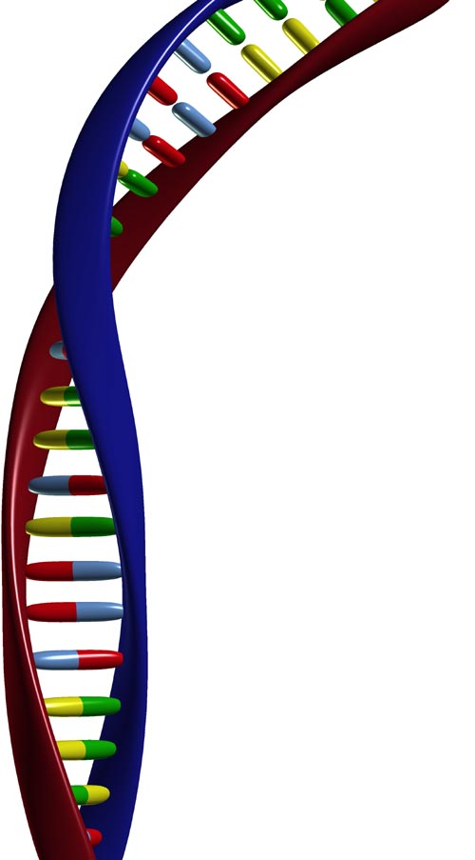
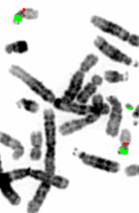

National Genetics Reference Laboratory (Wessex)
Salisbury District Hospital
Salisbury SP2 8BJ, UK

www.ngrl.org.uk

